**System Start Up;**

1. Log in to the bridge PC using EASE credentials
2. If you are using Microfluidics set these to flush first (see Microfluidics cleaning protocol)
3. Check you have the correct objective, Widefield (water) or TIRF (oil), the easiest is to check which one is on the bench, if the wrong objective is in find Dave or Toni to change it over for you.
4. Check the objective is completely lowered (you can see a bit of the copper ring on the micro-meter) and the condenser is raised.
5. Open Bluelake and start a new session, check your hardware config is correct (config or config-TIRF).
6. Apply 60ul water if you are using the widefield objective or apply oil (not condenser oil) to the TIRF objective (Don’t get this wrong!!!)
7. Put on slide or flow chamber, make sure it is flat and touching the magnets, give the holder a slight push to the top left corner, and focus the objective up using the micro-meter until you just see the water (or oil) touch the slide.
8. Check that the objective is positioned under the flow chamber, add **condenser oil** on top of the slide and then close the lid.
9. Turn on the laser, push the red button in, then pull it out and press the green button (it should light up).
10. On the software go to the trap laser controls and turn on the trapping laser, set this to 100% (see picture below).
11. Set Overall power to ~25% and the Trap 1 split to 50% (even if you will only be using Trap 1 for your experiment some light is needed trough Trap 2 at this point).
12. Turn on Brightfield LED (used for viewing beads and flow chamber edges) to ~10% 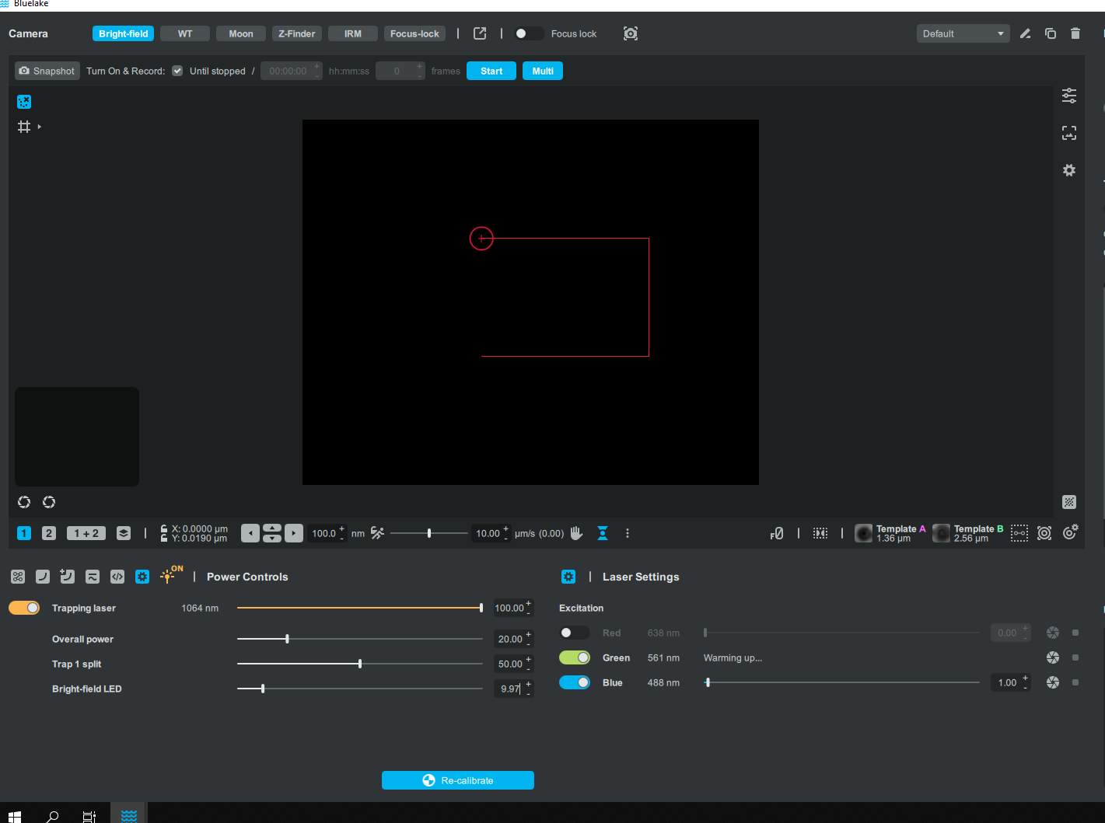

Select camera

Click here to see trapping laser power controls

LUT (inc. auto-adjust)

Background Subtraction

Camera settings (Exposure, gain etc.)

Focus Objective

1. Make sure the slide is positioned over the flow chamber using the micro-stage (trigger in on controller)
2. Select the Z-finder camera, camera settings LUTs etc can be found to the right of the camera picture. Tick auto-adjust.
3. Raise the objective using micro-meter on the front of the C-Trap until you see the first reflection, this can take a while. You will clearly see two spots where the two laser traps are located, if you are doing a surface assay using the TIRF objective then stop here and skip step 4. Make sure the nano-stage is in the middle Z-position.
4. Continue raising until you see the second and then third reflections, if the third reflection doesn’t appear with a similar distance as the first-second reflections double check that you are correctly positioned over the flow chamber, you will then need to restart the laser. Lower again until you are between the second and third reflections, the interference patterns should be at a maximum diameter (should shrink if you focus either up or down).

Focus Condenser

1. If you forgot to add condenser oil then do it now and then restart the laser.
2. Open the Condenser Control, Tools->Condenser Control
3. On the bridge PC open the appropriate Moon picture (water or oil objective)
4. Set the Trapping Laser to 30% (overall power remains as before, 25%) and open the Moon camera, set to auto-adjust
5. Select Approach, the condenser will lower to a safe position.
6. Using the condenser controls carefully step down until the image on the moon camera matches the picture on the bridge PC. Use a step size of 0.05 for coarse and 0.005 for fine
7. Save this as the focus position and close the condenser control
8. Set the laser back to 100%

If you are using a home-made flow cell or slide you are now ready to image. If you are using the provided flow cell and microfluidics then you will need to align its position.

Aligning Flow Cell

1. Select the brightfield camera and adjust the camera settings (auto-adjust).
2. Using the micro-stage (keep trigger pulled on joystick) move to the top edge of the flow cell and then find the inlet for channel 4. The map on the right-hand side of the screen should be roughly correct but won’t be exact.
3. Once a corner has been found the zoom in on the map (mouse scroll) to find the position and then right click on the map to set as current position.

**Microfluidics Cleaning:**

If you open Bluelake, close uFlux first or microfluidics controls won’t display properly in the Bluelake software.

Always check the valve lights to see if the system is flushing, uFlux will keep flushing even when the software is closed!

Before removing syringes, check the system has been vented.

Before Use:

The system should have been left in bleach overnight. Before removing a syringe check on uFlux that there is no pressure. If there is pressure press Vent and wait for it to drop. To remove a syringe turn 90deg clockwise then pull.

* Empty the waste falcon.
* Remove liquid from syringes 1-5 (don’t put tip right into inlet as this can cause air bubbles)
* Add 1ml milliQ water and flush all syringes at 2 bar (use the auto-adjust in uFlux), make sure to open the valves, there should be a blue light on each of the valves. If valve 6 is not open the waste is closed and there will be no flow.
* After 500ul of milliQ has flushed through close valves and vent system (about 10 mins)
* Replace remaining milliQ with 1:30 Reducing Reagent in milliQ water (or equivalently 1ml milliQ water + 30mM Sodium Thiosulfate)
* After 500ul of dilute Reducing Reagent has flushed through close valves and vent system (about 10 mins)
* Remove and replace with 1ml PBS (or other running buffer) flush 500ul through all syringes at 2 bar.
* If using proteins in the flowcell then follow the **passivation procedure**.
* Remove and replace with your experimental buffers. Usually; 1.Beads 2.Buffer 3.DNA 4. Second Protein of interest. 5. First Protein of interest. (500ul of each)

After Use:

* Empty the syringes and replace contents with 1ml milliQ. Flush at 2 bar for 500ul
* Empty the syringes and replace contents with 1ml 100% Cleaning Reagent (or 30% bleach). Flush at 2 bar for 500ul

EITHER

* Empty the syringes and replace contents with 1ml 50% Cleaning Reagent (or 15% bleach). Flush at 2 bar for 500ul, close valves and vent system.
* Check the lights on the valves are off before leaving overnight.

OR

* Add 500ul to make the volume up to 1ml at 50% cleaning reagent.
* In uFlux open the cleaning protocol and press run, the protocol should start to run and will close the valves when it is done.

**DNA workflow**

Set Up:

1. After washing out the bleach (see Microfluidics Cleaning) set up the microfluidics so that there in each syringe there is (numbered front to back):
   * + 1. 500ul of Beads (4.34um diameter current stock) 1:100 in PBS
       2. 500ul of DNA 1:1000 in PBS from stock (20ng/ul)
       3. 500ul PBS
       4. 500ul Buffer OR protein of interest (eg. YOYO1 @ 2nM)
       5. 500ul Buffer OR protein of interest
2. A screenshot of a computer

   Description automatically generated with medium confidenceSet the pressure at 0.1-0.3 and open the valves. Label the channels appropriately in the software in the uFlux window. If you have a protein of interest you need to flush through ~200ul before you get a consistent concentration (this can be done at higher pressure).
3. A screenshot of a computer

   Description automatically generated with medium confidencePut the flow cell in to place adjust the objective, condenser, and stage (see System Start up)
4. If you are using Ch5 in your experiment duplicate the existing beads, DNA and Buffer waypoints and move them by editing their X position in their description so they are closer to the Ch5 Junction.

Ch5

Ch4

1. Set up a path using the arrow symbol to add predefined waypoints to the path (make sure your path doesn’t go through walls). A standard path would be Beads->DNA->Buffer->J1-> Ch4. You can edit the speed of movement between waypoints in the path (0.2 is slow, 2 is fast). You can move between positions on the path using the hat on top of the joystick.

Paths

Waypoints

1. Move into the bead channel and capture 2 beads. Select Trap 1 (below the cameras) and move the joystick, the bead in Trap 1 will move. Move Trap 1 so that it is in the middle of its movement (x =20, y=14). Lock the Y movement.

Update Add to path New Duplicate Delete

Double click on text to edit position or name. Click on the circle to go to a waypoint.

The waypoint selected is the one highlighted in light grey (this is the one you will update etc.)

1. A screenshot of a computer

   Description automatically generated with medium confidenceSelect Trap 2 and position it to the left of Trap 1, lock X and Y, then select Trap 1+2 and move both Traps into the middle of the FOV. Use the Z to move the beads into focus (this is important if the last user was doing surface assays). Lock XY and Z on Trap 1+2.

Select to control Trap1, Trap2, Traps 1+2 (selected) or nano-stage

X,Y and Z locked

1. A screenshot of a computer

   Description automatically generatedA screenshot of a computer

   Description automatically generated with medium confidenceReturn to Trap 1 and turn on the trap one display, set the trap 1 position (shift-click on bead).
2. Ensure the two beads are good (no other rubbish in the traps) and move to the buffer waypoint using the hat on top of the joystick. Stop the flow by closing the valves.

Click to draw a template

Make sure you have given the correct bead diameter

Click to edit the tracking ROI

1. Make one of the beads a Template by clicking Temp A and dragging a square around the bead, enter the bead diameter (the exact value should be on the bead packaging).
2. A screenshot of a computer

   Description automatically generatedEdit the tracking ROI so that it covers the area where the beads are expected to be. As the beads are the same both beads should now be picked up by the software and have pink outlines and a percentage fit to the template associated with them. A line should appear between the two beads picked up by the template, adjust the Trap1 position until it is horizontal then lock the Trap1 Y direction.

Select laser settings

Click Recalibrate

1. A screenshot of a computer

   Description automatically generated with medium confidenceA screenshot of a computer

   Description automatically generated with medium confidenceA screenshot of a computer

   Description automatically generated with medium confidenceCalibrate the beads (make sure there is no flow, all valves are closed), go to the trapping laser settings and click the box at the bottom of the screen. Points/Block = 200 and Hydrodynamic correction selected then select Measure and after if a good fit is achieved click Apply. Increasing the overall power will give a stiffer trap.

New fits

Changing the lower bound to 200 to excludes the low frequency peak, click Analyze to recalculate the stiffness.

This calibration is not well fit.

DNA Fishing:

1. A screenshot of a computer

   Description automatically generated with medium confidenceOn the left monitor bring up the F/d graph, pick, Trap2 and Distance 1 to compare. Select the standard curve (eWLC is the correct model for lambda-DNA) and input the contour length. Zero the forces with no DNA tether using the buttons on the base of the joystick (9 zeros, 10 clears the graph).

Trap 2

Distance 1

eWLC

Set length of DNA in kb

F/d

1. Empty traps, move to the beads waypoint, turn on the flow (valves open pressure 0.1-0.3) and pick up beads.
2. Move to the DNA waypoint and probe for DNA by moving Trap 1 towards and away from Trap 2 (around the distance where the F/d curve is predicted to rise). Move to the buffer waypoint.
3. At this point test the number of tethers. Turn off the flow (close valves) and then zero the force (do this with the beads about half the contour length away from each other so there is no tension between them). Move the beads away from each other slowly by moving Trap 1 (in X locked in Y). If the F/d curve follows the model (yellow line) you have 1 tether. If there are multiple tethers the curve will rise earlier and may achieve a higher force (60pN is the melting point for 1 tether). It is possible to break some tethers by moving the beads apart and leave just one remaining.
4. If you have don’t have additional protein in your assay continue to step 8.
5. When you have just one tether you can then move into the protein channel (eg. YOYO1), keep the tether extended under ~10pN load as you move. Follow the path to the junction and then into the protein channel.
6. You can now image using widefield fluorescence. A starting point for illumination settings is laser powers 5-20% with an exposure time of 500ms and Frame Rate of 1.5Hz
7. You may want to correct the template for Trap1 position for this camera (Trap 1 and the Ctrl-Click). You may also need to re-adjust the bead focus to bring the tether into focus. To do this use the Trap 1+2 Z control (unlock and then lock again after use). If the 1+2 Z is adjusted, then you need to redo the bead templates and recalibrate with new beads (without DNA).
8. To collect F/d data then move Trap 1 towards/away from Trap 2 extending and relaxing the DNA. Do this with the flow off in either protein or buffer whichever is appropriate for your experiment. You can start a camera recording which will output the video files to the D Drive and place a marker in the force data. Alternatively, you can place a marker in the force data by pressing button 11 on the joystick base during acquisition to start/stop or by right clicking on data trace later.

**Fluorescence/IRM**

-Laser settings, the green laser takes time to warm up so avoid turning off where possible. Use the shutter instead (icon to the right of the slide bar). If exposure synchronisation is on, then the lasers will only emit when the camera is acquiring but the laser shutters can’t be operated manually.

- Select Align Colours to get a nice overlay of different fluorescent colours. Alignment matrices for the RGB channels are Exported with the meta data- but images will be mis-aligned and need correction.

-Make sure Frame rates of all cameras (eg WT and IRM) are the same if you will want to play movies side by side or overlay them.

-Recording movies (Start/stop). Data is output to the D drive and a mark is made in the force data. If you want to record on different cameras simultaneously, go to Multi and select the cameras you are interested in, also turn on Multi (the button should go green and the number of cameras should appear next to the start button).

-To move in to TIRF, toggle the switch (must be using the TIRF objective). Adjust the TIRF angle (up in camera bar) using the arrows to move in y.

-To set the field of view use the button on the RHS of the top camera bar (it goes blue and an ROI appears which can be adjusted to your desired FOV). Once the FOV is as you want it then deselect the button, the camera view will be cropped.

-Setting up IRM (only when using the TIRF objective), turn on IRM LED (turn off after use this will remain on - Exposure Time ~4ms, Background Subtract ~10, Gain 0, Freq 250Hz, if doing a background subtraction use a radius of 10 (check the nano-stage is not at its limits first).

-Focus Lock- Shows up on LHS if selected, on focus lock camera make sure dots are in the camera FOV (smaller FOV is better)

**Setting up Force Measurements (TIRF/IRM Surface microtubule experiments)**

-Centre the Nano-stage in XY and find the surface (can adjust the nano-stage speed if it is to slow/fast). Set the trapping laser to ~1% overall power and 100% Trap1 split.

Select laser settings

Select nano-stage and set x/y =100

Z-control

Brightfield camera

-Using the micro-stage (trigger in) find MT and set a waypoint in XY and Z, from now on don’t pull the trigger and move the micro-stage as this will lose your waypoints.

Waypoints

Trap 1 Split to 100%

Overall Power 1%

-Using the brightfield camera, step the nano-stage down one bead diameter and set an approach waypoint in Z.

-Step the nano-stage down 4 more bead diameters, set a Solution waypoint in Z. Capture a bead.

-Select Trap 1 and turn on the Trap 1 display, set the trap 1 position (shift-click on bead) and then use the joystick to move the bead to the middle of the trap 1 position box (or ctrl-click).

-Select Trap 1 + 2 and position the trap in the middle of the field of view then lock the X and Y controls, focus the bead in Z (can use the thumb control on the joystick).

-Select Trap 1 and re-set the bead position in the viewer.

-Select the nano-stage. With a bead still in the trap, move to waypoint MT in XY and Approach in Z, switch to IRM or WT camera to see the MTs (they will be out of focus). Gradually (50nm intervals) move the nano-stage up in to focus, testing (looking at the force curve) if the bead is in contact with the surface by moving the nano-stage in X and Y.

-If the bead contacts the surface before the MT is in focus return to Trap 1+2 and move the trap position up slightly. Continue until the surface is in focus and the bead is just touching MTs on the surface. From now on don’t touch Trap 1+2

-Go back up to the Solution waypoint on the nano-stage and if necessary, release the bead (may have picked up lots of rubbish) and move to a new X-Y area to capture a new one. Set the new bead as a template and then perform a calibration (Untick Hydrodynamic correction, Pts/block=200, lower bound=10Hz, aiming for ~0.05pN/nm). After performing a calibration do not touch 1+2 Z position or the trapping laser power.

-Move back over the MT using the XY waypoint and then return to the surface using the approach and then surface waypoints. The bead can be moved over the MT using either the nano-stage or Trap 1.

-If the bead starts to bind the MT and move then make a marker on the force trace or press button 11 on the joystick base to start/stop marking. If you make a movie (start/stop on the cameras) then this will also mark the force data.

A**utomation**

-It is possible to automate the movement of Trap 1, to do this select the F/d curve symbol in the control panel below. You want to set Trap: 1 and as a starting point Speed = 1uM/s. You can either add a waypoint for Trap1 start and end positions or move the trap position relative to your current (start) position. Pressing “To End” moves the trap to the end position, “To Start” moves the trap to the start position. The ping-pong symbol will keep repeating the movement until stopped. Using this function will automatically mark and save the data as an F/d curve experiment.

-The scripting function allows a script to be loaded to automate data acquisition.

-The Force Feedback function will maintain a constant force. If you are using it in the DNA tether set up you want to set Force: Trap2 and Lock angle: Distance. To turn on select Enable, make sure to turn off or your beads will keep flying off whilst trying to achieve the required force.

**After Use and Exporting Data**

-When you are finished, if you have been using microfluidics you should start the end of day cleaning procedure.

-At the end of your session make sure all the data you want to keep has been marked, you can right click and set a marker on any unmarked data you think is interesting.

-Pick which markers you want to export, press the “download” symbol next to them. When exporting force data take the HF (high frequency) Force data.

-Click export, the data should appear in the D drive (any videos you took will already be saved here), from here move it into the bridge folder and then on the bridge PC move it to your data store.

-Do not leave data on the D drive or in the bridge folder as they may be deleted by the next user. At the end of your session please check and empty the D drive.

-Once you have moved all your data you should delete your session as the data will build up quickly.