JAMES RENNIE BEQUEST

REPORT ON EXPEDITION/PROJECT/CONFERENCE

Expedition/Project/Conference Title: Assessing the impact of the invasive little red fire ant Wasmannia auropunctata on the Herpetofauna of the West African rainforest

Travel Dates: 9/06/08 – 20/08/08

Location: Lope National park, Gabon

Group Member(s): Emilie van Strydonck, Nico Rumboll, Josephine Beynon, Jamie McWilliam and Amy Beavan.

Aims:

- Measure the effect of little red fire ant Wasmannia auropunctata infestation on the diversity of Herpetofauna in Lopé National Park, Gabon
- Collaborate with Dr Jeffery (project supervisor) and Vianet Mihindou (Gabonese student).
- Highlight and publicise the National Park’s conservation importance through film documentation to increase awareness of the threats posed by invasive fire-ants to biodiversity.
- Promote local capacity; work with Gabonese students and local field guides to ensure ongoing research.

OUTCOME (not less than 300 words):-

In June of this year I set out with four undergraduate biologists and ecologists to the heart of Western Equatorial Africa where we carried out a conservation research project to assess the impact of a globally prominent and devastating invasive species of fire ant, Wasmannia auropunctata on reptile and amphibian communities.

The little red fire ant, Wasmannia auropunctata originally from South America is listed as one of the 100 worst invaders in the world by the Invasive Species Specialist Group. In the last century, global anthropogenic transport has facilitated the establishment of populations in tropical regions all over the world.

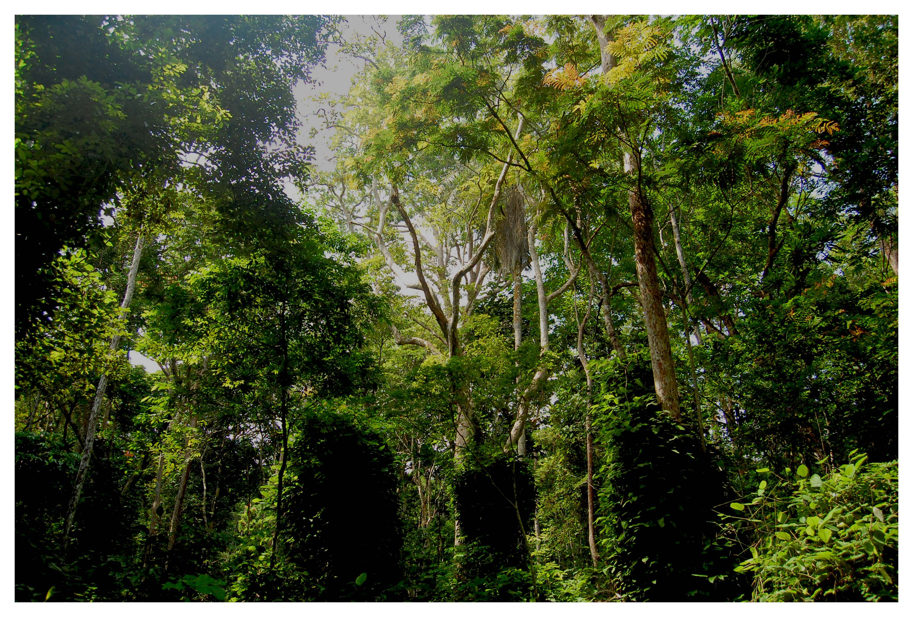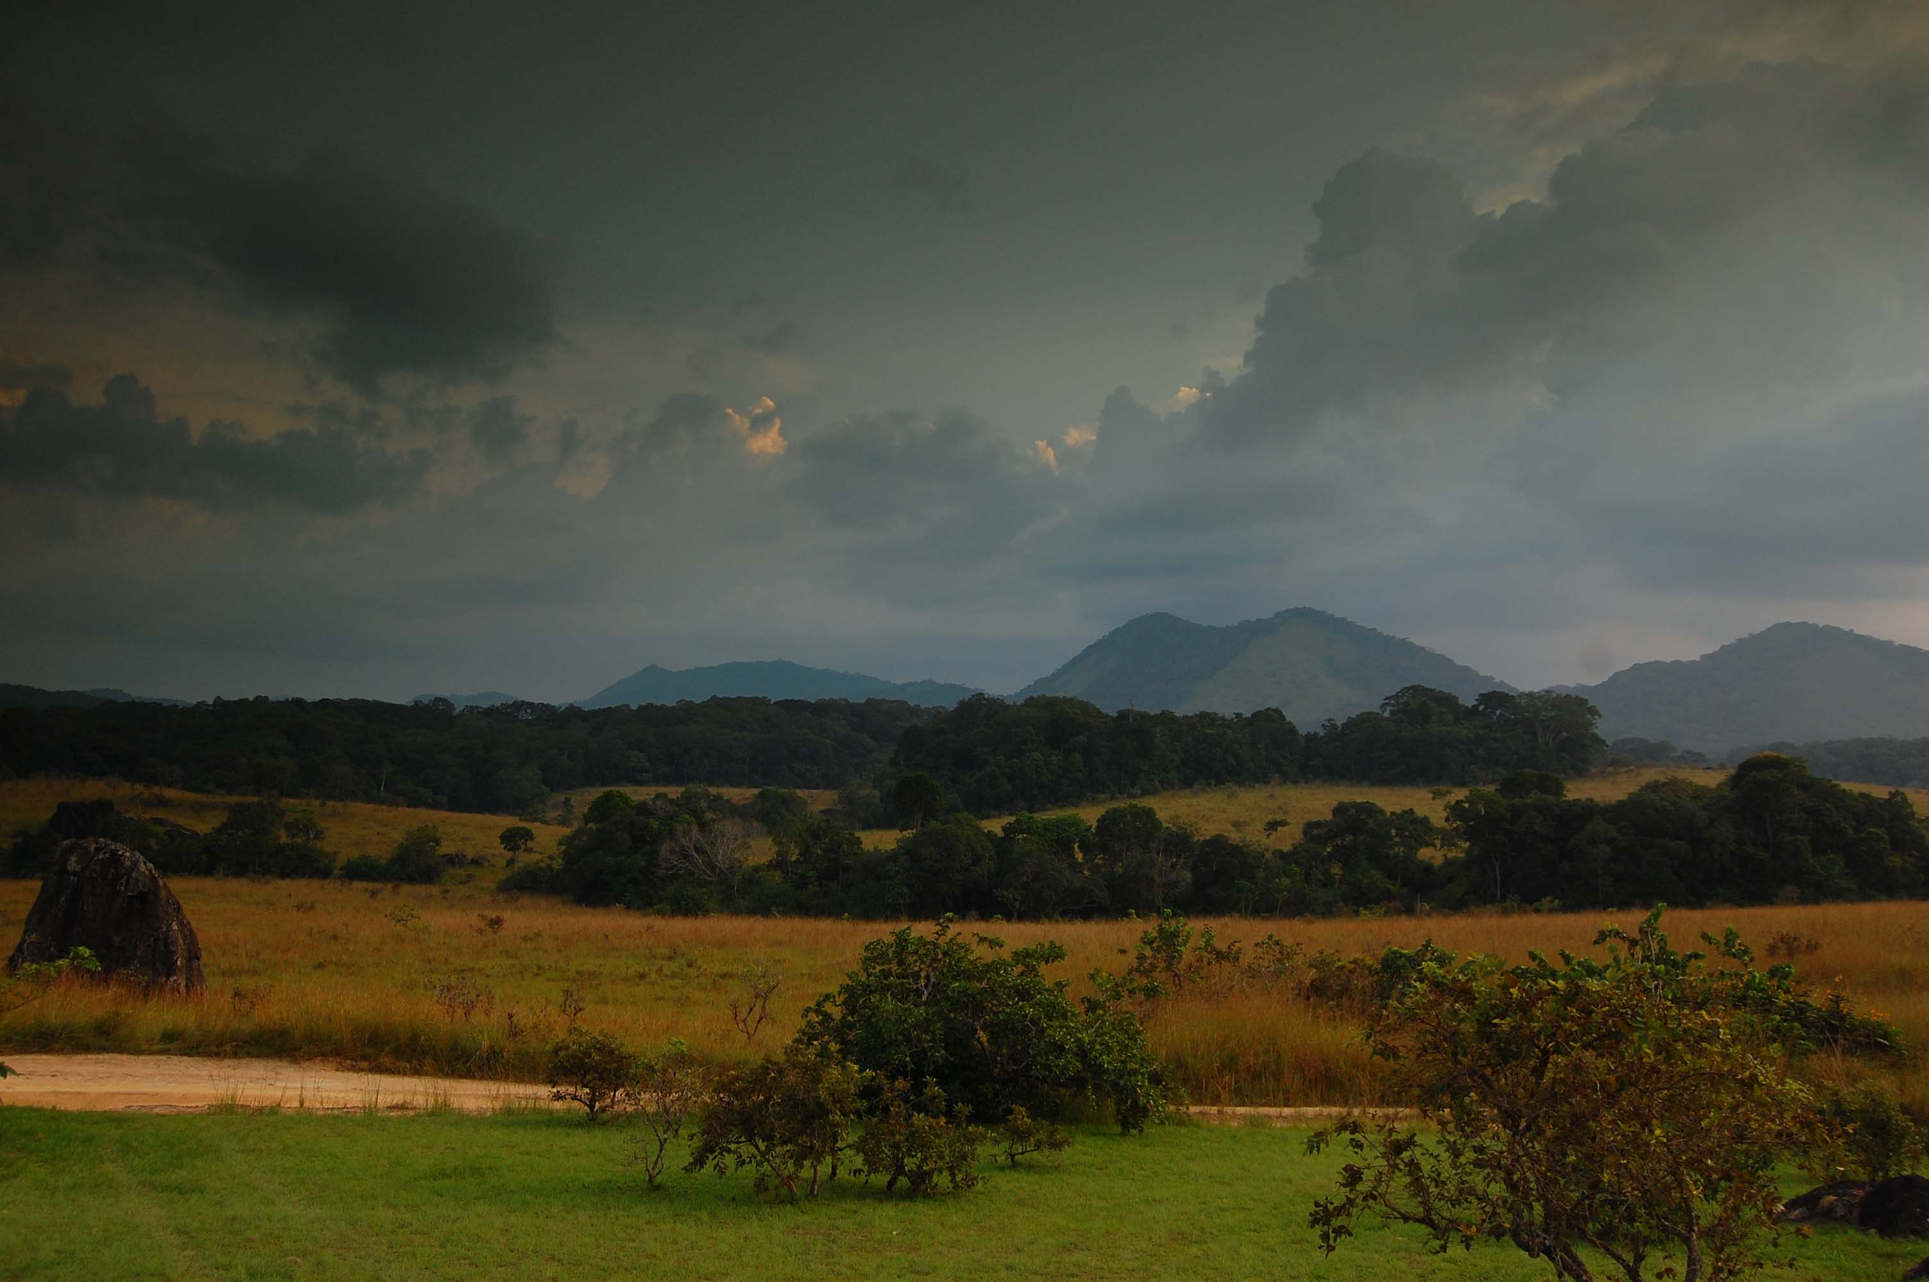

Our project location was Lope National Park, Gabon an isolated national park which is home to a huge variety of species including mandrills, forest elephants, gorillas, the elusive golden cat and over 500 species of bird. With one of the highest biodiversity levels of anywhere in the world, the invasion of W. auropunctata poses an extremely serious problem to this rich ecosystem. Continuous assessment of the ant spread carried out at the SEGC (Station d’Etudes des Gorilles et des Chimpanzés) have shown that the infestation of W. auropunctata are having noticeable impacts on the parks flora and fauna. Therefore our project was much needed in the park.

Our project turned out as a great success, with the finding that Wasmannia auropunctata is having a serious effect on reptile and amphibian communities in Lope national park. We are now hoping to publish our findings in a scientific journal in order to increase awareness of the problems that this invasive ant is causing which in turn will stimulate new research.

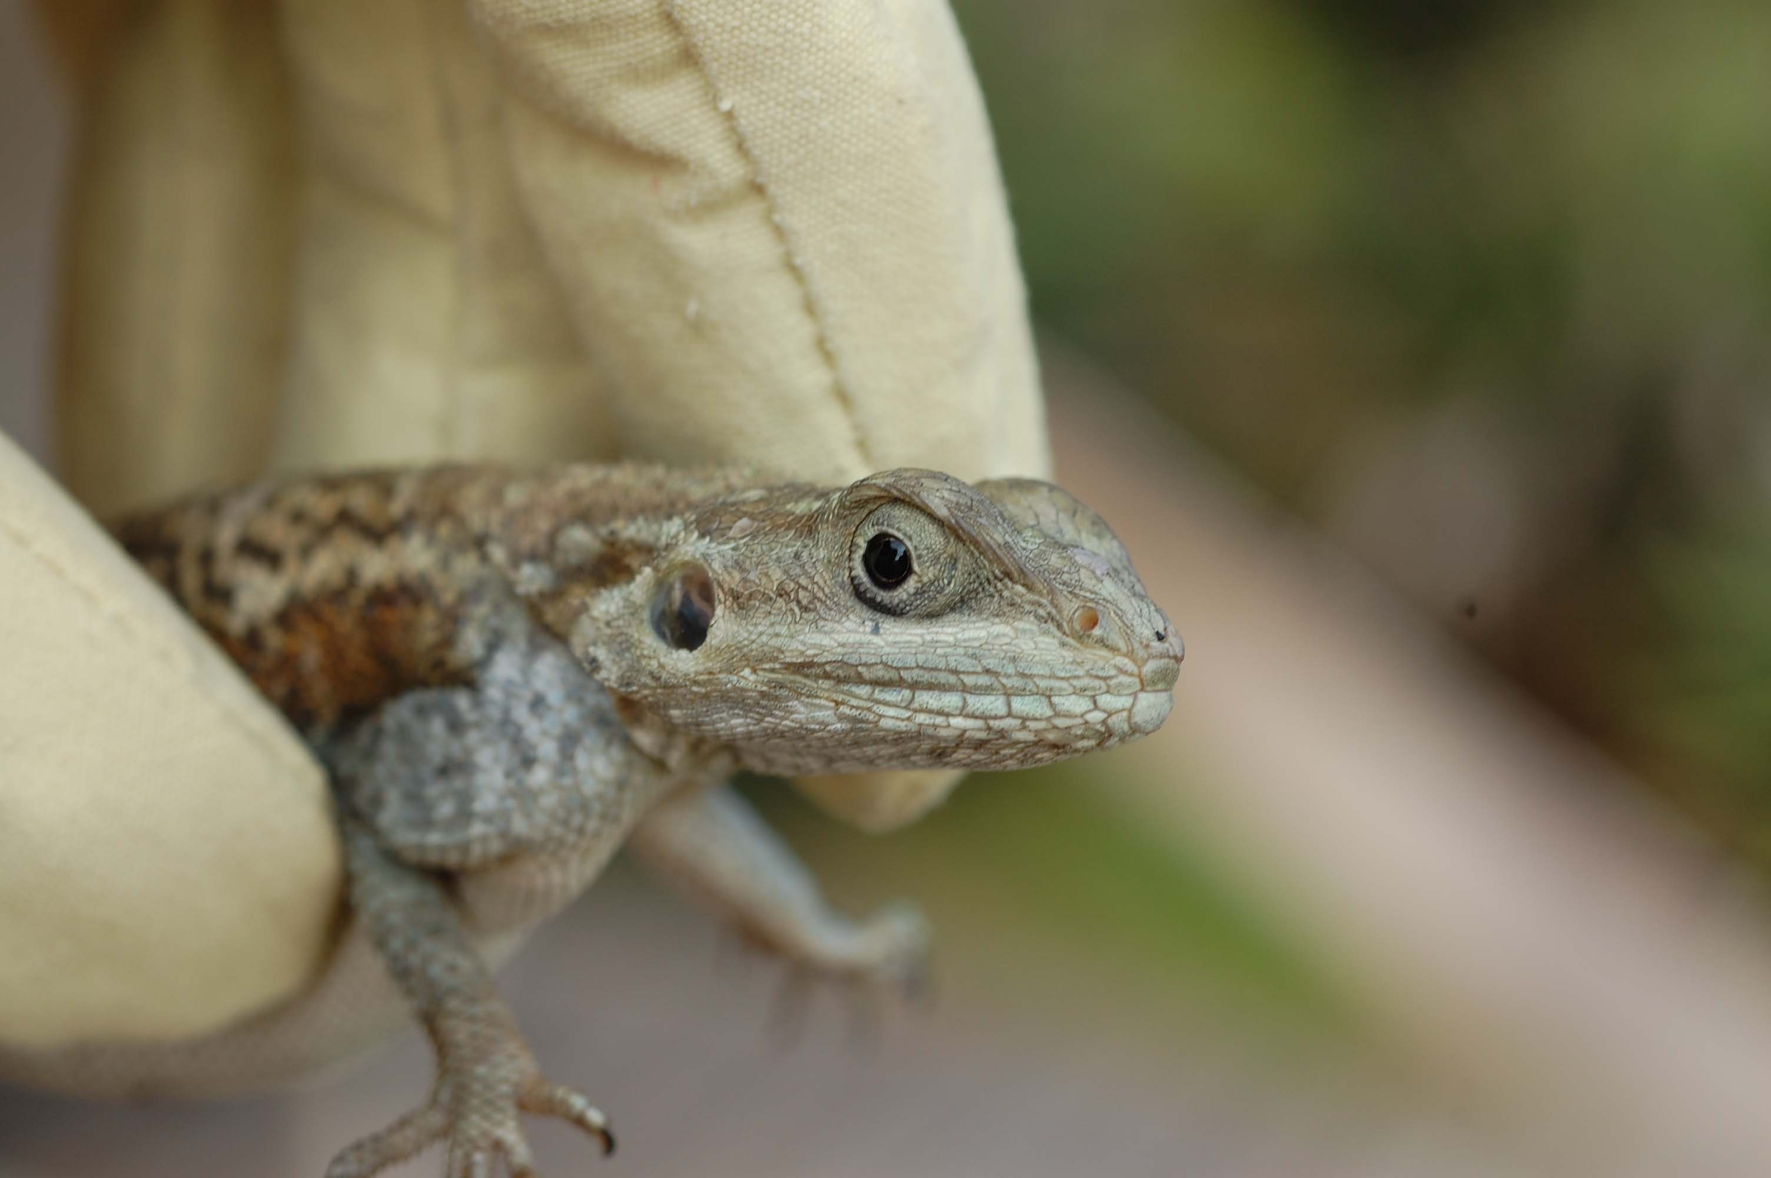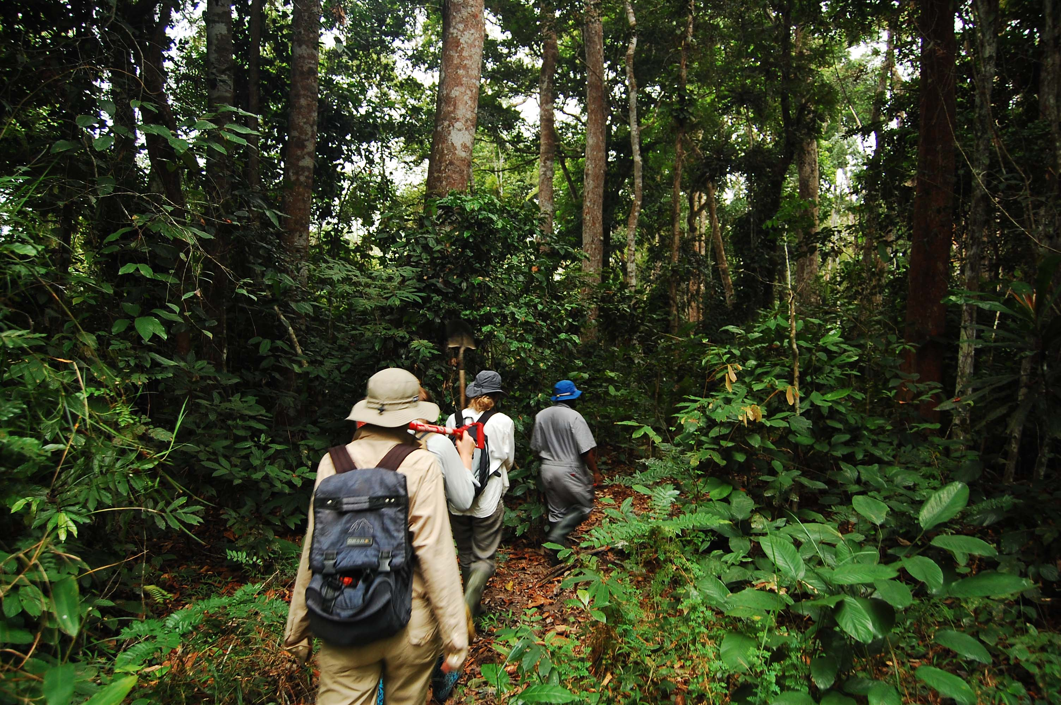

During the project I used GIS software to develop a map of the area that we worked in. It turned out to be an integral tool in the development of the project in country and helped to highlight the importance of GIS in conservation based research to all team members. This has resulted in two expedition members taking courses in GIS.

A film documentary of the expedition is currently been created and edited and once finished will be distributed along with our main report. This will be used to increase awareness of the threats posed by invasive fire-ants to biodiversity and to give other future undergraduate students an idea of what occurs during an expedition.

From a personal context carrying out this expedition was for me the most rewarding experience of my life. While it took nearly over a year to plan with many sleepless nights, frantic phone calls and hundreds of emails, the result was worth it. This expedition gave me the opportunity to develop many new skills in GIS (geographical information systems), photography, ecology, languages and communicating with people in general. It made me realise fully why I am doing a degree in ecology as well as my aspirations after I finish university. I met many researchers from around the world and had the chance to work closely with local park guides and students. This gave me an idea of how conservation actually works on the ground, rather from reading about it in a book and has really encouraged me to carry out conservation based work once I leave university.

I would like to thank the James Rennie Bequest from paying for my travel costs for this expedition. The award really helped us financially as we needed to raise a large amount of money to cover the travelling costs of five people.

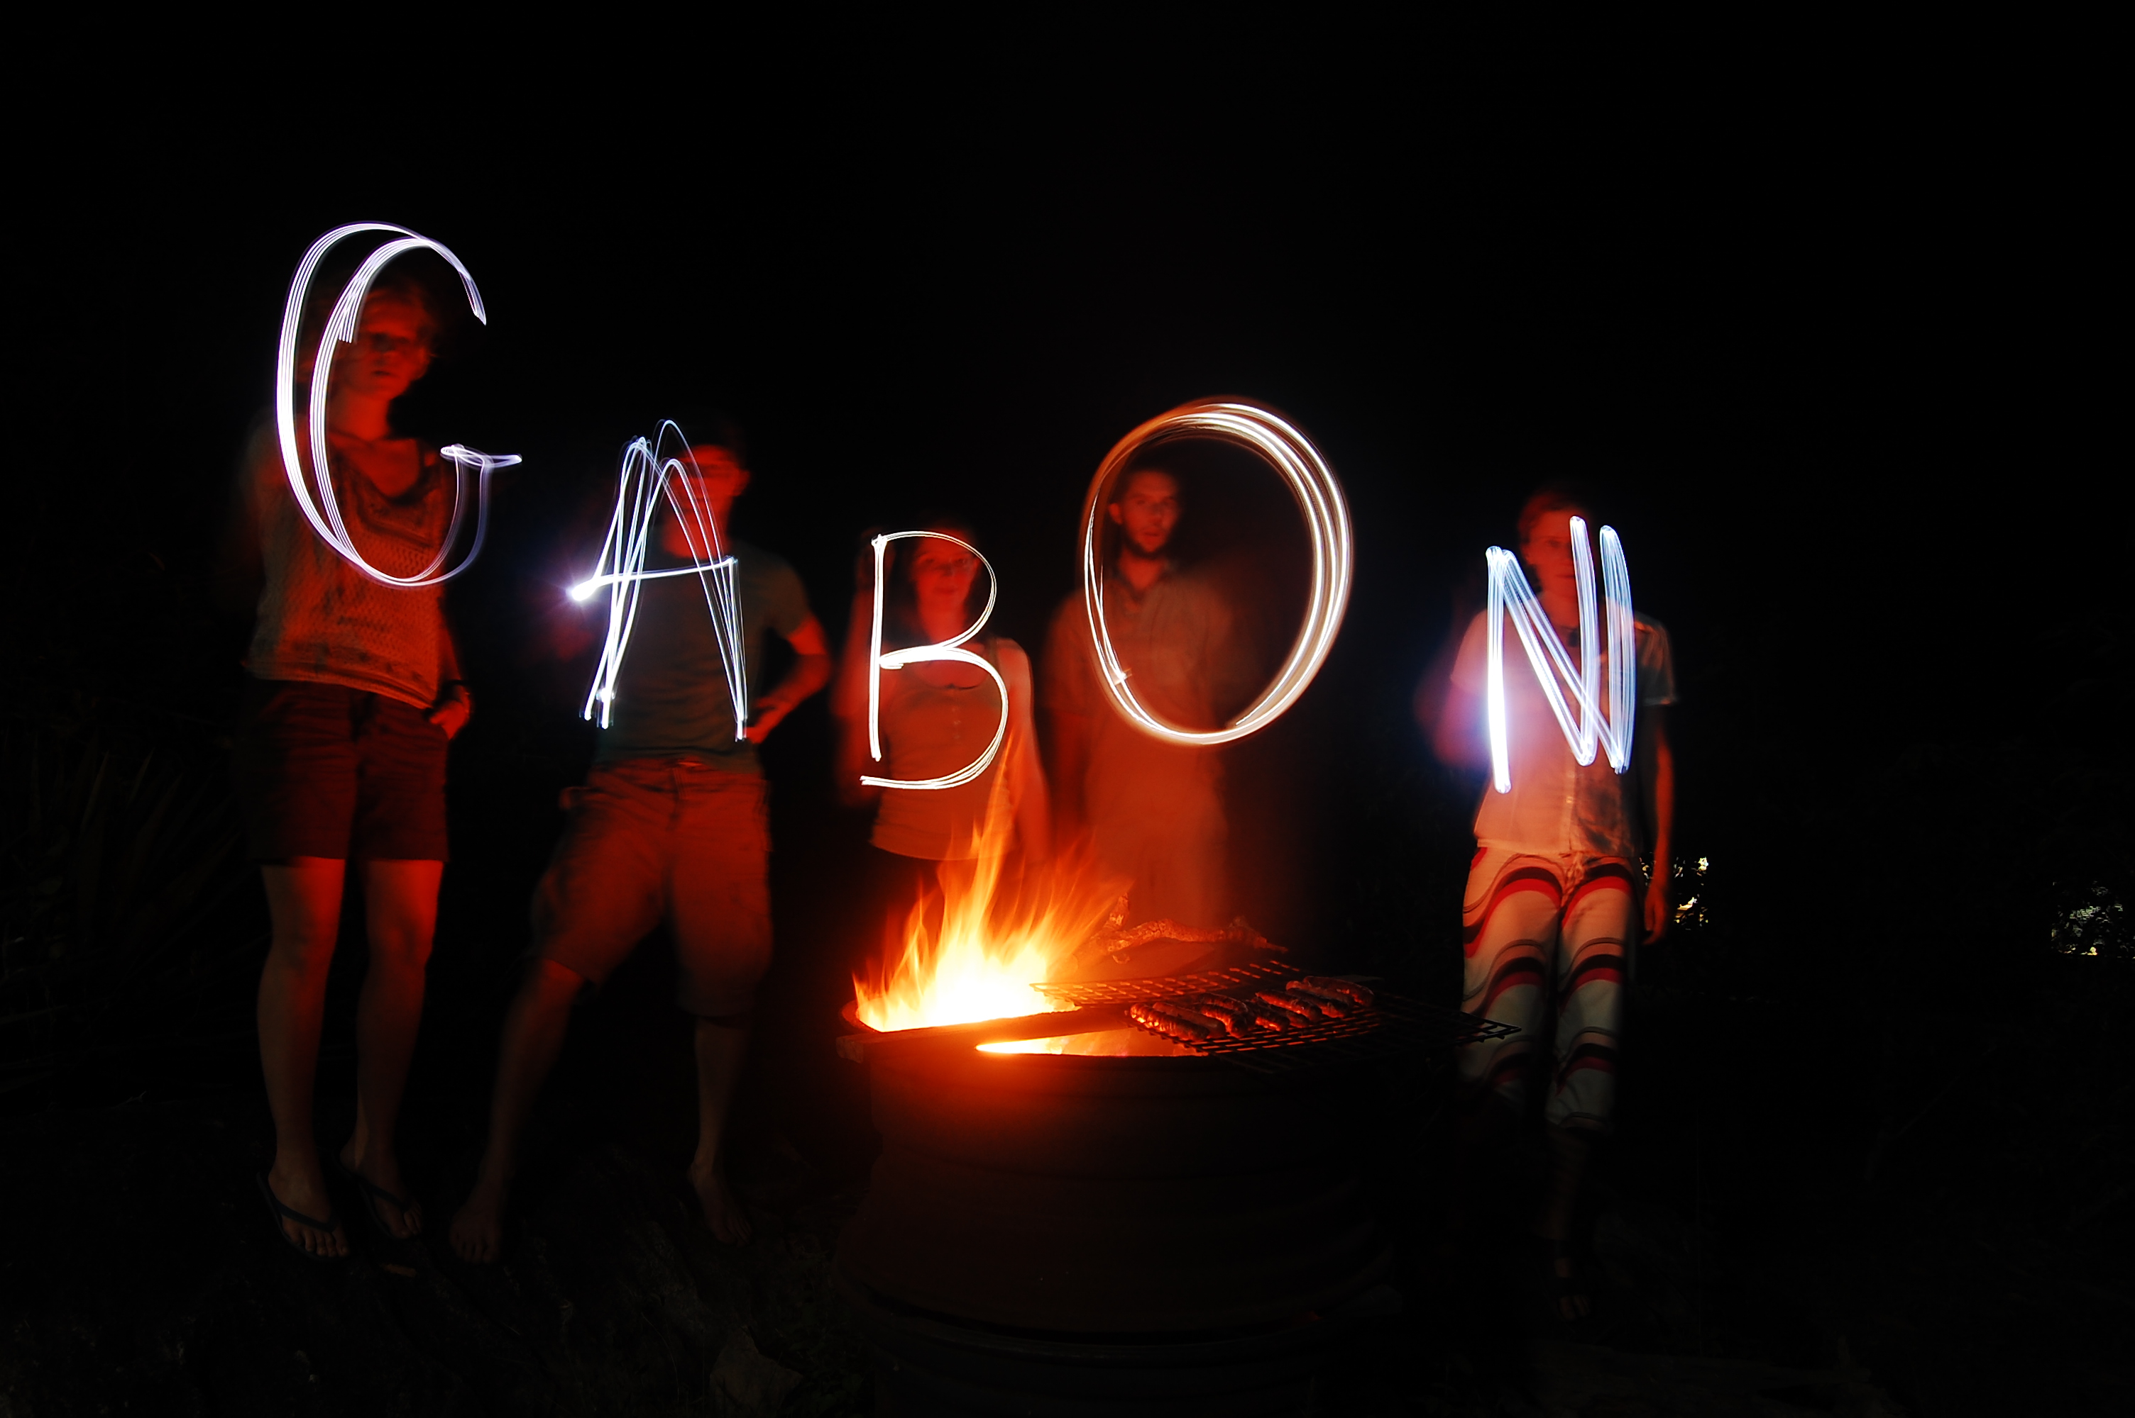

Acknowledgements

I would like to thank the following for their support of this project

Friends and family who donated money towards the expedition
Dr John Deag
Dr Kathryn Jeffery
Royal Geographic Society
The Zoological Society of London
Royal Scottish Geographical Society
Carnegie trust
The Davis Trust
The Weir Fund
The Barson Bequest
Chris Place and Edinburgh University IT support team
WCS (Wildlife conservation society)

