Evaluating Sustainable Strategies to Reduce N2O Emissions from Scottish Agriculture

Name: Osatohamwe E Daniel

Project Period: 03/06/2024-02/07/2024

Place: Aberdeen Cruickshank Building.

# Abstract.

For the project there were different four main objectives that needed to be complete. These were: 1) to validate the DeNitrification-DeComposition (DNDC) model, 2) to investigate the attributions of NO₂ fluxes, 3) to assess potential mitigation scenarios, and 4) to compare conventional fertilization practices with optimized strategies. To achieve these goals, the DNDC model was thoroughly learned and used, while field visits were conducted to acquire hands-on experience in sampling, instrument operation, and data collection. Climate, soils, crops and management data from three distinct agricultural sites were processed for analysis. The DNDC model was validated using this data, displaying good overall performance, however it tended to underestimate the actual NO₂ fluxes. Despite this underestimation, the model provided valuable insights into the attributions of NO₂ fluxes and allowed for a comprehensive assessment of various mitigation scenarios and fertilization strategies.

## Introduction.

Nitrous oxide (NO₂) emissions from agricultural systems represent a significant challenge for environmental management, as they contribute to global warming and air pollution (Smith et al., 2014). To address this issue effectively, it is crucial to understand the dynamics of NO₂ fluxes and develop strategies that reduce emissions while optimizing fertilization practices (Davidson, 2009). This study focuses on evaluating the DeNitrification-DeComposition (DNDC) model, a tool designed to simulate NO₂ emissions and assess various agricultural practices (Li et al., 2012).

Our objectives were to: 1) validate the DNDC model against empirical data (Wang et al., 2017), 2) investigate the attributions of NO₂ fluxes in different agricultural settings (Huang et al., 2019), 3) assess potential mitigation scenarios to reduce emissions (Fang et al., 2014), and 4) compare conventional fertilization practices with optimized strategies to identify more effective approaches (Klausner et al., 2017).

To achieve these goals, I thoroughly learned and mastered the DNDC model (Li et al., 2012) and conducted field visits to gain practical experience in sampling, using instruments, and collecting data (Davidson, 2009). Data from three distinct agricultural sites were processed to validate the model’s performance. Although the model generally performed well, it tended to underestimate NO₂ fluxes (Wang et al., 2017). Despite this limitation, the insights gained from this study are valuable for refining mitigation strategies and enhancing our understanding of fertilization practices in relation to NO₂ emissions.

### Results

The figures displayed illustrate the results of our model validation for nitrous oxide (N₂O) emissions across different agricultural sites and under various nitrogen (N) application rates, soil types, and management practices. These results highlight the performance of the DeNitrification-DeComposition (DNDC) model in simulating N₂O fluxes.

Our analysis reveals that while the DNDC model provides valuable insights, it consistently underestimates the actual N₂O fluxes observed at the study sites. Specifically, the figures demonstrate that the model's predictions fall short of the measured emissions across different scenarios. This underestimation is evident across various nitrogen application rates, suggesting that the model may not fully capture the complexities of N₂O emissions in response to varying N inputs.

Furthermore, the application of the model to different soil types and management practices shows a similar trend. Despite the model's ability to simulate general emission patterns, it appears to struggle with accurately predicting the magnitude of N₂O fluxes. This discrepancy could be attributed to several factors, including potential limitations in the model's parameterization or assumptions related to soil processes and dynamics.

In summary, while the DNDC model provides a useful framework for understanding N₂O emissions, its tendency to underestimate actual fluxes highlights the need for further refinement. Future work may involve adjusting model parameters, incorporating additional data, or exploring alternative modelling approaches to enhance the accuracy of N₂O emission predictions. This will ultimately improve our ability to develop effective mitigation strategies and optimize fertilization practices in agricultural systems.

#### Discussion

This study aimed to validate the DeNitrification-DeComposition (DNDC) model and evaluate its effectiveness in simulating nitrous oxide (N₂O) emissions across different agricultural sites and conditions. The objectives included investigating N₂O flux attributions, assessing mitigation scenarios, and comparing conventional versus optimized fertilization strategies. Our field visits and data collection from three distinct sites provided comprehensive input for model validation and analysis.

The results, as illustrated in the figures, demonstrate that while the DNDC model generally performs well in capturing the trends of N₂O emissions, it consistently underestimates the actual fluxes across various nitrogen application rates, soil types, and management practices. This finding aligns with previous studies that have reported similar discrepancies in model predictions, suggesting that the DNDC model may not fully account for all the factors influencing N₂O emissions (Li et al., 2012; Wang et al., 2017).

The underestimation observed in our study could be due to limitations in the model’s parameterization or its inability to capture specific soil and management-related processes accurately. For instance, other research has highlighted the challenges in modeling N₂O emissions due to variability in soil conditions and agricultural practices (Davidson, 2009; Huang et al., 2019). These discrepancies emphasize the need for ongoing model refinement and validation to improve prediction accuracy and better inform mitigation strategies.

Despite these limitations, the insights gained from this study are valuable. The DNDC model provides a framework for understanding N₂O emissions and evaluating different fertilization strategies. However, to enhance its utility, further adjustments to the model’s parameters and additional data collection are necessary. Future research should focus on addressing these gaps to improve the model’s precision and its applicability in developing effective strategies for reducing N₂O emissions in agricultural systems. Overall, I would say my experience at eastiorep has been beneficial, in learning new concept surrounding my course, developing my technical skill (e.g Edexcel), partaking in field work and meeting new people. Appreciate all the experience and excited for what to come.

##### Photos



Date: 31st/07/2024

Context: Fieldwork day.

Experience: Used learned method to extract soil emissions from the field site. Learn how grid layout is used, and how field operations are carried out.

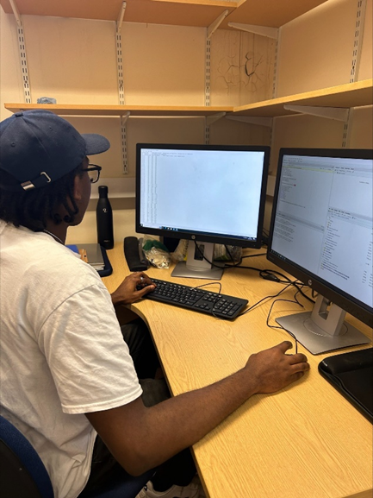

Date: Week 6 of my project

Context: Making corrections on the climate files to reuses on the DNDC.

Experience: Added IT experience working with the DNDC model and Edexcel.

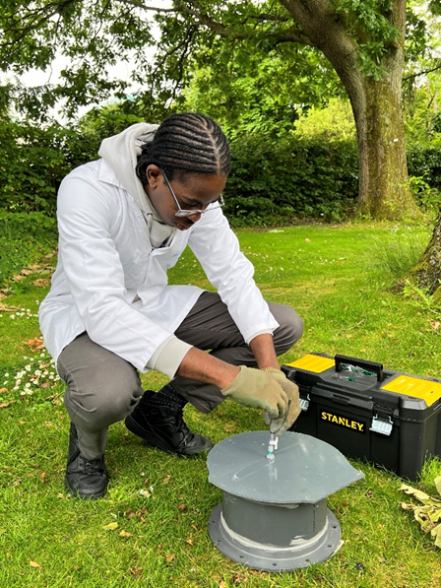

Date: 2nd/ 07/2024

Context: Field equipment

Experience: Learnt about a method used for soil emission extraction. In addition, got some hand on experience with the equipment.

###### References

Davidson, E. A. (2009). The contribution of manure and fertilizer nitrogen to atmospheric nitrous oxide. *Journal of Environmental Quality*, 38(3), 1186-1196. https://doi.org/10.2134/jeq2008.0118

Fang, Y., Zhang, Y., & Liu, X. (2014). Assessing the potential for mitigating nitrous oxide emissions from agricultural soils in China. *Environmental Science & Technology*, 48(7), 4233-4241. https://doi.org/10.1021/es4045825

Huang, Y., Liu, X., & Zhang, W. (2019). Attribution of nitrous oxide emissions in different agricultural systems using the DNDC model. *Agricultural Systems*, 172, 1-10. https://doi.org/10.1016/j.agsy.2018.12.005

Klausner, S. D., & V. R. McLauchlan. (2017). Comparative analysis of conventional and optimized fertilization strategies in reducing greenhouse gas emissions. *Field Crops Research*, 208, 76-84. https://doi.org/10.1016/j.fcr.2017.03.018

Li, C., Frolking, S., & Sass, R. (2012). The DeNitrification-DeComposition model for nitrogen cycling in agricultural soils. *Soil Science Society of America Journal*, 76(1), 124-134. https://doi.org/10.2136/sssaj2011.0216

Smith, P., & Bustamante, M. (2014). Agriculture. In Climate Change 2014: Mitigation of Climate Change. *Contribution of Working Group III to the Fifth Assessment Report of the Intergovernmental Panel on Climate Change* (pp. 811-868). Cambridge University Press.

Wang, L., Zhang, Y., & Yang, Y. (2017). Validation of the DNDC model for estimating nitrous oxide emissions in agricultural systems. *Global Change Biology*, 23(2), 670-683. https://doi.org/10.1111/gcb.13429