Bring an Intern on Board Form

*Please return this form completed, to propose a professional internship, to the EASTBIO Doctoral Training Partnership Manager.*

**Email:** [placements@eastscotbiodtp.ac.uk](mailto:placements@eastscotbiodtp.ac.uk)

### ****Address:**** University of Edinburgh

The Biotechnology and Biological Sciences Research Council (BBSRC) is offering an exciting opportunity for **any non-academic organisation** to take advantage of fully funded Professional Internships for PhD Students (PIPS). These three-month professional internships can be in any field or sector.

**Internship roles**:

Something that is clearly important to the organisation. Ideas could include, but are certainly not limited to:

* researching new development ideas or products (but not within an academic or research institute)
* creating a marketing, publishing or sales campaign
* a business development project
* managing a specific project
* developing science communication materials
* improving a specific policy or working in a setting related to policy (e.g. government department or charity)

**Benefits for a business taking on a PhD intern:**

* A high-calibre temporary resource to assist with a strategic project
* Extra support at no cost as PIPS students are fully funded by the University through their PhD salary
* Resource to undertake projects that might have been on hold/will not otherwise be done
* Involvement with intelligent minds that bring innovation, skills and knowledge to benefit your business success and performance
* Opportunities to get energy and fresh insights to a particular business area; a different perspective to problems, and a new motivated member of the team

**Benefits for PhD students:**

* A chance to try out a particular professional area; to test career goals and get an idea of what a job really involves. This will help students make informed career choices in the future and dispel any misconceptions
* An opportunity to develop employability by learning through high-quality work experience in a non-academic setting

**Cost:**

* This professional internship is funded by the BBSRC as part of the PhD, with students continuing to receive their PhD payment as normal, so there are no tax implications for your organisation
* We encourage a contribution from your organisation towards their travel or accommodation costs if the student lives more than 50 miles from the organisation

**Timescale:**

* 12 weeks in a single block or multiple shorter blocks
* Flexible – anytime so you can make them a part of your business priorities

**Requirements:**

* A challenging internship project with clearly defined task/s – either one big project or the workload could be spread across a number of areas to give as much diversity in work as possible
* Work space and equipment
* An experienced employee who will act as a mentor to support the PhD intern. The mentor is responsible for the induction process, supervising the delivery of a piece of work, providing training, feedback, encouragement and is the designated point of contact for the DTP Manager coordinating the PIPS Scheme.
* Interns need to be included in team/departmental meetings, training, and ad-hoc events as appropriate.

**Designing an internship project:**

* PhD interns have the potential to make a huge contribution to your organisation in a short time at no cost but only if they get clear direction, support and sufficient challenge. It is imperative that interns are given no more menial tasks than are expected of other employees
* Interns need an opportunity for professional development – some will be using this as a way of determining whether or not they want to pursue a career in your sector and/or profession - tea making and data entry won’t give them this!

**What sort of work is appropriate for an intern?**

* Work that offers a genuine “something extra” that has a medium to long term benefit rather than simply a short term “extra pair of hands”
* Project which gives the PhD intern ownership/responsibility for some aspects of their work, and has the opportunity to present it or explain it to others
* Ideally work with a range of people, providing the opportunity to network and build relationships with a range of people at multiple levels
* Opportunity to experience client focus and interaction
* Chance to use written/verbal communication skills in a professional, rather than academic context
* Chance to see how their role fits in to the wider context and learn about business culture
* Shadowing at a more strategic level

**What happens next?**

* The internship vacancy will be advertised to a talented pool of high-calibre Life Science PhD students from University of Aberdeen, Dundee, Edinburgh, St Andrews and Stirling, as well as Scotland’s Rural College (SRUC), James Hutton Institute (JHI) and Moredun Research Institution (MRI).
* Eligible, interested students will apply directly by CV and be interviewed and selected by you.
* The final internship details are expected to fit with the needs of the University, the host organisation and PhD intern as outlined and agreed in the ‘PIPS Internship Agreement’. This is signed by all parties involved and finally approved by the EASTBIO DTP Manager before the internship can commence. Please see Appendix 1.

|  |  |  |  |
| --- | --- | --- | --- |
| **Host Organisation Details** | | | |
| Host Organisation Name | Scottish Government | | |
| Host Organisation Sector Type  (please select from list in Appendix 1) | Government & Civil Service (including public service administration) | | |
| Please write a brief description of what your organisation does | The Scottish Government is the devolved government for Scotland and has a range of responsibilities that include: the economy, education, health, justice, rural affairs, housing, environment, equal opportunities, consumer advocacy and advice, transport and taxation. | | |
| Address | Scottish Government  People Directorate,  Saughton House  Broomhouse Drive  Edinburgh  EH11 3XD | | |
| Website | [The Scottish Government - gov.scot (www.gov.scot)](https://www.gov.scot/) | | |
| Contact person name | Luke Cavanagh | | |
| Contact person email and phone | [Luke.cavanagh@gov.scot](mailto:Luke.cavanagh@gov.scot)  07789692467 | | |
| Will your Organisation provide physical premises external to the University with professional staff who will support the development of an intern’s professional skills appropriate to PhD level?  Please note that University service providers and organisations that run virtually are not suitable for PIPS | Yes |  |  |
| Any other information: we work in a hybrid way and individuals have flexibility and choice in where they work, either at home or at a Scottish Government office building. | | |

|  |  |
| --- | --- |
| **PIPS Internship Details and Desired Outcomes** | |
| PIPS Project Title | Scottish Government Workforce Diversity: Analysis |
| Description of the internship project you are offering  OR | This project will involve analysing data from two datasets:  Firstly, from late 2024, the Scottish Government will have new, more comprehensive diversity information about its workforce and this will be an opportunity to work with analysts on understanding and using this new dataset. The Scottish Government recently published its new Diversity and Inclusion Strategy and it relies heavily on evidence and data to inform and evaluate its delivery.  Secondly, there is data from the annual People Survey, which is about employee engagement in the Scottish Government and helps to understand experiences of working in the Scottish Government.  The analytical project will be used to guide policy aimed at improving the experiences of traditionally under-represented groups of staff working within the Scottish Government and will contribute to our overall Diversity & Inclusion Strategy.  The project is focused on statistical analysis of new HR data and existing survey data, which may include multi-variable logistic regression, and will include a focus on intersectionality and understanding the effect of belonging to two or more minority groups on staff experiences of working within core Scottish Government directorates. Coding experience is a must, though training in specific coding languages can be arranged during the project. The intern will be working alongside other analysts who can provide analytical guidance and support.  The intern will have the opportunity to work alongside government analysts and engage with policy officials throughout the project and to present their work to policy officials in government at the end of their project. |
| Advert to recruit interested PhD students to apply directly by CV to generate a tailored internship project with your Organisation |
| Location of this internship | Flexible – our main office is in Edinburgh, but we are flexible on location as our team works across Scotland. For example, we have successfully hosted PhD interns based in Aberdeen in the past. |
| What range of professionals will the PhD student work with during this internship? | Government Statisticians  Government Social Researchers  HR Analysts  HR Civil Servants  Policy Civil Servants  Operational Delivery Civil Servants |
| What specific results do you want the PhD intern to achieve? | We want the student to draw out any disparity in experiences between groups, based on combinations of their diversity characteristics.  There will be a specific focus on whether and to what extent looking intersectionally (i.e. across multiple diversity characteristics simultaneously) highlights any additional disparities beyond those explained by individual characteristics and identifying, where possible, any demographic characteristics that act as explanatory variables for a differential experience.  We want the student to present their findings at the end of the project to policy colleagues to guide their policy-making process. |
| How do these outcomes fit with your wider business objectives? | The Scottish Government aim to create a workforce culture that is inclusive, with employees from all backgrounds and characteristics and experiences reporting they feel valued. This project contributes to the latest version of the Scottish Government’s diversity and inclusion strategy. |

|  |  |  |  |  |
| --- | --- | --- | --- | --- |
| **PIPS Internship Timing / Duration / Management** | | | | |
| Timing of the Internship | PIPS start date  Flexible | | PIPS end date  Flexible | |
| Format of the Internship  (Is it a one 3 month block or a number of shorter blocks?) | The internship would be one 3 month block. We can be flexible on the timing of the internship and when the 3 month internship takes place. | | | |
| Name of person who will act as the PhD student mentor during this internship | Eoin Ó Laighléis | | | |
| Position of mentor in the host organisation | Government Statistician | | | |
| Contact email and phone for mentor | eoin.o-laighleis@gov.scot | | | |
| Is the Organisation willing to make a contribution towards intern’s travel or accommodation costs?  Please note that if the student lives more than 50 miles from the Organisation, we encourage a contribution towards their travel or accommodation costs but this is optional. | Yes |  | |  |
| The Scottish Government can contribute to travel and subsistence, but not accommodation. | | | |

|  |  |
| --- | --- |
| **Person Specification**  *Please give details of what is required for this internship e.g. the skills, experience and personal qualities specifying which are essential and which are desirable.* | |
| What skills does the PhD student need to complete this internship project? | **Essential**  Experience of working with data using statistical skills (e.g. confidence intervals, testing for statistical significance)  Programming experience  Communication skills  Planning & managing your work  **Desirable**  Programming experience in R or SAS |
| What soft attributes do they need to fit in/contribute? | Being able to work as part of a team |

|  |  |  |
| --- | --- | --- |
| **Application Details** | | |
| I wish this internship to be advertised open ended to PhD students? | Yes |  |
| If ‘No’ please specify a closing date for receiving CVs from interested students? |  | |
| Name and contact details for PhD students to submit CV applications | Luke Cavanagh  Luke.cavanagh@gov.scot | |
| Any other information:  We are flexible on a start date for this 3 month internship and it could be undertaken at any point in 2025 or into 2026. Anyone joining SG as an intern will need to go through government security checks and will be provided with a government laptop while working in the Scottish Government, which can be used to work flexibly. | | |

|  |  |
| --- | --- |
| **Completed by:** | |
| Name | Luke Cavanagh |
| Date | 10/10/2024 |

Thank you for your interest in the BBSRC PIPS Internship scheme.

**APPENDIX 1**

**Responsibilities for the host organisation to secure a BBSRC funded PIPS**

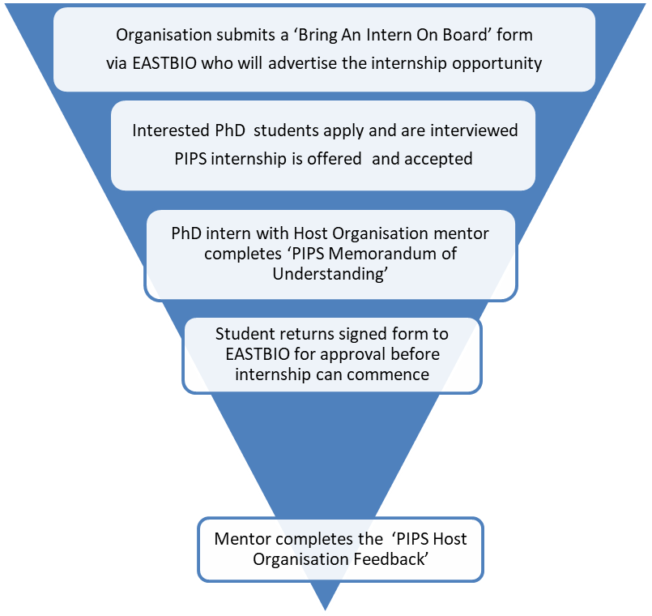

**PIPS begins**

**APPENDIX 2**

**Employment Sector List**

|  |  |
| --- | --- |
| Academia | Fire, Police & Security |
| Advertising, Marketing & Public Relations | Food & Beverage |
| Aerospace & Defence | Government & Civil Service (including public service administration) |
| Agriculture, Livestock breeding & Fishing (including production, animal welfare) | Health & Social Care |
| Biotechnology, Medical & Pharmaceuticals | Hospitality, Leisure, Travel, Tourism and Sports |
| Business and Management (including business intelligence & market research) | IT & Telecommunications (Hardware & Software) |
| Chemicals | Law (including legal services) |
| Clothing, Footware & Fashion | Logistics, Transport, Purchasing & Supply |
| Consultancy | Media, Communication, Journalism & Publishing |
| Charities & Voluntary work (non-profit / third sector) | Metals & Construction Materials |
| Creative arts, Design and Culture | Product Manufacturing |
| Education & Training (including teaching) | Real Estate & Renting |
| Energy & Utilities (including renewable energy and energy conservation) | Recruitment & Human Resources |
| Engineering (civil and mechanical) | Retail, Buying & Merchandising |
| Environment (including recycling, environmental services and industries) | Science & Research |
| Financial services (including accounting, auditing & banking) | Other |