**EastBio Research Placement End of Project Report**

**Chloe Brown**

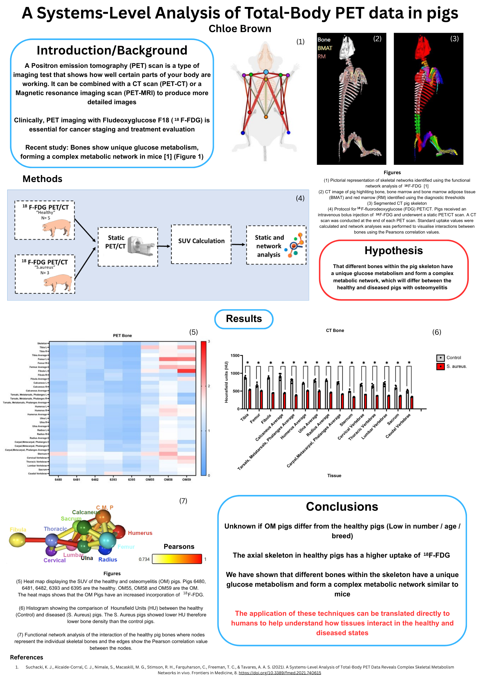

**Overview of Research Experience**

This project aimed to identify (1) if different bones within the pig skeleton have a unique glucose metabolism and form a complex metabolic network and (2) if these networks were different between the healthy and diseased pigs.

During the project I was able to learn many skills that will benefit me in my future education and work. I was introduced to a software called Analyze in which I was shown how to analyse Positron emission tomography (PET CT) scans of pigs. The thresholds had to be set to view only the bone, bone marrow, red marrow, and yellow marrow of each pig. We used the thresholds of a human for our project as the thresholds for a pig have not been extensively researched. From there, I learnt how to clean up each of the thresholds as it often picked up unwanted parts of the scan. Once the cleaning was done, I was able to move on to segmenting. This part of the project took the most time but was straightforward and I really enjoyed carrying out this part of the method. The next step was to export the results and organising them in an excel file. This was helpful in showing me how to organise complex data and understanding what the numbers mean in relation to the results. All these skills will be incredibly valuable to me as I continue my academic journey. The last step was to visualise the data and carry out statistical analyses on the results. This was done on a software called Graph Pad, this software was also completely new to me. I was happily surprised at my ability to pick up both Analyze and Graph Pad. I was able to carry out many different processes within both software’s and I was pleased with all the work I had carried out.

Completing the East Bio project has helped me gain so many skills that will be unvaluable and will be extremely beneficial to my education and future career. In addition to the academic skills, I have also grown in confidence which was something I hoped I would gain from this experience. My confidence in working independently has also grown, and I now feel more assured in the quality of my work. I thoroughly enjoyed working on this project, and it has helped me decide that I want to strongly consider a career in academia. Overall, this project has been a wonderful experience which has given me so many skills and opportunities and for that I am extremely grateful. On completion of the project my supervisor and I summitted an abstract to the PET is wonderful conference which I will be attending in October. We are currently waiting to hear the result to find out if we have a poster or a talk. I would like to thank EastBio for funding this opportunity and my supervisor for making my placement so worthwhile and enlightening.