JAMES RENNIE BEQUEST

REPORT ON CONFERENCE

Conference Title: Neurospora 2006

Travel Dates: 30th March – 2nd April, 2006

Location: Asilomar Conference Center, Pacific Grove, California, USA

Group Member(s): Graham Wright, ICB (Prof Nick Read)

Aims: Present poster and attend conference

OUTCOME (not less than 300 words):-

I would like to express my gratitude for the James Rennie Bequest travel award. The money enabled me to attend the Neurospora 2006 meeting in spring 2006 near Monterey, California. This meeting takes place every 2 years, alternating annually with the broader and larger Fungal Genetics Conference at the same venue. Concentrating solely on the model filamentous fungal genera, Neurospora, the meeting brings together the key figures in this lively field of research and is a great opportunity for the younger scientists to interact with these important people. One of the advantages of the conference over bigger more varied meetings is that the community is small and by the end of the meeting everyone was a familiar face and I felt able to approach any delegate.

The conference grounds are not far from Monterey, situated at the northern edge of the famous 17 mile drive and California’s Big Sur coastline. The onsite accommodation and catering means that the whole delegation gets to spend time with one another out of the formal talks. What with a beach just a few hundred metres away relaxing after a day of seminars was very easy. Talks took place in the Chapel and with no concurrent sessions meaning I was able to attend all the talks and not miss out on anything.

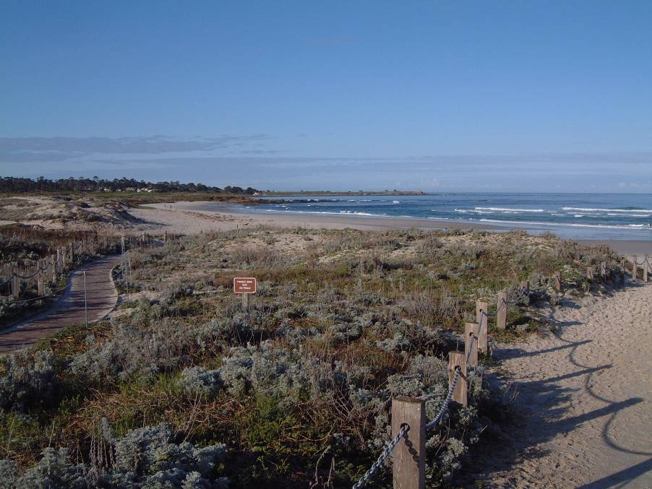
The beach just next to the Asilomar Conference Grounds.
The conference opened with a welcome ‘mixer’ where we were encouraged to get to know other delegates. The following morning the sessions began with ‘From Genes to Populations’. This was followed in the afternoon with a workshop on how to utilize the latest online tools and resources that have emerged from the Neurospora genome project, given by the creators and curators of these websites. This really opened my eyes to what was already available. The speakers also encouraged the audience to suggest ways of improving the resources to offer a better service. The day was rounded off in the evening with an update on how the genome project is progressing. Such activities are a good example of how the scientists working on Neurospora do so as a community with many collaborative projects and efforts working towards the greater good.

The next day contained the sessions of most interest and relevance to me: ‘Cell morphogenesis and Assembly’ and ‘Cell signalling and Gene Regulation’. The latter included a talk by my supervisor, Prof. Nick Read, which used some of my data. This was great to see and initiated a number of discussions with other members of the audience once the presentation was over. Other talks, especially that of Greg Jedd’s on Woronin body formation was directly related to my research. That evening was the banquet during which a number of awards were given to recognize outstanding contributions to the field, followed by the poster session. This was very well attended and a number of people took an interest in my poster, helped no doubt by the earlier prompt in the talks. Between discussions I also took the chance to go and talk to the authors of a number of interesting posters on show. The final day of talks concentrated on the circadian clock.

The whole experience of attending and presenting at such an international conference was fantastic. Happily the poster was well received and I was pleased that a number of interesting discussions took place during the meeting. It was only by being at the conference that these opportunities arose.

As a venue for the conference Asilomar was superb. With the few days to spare before the conference I got to enjoy San Francisco and Monterey with a colleague. We then collected our supervisor from Stanford University to drive the Big Sur the morning before the conference began.

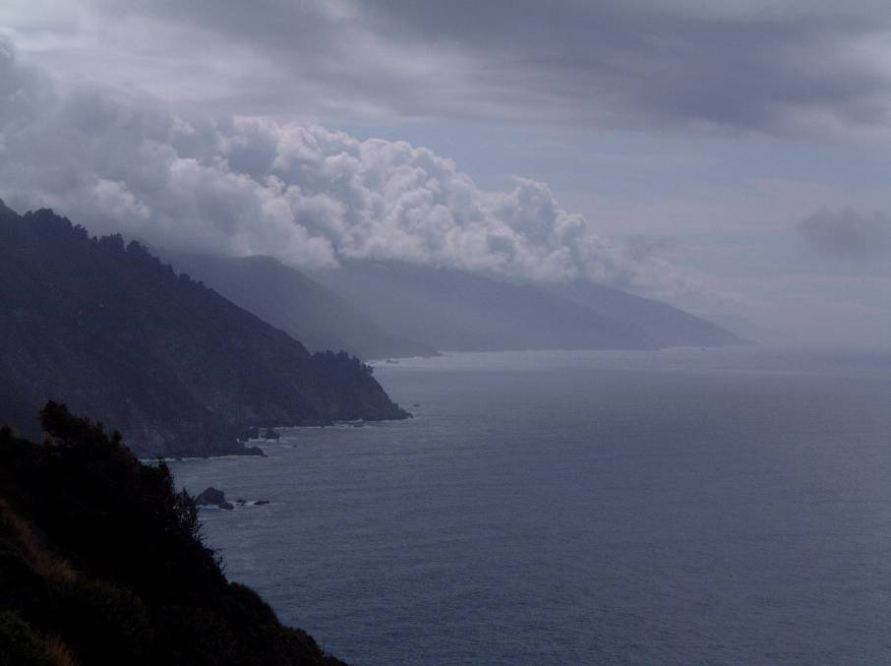
The Big Sur – the breathtaking coastline stretching from Monterey to Los Angeles.

