JAMES RENNIE BEQUEST

REPORT ON EXPEDITION/PROJECT/CONFERENCE

Expedition/Project/Conference Title: SPIE – The International Society for Optical Engineering. Optics and Photonics - Optical Trapping and Optical Micromanipulation II

Travel Dates: 31st July – 4th August 2005

Location: San Diego Convention Centre, San Diego, California, USA

Group Member(s): Graham Wright, ICB (Prof Nick Read)

Aims: Present talk and attend conference

OUTCOME (not less than 300 words):-

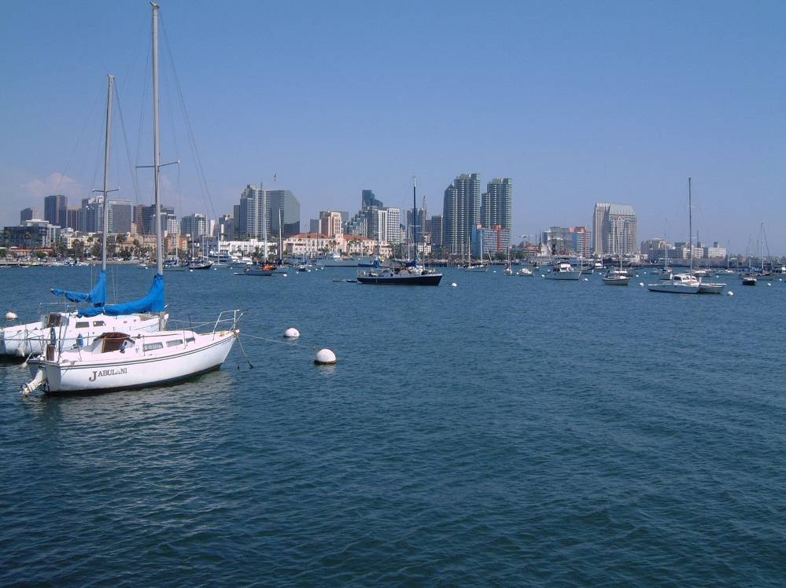
I would like to express my gratitude for the James Rennie Bequest travel award. The money enabled me to attend the SPIE Optics and Photonics meeting last August in San Diego, California. This meeting marked the 50th Anniversary of this vast society and as such a number of celebrations went on along side the 5 days of conferences, meetings and short courses accompanied by a huge industrial exhibition. The main plenary session, which opened the conference, was given by K. Eric Drexler on his vision for nanotechnology. Although his presentation was interesting it lived up to his reputation by being a little controversial. A welcome meeting for the whole meeting took place in Petco Park, home to the San Diego Padres baseball team, which was a good chance to meet new people and catch up with friends and colleagues from the field.

A view of downtown San Diego from the harbour walls

The specific conference I attended was entitled Optical Trapping and Optical Micromanipulation II, chaired by Kishan Dholakia of the University of St. Andrews and Gabriel Spalding of Illinois Wesleyan University. In its second year, the conference has grown and attracted a greater variety of scientists from all over the world along with some eminent names of optical trapping, building on the success of the previous year. The conference opened with the keynote talk given by Steven Block, from Stanford, who gave a history of his illustrious career to date and went on to describe his current work investigating the biophysics of single molecules with optical traps. His talk was followed over the proceeding 5 days with sessions on biological applications, materials science, spectroscopy in traps, lab-on-a-chip developments and the basic science of optical trapping. I found that all the sessions contained interesting and enlightening information that I could have only discovered by attending the conference. I personally found the conference well weighted with the opportunity to learn more from the physics talks, but at the same time welcoming and inviting to biologists because of the more applied talks in the program. The talks were also accompanied by two poster sessions that offered a great chance to talk to other researchers within the field. The title of my talk was ‘Measuring Fungal Forces with Optical Tweezers’ in which I presented our use of tweezers to measure the forces produced by the growing tips of filamentous fungi.

The whole experience of attending and presenting at an international conference of this scale was an exciting and useful one. A number of lessons were learnt from the preparation of the manuscript that accompanied my presentation, to the writing and practice of the presentation itself in the weeks leading up to the conference. Then there was presenting to a large and knowledgeable audience and fielding the subsequent questions. As the audience was mixed, ranging from pure physicists to biologists, the questions generated were from different angles from what I am used to. Happily the talk was well received and I was pleased that a number of interesting discussions followed the session. Out of these discussions a number of ideas for future directions were formed and a collaboration that continues to date was also established. Again it was only by being at the conference that these opportunities arose.

As a venue for the conference San Diego was superb. With the few days to spare after the conference I got to enjoy the city itself with some colleagues; highlights for me included the zoo and the museum onboard the aircraft carrier USS Midway. We also enjoyed a quick trip to Mexico, which is only a 20 minute tram ride from the centre of San Diego.

