**The importance of coastal Kenyan isolated hill forest outliers and limestone outcrops to botanical conservation in East Africa**

Davis Expedition Report

Galena Woodhouse

The University of Edinburgh. MRes in Geosciences.

**Background**

Kenyan coastal forest fragments are of global importance due to a high concentration of narrowly endemic species and limited geographic extent (Myers et al., 2000, Matiku., 2003, Mittermeier et al., 2009, Clarke, 1998, Brooks et al., 2002, Burgess et al., 1998, CEPF 2005, Burgess et al., 2003). Situated within the East African Coastal Forest hotspot, which ranks first for densities of endemic plants and vertebrates out of the 25 most important global biodiversity hotspots (Mittermeier et al., 2009): 544 species of endemic plants and 53 endemic animals are found in the Kenyan Coastal forests.

Kilifi County has the highest rate of forest loss in coastal Kenya (Tabor et al., 2010), with potential for species extinctions. Half of Kenya’s threatened woody plants, 60% of its threatened forest dependent birds and 65% of its threatened forest dependent mammals are found within the coastal forests (Matiku., 2003).

Figure1. Left to right. Flower of *Mkilua fragrans,* Mature *Oxystigma msoo,* Entrance to the cave system at ChaSimba limestone outcrop.

The rate and severity of forest loss in the region is dramatic. Changing climate, unsustainable agricultural practises and a growing population has degraded both protected and unprotected forest patches in Kilifi county. Much of the understanding of the true value and diversity of Kenyan coastal forests is based on historical survey data. With the assistance of the Davis Expedition Fund and as part of my MRes in Geosciences, I conducted the first thorough vegetation survey in four critically important and unprotected sites in well over 20 years. This study has demonstrated that there remains a high number of endemic plants including rare and threatened species, however the level of threat to the available habitat has dramatically increased.

Figure 2. Agricultural encroachment and recent tree felling at ChaSimba limestone outcrop.

The East African Coastal forests are an archipelago like regional sub centre of endemism. Defined as forest *sensu* White (1983a) the vegetation is typified by semi-evergreen or evergreen undifferentiated dry forest however it is also comprised of variant types and sub-types.

* Eastern African Coastal Scrub Forest. (variant type)
* Eastern African Coastal *Brachystegia* Forest (variant sub-type)
* Eastern African Coastal Riverine/Groundwater/Swamp Forest (transitional sub-type)
* Eastern African Coastal/Afromontane transition forest (transitional type)

There have been numerous and diverse attempts to classify the forests of the East African coast, revealing a wide range of opinions on geographic distribution, vegetation types and biological affinities. To group the coastal forests together as one vegetation type would be to oversimplify the complex and naturally fragmented nature of the region. Major factors influencing the high diversity of vegetation in the region include the varying surface geology, geomorphology, soils, climatic history and changing climate

Kenya’s coastal forest now covers only 787km², 21% of its historic extent (Burgess et al., 2003). Within this area thirty-five known forest patches (95km2) are not under legal protection (Githitho, 2004). Isolated hill forest outliers and limestone outcrops have been highlighted as priority areas for assessment with a view towards protection (Robertson and Luke, 1993, Githitho, 2004). Historic plant collections point towards the presence of highly endangered species, including species exhibiting single site endemism.

My research collected over 400 herbarium specimens which I identified at the East African Herbarium in Nairobi. Many of the specimens collected were new records for the surveyed locations. The data are now being analysed to provide insights into levels of endemism, current threats and potential for conservation.

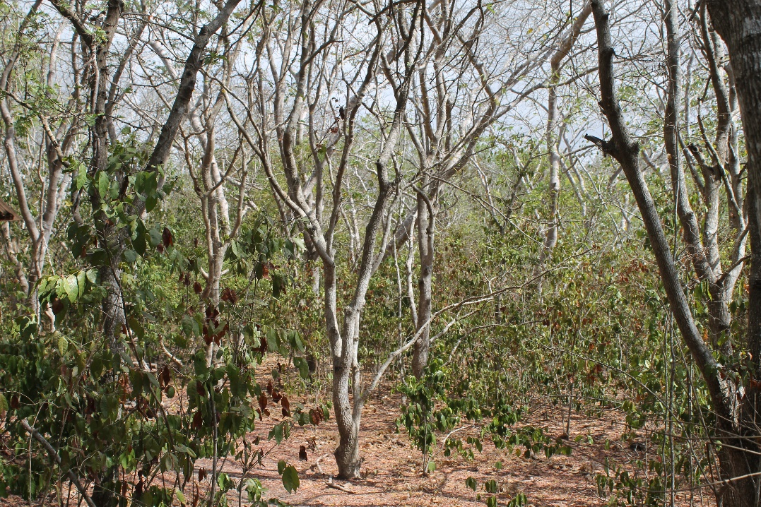

Figure 5. East African Coastal Dry forest in Arabuko Sokoke Forest during drought conditions. Dominated by Cynometra-Manilkara community.

Figure 3. Groundwater sub-type at Cha Simba Rocks. Dominated by Pandanus rabaiensis and larger emergents such as Gyrocarpus americanus and Moraceae

Figure 4. View towards Shimba hills summit, showing Eastern African Coastal/Afromontane transitional forest sub-type.

Figure 6. Burning of land for agriculture adjacent to Arabuko Sokoke Forest.

**Study aims**

1. To understand the diversity and endemism of vegetation in unprotected forests within coastal Kenya.

Outcomes

1. Full species lists following the Rapid Botanical Survey Protocol
2. Data analysed for representation of endemic species.
3. Bioquality estimates and maps generated for the survey sites.
4. To assess the threat levels experienced by these and other unprotected forest patches.

Outcomes

1. Distribution of rare endemics mapped against population density, land use change and forest loss over the last 30 years.
2. Forest loss verified through field work and satellite imagery.
3. To engage in and promote conservation activity

Outcomes

1. Plans and networks created for the capacity improvement of Pwani University Botanic garden as a focus for species conservation.
2. Support and advice for seed collection of rare endemics, alongside a seed collection workshop conducted in cooperation with the Global Trees Campaign and key stakeholders involved in the conservation of unprotected forest patches (eg KEFRI, BGCI, KFS).
3. Emergency land purchase plan of action created for A Rocha International, for the purchase of Mwangea Hill.

Permission to conduct the research was granted from the National Commission for Science and Technology, the Kilifi county governor and the National Museums of Kenya with which this research was affiliated. Prior to the vegetation surveys I visited all the chiefs of the areas in which the sites lay to receive their explicit permission to conduct research. This process allowed me to conduct research with the support of the local community and provided a deeper understanding of the governance and societal conditions surrounding the sites.

**Study Sites**

Selection of sites was based on status of legal protection (lack of), historic records of at-risk endemics and priority within regional conservation assessments.

Figure 7. Sizes of sites, total number of species in the sample and number of which were endemic.

|  |  |  |  |
| --- | --- | --- | --- |
| Name of Site | Size of surveyed vegetation unit (m²) | Number of species in sample | Number of which endemic |
| ChaSimba | 557 | 93 | 34 |
| Mwarakaya | 186 | 76 | 17 |
| Pangani | 892 | 91 | 19 |
| Mwangea | 418 | 88 | 30 |

**I Cha Simba Limestone outcrop**

Located next to the main road between Mariakani and Kilifi at an altitude of 120m asl, Cha Simba forested outcrop occupies less than 0.1km². Surrounded by subsistence agriculture the outcrop is experiencing high levels of encroachment. My study area covered the vegetation within the centre of the outcrop, including the entrance to a large cave. The dominant trees observed were *Lannea welwitschii*, *Inhambanella henriquesii*, *Cola pseudoclavata, Gyrocarpus americanus* and *Pandanus rabaiensis*. Notable species found within the survey and their IUCN status: *Kalanchoe ballyi* (EN), *Isolona cauliflora* (EN), *Chytranthus obliquinervis* (VU), *Cyathogyne usambarensis* (VU), *Zehneria sp.nov*, *Euphorbia wakefeildii* (EN), *Combretum chionanthoides* (NT), and *Saintpaulia ionantha* subsp. *rupicola* (CR), endemic to Cha Simba. Further survey conducted by my team for the Global Trees Campaign revealed *Oxystigma msoo* (VU), *Cordia torrei* (EN), and *Cola octoloboides* (EN).

Figure7. Damaged forest edge due to burning for agriculture

**II Mwarakaya limestone outcrop**

Meaning the entrance to the Kayas (culturally important sacred forests of the Mijikenda tribes) in Chonyi language Mwarakaya is a limestone outcrop at an elevation of 152m asl which has received minimal conservation attention. It was the last recorded location of two individuals of the tree *Karomia gigas* in Kenya. The interior of the outcrop proved challenging to enter due to unstable terrain and dense scrub, and so the survey focussed on the sheer rockface and edge of the South West side of the outcrop. There were few large trees left on the site, and I observed recent felling of a large *Antiaris toxicaria* for canoe building. The remnant trees surveyed included a large individual of *Rinorea illicifolia* as well as *Ficus wakefieldii, Gyrocarpus americanus, Ficus sansibarica, Sterculia apendiculata, Cussonia zimmermanii, Cynometra webberi, and Ricinodendron hudelotii.* Notable plant species and their IUCN status: *Aristogeitonia monophyla* (VU), *Monanthotaxis trichocarpa* (LC) and *Justicia pseudorungia* (LC). Although this site did not have high densities of rare species its diversity of endemics was notable considering its small size. Further survey within the outcrop would potentially yield findings of importance.

Figure 8. Drone images showing Mwarakaya limestone outcrop and the surveyed South Western edge.

Figure 9. Clockwise from left (All Mwarakaya). Area of intensive burning for agriculture next to the remnant patch of forest, central pressing point, large felled *Antiaris toxicaria* for canoe building.

**III Pagani Rocks**

Pangani Rocks covers a forested area of around 0.5km² at 75m asl. The forest is contiguous with Kaya Jibana sacred grove and a few caves within Pangani are considered sacred by the local community. Disturbance is very visible within the interior forest with multiple animal traps and recently felled large trees. The edge of the forest is highly threatened with encroaching agriculture. The area consists of riverine forest and mixed dry forest. Trees found within the survey area were *Ficus sycomorus, Lannea welwitschii, Ficus glumosa, Milicia excelsa* (NT), *Gyrocarpus americanus,* and *Blighia unijugata.* Notable findings and their IUCN status. *Uvaria faulknerae* (EN), *Combretum chionanthoides* (NT), *Dichrostachys cinerea* (LC), *Euphorbia wakefieldii* (EN), *Styloaechiton bogneri* (EN), *Cynometra webberi* (VU), *Encephalartos hildebrandtii* (NT) and *Aristogeitonia monophyla* (VU). Further GTC surveys revealed a population of *Cola porphyrantha* (EN) and *Argomullera mijikendae* (EN).

Figure 10. (All Pangani) Clockwise from left. Clearing around limestone outcrops for cultivation, larger remnant trees of *Gyrocarpus americanus*, dense forest within the centre of the outcrop with *Pandanus rabaiensis* and *Sterculia apendiculata*

**IV Mwangea Hill**

Mwangea Hill is an isolated hill within the hinterland of Kilifi county around 50km to the West of Malindi and close to the Sala gate of Tsavo national park. It is one of the highest points in the Kenyan coastal plain at 520m above sea level. The hill is composed of two summits; Mwangea and Mwahera. The summits are separated by a valley which is the result of a fault line running east to west. The hills cover an area of 35km² above the surrounding plain. The hilltop forest was once contiguous with Arabuko Sokoke forest. Remnant *Cynometra/Brachyleana* thicket on red soil leads up to the hill, identical to the vegetation type on the west of Arabuko Sokoke FR. The sandy lower eastern slopes of Mangea are composed of remnant *Brachystegia* forest transitioning into *Julbernardia* and then into smaller patches of diverse forest. The North and West slopes are steep and rocky and support a much drier flora. The summit of the hill is recorded to have once supported exceptional East African Coastal/Afromontane transitional forest however this is no longer extant. The survey site was within an area of legume dominated dry forest with notable trees of *Julbernardia magnistipulata, Manilkara sulcata, Afzelia quanzensis, Aloe rabaiensis* and *Brachystegia spiciformis*.

Notable botanical finds and their IUCN status: *Lannea schweinfurthii var. acutifoliolata* (NT), *Uvaria lucida subsp. lucida* (LC)*, Euphorbia taruensis* (Not yet redlisted K7 endemic), *Oldfieldia somaliensis* (NT), *Dorstenia hildebrandtii var. hildebrandtii* (NT), *Asteranthe asterias* (NT), *Uvariodendron kirkii* (VU), *Buxus obtusifolia* (VU), *Mildbraedia carpinifolia var. carpinifolia* (VU),  *Cola minor* (NT), *Combretum tenupetiolatum* (CR), *Uvaria puguensis* (CR). Further surveys for the GTC revealed *Rothmannia macrosiphon* (VU).

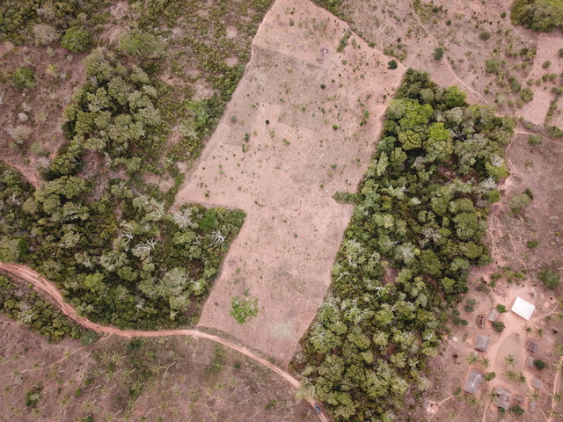

Figure 11. All Mwangea (Above)Drone image of remnant legume dominated forest near the peak of the hill with nearby settlement and coconut plantation. (Below, left to right) Central pressing point, recent tree felling, legume dominated dry forest.

**Field Survey methodology**

Data were collected following the Rapid Botanical Sampling methods out lined by Hawthorne and Marshall (2016).

Sampling began from a determined central point within a site. The range of the site was defined by the team leader (myself) and emphasised before collection began. The site constraints require the area to contain a single discrete vegetation type and not extend further into other vegetation types. The high heterogeneity of the East African Coastal forest meant that defining single vegetation types for sampling became difficult. To manage this, species count was taken into consideration (do samples contain more or less than 60 species.) and descriptions of samples were detailed as to whether they covered more than one vegetation type. Most of the surveys were undertaken in transitional areas such as forest edges and so detailed descriptions of adjacent land use were taken. GPS track files were created for each individual RBS sample outline.

Collecting was conducted in ‘wedges’ within the sample by individual team members to minimise the possibility of collecting specimens’ multiple times. Specimens were brought back to the central point and recorded and pressed by two team members positioned there. At this central point I was able to monitor the incoming samples for repeat collecting and correct data entry.

Photographic records were taken of all specimens collected.

It was estimated that around 40 species for each sample would be recorded within a timeframe of 3 hours, however it quickly became evident that the diversity of species was much higher, and we were collecting between 70 and 90 species within the first 3 hours. Collection continued until no new species were recorded.

Species were counted and allocated a simple abundance score.

1: scattered or only seen once. (Default score if not 2 or 3)

2: common

3: very abundant

Indicators of anthropogenic disturbance were recorded, presence of tree stumps, manmade paths, signs of limestone mining activity and proximity of farmland. Informal interviews with residents provided insight into perception of the forest patches, derived uses and pressures.

**Team composition**

The field team was composed of seven individuals with three specialist botanists. We divided the team into a recorder, a presser, a photographer and four collectors.

**Processing**

Identification of pressed specimens and databasing was conducted at the East African Herbarium in Nairobi. Identification of species followed The field guide “Kenya Trees, Shrubs and Lianas” (Beentje 1994) and The Flora of Tropical East Africa (FTEA).

RBS plot data were collected on field sheets and then transferred to MS-Excel spreadsheets. The database was compiled with corresponding star ratings (global rarity) for each species. This was done using the Tropical Africa database (Marshall et al, 2016).

**Conservation outcomes**

My surveys generated much interest from local conservation organisations. I organised a working group within Pwani University to improve the conservation capacity of the existing Botanical Garden, with the long-term aim that the garden maintains a living gene bank for rare coastal trees and provide education opportunities on forest conservation. I gave a lecture to the botany students at the university, outlining experimental design and botanical fieldwork as well as the importance of the coastal forests. Pwani University is in a position to progress scientific research and develop a new generation of Kenyan conservationists.

Working with Botanic Garden Conservation International (BGCI) I helped coordinate a seed collection training workshop with local landowners and various stakeholders including Kenya Forestry Research Institute (KEFRI), Kenya Forest Service (KFS) and the National Museums of Kenya (NMK).

Working with the conservation organisation A Rocha International, I produced a report based on the findings of this survey to be utilised for emergency land purchase of Mwangea Hill. The report has been accepted and is being considered for submission to IUCN and other land purchase funds.

I am currently advising a Global Tree Campaign collection expedition within the forests that I surveyed to carry out further priority species collection.

Figure 12. Seed collection training workshop at Kivukoni indigenous tree nursery.

**Continued analysis**

Currently I am undertaking analysis of the survey data to understand the representation of endemic species and how the surveyed sites fit into the wider biological importance of the East African coastal forest’s hotspot. The creation of detailed maps, overlaying population density, forest loss, land use and existing forest patches will allow for a closer understanding of remnant botanical diversity and the priority sites for conservation. Vegetation community analyses will also provide insights into how these patches compare in diversity to the wider region and predictions for the future of these highly threatened habitats.

Annex A provides the timeframe for the study. Annex B outlines the expenditure in relation to the received budget.

My thanks to the Davis Expedition fund committee for their generous contribution to this work.

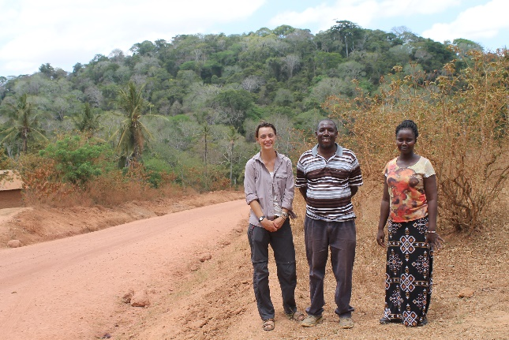

References

CEPF (2005) Ecosystem Profile. The Eastern Arc Mountains and the Coastal Forests of Tanzania and Kenya. Available at: https://www.cepf.net/sites/default/files/final.easternarc.ep_.pdf

Clarke, G.P. (1998) A new regional centre of endemism in Africa. In C.R. Huxley, J.M. Lock and D.F. Cutler (Editors) Chorology, Taxonomy and Ecology of the Floras of East Africa and Madagascar. P 53-65. Royal Botanic Gardens Kew.

Brooks, T. M., Mittermeier, R. A., Mittermeier, C. G., Da Fonseca, G. A., Rylands, A. B., Konstant, W. R., Flick, P., Pilgrim, J., Oldfield, S., Magin, G. and Hilton‐Taylor, C. (2002), Habitat Loss and Extinction in the Hotspots of Biodiversity. Conservation Biology, 16: 909-923.

Burgess, N.D. 2000. Global importance and patterns in the distribution of coastal forest species. In the Coastal Forests of Eastern Africa. N.D. Burgess & G.P. Clarke, eds. IUCN: Cambridge and Gland. Pp. 235–248. Burgess, N.D. & G.P. Clarke, eds. 2000. The Coastal Forests of Eastern Africa. IUCN: Cambridge and Gland.

Burgess N.D, Clarke G.P, Rodgers W.A, (1998). Coastal forests of eastern Africa: status, endemism patterns and their potential causes. Biological journal of the Linnean Society, 64: 337-367

Burgess, Neil & Doggart, Nike & Doody, Kathryn & Negussie, Gezahegn & Sumbi, Peter & Perkin, Andrew. (2003). New information on the lowland coastal forests of eastern Africa. Oryx. 37.

Gereau R.E, Cumberlidge N, Hemp C, Hochkirch A, Jones T, Kariuki M, Lange C.N, Loader S.P, Malonza P.K, Menegon M, Ndang’ang’a P.K, Rovero F, Shirk P. (2016) Globally Threatened Biodiversity of the Eastern Arc Mountains and Coastal Forests of Kenya and Tanzania. Journal of East African Natural History. 105:115-201

Githitho, A. (2004) The coastal terrestrial forests of Kenya. A report on resources, threats and investments. WWF Eastern African Coastal Forest Programme. Avaliable at: http://coastalforests.tfcg.org/pubs/CFResource-Ken.pdf (Accessed:14/09/2018).

Hubbard C.E, Milne-Redhead, E. Polhill. (ed.) (1952-1983). *Flora* *of Tropical East Africa.* London: HMSO.

Mittermeier RA, Turner WR, Larsen FW, Brooks TM, Gascon C (2009) Global biodiversity conservation: the critical role of hotspots. In: Zachos FE, Habel JC (eds) Biodiversity hotspots—distribution and protection of conservation priority areas. Springer, New York

Myers, N., R.A Mittermeier, C.G. Mittermeier, G.A.B. da Fonseca & J. Kent. (2000). Biodiversity hotspots for conservation priorities. Nature 403: 853–858.

Tabor K, Burgess N.D., Mbilinyi B.P., Kashaigili J.J. and Steininger M.K. Steininger (2010) Forest and Woodland Cover and Change in Coastal Tanzania and Kenya, 1990 to 2000. Journal of East African Natural History, 99(1):19-45.

Van Leeuwen M.W.N (1982) Vegetation and Land use Map of the Kilifi Area. University of Wageningen. Available at: http://edepot.wur.nl/302938

White F.1983. The vegetation of Africa, a descriptive memoir to accompany the UNESCO/AETFAT/UNSO vegetation map of Africa. UNESCO, Natural Resour. Res. 20: 1-356

**Annex A: Timeframe**

One of the major challenges during this research was a severe drought. This meant that we delayed survey until the beginning of the rain in April. During this delay I was self-funded for living expenses.

|  |  |
| --- | --- |
| Date | Action |
| March 1st -7th | Preparation of equipment and presentation of findings from desk-based research. |
| 7th-14th | Meeting with Chiefs and Coastal Forest Unit |
| 15th March-17th April | Delay due to drought conditions  Self-funded during this time |
| 19th April | Cha Simba data collection |
| 20th | Pangani Rocks data collection |
| 21st-27th | Sorting of collections, accessioning of collections within Kivukoni nursery, collating data. |
| 28th | Mwarakaya data collection |
| 29th-4th May | Sorting of collections, accessioning of collections within Kivukoni nursery, collating data.  Meeting with PUBG committee |
| 5th | Mwangea Hill data collection |
| 6th-9th | Sorting of collections, accessioning of collections within Kivukoni nursery, collating data.  BGCI seed collection workshops |
| 9th May -2nd June | Processing Collections within NMK Herbarium |

**Annex B: Expenditure**

|  |  |  |
| --- | --- | --- |
| Item | Source | Amount Pounds Sterling |
| Research Permit | NACOSTI Kenya | £265.29 |
| National museums permit | NMK | £300 |
| Flights EDI-NB | Kenya Airways | £500 |
| Visa |  | £38.95 |
| Subsistence (accommodation and food) |  | £1110 |
|  |  |  |
| In Country Travel |  |  |
| Car hire and driver |  | £400 |
| Fuel and repairs |  | £300 |
| Flights to/ from Nairobi | Safarilink | £195.81 |
|  |  |  |
| First aid kit |  | £85 |
| Insurance | Go Walkabout | £50 |
| Medivac | AMREF Maisha silver | £37.15 |
|  |  |  |
| Local Counterparts/ Guides |  |  |
|  |  |  |
| Norbert Rottcher/ Kivukoni Nursery staff |  | £657.58 |
| Thomas Mwadime (NMK) |  | £378.79 |
| Herbert Miguro (BBG) |  | £113.64 |
| Other local guides |  | £568.18 |
|  |  |  |
| Total |  | £5000.39 |