JAMES RENNIE BEQUEST

PROJECT REPORT

Project: Analysis of the susceptibility of malarial parasite-induced regulatory T cell to apoptotic death in vitro

Travel Dates: 30th June 2007 – 31st August 2008

Location: The Medical Research Council (UK), Atlantic Road, Fajara, The Gambia

Group Member: Christopher Williams

OUTCOME :-

Introduction
Regulatory T cells (Tregs) are involved in the suppression of both T cell differentiation and effector function. As well as being generated by the thymus, recent reports have found that Tregs can be induced de novo in the periphery from naïve undifferentiated T cells under the influence of the cytokine TGFβ. Recognition of TGFβ by naive T cells leads to the expression of the Treg lineage specific transcription factor, Forkhead box P3 (Foxp3) and hence a Treg phenotype,.

In his 2005 paper, Dr. Michael Walther determined that malarial parasites could induce blood monocytes to produce large quantities of TGFβ. In addition to this, Dr. Walther’s work indicated that the large population of adaptive Tregs resulting from this TGFβ release could downregulate the proliferation of peripheral blood mononuclear cells responding to Plasmodium falciparum schizont extract.

Could it be that the body has developed a mechanism that exacerbates malarial infections and if so, why? It is possible that Treg mediated downregulation of the immune response to P. falciparum is designed to prevent immunopathology. Indeed, in murine malaria, the downregulatory cytokines TGFβ and IL-10 are essential in performing this task,. Moreover, a delay in the resolution of a malarial infection may be key to developing and maintaining long term memory, as has been shown in Leishmania infection.

Alternatively, the induction of Tregs by malarial parasites could be a facet of the protozoa’s virulence factor repertoire – it is possible that malarial parasites have evolved to stimulate monocyte TGFβ release in order to bring about Treg differentiation and hence allow themselves to survive and replicate in the human body more successfully.

Unpublished data from the Walther lab has recently identified malarial parasite-induced Tregs as having an unusual phenotype with regard to apoptotic markers when compared with conventional memory T cells. In contrast with the latter cell type, the former have high levels of CD95 (Fas) expression and low levels of Bcl-2 expression. When ligated by Fas ligand, CD95 initiates apoptosis, an ordered form of cell death. Conversely, Bcl2 is an anti-apoptotic factor that protects cells from this process.

Therefore, it is hypothesised that Tregs in malaria may have developed a hyper-susceptibility to apoptosis in order to protect the host from malarial parasite-induction of excess Treg numbers. This project aimed to undertake the initial investigations necessary to begin to substantiate this claim by analysing the relative susceptibility of malarial parasite induced Tregs to apoptotic cell death.

It was proposed to study apoptotic markers expressed by Tregs using a complex array of monoclonal antibody stains to be read with a 9-colour FACS machine. This would have involved a panel of stains as follows:
- CD95 (Fas) – assesses cellular susceptibility to Fas ligand mediated apoptosis
- Bcl2 – an antiapoptotic factor to assess Tregs’ levels of protection from apoptotic death
- CD45RO – a reasonably reliable marker of memory cell phenotype
- CD4 – a marker of T helper cells of which Tregs are a subtype
- CD25 – the high affinity IL-2 receptor, of some use in identifying Tregs
- Annexin V – a chemical that attaches to phophatidylserine in the inner leaflet of the plasma membrane to identify cells with damaged or incompetent membranes (dead cells)
- CD127 – the IL-7 receptor alpha. Some papers describe CD4⁺ CD25⁺ CD127⁺ as Tregs
- FOXP3 – the lineage specific transcription factor of Tregs
- CD3 – a marker of T cells

Although CD4 CD25 positivity is often used as a reliable indicator of the Treg phenotype in murine models, this has not proven to be an accurate technique when working with human cells. This necessitates staining T lymphocytes for FOXP3 ⁵ when attempting to identify Tregs, which, as a transcription factor, requires the permeabilisation of the cell in the staining process. The Bcl2 used in the above panel is also an intracellular molecule that requires cell permeabilisation for staining. After several trials of the staining panel, it was observed that the most important stain, Annexin V was not functioning correctly. Annexin V is used to assess cell death and can differentiate early and late apoptotic/necrotic cells when used in conjunction with propidium iodide, a chemical which attaches to DNA and RNA and hence identifies cells whose membranes have been destroyed. Although Annexin V was being used before the permeabilisation process to avoid all the cells staining positively for Annexin V, the chemical, which cannot be exposed to a fixing agent and is very unstable, was not surviving the use of fix/perm buffer and/or the length of time taken to stain for FOXP3 after Annexin V staining.

Whilst an alternative staining panel was being devised, it was necessary to design a positive control for apoptosis in order to assess the efficacy of the Annexin V stain. In this experiment, no identifier of late apoptotic/necrotic cells (propidium iodide or 7-AAD) was used owing to the fact that all the FACS machine channels were already being used for other antigen stains. A well designed positive control would ensure that the Annexin V was binding to cells in early apoptosis and not just necrotic cells. Research using the PubMed database revealed the common use of hydrogen peroxide (H₂O₂) as a stressor to induce apoptosis. Trials in our lab revealed 150μM to be an appropriate final concentration for this purpose and, using the simple definition for Tregs of CD4 CD25 positivity, found that further investigation into our hypothesis was certainly warranted as Tregs were apoptotic/necrotic in both unstimulated and H₂O₂ stimulated conditions in far greater proportions than existed for other CD4⁺ T
cells (Fig. 1). More precise phenotyping of Tregs and selection of CD4⁺ FOXP3⁺ rather than CD4⁺ CD25⁺ T cells would permit the creation of a theory for the mechanisms behind the observed increased susceptibility to apoptosis.
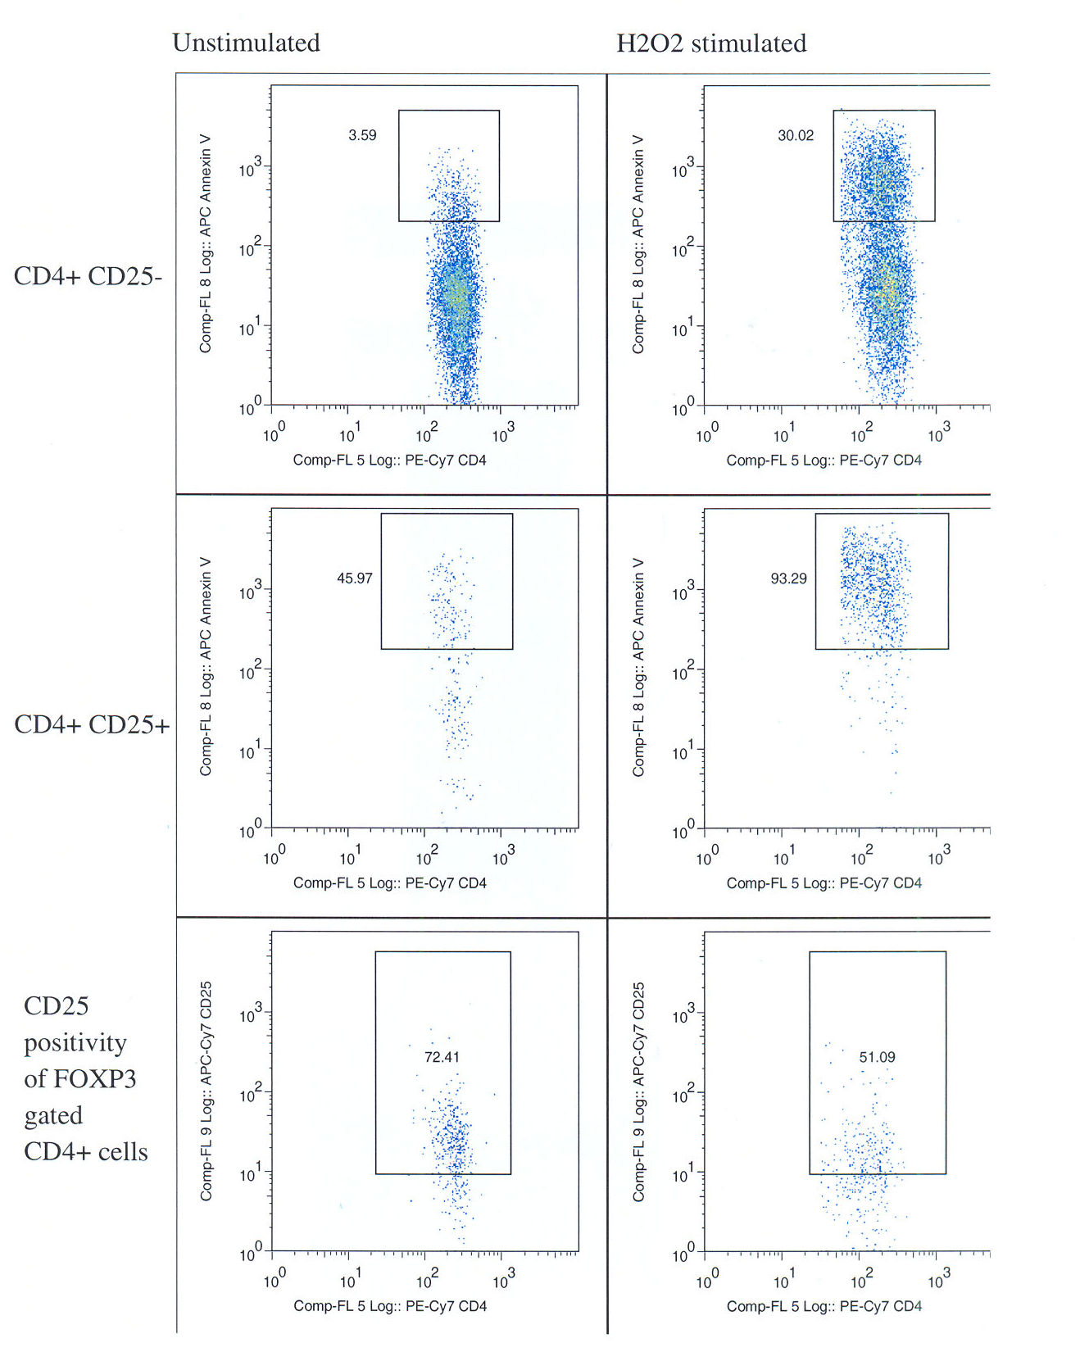
Fig. 1: FACS plots showing percentage of cells gated for CD4 and CD25 or CD4 and lack of CD25 that stained Annexin V positive. Following isolation, cells in the first column were incubated at 37ºC for 2 hours in complete medium; cells in the second column were incubated at 37ºC for 2 hours in complete medium supplemented with H₂O₂ at a final concentration of 150μM. The third row of plots shows the percentage of CD4⁺ FOXP3⁺ cells — taken from a sample of similarly treated cells — that were CD25⁺. This shows that the majority of such cells were CD25⁺.

In the last week of my time in The Gambia, I established a time-trial to observe the kinetics of markers of apoptosis and susceptibility to this form of cell death. Three panels of FACS stains were used to investigate this:

 | FITC | PE | PerCP | PeCy7 | APC | APC-AF750 | Pac Blue | Cas Yellow
1 | CD95 | CD8 | CD4 | CD25 | Annexin V | CD127 | — | Live/Dead stain
2 | CD95 | Bcl2 | CD4 | CD25 | FOXP3 | CD127 | — | —
3 | CD14 | CD56 | CD4 | CD19 | CD95L | CD127 | FOXP3 | —

Panel 1 was used to indicate when apoptosis starts, describing CD4⁺ CD25⁺ CD127⁺ cells as Tregs. Live/Dead stain can identify necrotic cells specifically and so allows identification of Annexin V⁺ Live/Dead– cells as those in early apoptosis. Panel 2 was designed to show the kinetics of CD95 and Bcl2 on FOXP3⁺ cells and Panel 3 aimed to elucidate the kinetics of Fas L expression by PBMCs.

PBMCs were isolated from blood samples taken from healthy, non-malaria exposed volunteers and cultured in RPMI supplemented with 10% human AB serum, L-glutamine and pen. strep. for 14 days (medium changed every 5 days). When plating out the PBMCs, samples of the cells were exposed to malaria infected red blood cells and others were exposed to uninfected erythrocytes or no erythrocytes as controls. Samples of the cells were stained with the three staining panels on days 0, 1, 3, 6, 8 10 and 14.

Unfortunately, owing to problems with the 9-colour FACS machine, the time trial did not prove successful and as my stay in The Gambia was drawing to a close, there was no time to repeat the experiment to try and obtain more results.

However, what I did manage to achieve at The MRC malaria research base was to identify H₂O₂ as a useful stressor when a positive apoptotic control is required. Also, my preliminary data in Figure 1 suggests that further study is warranted and finally the design of the staining panels for the time trial is now in place so that the experiment can be repeated. Over the coming months, this experiment will be continued by Dr Judith Satoguina who, along with Dr Olivia Finney will analyse the results for inclusion in a paper on the susceptibility of Tregs to apoptosis in malaria due to be submitted for publication next year.

It only remains for me to thank all those at the MRC research centre in The Gambia who helped me arrange my stay there and who were always on hand to answer my questions — especially Dr Michael Walther and Dr Satoguina — and all the staff, students and volunteers who made me feel so welcome there. I would also like to thank the Board of the James Rennie Bequest for providing me with the essential financial support that made my stay in The Gambia possible.

Sojka D., Huang Y-H. & Fowell D. Mechanisms of regulatory T-cell suppression – a diverse arsenal for a moving target. Immunology. 124: 13-22 (2008).
? Sakaguchi S. & Sakaguchi N. Thymus and autoimmunity: Transplantation of the thymus from cyclosporin A-treated mice causes organ-specific autoimmune disease in athymic nude mice. J. Exp. Med. 167: 1479-1485 (1988).
? Chen W., Jin W., Hardegen N., Lei K., Li L., Marinos N., McGrady G. & Wahl S.M. Conversion of peripheral CD4⁺ CD25– naive T cells to CD4⁺ CD25⁺ regulatory T cells by TGF-β induction of transcription factor Foxp3. J. Exp. Med. 198: 1875-1886 (2003).
? Hori S., Nomura T. & Sakaguchi S. Control of regulatory T cell development by the transcription factor Foxp3. Science. 299: 1057-61 (2003).
? Fontenot J., Gavin M. & Rudensky A. Foxp3 programs the development and function of CD4⁺ CD25⁺ regulatory T cells. Nat. Immunol. 4: 330-36 (2003).
? Walther M., Tongren J.E., Andrews L., Korbel D., King E., Fletcher H., Andersen R.F., Bejon P., Thompson F., Dunachie S.J., Edele F., de Souza J.B., Sinden R.E., Gilbert S.C., Riley E.M. & Hill A.V.S. Upregulation of TGFβ, Foxp3, and CD4⁺ CD25⁺ regulatory T cells correlates with more rapid parasite growth in human malaria infection. Immunity. 23: 287-296 (2005).
? Li C., Sanni L.A., Omer F., Riley E. & Langhorne J. Pathology of Plasmodium chabaudi chabaudi infection and mortality in interleukin-10-deficient mice are ameliorated by anti-tumor necrosis factor alpha and exacerbated by anti-transforming growth factor beta antibodies. Infect. Immun. 71: 4850-4856 (2003).
? Omer F.M. & Riley E.M. Transforming growth factor beta production is inversely correlated with severity of murine malaria infection. J. Exp. Med. 188: 39-48 (1998).
? Belkaid Y., Piccirillo C.A., Mendez S., Shevach E.M. & Sacks, D.L. CD4⁺ CD25⁺ regulatory T cells control Leishmania major persistence and immunity. Nature. 420: 502-507 (2002).
? Sakaguchi S. Naturally arising CD4+ regulatory T cells for immunologic self-tolerance and negative control of immune responses. Annu. Rev. Immunol. 22: 531-562 (2004).
? Iwata M., Myerson D., Torok-Storb B. & Zager R. An examination of renal tubular DNA laddering in response to oxygen deprivation and oxidant injury. J Am Soc Nephrol. 5: 1307-1313 (1994).

