JAMES RENNIE BEQUEST REPORT

Expedition/Project/Conference Title: Save the Elephants Internship

Travel Dates: 03 June–12 August 2009

Location: Samburu National Reserve, Kenya

Group Member(s): Sarah White

Aims:
- To assist with the long-term monitoring of elephant populations within the Samburu-Laikipia ecosystem in northern central Kenya, through direct observations and remote tracking data generated through the use of GPS radio-collars.
- To assist with the removal and fitting of GPS collars to elephants in the field.
- To analyse the performance of nearly 250 GPS collars used by Save the Elephants since 1998 and disseminate this information to other researchers through publication of the results.

OUTCOME (not less than 300 words):-

Introduction
Save the Elephants (STE) was founded in 1993 by Dr. Iain Douglas-Hamilton, one of the world’s leading authorities on the African elephant, Loxodonta Africana. The organisation aims to secure a future for elephants by sustaining the ecological integrity of the places in which they live, which involves the four core activities of scientific research, protection and monitoring, global education and local grass-roots community involvement. Pure research is being carried out to help us better understand the ecology and behaviour of the African elephant, including migration patterns and range sizes, mating strategies, communication channels, consciousness and the complexity of their social structures. Applied research is also helping to reduce conflict with humans whilst allowing elephants continued access to the areas important to them. A key component of this research is the use of Global Positioning System (GPS) radio-tracking collars, pioneered by STE during the 1990s. Since 1998, STE has carried out nearly 250 elephant collarings across four regions of Africa (Kenya, Mali, Central Africa and South Africa) resulting in approximately 2 million GPS location data points, a tremendous accomplishment unrivalled by any other elephant research organisation. The main STE research base is located in Samburu National Reserve, in northern central Kenya, along the northern bank of the Ewaso N’giro River (Figure 1).
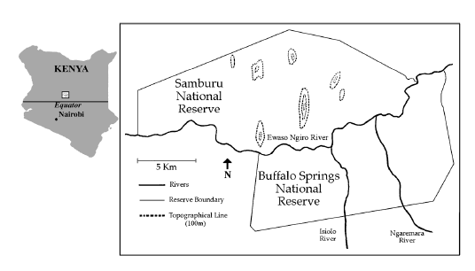
Figure 3. Map showing the location of the Samburu National Reserve, northern central Kenya

During summer 2009 I was invited to spend 10 weeks as a research assistant for Save the Elephants, based at the main research camp in Samburu National Reserve. This gave me the opportunity to work alongside local researchers with their expert knowledge of the local ecology, as well as experience the challenges of working in a completely new environmental context. Much of my time was spent assisting with the daily long-term monitoring of elephant populations, the core activity upon which much other research depends. Approximately 900 elephants have been individually identified and monitored in the Samburu-Laikipia region of Kenya since 1993. This aspect of research involves maintaining accurate photo-identification records of each elephant, as well as recording observational data on their health, behaviour and movements. This was particularly important during 2009 since the reserve was suffering from the worst drought for decades. Regrettably much of our time was spent locating and recording reported elephant deaths in association with the Kenya Wildlife Service (KWS), including several matriarchs and juveniles too weak to survive the drought conditions. In addition to monitoring the local elephant populations, I also helped conduct general mammal census surveys throughout the reserve, in order to establish interactions between elephants and other mammals. Again this was particularly important during the drought conditions since we were able to record many instances of elephants coming into conflict with livestock, which were being illegally brought into the reserve in a desperate search for food and water.

Tracking Elephants for Conservation
A large component of the research carried out by Save the Elephants is based around tracking the movement of elephants by fitting them with GPS radio-collars. During my stay I was fortunate enough to be involved in several elephant collaring operations carried out by STE in association with the KWS veterinary team. These involved long days of scouting the reserve for possible collaring targets, who were either elephants with existing collars which needed replacing, or new elephants whose movements were of particular interest, for example elephants who were known crop-raiders of nearby settlements. Once a target was located the team would stay with them and observe their movements and behaviour until a suitable opportunity arose to anaesthetize and subsequently collar the elephant. Figure 2 below shows some photos of the collaring of Anastasia, a female from the Royals Family, who is now the record all-time most collared elephant. Here she is being fitted with her sixth consecutive GPS collar in July 2009.

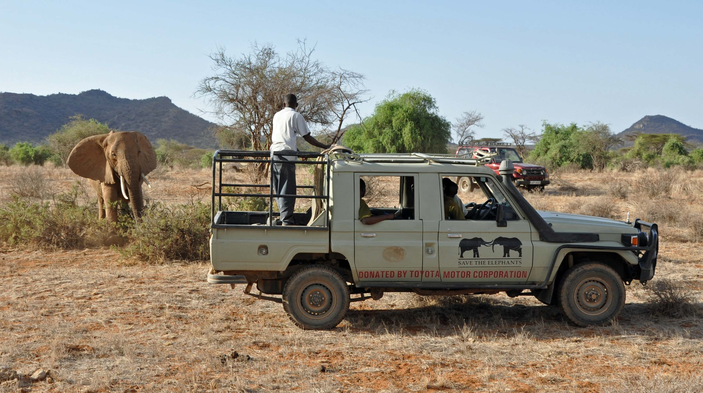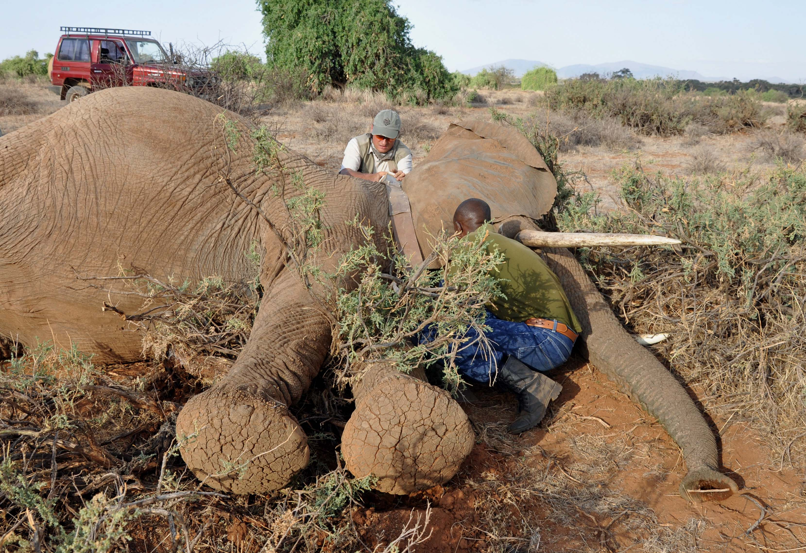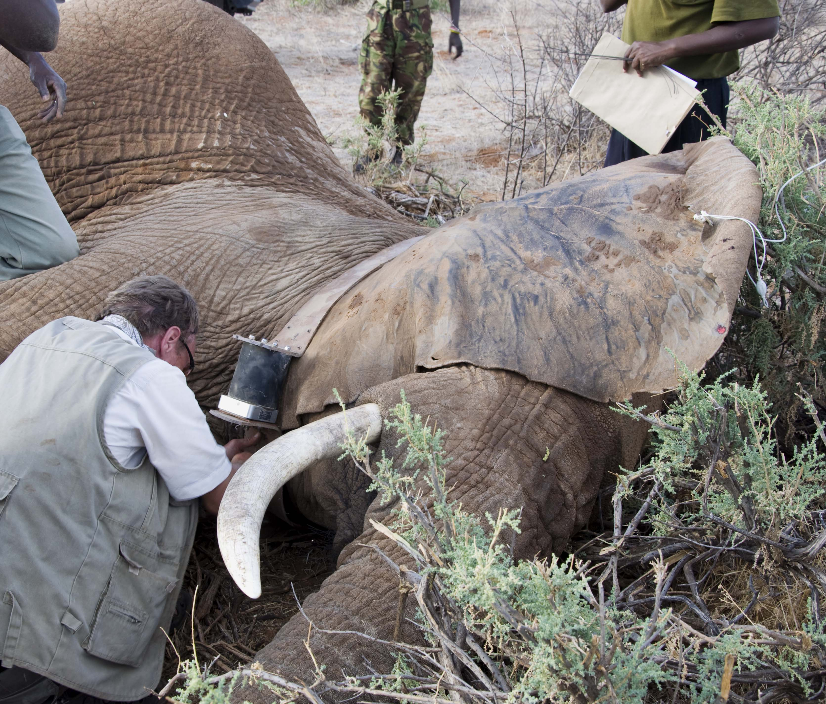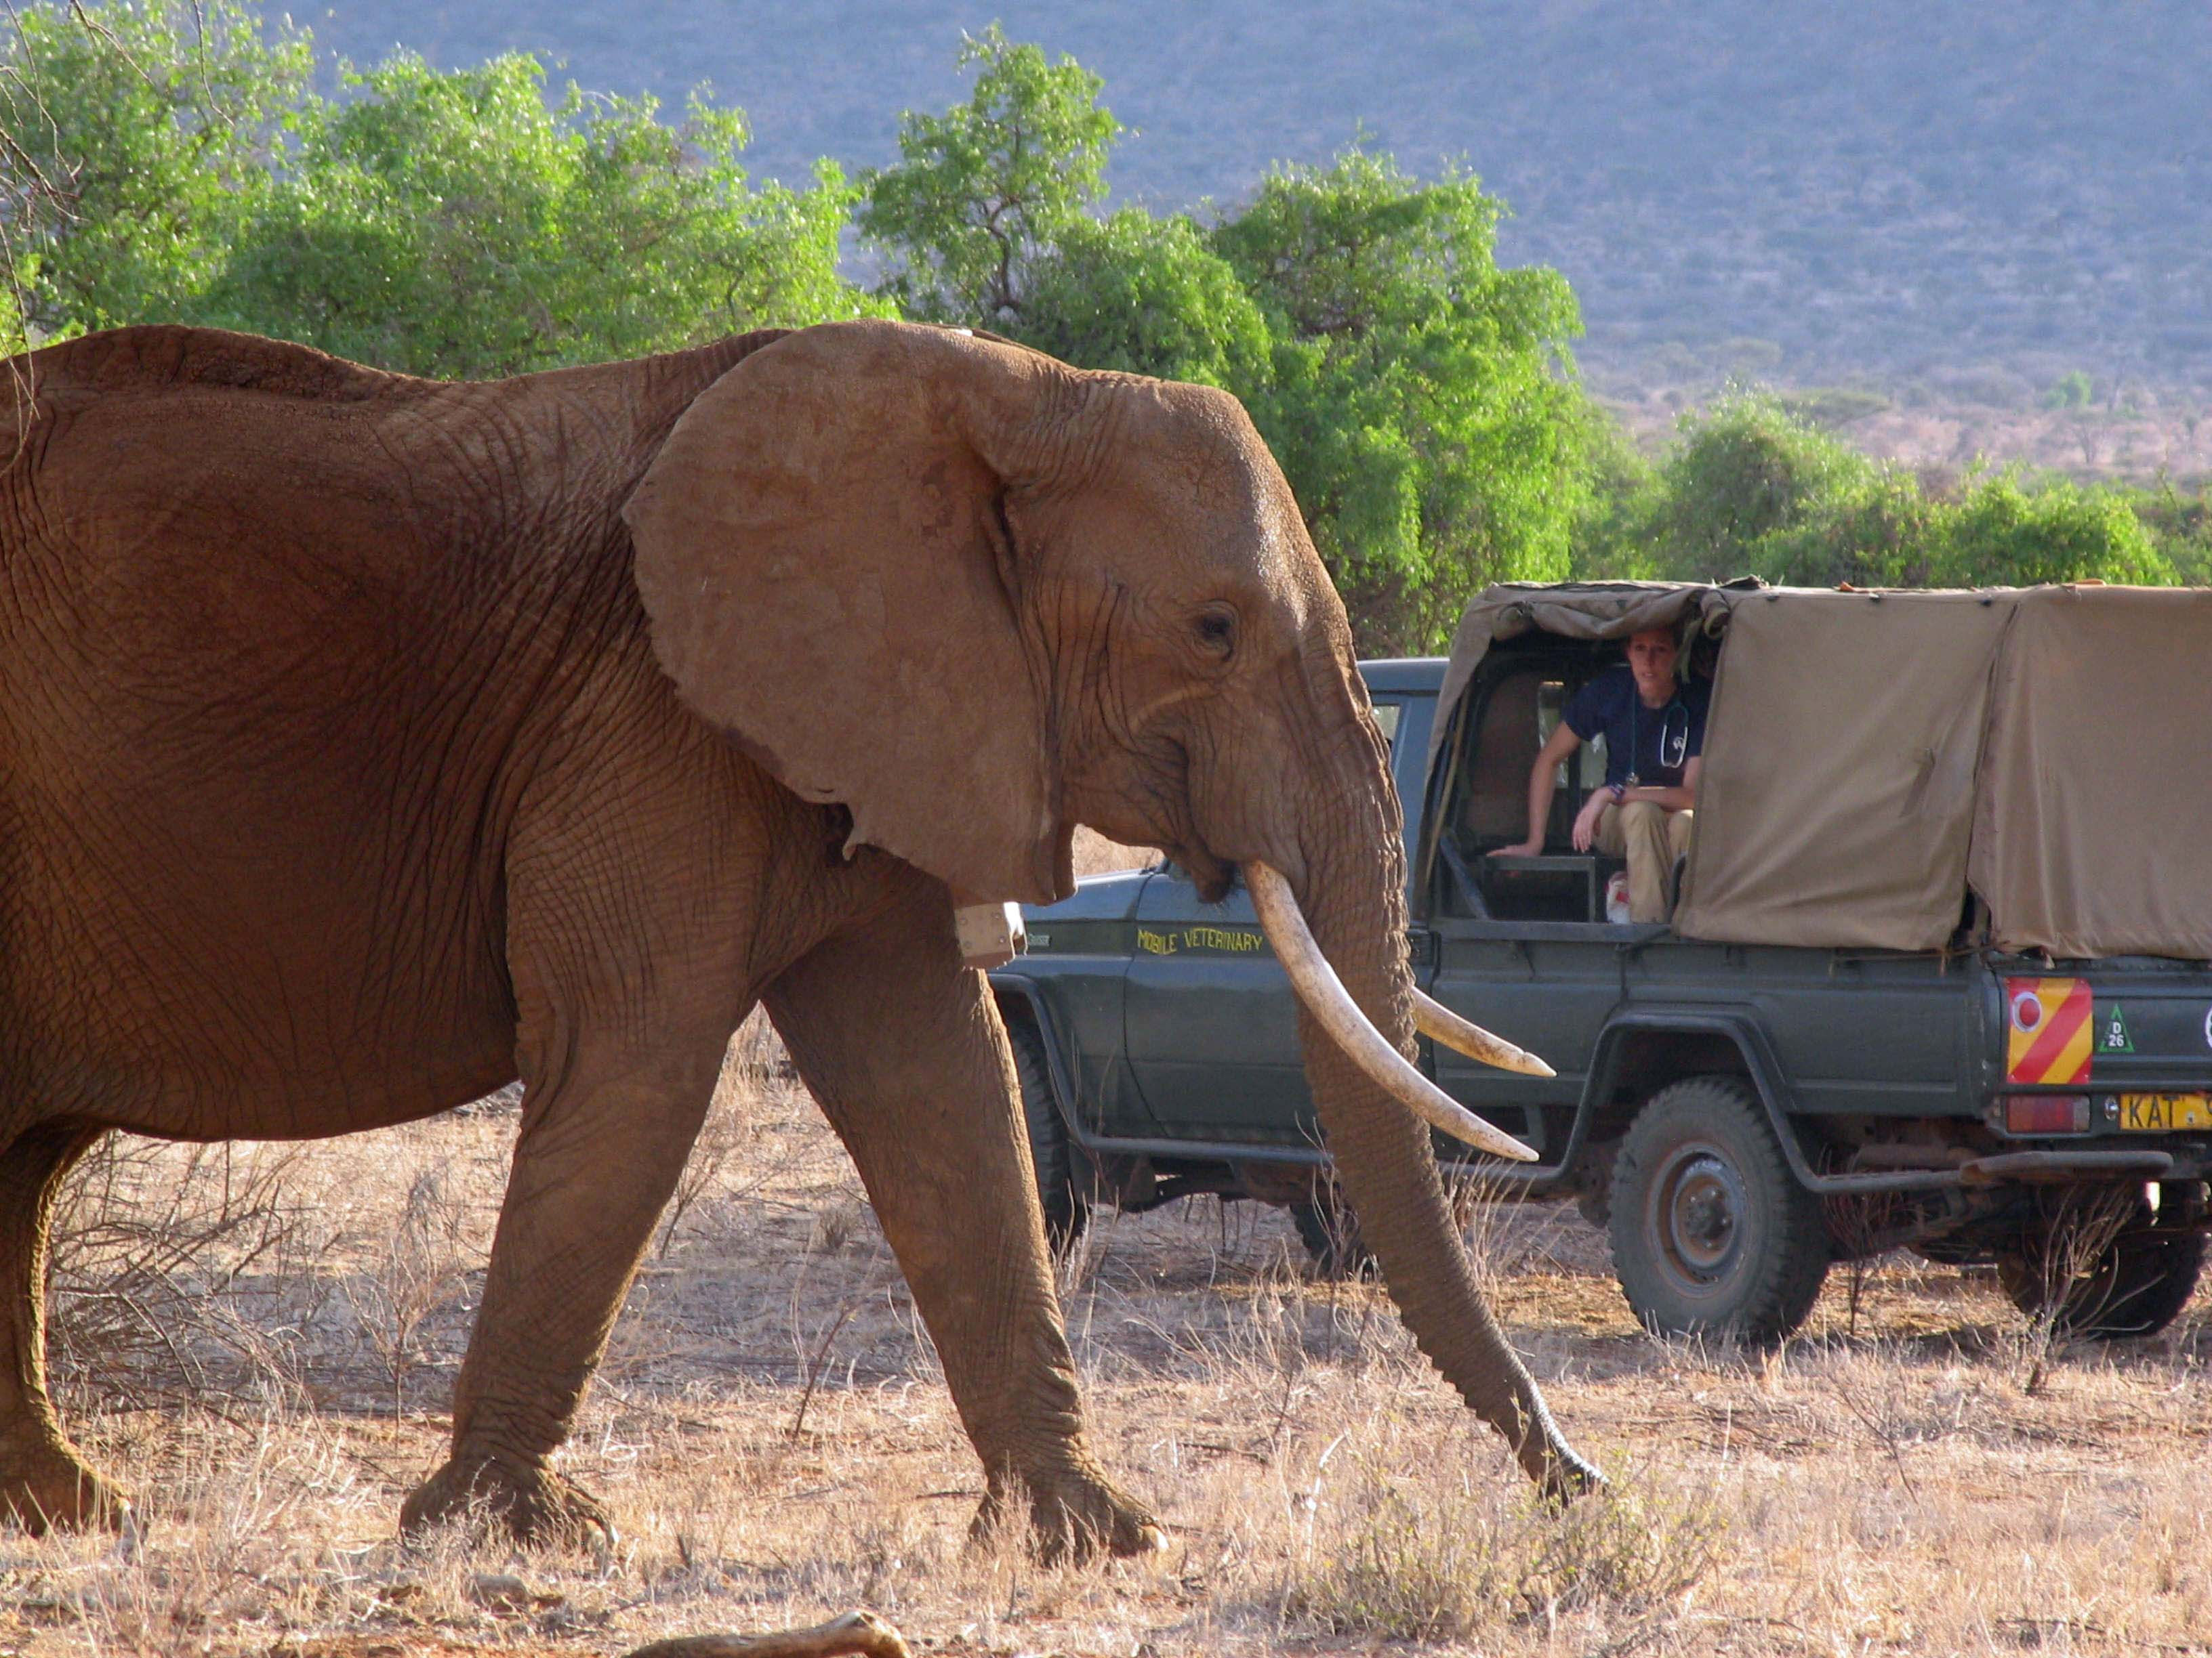
Figure 2. Fitting Anastasia, a female from the Royals family, with a new GPS radio-collar: (clockwise from top left) waiting for the drugs to take effect after having darted Anastasia; Save the Elephants researchers fitting the new GPS collar; Anastasia recovered with her new collar shortly after an antidote was administered by the KWS veterinary team.

Save the Elephants is sponsored by the Environmental Systems Research Institute (ESRI) who produce leading ArcGIS software for spatial data analysis. The STE team has written a unique suite of software programs to allow quick and clean output from the elephant tracking database. This tracking data is then visualized using Google Earth technology, an example of which is shown in Figure 3 below. This allows the STE researchers to monitor the movements of elephants in real-time each time a new GPS location is received. Obtaining detailed information on elephant movements and seasonal dispersal patterns is vital in order to protect and manage elephant populations effectively. Knowledge of fine-scale movements allows managers to establish protected corridors which allow elephants to move from one part of their range to another, whilst minimising conflict with surrounding communities. Save the Elephants is currently pioneering “geo-fencing” technology, whereby a virtual fence line is established within a computer Geographical Information System (GIS), surrounding an important feature on the ground such as farmland or settlements. If the tracking data indicates that an elephant has crossed the virtual fence line then land managers can be alerted and a team activated on the ground to chase the elephant away before conflict with landowners occurs.

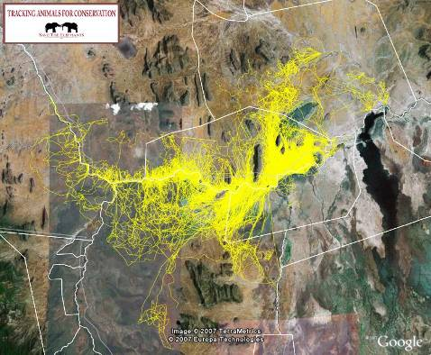
Figure 3. Map showing the movements of the elephant Anastasia in and around the Samburu National Reserve (tracking data for 2007)

The Performance of GPS collars
When not in the field I was responsible for carrying out an analysis of the performance of all GPS collars used by Save the Elephants since 1998. This was a huge undertaking involving data from 248 collarings carried out across Kenya, Mali, Central and South Africa. A total of eight different types of collars were analysed, supplied by three manufacturers: Lotek Engineering of Canada; Televilt Positioning AB of Sweden; and African Wildlife Tracking (AWT) of South Africa. Early collars were simple data-loggers capable of storing several thousand GPS data points which had to be periodically downloaded in the field using a radio link to a remote Very High Frequency (VHF) receiver. More recent collars are able to transmit GPS location data via a satellite link to a computer server, having the advantage that data can be analysed in real-time whilst the collar is still deployed in the field. Since 2004, Save the Elephants has also pioneered the use of GSM-type collars which contain mobile phone SIM cards, enabling GPS location data to be transmitted by text message using the GSM telecommunications network. These collars also have the advantage that they can be reprogrammed whilst deployed, simply by sending a text message to the collar. Figure 4 below shows some photos of the different collars used by Save the Elephants since 1998.
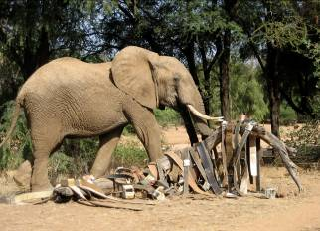
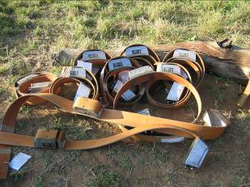
Figure 4. A batch of new Televilt satellite-type collars (left). A young bull investigates the stockpile of now-disused collars kept at the Save the Elephants research camp (right)

Collaring operations are costly, both financially and in terms of the risks to the elephants and researchers involved. Therefore it is crucial that collars be used which send reliable tracking information and should ideally last for a minimum of 2-3 years, allowing migration routes to be identified and protected. Every time a collar fails, expensive and risky re-collaring operations are needed, reducing the number of new elephants which can be collared. Therefore, the analysis of collar performance concentrated on the lifespan of different types of collars, common reasons for collar failure, and the general success of different collars in acquiring the GPS locations they were scheduled to collect. Figure 5 shows survival curves generated for three different types of collars, one from each manufacturer and spanning different timescales of use.
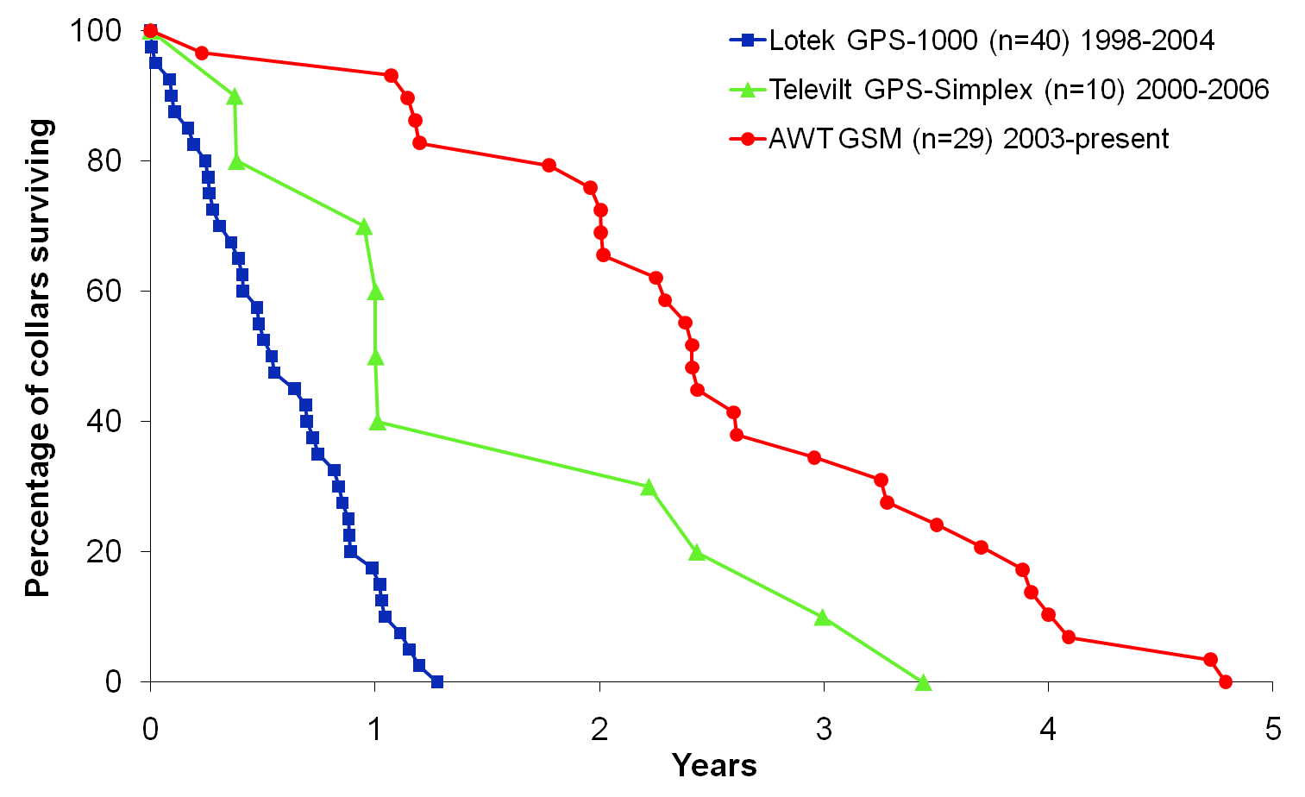
Figure 5. Survival curves for 3 types of GPS collars used by Save the Elephants since 1998. The total number of collars (n) is shown, along with the years during which the collars were used.
Generally, the lifespan of GPS-collars has improved with time as the collar technology has gradually improved. The best performing collars to-date are the AWT GSM-type collars, which have achieved a mean lifespan of 2.62 years (standard error=0.21 years, n=29). Early collars such as the Lotek GPS-1000 only achieved a mean lifespan of 0.59 years (standard error=0.06, n=40), although since they were the first design to be deployed on elephants they were not expected to last much beyond a year of operation. Across all collar types the most common reasons for failure were premature battery expiration and physical failure of the collar belting material, the latter explaining the failure of seven out of the ten Televilt GPS-Simplex collars whose survival curve is shown in Figure 4. More recent collars have addressed this problem and now use superior belting materials able to withstand the high levels of wear-and-tear they are subjected to during elephant deployment. The largest remaining problem to-date is battery life, with many collars failing due to premature battery expiration.

The full results of the GPS-collar analysis have recently been submitted for publication in Pachyderm, Journal of the African Elephant, African Rhino and Asian Rhino Specialist Groups, so that the findings can be shared with other researchers in the field.

Acknowledgements
I would like to thank the patrons of the James Rennie Bequest for awarding me travel funds which made my visit possible. I would also like to thank Dr Iain Douglas-Hamilton and all the staff at Save the Elephants for giving me such an incredible opportunity to become involved in their research and fulfilling my lifelong dream to observe African elephants in the wild. I left Kenya filled with fond memories, having met many amazing people and with an even stronger desire to pursue research in Africa in the future.

References
Save the Elephants website - www.savetheelephants.org
Pachyderm journal - www.african-elephant.org/pachy

