JAMES RENNIE BEQUEST

REPORT ON EXPEDITION/PROJECT/CONFERENCE

Expedition/Project/Conference Title: The 4th Wolbachia Meeting, Puerto Rico

Travel Dates: 25th-29th June

Location: Hotel Paradisus, Puerto Rico

Group Member(s): Lucy Weinert

Aims: To broaden my knowledge of up to date research in the field of Wolbachia
To convey my research to people within my discipline and to talk to them regarding this
To create collaborations and look for job opportunities

OUTCOME (not less than 300 words):-


The beach at the hotel taken by Conor McMeniman

If Carlsberg made conferences, I don’t think it could’ve done much better than the 4th Wolbachia meeting 2006. It was held on the beautiful island of Puerto Rico in late June of this year on a five star, all inclusive resort with free food and alcohol provided all day everyday and symposia arranged to accommodate the Fifa World Cup. Despite all this, we did still manage to get some work done.

The Wolbachia meeting is held every other year and typically quite small with only 150 researchers in attendance. The community itself very friendly and informal, there are no invited speakers, and the symposia are hosted by young researchers. There were a total of 43 talks over 5 days. Even though my talk was based on a related bacterium Rickettsia, this meeting is really the only specialist conference in my field and I was the only representative from the University of Edinburgh. But the relaxed surroundings and friendliness of the researchers meant that this has been the only conference I’ve so far attended where I did not feel intimidated to talk to people and it indeed was the most useful and informative I have been to yet.

Because of the many reproductive phenotypes that Wolbachia manifests in its hosts and the interesting evolutionary consequences of these actions, Wolbachia initially attracted the attention of population geneticists and theoreticians. But the Wolbachia world these days has undoubtedly taken a turn towards the mechanistic level.
Jack Werren, one of the leading authorities in Wolbachia research addressed the main unresolved questions of Wolbachia and the direction the work is taking. The biggest questions being addressed are:
How common/important is Wolbachia in insects?
What is the nature of Wolbachia to its host?
What happens in the early stages of evolution?
How is Wolbachia lost?
How does Wolbachia induce phenotypes?
How do phenotypic switches take place?
How do new cytoplasmic incompatibility types evolve?
Does Wolbachia accelerate divergence and speciation?

One of the main problems with Wolbachia research is that because the bacterium is so common, many closely related strains exist and there is currently no correct nomenclature. Another problem is that people use the highly evolving wsp gene to build phylogenies but this has been shown to undergo recombination and so frequently does not reflect the true evolutionary history of the bacterium. Laura Baldo and other researchers have been busy designing a system to combat this problem. She presented a workshop on Multi Locus Strain Typing (MLST), which sparked much debate within the group. The main problems people had with it was the amount of sequencing required will work out to be very expensive, it will be more time-consuming and the fact that it will not be able to distinguish between double infections.

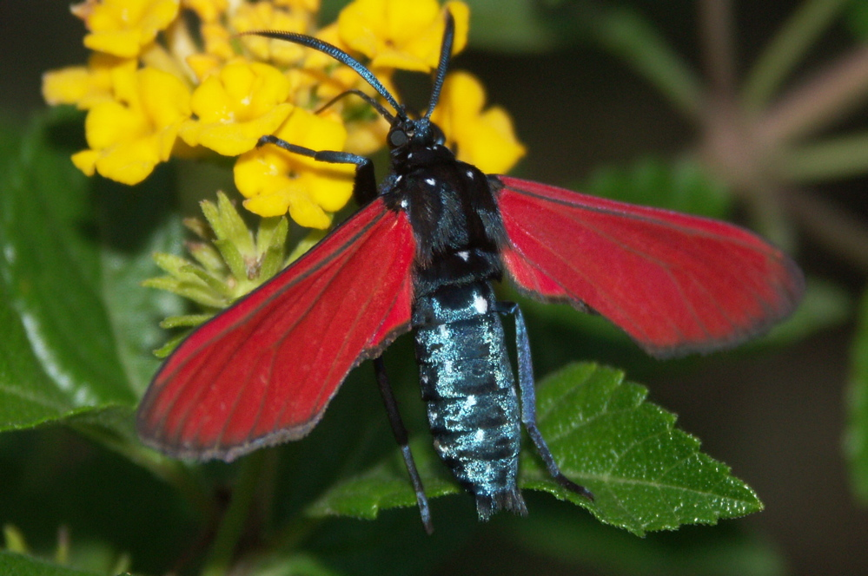
Puerto Rican Hawk Moth taken by Steve Sinkins from outside the hotel. (over 20% chance is infected with Wolbachia)

One very interesting talk was introducing Wolbachia research in to schools. Seth Bordenstein is working with teachers, talking to them about Wolbachia in insects and how to go about finding it, extracting it and PCRing up sequences. Some teachers have already sort out funding for PCR machines and this approach will not only get school children interested in molecular biology but also add to the wealth of Wolbachia sequences out there and increase its profile.

Specifically to my research, my oral presentation received a good audience. I was discussing a plasmid I had found in the bacteria I work on and how unusual that is for intracellular pathogens. This was my first presentation to an international audience and I was nervous but also disappointed that it was to be on the last day. And I was speaking right after Greg Hurst, a very good speaker who has an interesting story regarding Hypolimnas butterflies in Polynesian Islands (see Hornett et al., 2006). But despite these reserves I thought my talk went well and I managed to have sober talks with quite a few people before the night descended in to a salsa dancing frenzy.

I talked to Martha Hunter, who had just published a review on the emerging diversity of Rickettsia (Perlman et al., 2006), something which I had briefly mentioned in my talk. Many more researchers are testing insects for symbionts and there are lots of new sequences very similar to Rickettsiae, which seem to be purely associated with arthropods. Most of the current research is conducted on Rickettsiae with a vertebrate part to their lifecycle as they cause many diseases but studying non-vertebrate Rickettsiae will help dissect the different components of the life cycle. The plasmid I discovered seems to be in basal Rickettsia and so it will be interesting to look for the plasmid in the new emerging Rickettsia to establish the host range of the plasmid, at what point the plasmid was acquired and what effects it is having on its host. I also talked to Seth Bordenstein and Jack Werren who were interested in the plasmid and MLST in Rickettsia. As well as this, I have been invited to several other Universities to do some research in areas where the University of Edinburgh lacks the facilities and expertise, so it will be interesting to follow these leads up.

In short, the only fault I could find with the conference was the expense itself and so I wish to thank the James Rennie Bequest as without their support, I would not have been able to attend the Wolbachia meeting and would not be in the good position I am now.

References

Hornett EA, Charlat S, Duplouy AMR, Davies N, Roderick GK, et al. (2006) Evolution of male-killer suppression in a natural population. PLoS Biology. 4(9): e283

Perlman SP, Hunter MS, and Zchori-Fein E. (2006) The emerging diversity of Rickettsia. Proceedings of the Royal Society of London, Series B. 273: 2097-2106

