**REPORT ON EXPEDITION/PROJECT/CONFERENCE**

|  |  |
| --- | --- |
| **Expedition/Project/ Conference Title:** | Biodiversity Assessment Project in Mexico |
| **Travel Dates:** | 11th June - 9th July 2012 |
| **Location:** | Calakmul Biosphere Reserve; Centro Ecologico Akumal |
| **Group member(s):** | Joey Warner |
| **Aims:** | To aid in the documentation of flora and fauna in Calakmul |
|  | Biosphere Reserve and at Akumal |
|  |  |
| **OUTCOME (not less than 300 words):-** | |

The Project consisted of 3 weeks in the Calakmul Biosphere Reserve, a protected tropical deciduous forest in the Yucatan Peninsula. This was followed by 1 week at the Centro Ecologico Akumal, a local wildlife research and education centre located on the Caribbean Sea.

The Journey began in Puerto Morelos, a peaceful village located just south of Cancun. All the volunteers were introduced here and the scope and aims of the project were outlined, along with the last large meal we would be having for a while. We were to be taken by coach to the very centre of the Mexican jungle, 20km from the nearest civilisation and very close to the Calakmul Mayan ruins. The journey was about 8 hours and often involved rather treacherous roads, but getting to know everyone made the time pass quickly. For anyone interested, the GPS co-ordinates for the camp are 18.3647431,-89.891078.

Once in the jungle we were briefed about the kind of work we were to be undertaking. 4 transects cut into the jungle at the 20km camp, an aguada (a kind of stagnant lake) even deeper into the jungle at 27km, and the ruin area itself at the end of the road (42km) were to be the main areas of research. The area is very rich in wildlife so the project was divided up into groups based on the type of animals to be detected. Each group was led by specialist scientists in the relevant areas and included both local and British scientists. The groups were:

* Mammals - including jaguar, margay, howler and spider monkeys, peccary, tapir, and some smaller deer species
* Bats - although mammals, they were so abundant they deserved their own group
* Birds - over 300 species of bird are known to frequent Calakmul, among them: the toucan, motmot, oriole, royal flycatcher, hummingbirds, and many more melodious birds detectable by their calls
* Herpetofauna - so many frogs and toads, as well as many species of snakes. These included the Morelet's crocodile, several anoles, false coral snake, 3 local species of pit viper (all venomous), and the coral snake (also venomous)

We utilised several different methods of animal detection, tailored to each group. The mammal groups were mainly based around the aguada and involved looking for tracks (when looking for ground mammals) and recording monkey behaviour and social dynamics. We found strong evidence of breeding tapirs, jaguars, peccary (which have a distinct smell of onions) and white-tailed deer among others.

Birds were detected by going out on nest surveys, birdcall surveys on transects, and mist-netting during the day. The birdcall surveys were particularly effective at detecting species, aided by the excellent bird specialist Luis, and many species were detected.

The bats surveys were done at night. Mist-netting was effective and specimens were taken back to camp for study. The bats were measured and recorded and also served as an education tool for the non-bat specialists. The local bat population is gigantic due to a large cave nearby containing an estimated 1.5million bats, and as many bat specialists as possible were required. The cave itself was visited in order to see the wonderful spectacle of the bats leaving the cave at night. The cave is located at the bottom of a large sinkhole in the rock and the bats need to fly out in a whirlwind-like fashion resulting in an amazing cyclone of bats, large enough to cause a breeze!

Herptiles were detected on night-time transect walks, pit-fall traps, and at the aguada, a known haunt for the morelet's crocodile. The herpetofauna is so diverse and detecting species was easy (on one walk I think we counted 30 individuals of one species alone!).

After our 3 weeks in the jungle, we were then carted to the Caribbean coast at the turtle hotspot of Akumal. We spent 5 days learning how to SCUBA dive, whilst also doing surveys of the coral reef. We also took part in tourist outreach programmes to help keep the public informed about turtle protection.

This expedition was amazing and only possible for me through the generous Rennie Bequest. I gained a valuable insight into what conservation entails and have helped clarify my desire to undertake more work of this sort. A great many thanks go to them for allowing me this opportunity.

Pictures (all taken by people on the expedition):

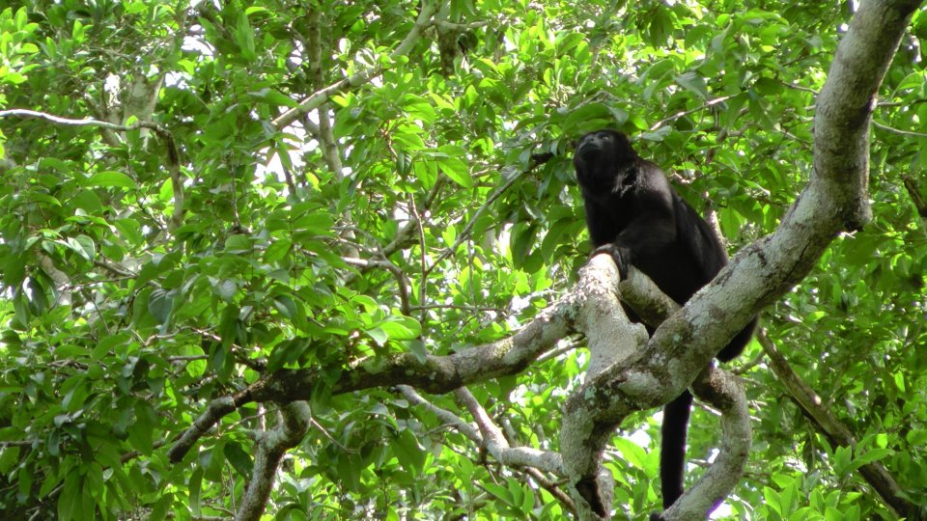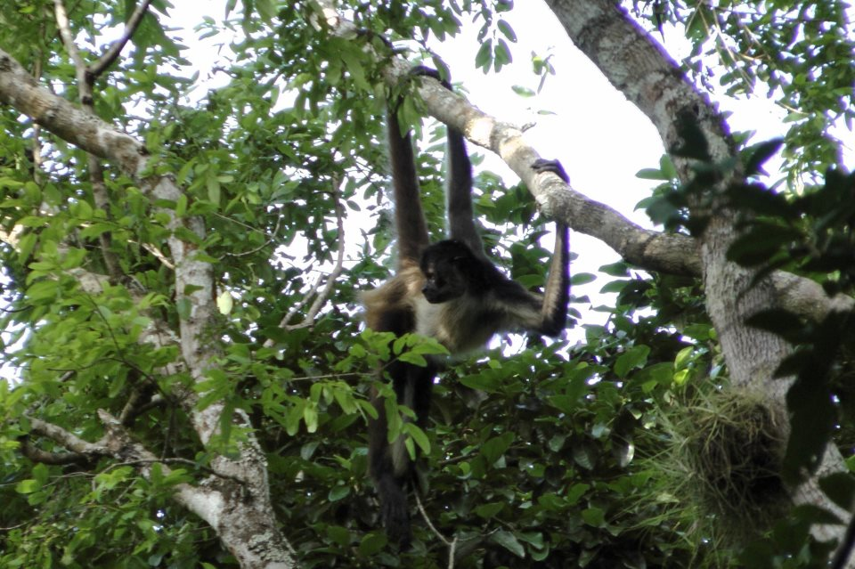

The two different primate species: black howler monkey (left) and spider monkey (right)

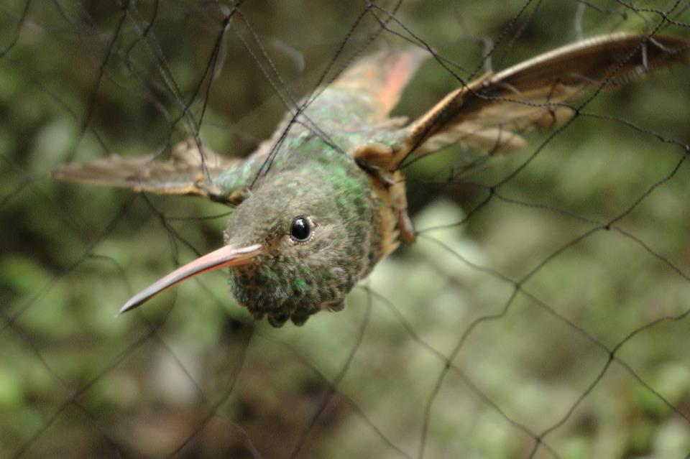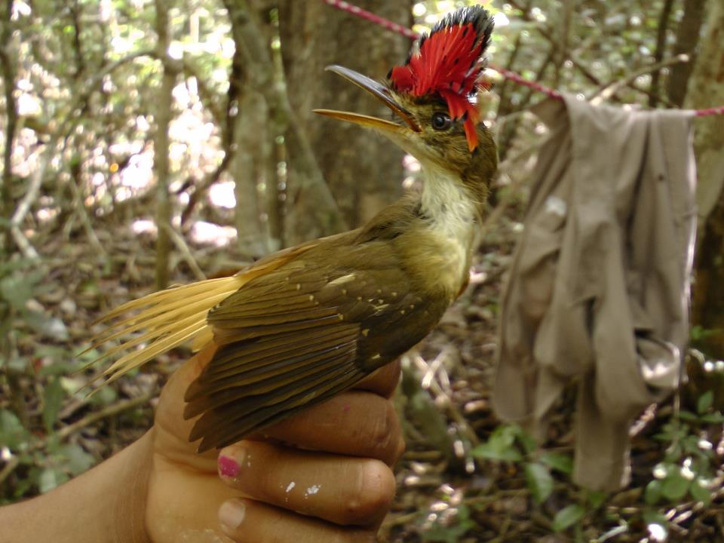

The cinnamon hummingbird (left) and the royal flycatcher (right), both caught by mist-netting

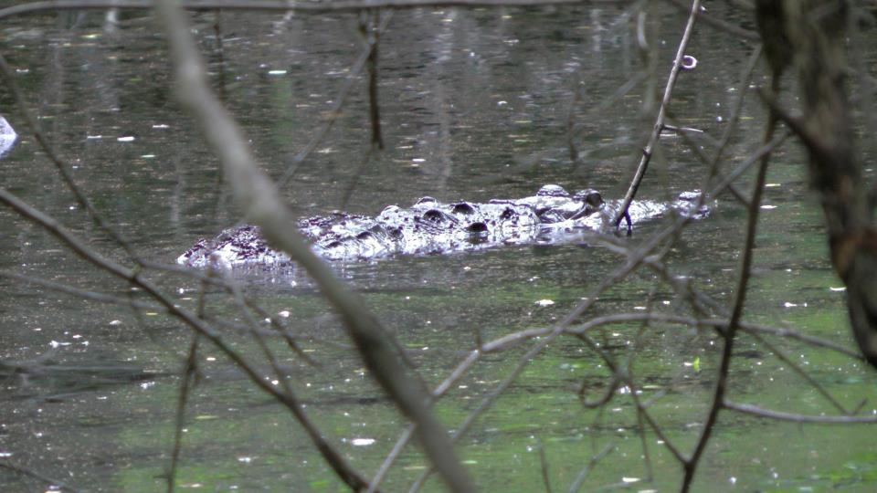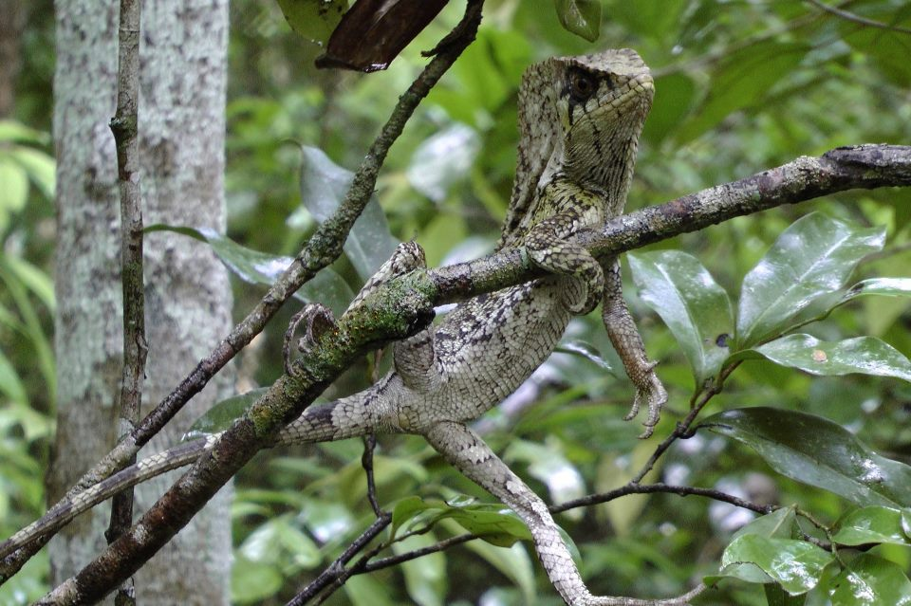

A helmeted basilisk (left) and the best photo of a Morelet's crocodile in the wild you will ever see (right)

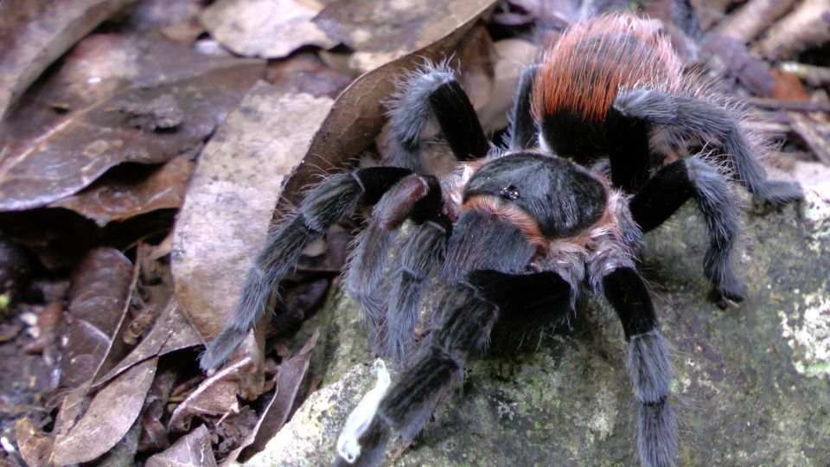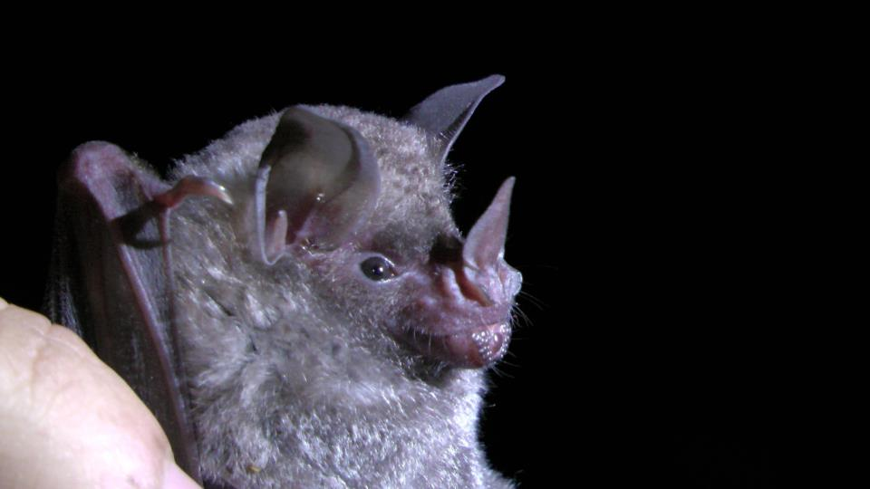

A short-tailed leaf-nosed bat (left) and a red rump tarantula (right)

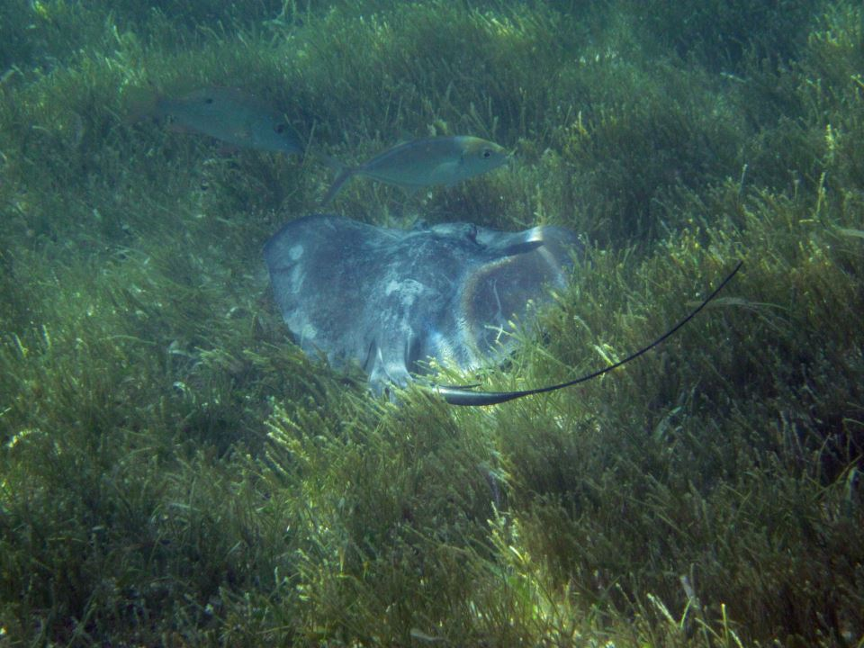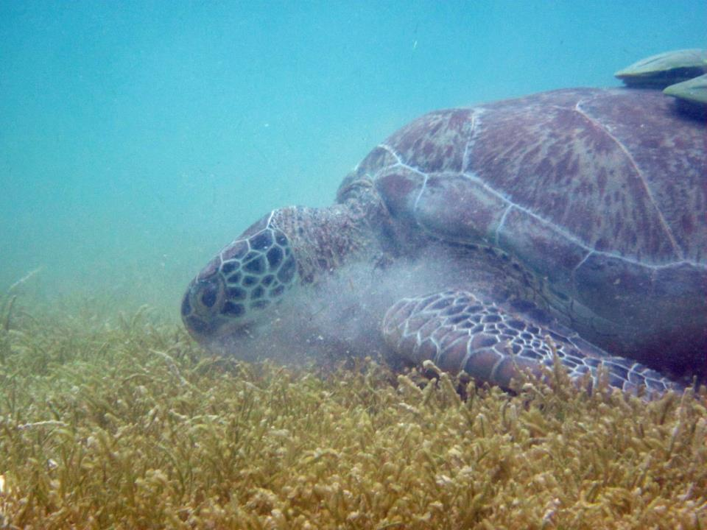

A green turtle feeding on seagrass (left) and a stingray filtering through sand (right)