REPORT ON EXPEDITION/PROJECT/CONFERENCE

Expedition/Project/ Conference Title: | Volunteer Coordinator for the Orangutan Tropical Peatland Project
Travel Dates: | 7th July – 28th August 2012
Location: | The Sabangau Forest, Central Kalimantan, Indonesia
Group member(s): | Sara Anne Thornton
Aims: | To work as a volunteer coordinator for the Project’s summer
 | volunteer programme.
OUTCOME (not less than 300 words):-

The Orangutan Tropical Peatland Project is based in the Sabangau Forest in Central Kalimantan, Indonesia. It works to protect the vital habitat of the peat-swamp forest which is inhabited by several endangered and endemic species such as the impressive Bornean Orangutan (Pongo pygmaeus) and agile gibbons (Hylobates albibarbis). It carries out vital forestry and ecological research which is vital in understanding the forest structure and systems. The volunteer programme has been running since 2001 and is vital in collecting the quantities of data needed for effecting monitoring and conservation of the area. It furthermore provides employment and financial benefits for the local community – helping to replace illegal logging as the main source of income in the northern Sabangau Forest.

The first time I was in Borneo, working for the Orangutan Tropical Peatland Project (OuTrop), was the summer of 2011 where I worked as a volunteer. This experience was a truly unique one, which opened my eyes to conservation issues and projects in Indonesia and on the island of Borneo. It sparked my interest in conservation in this area, and through the following year I used every university assignment I could to increase my knowledge on the various aspects of biodiversity conservation in Indonesian Borneo. In the winter of 2011, I furthermore received a wonderful email from OuTrop, asking if I would be interested in working as a volunteer coordinator the following summer. It was an opportunity I could not miss, and so I began preparing my next trip to Indonesia.

Being in my third year of University however, I found myself unable to work as many hours part-time as I had in all my previous years to help fund my practical ecology experiences. I have found, and still find that my volunteer work is vital for me to gain work experience as an ecologist, and will be priceless once I graduate as I aim to move directly onto a PhD. Therefore, the James Rennie Bequest was once again extremely helpful in allowing me to travel to Indonesia.

This year, the experience was to be very different from my previous year as a volunteer. Now it was my turn to, along with one other volunteer coordinator, be responsible for organising, guiding and making sure that all research protocols were met, for 8 volunteers from different countries: the UK, Canada, Ireland and Singapore. We had three undergraduate theses which were worked on, gathering data regarding butterfly abundances, looking at understory plant species, and tree traits. Most of our days were therefore split working on these projects, with some opportunities of orang-utan, gibbon and red langur follows.

Every year I write in my reports that the experience was a life-changing one. It is true, you learn so much with every experience that you always come back being slightly different to the person who left in the beginning of summer. But this experience had a huge effect on me. I came back with a greater self-confidence as I had been able to handle a situation which was very intimidating to me before the trip; I successfully completed my role as a volunteer coordinator, being in charge of an international group of people, in a foreign country where my Bahasa Indonesian language could only be described as basic. It was also a great experience of people management which takes a rather different meaning in a tropical country where field work can easily lead to fatigue, making teams very sensitive to tension. But we all had a fantastic experience, and we also got great feedback from all of the volunteers regarding their own experiences. I therefore came back feeling like I had successfully completed my task as a volunteer coordinator.

Working in a tropical environment can be physically and mentally challenging. The peat-swamp forest can be an unforgiving environment, but that is exactly what makes me love working in it. It lets me push my own limits and I always come back from the forest feeling accomplished. Every now and then, you also have fantastic animal-filled days which make working in the forest even more rewarding.

On one such day, I woke up at around 4am to join a red-langur follow. We walked into the dark forest and sat down by the tree which the monkeys had been reported to be sleeping in. Watching the forest wake up, with all its sounds and colours is an amazing experience and always makes the early rise worth it. To our dismay however, with the awaking of the monkeys in their sleeping tree, they had managed to escape us and had vanished into the trees without us noticing in which direction they had left. We therefore had to begin searching for them which is not always a straightforward task with the very timid langurs.

We were lucky that day, and splitting up into two groups walking in opposite directions, me and one of the Indonesian field assistants ran into the two langurs on one of the transects. I was looking at these beautiful red monkeys eating in a tree when a raucous caught our attention behind us. We quickly realised that we were in-between the pair of langurs to our left, and a group of gibbons moving quickly towards us to our right. The gibbons’ graceful swinging through the trees always makes me catch my breath, and you become entranced with their movements. But the langurs made their way deeper into the trees, and we followed, leaving the gibbons to move on without us.

The langurs eventually found a tree full of ripe fruit. As they can take a good while eating and resting in a tree, we all sat down for our own lunch. We suddenly heard dog-like sounds coming from the forest, as a group of macaques rushed right past us. A large male macaque jumped into my vision and looked straight at me with an intimidating stare before he lunged away once more. It seemed like the forest was unusually alive, with this being the third primate sighting of the day already! But we were still to realise the female orang-utan sitting above us in a tree popping open one fruit after another. That day I ate my lunch right beneath a female orang-utan eating hers – a memory which still makes me feel extremely privileged and fortunate to have experienced. We soon found that this female orang-utan was also carrying in her arms her newly born son. As our team that day was the first to see Indy’s son, we were given the honour to name him Icarus.

While the two month experience was filled with fantastic days and moments such as the one I have briefly described, there are always a couple which you walk away treasuring the most. I will always remember the people I worked with who all inspire me, seeing the sun rise above the canopy of the jungle sitting high up on the weather tower, and watching the large male orang-utan eating termites on the forest floor. These are all what make working in the challenging environment of a peat-swamp forest worth it. In Borneo I was also able to meet a professor with whom, along with OuTrop, I am now working with developing possibly my future PhD. If I hadn’t been at the base camp this summer, I would not have had such a great opportunity. I cannot thank the trustees of the James Rennie Bequest enough for their consideration and support. The James Rennie Bequest has helped shape my future career as an ecologist, and I will always be truly grateful for its contribution to my experiences.

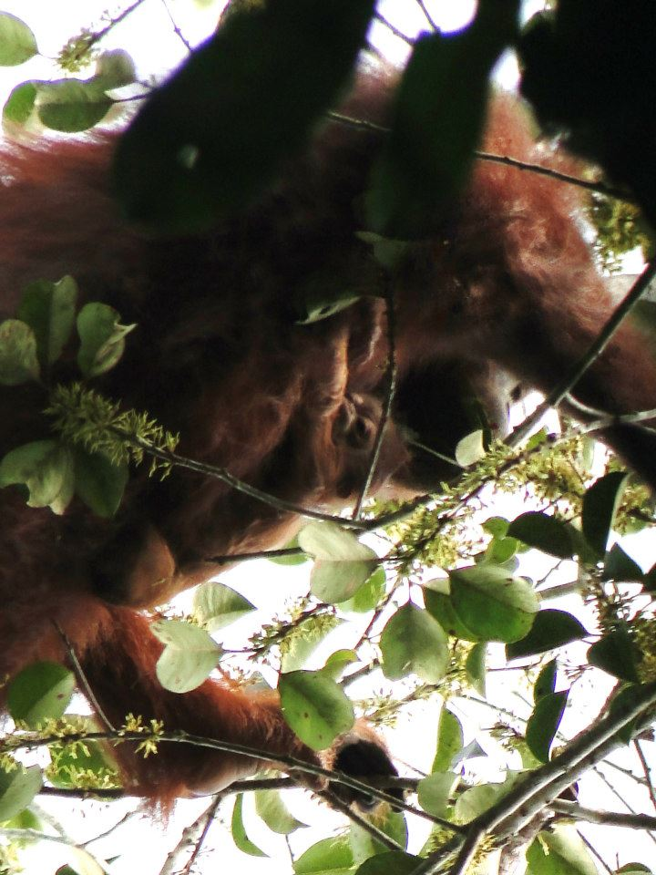
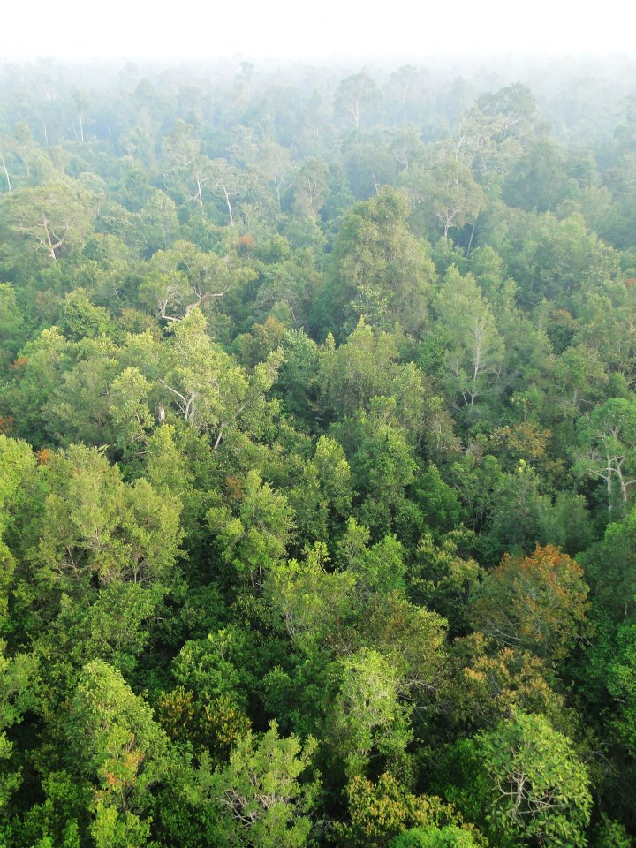
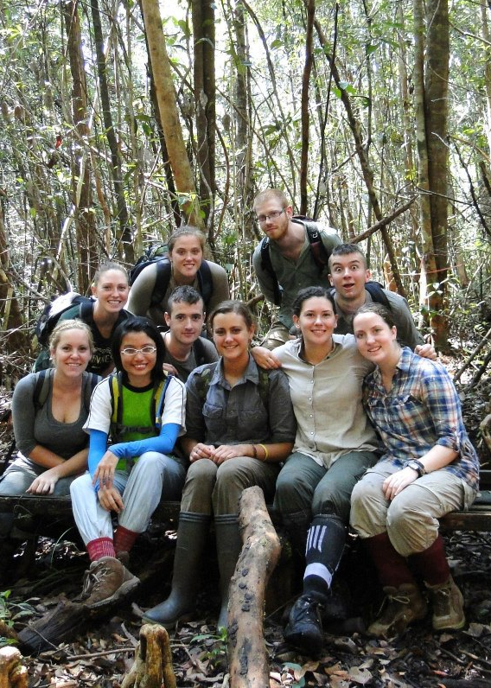
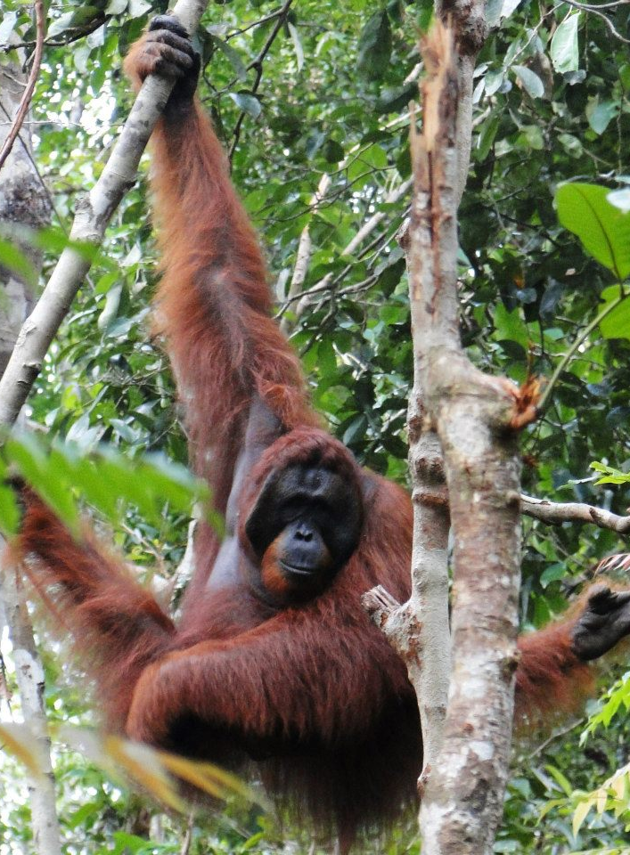
Top L: Indy carrying her new born son Icarus
Top R: Looking over the canopy of the forest from the weather tower
Bottom L: A large male orang-utan at Tanjung Puting National Park
Bottom R: Me (bottom far right) with the other volunteer coordinator and the volunteers!

