**REPORT ON EXPEDITION/PROJECT/CONFERENCE**

|  |  |
| --- | --- |
| **Expedition/Project/ Conference Title:** | Conservation expedition in Honduras |
| **Travel Dates:** | 18th June- 19th July |
| **Location:** | Honduras |
| **Group member(s):** | Fanni Daniella Szakal |
| **Aims:** | Assisting the conservation of Honduran cloud forests, and coral reefs. |
|  |  |
|  |  |
| **OUTCOME (not less than 300 words):-** | |

This summer I spent four weeks in Honduras with Operation Wallacea. It was an utterly amazing experience that I will never forget. I have learnt important techniques of biodiversity sampling, met scientists and fellow students from all around the world, and I was able to contribute to saving the rich ecosystems of Cusuco National park.

The expedition started on the 19th of June, in a hotel in San Pedro Sula. The journey to the cloud forest took several hours, and several different vehicles. The base camp is situated above 1700 metres. The air is extremely humid, and it is quite dark under the trees. We could hear the sound of birds and other organisms in the rich forest as we mounted higher.

In the first part of the first week we completed an ecology course about the national park, and learnt important sampling techniques. In the second part of the week we were taken away on a 3-day-long jungle training course. We had to bring all our belongings, food, pots, hammocks, and other necessary equipment in our backpacks. We were trekking in the forest for 4-5 hours, usually uphill, so our new camp was above 2100 m elevation. Here we had to set up the hammocks, try to light a fire, and cook dinner. It was something I had never done before. I have to say, despite of the cold and the mosquitoes, falling asleep to the sound of nearby monkeys was an amazing experience. The next day we packed up and went to another camp, this time going downhill. This resulted in most people sliding down the hill and getting completely dirty, but we enjoyed it.

The second week I was able to take part in the research projects. We had the option to sign up to different activities, for example I went out with the bird group doing point counts and mist netting. One of my favourite moments of the trip was when I was able to release a hummingbird back into the wild after taking its measurements for research. I also went out with the herpetology group. We were catching frogs, and taking samples to test for the presence of the chytrid fungus which is threatening local frog populations. Later I was also able to complete a DNA course, where we could test for chytrid fungi by PCR.

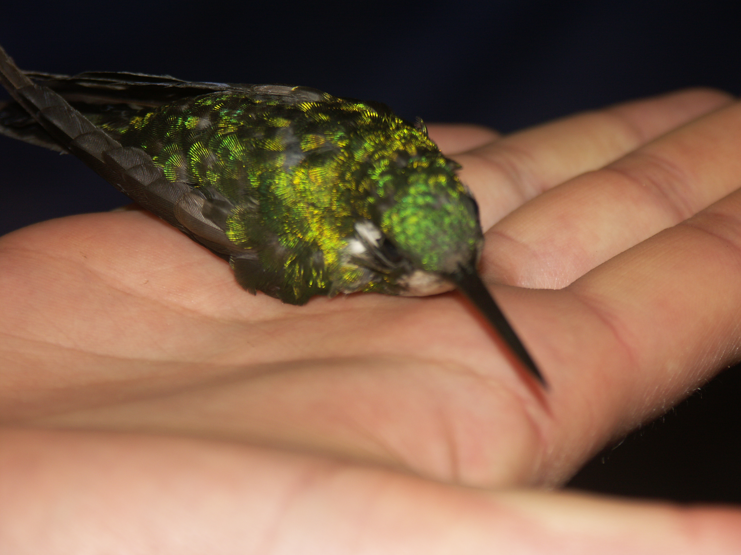

In the second part of the expedition, I was transferred to the marine site. The camp was on Cayo Menor, which is one of the Bay Islands. The island itself was restricted to researchers only, tourists were not allowed to come to the island, or to dive there. The effect was amazing. The land animals, such as iguanas, were not afraid of humans, and we could observe them easily. In the two weeks that I spent here I leant to dive, and I completed a reef ecology course where we have learnt the names of corals, algae, fish, and invertebrates common in the Carribean Sea. It was really satisfying to be able to identify what I was seeing while under water.

I was also able to assist the terrestrial research on the island. There is an endemic species of boa here, the Hog island boa. They have a beautiful pink colouration as babies, and once handled for a while, they become absolutely docile. We were taking measurements to assess the population, and pit tagging to identify recaptures. Unfortunately the research has shown that with the extinction of larger mammals in the island the boa populations are decreasing. We have found a couple of individuals which were too thin to have enough energy to digest a bigger meal.

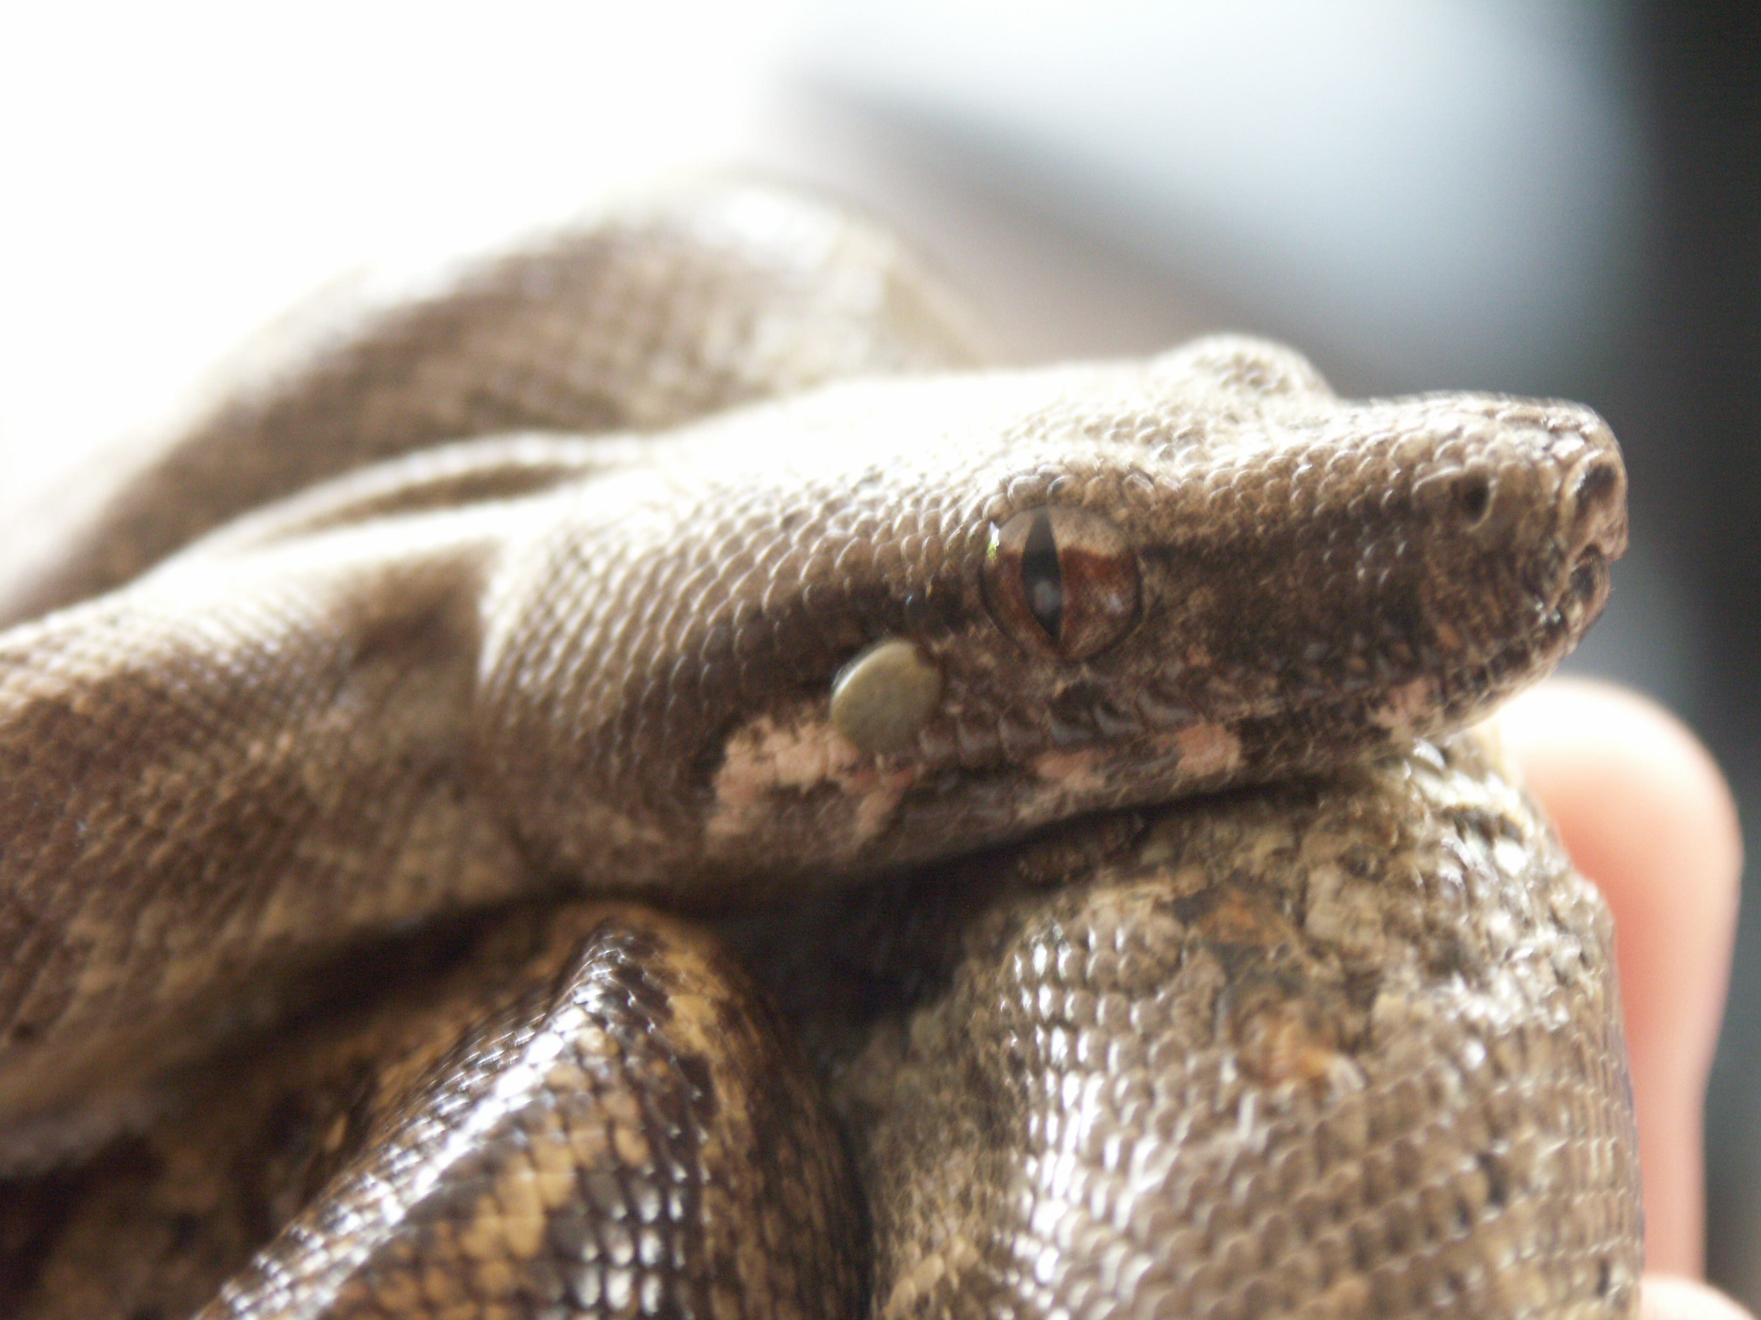

Overall, this was an amazing experience, and I would like to thank James Rennie Bequest for the contribution which enabled me to go. I got a much clearer idea of what conservation research is, which have provided me with some guidance of what I would like to do in the future.

Fanni Daniella Szakal

19/09/2013