JAMES RENNIE BEQUEST

REPORT ON EXPEDITION/PROJECT/CONFERENCE

Expedition/Project/Conference Title: 5th ASM Conference on Biofilms

Travel Dates: 12-24th November 2009

Location: Cancun, Mexico

Group Member(s): Sarah Spragg

Aims: To attend and present a poster at the 5th ASM Conference on Biofilms

OUTCOME (not less than 300 words):-

The 5th Biofilm conference of the American Society of Microbiology (ASM)) was held in at the Hilton Hotel in Cancun, Mexico during November of 2009. This conference is held approximately every three years and as such was my only chance to attend during my Ph.D. The stunning location provided a wonderful backdrop to a great conference.

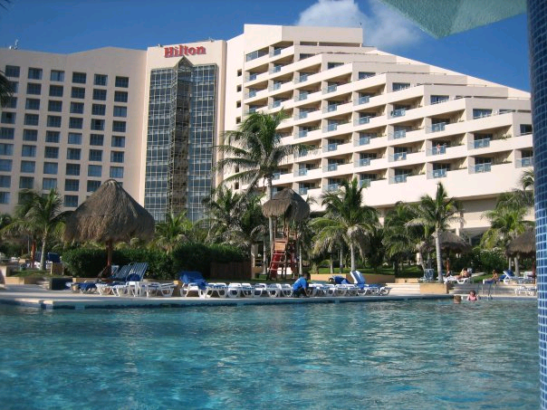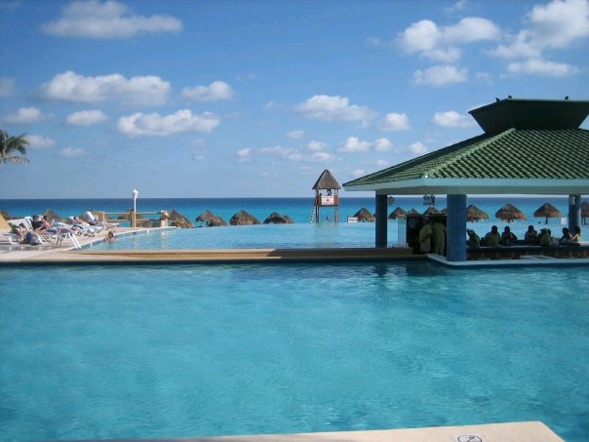

Biofilms are communities of bacteria attached to surfaces and interfaces and are believed account for 99% of bacteria within environments. Biofilms are extremely difficult to eradicate and treatment with antibiotics or antimicrobial agents frequently fails to either sterilise or remove the biofilm. Therefore the opportunity to attend an international conference, to discuss differences in biofilm formation and treatment in both industrial and medical situations was fascinating.

The conference kicked off with a practical workshop, specializing in standardizing methods for biofilm research. The workshop included interesting sessions on biofilm formation, antimicrobial treatment and analysis, all of which were directly relevant to my studies. I also had the opportunity to ask the workshop organisers questions informally about issues arising with my work. This has led me to change my experimental protocols and the subsequent analysis in my thesis.

After the workshop sessions, it was time for the 5th conference to begin. The speakers provided a comprehensive program of seminars gave an in-depth history of biofilm research as well as insights into future areas of study. However, one of the most useful parts of this conference was the opportunity to present my own work in one of three poster sessions. My poster was one of 297 presented during the afternoon sessions and the refreshments provided produced an informal atmosphere. This was an ideal environment to mix with some of the key players in the fields of biofilm research and gain valuable suggestions and comments about my work. During these sessions I also managed to speak to other researchers and find out about novel research prior to publication.

On the final evening of the conference, a banquet was organised to provide a chance to socialise with other delegates. This was set up in the lush gardens of the hotel during the balmy evenings, allowing us to dance under the stars. During this event I met a number of colourful characters, some of which I am corresponding with since my return.

The conference timetable was packed into just 4 days, which left limited time for exploration. However, I extended my stay to allow me to experience this wonderful country. One of the most fascinating sights was the ancient ruins at Chichen Itza, one of the New Seven Wonders of the World.

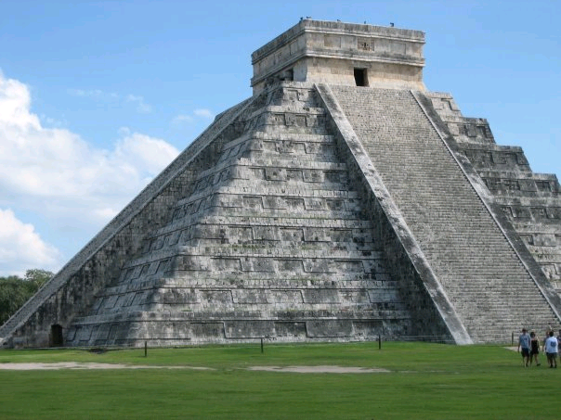

I would like to express my thanks to the James Rennie Bequest for awarding me funding towards my travel costs to Mexico. This allowed me to attend this fantastic conference and present my work to a group of highly respected scientists. I feel that this experience will help greatly as I write-up my Ph.D. as well as in my future scientific career.

