JAMES RENNIE BEQUEST

REPORT ON EXPEDITION/PROJECT/CONFERENCE

Expedition/Project/Conference Title: volunteer work at the Centre for Dolphin Studies

Travel Dates: 27th July – 17th September 2008

Location: Plettenberg Bay, South Africa

Group Member(s): Jennifer Scholefield

Aims: To experience and conduct marine mammal research first-hand, gain conservation knowledge and knowledge on marine mammals in general, and to satisfy a life-long aim to discover more about these animals and spread this knowledge to younger generations to enable the continuation and improvement of conservation practices.

OUTCOME (not less than 300 words):-

Centre for Dolphin Studies, Plettenberg Bay, South Africa
July-September 2008
By Jennifer Scholefield.

As I return to university life in Edinburgh, my summer activities fade away until it seems as though they must have been a dream. It has been a life-long passion for me to see whales and dolphins up close and doing volunteer work at the Centre for Dolphin Studies certainly gave me that and much more!

The Centre for Dolphin Studies (CDS) is a marine mammal research institute based in Plettenberg Bay in South Africa but with interests all over Africa and around the world. Continuous research is managed both locally and abroad by the organisers Dr Vic Cockcroft and Dr Debbie Young who supervise a team of post-graduate students in various locations and are aided in Plettenberg Bay by up to 10 marine mammal enthusiasts - the volunteers! I joined the team for 5 weeks during which time I was kept occupied by a wide variety of tasks from photo identification and collecting data on whale or dolphin sightings to scrubbing bones and other less appealing jobs.

As a result of close links with Ocean Safaris, a local whale-watching business, we were able to go out on the tourist boats whenever there was space. This enabled us to collect data on the abundance, behaviour and GPS location of the marine mammals as well as recording any changes in movement or behaviour due to the presence of the boat. I found that some of the whales were very curious and would swim right up to the boat to have a look. These experiences were just incredible but in fact it was more rewarding to watch the whales’ behaviour from a distance as this way their agile movements and interactions could be seen. The vast majority of whales that were seen during my time at the CDS were Southern Right Whales (Fig 1) that come into sheltered bays along the South African coast to mate and give birth.

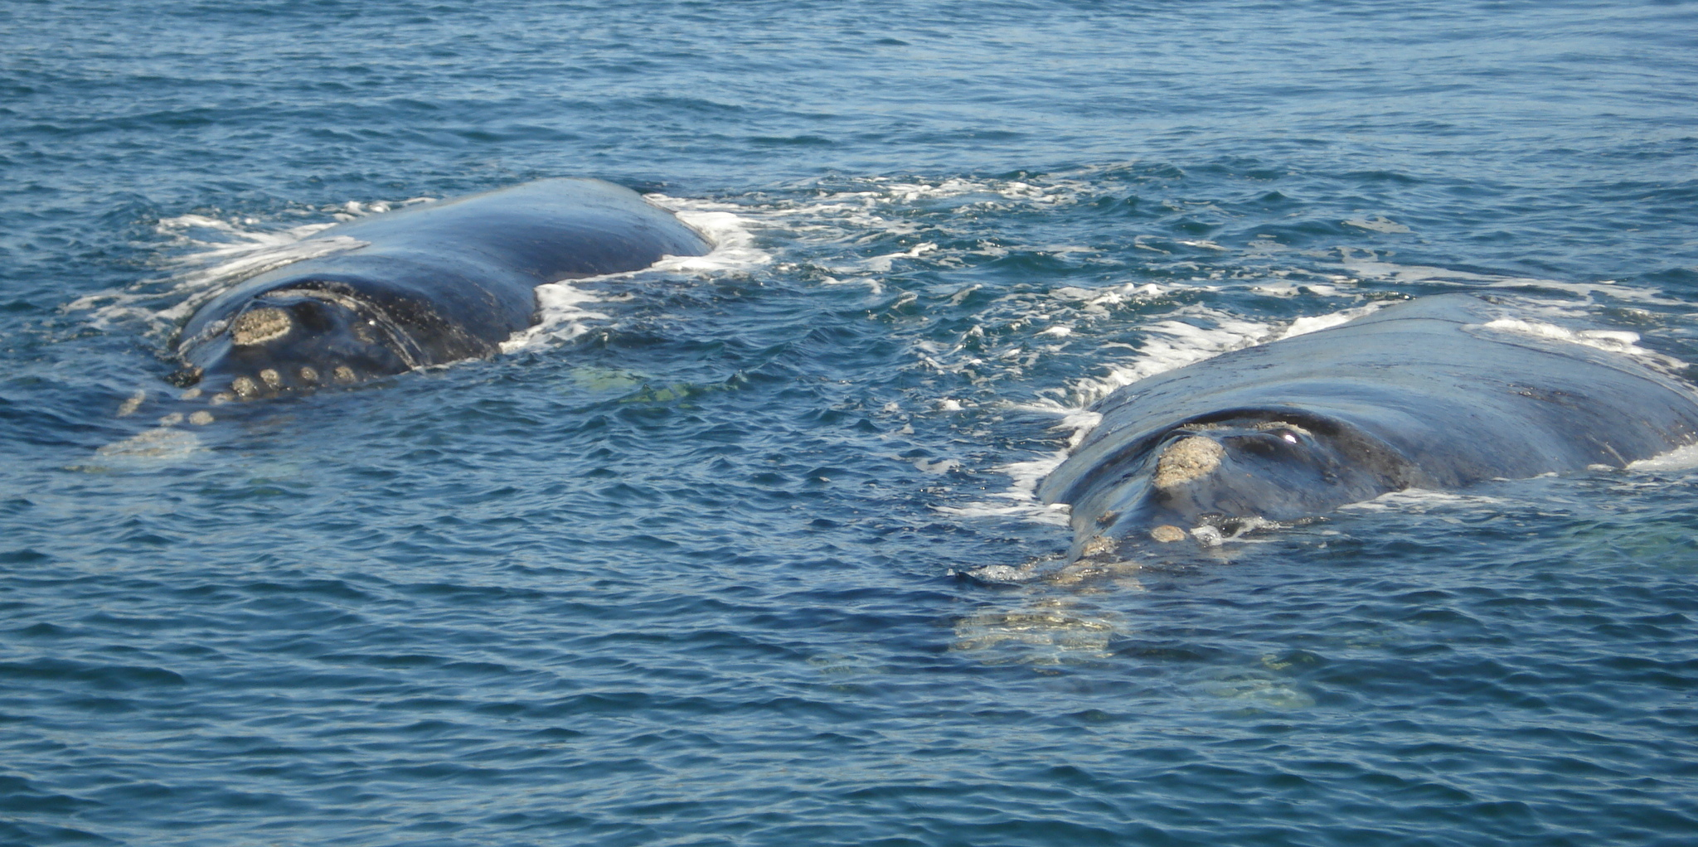
Figure 1: Two huge Southern Right Whales make their way towards the boat. The colossities on the head are clearly visible and therefore easy to use for identification.

This species of whale is docile and curious and can be found just behind the breakers very close to shore. For this reason they were hunted extensively in the past but numbers are thought to be slowly recovering. I was also very lucky to see Humpback Whales making their long migration to the Antarctic from warmer Mozambiquan waters and to talk to Aaron Banks a PhD student studying their migration dynamics.

Time in the office was given largely to photo identification of Bottlenose and Humpback Dolphins and Humpback Whales. Each time creatures are seen, photos are taken of their dorsal fins and, for the Humpback Whales, their tails. Apart from the very young animals, the majority of them have individual markings, scars and notches on their fin enabling us to categorise them and match them to previous sightings. This mark and recapture method allows the CDS to get an idea of the population of animals in the area which provides an important starting point for research and conservation work. Whilst I was there a similar catalogue was being prepared for Southern Right Whales, using the colossities (white bumps on the head) for ID.

There was also a course for volunteers on general marine mammal biology in which I, being a Zoology student, thoroughly enjoyed learning as much as I could in the time given. We covered diversity, evolution, physiology and anatomy and ended with the dissection of a seal pup that had been found dead on the beach. This individual hands-on experience is not something that happens much at university so was a great opportunity for me. Another way to gain knowledge was in the weekly Q & A sessions where everyone contributed and researched a question about any aspect of marine life from whaling laws to penguin communication. This led to passionate discussions about possible ways to go about conserving marine mammals and exchanging ideas between people from all walks of life and different cultures meant that we all learnt more as a result.

One of the most memorable days was when we visited a local school and played games (with an ocean theme) with the children. These ranged from simple memory and card games, to arts and crafts, to obstacle courses set up in the school playground that involved children wearing a dorsal fin and following a humpback whale migration route. It often turned out that they knew more than we did about marine mammals! For me, educating the next generation about the ocean and its wonderful animals is a big step towards increasing awareness of the dangers that face many marine species as a result of anthropological influence and what can be done to improve the situation.

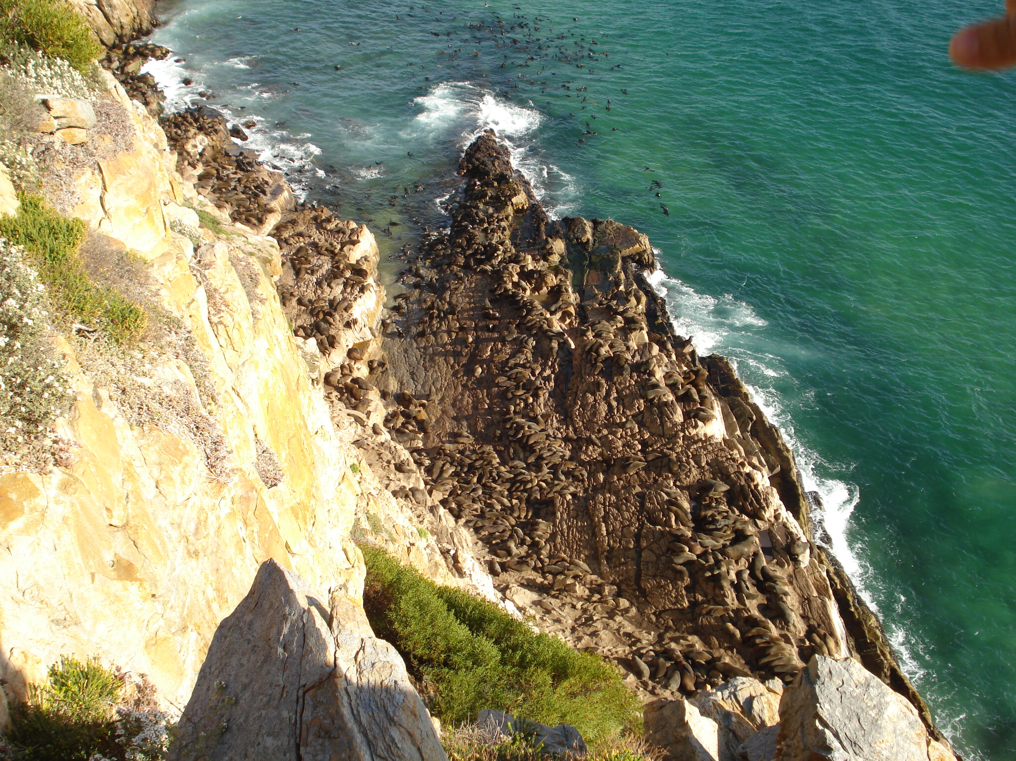
Another activity I looked forward to was the fortnightly walks to the Cape Fur Seal colony at Robberg just outside Plettenberg Bay (Fig 2). Robberg is a peninsular jutting out from the mainland and is a wonderful example of the beauty of the South African coastline.

Figure 2: looking down on the cape fur seal colony at Robberg.

We would conduct a rather challenging seal count of the ~4000 strong colony before picking our way down the cliff to collect ‘scats’ (better known as seal faeces). These were then taken back to the farm where we sorted through them picking out otoliths (fish ear bones) which were then identified (each fish species has a unique shaped otolith), counted and measured. This process was by far the least enjoyable for many of the volunteers however the data goes towards an ever-growing study on the diet of cape fur seals. The seals come into conflict with fishermen in the area who claim that they deplete economically important fish stocks and therefore feel the seal population should be kept at low numbers. However the data, which has been collected for some years now, indicates that seals consume a highly varied diet including many species of which are not valuable to man. The Cape Fur Seal used to inhabit much of the coastline of Southern African and Namibia however their numbers were severely depleted in early colonial times. Although they are abundant in certain locations, their numbers are still low and as they form a significant link in the coastal food chain, they need to be protected.

Weekends were spent enjoying the many activities that this area of South Africa has to offer. These included walking through the lovely native forests of Tsitsikamma National Park, visiting Monkeyland and Lawnwood Snake Sanctuary, cycling the historic Montagu Pass and visiting the rescued elephants that lived opposite the volunteer house. I also used this opportunity to return to Zimbabwe where I was born and lived until I was 16. I was lucky enough to go on a canoeing safari on the Zambezi River through the incredible Mana Pools area where human impact is thankfully remote. It was a real privilege to visit such a place, learn so much about the animals and plants found there and experience the wonderful peace of the African bush. I will not forget it for a long time.

I would like to thank the patrons of the James Rennie Bequest for allowing me this awesome opportunity. It enabled me to be exposed to marine mammal research, learn about animals I have always had a passion for, and develop both scientific and personal skills that I know will benefit me in the future. I am truly grateful.

Reference:
Centre for Dolphin Studies website – www.dolphinstudies.co.za

