DAVIS EXPEDITION FUND

REPORT ON EXPEDITION/PROJECT

Expedition/Project Title: Taxonomy and phylogeny of Sphaerocarpos

Travel Dates: 15 March -30 March 2008

Location: California.

Group Members: Daniela Schill

Aims: collection of Sphaerocarpos specimens for monographic work and molecular study

OUTCOME (not less than 300 words):- see attached report

Final Report for the Peter Davis Expedition Fund

Taxonomy and phylogeny of Sphaerocarpos
Daniela Schill, 13 July 2008

Introduction Traditionally the Sphaerocarpales (Bottle Liverworts) have been treated as a distinct order within the Liverworts (Marchantiophyta). They are a small group, consisting of less than 30 species in three genera Geothallus, Sphaerocarpos and Riella. All display very unusual and highly reduced gametophyte morphology, but share the unique feature of enclosing gametangia (antheridia and archegonia) in flask-shaped bottles borne on a highly reduced thallus. All are adapted to extreme climates such as hot arid regions and seasonal lakes and pools. A feature they share with the Marchantiales (Complex Thalloids) is the highly ornamented spore sculpturing unlike the Leafy and Simple Thalloid liverworts. For this reason they have traditionally been classified next to but separate from the Complex Thalloids, though the thallus morphology is quite similar to that of some Simple Thalloids such as Petalophyllum and Fossombronia. These somewhat conflicting signals have led to long-standing controversy and doubts about the relationships of Sphaerocarpales to other liverworts.
Plants in the genus Sphaerocarpos are specially adapted to transient habitats in warmer areas of Mediterranean type climates. The plants are short-lived annuals, showing a rapid life cycle and having large durable spores. A remarkable feature of the genus is the range of striking spore ornamentation patterns that are found for the individual species. California is a diversity hotspot for the order Sphaerocarpales: some species of Sphaerocarpos and also the very unusual monotypic related genus Geothallus can only be found in this part of the world.

Aims The purpose of the study is (a) to sort out the taxonomy of Sphaerocarpos, so that people can more easily identify the species, and (b) to try to work out how they evolved from related liverworts, especially the sister genera Geothallus and Riella.
In the field I will collect herbarium specimens of Sphaerocarpos, take digital photographs, collect samples in silica gel for DNA sequencing and collect ripe spores for study under the Scanning Electron microscope. All these genera have very complex patterns of spore ornamentation which may be useful in classifying them. Studying them in the field additionally enables other very useful data on ecology etc. to be recorded.

Field work schedule
17 March 2008: San Diego County
18 -19 March: Riverside County
21-24 March: San Luis Obispo County
25 March: Monterey County
27-28 March: Contra Costa County, Alameda County

Results A total of 27 Sphaerocarpos specimens were collected and the herbarium vouchers were deposited at E. For the list of collected Sphaerocarpos specimens see Appendix. Plants were commonly found on damp bare soil, banks next to footpaths or close to shrubland.
Silica dried material was collected for ten samples of Sphaerocarpos and will be used for DNA sequencing of two chloroplast regions. The results of the phylogenetic analyses of these samples will increase the number of Sphaerocarpos specimens and so contribute to a broader study of the genus. The samples will be used to work out the phylogenetic relationships of the species within the genus and classification. Furthermore the similarity between the American and European S. texanus can be clarified through the phylogenetic analysis.
Further work in the herbarium will be carried out to identify specimens and spores will be studied under the SEM to confirm identification. The results from the morphological and molecular work will be compared. Observations made in the field were useful for a better understanding of the habitat preference and ecology of these plants.

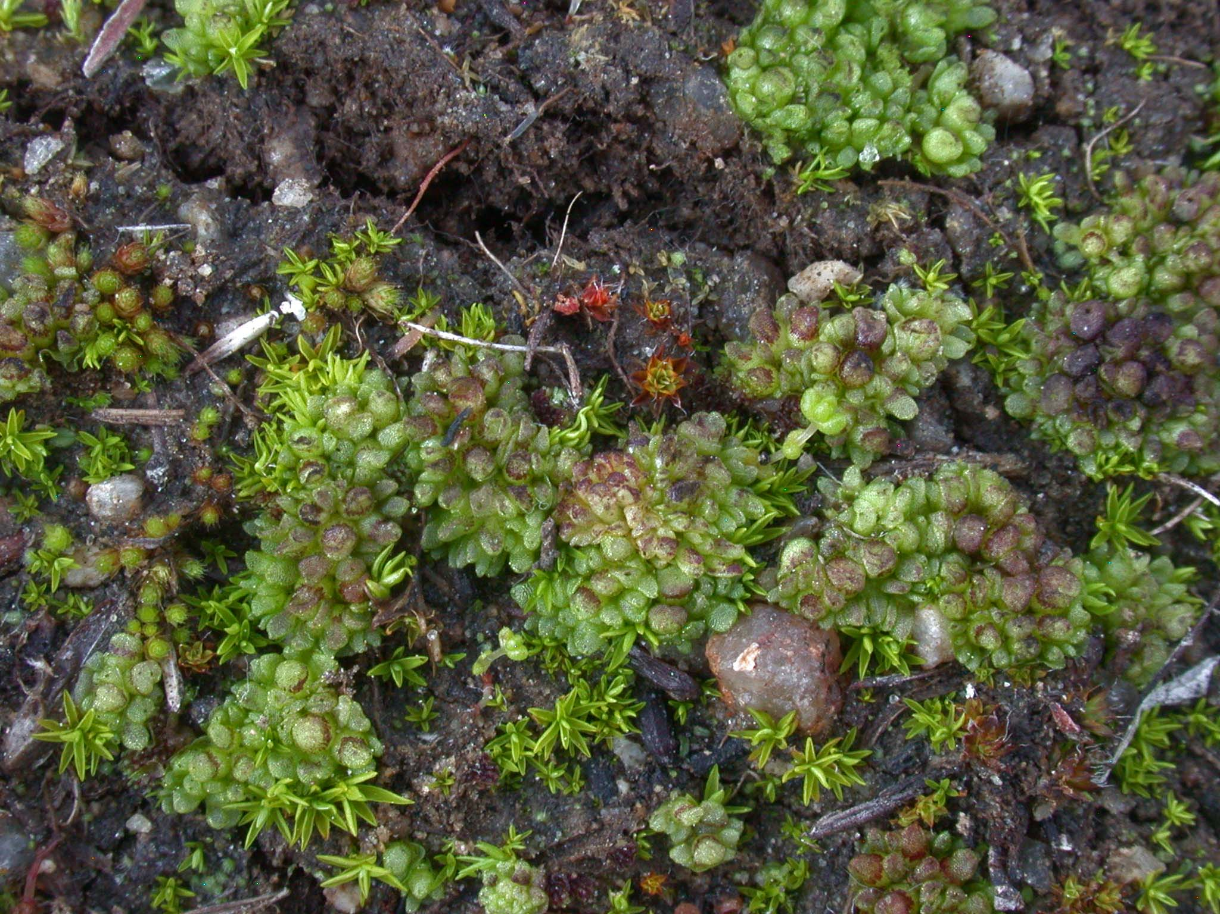
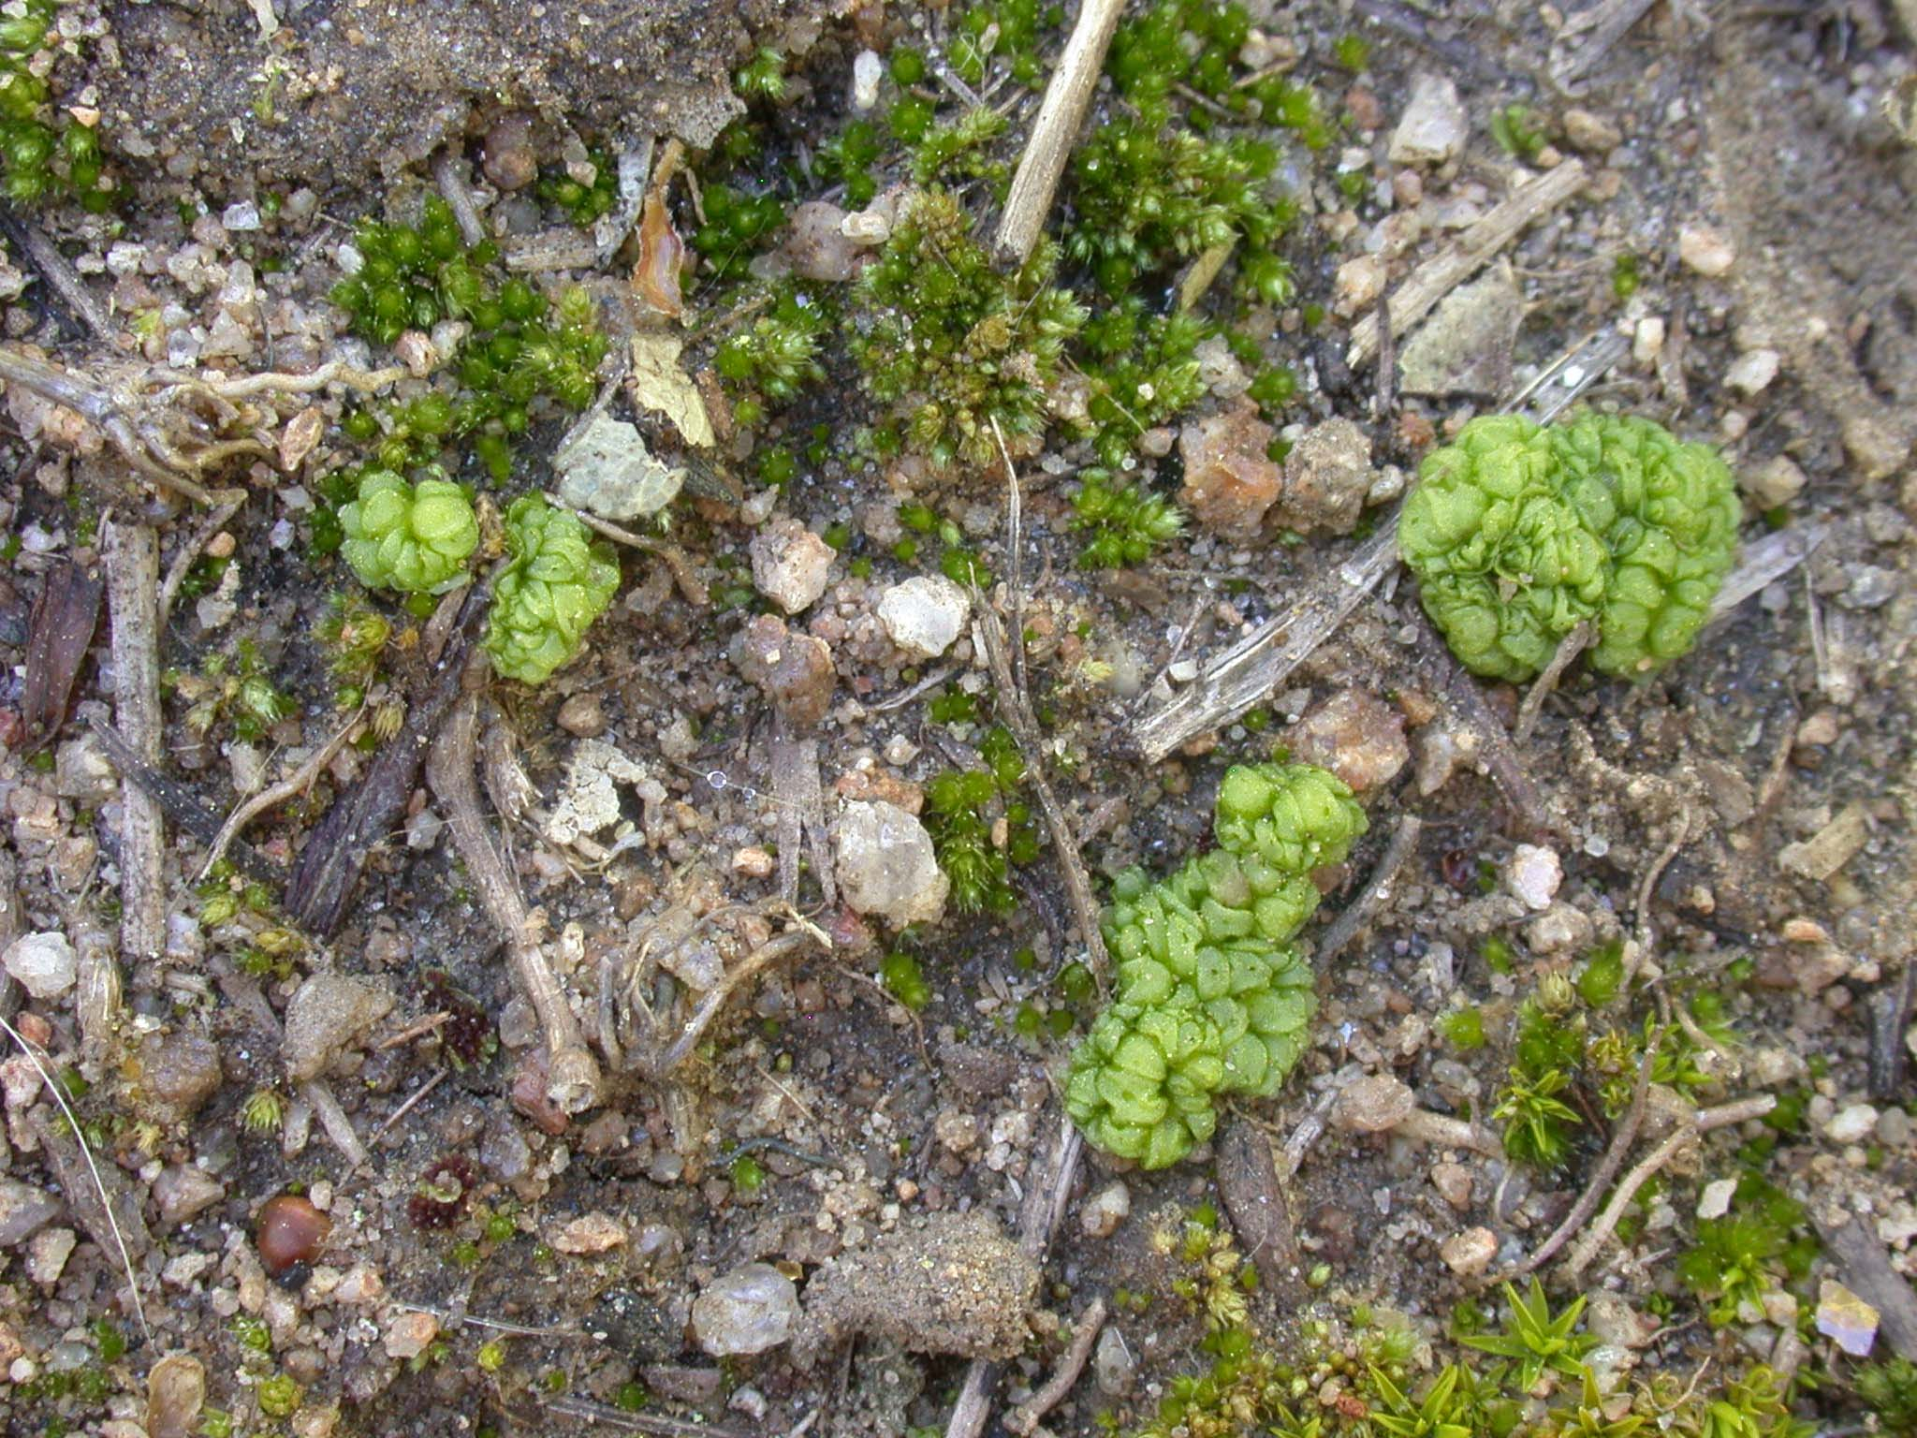
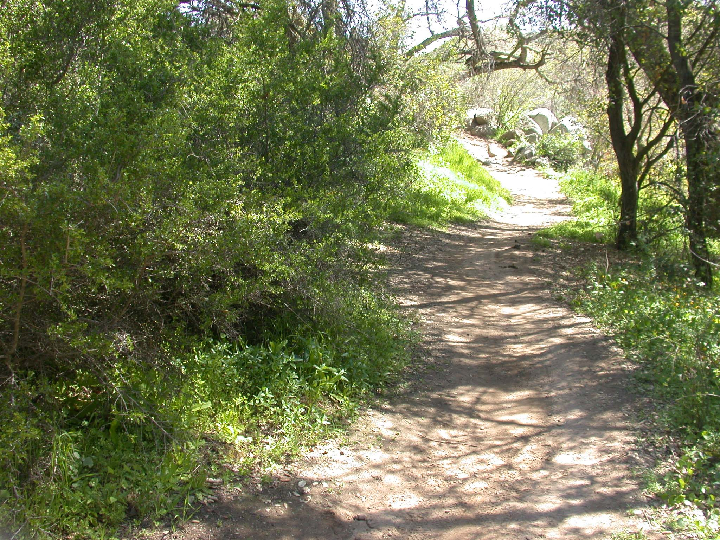
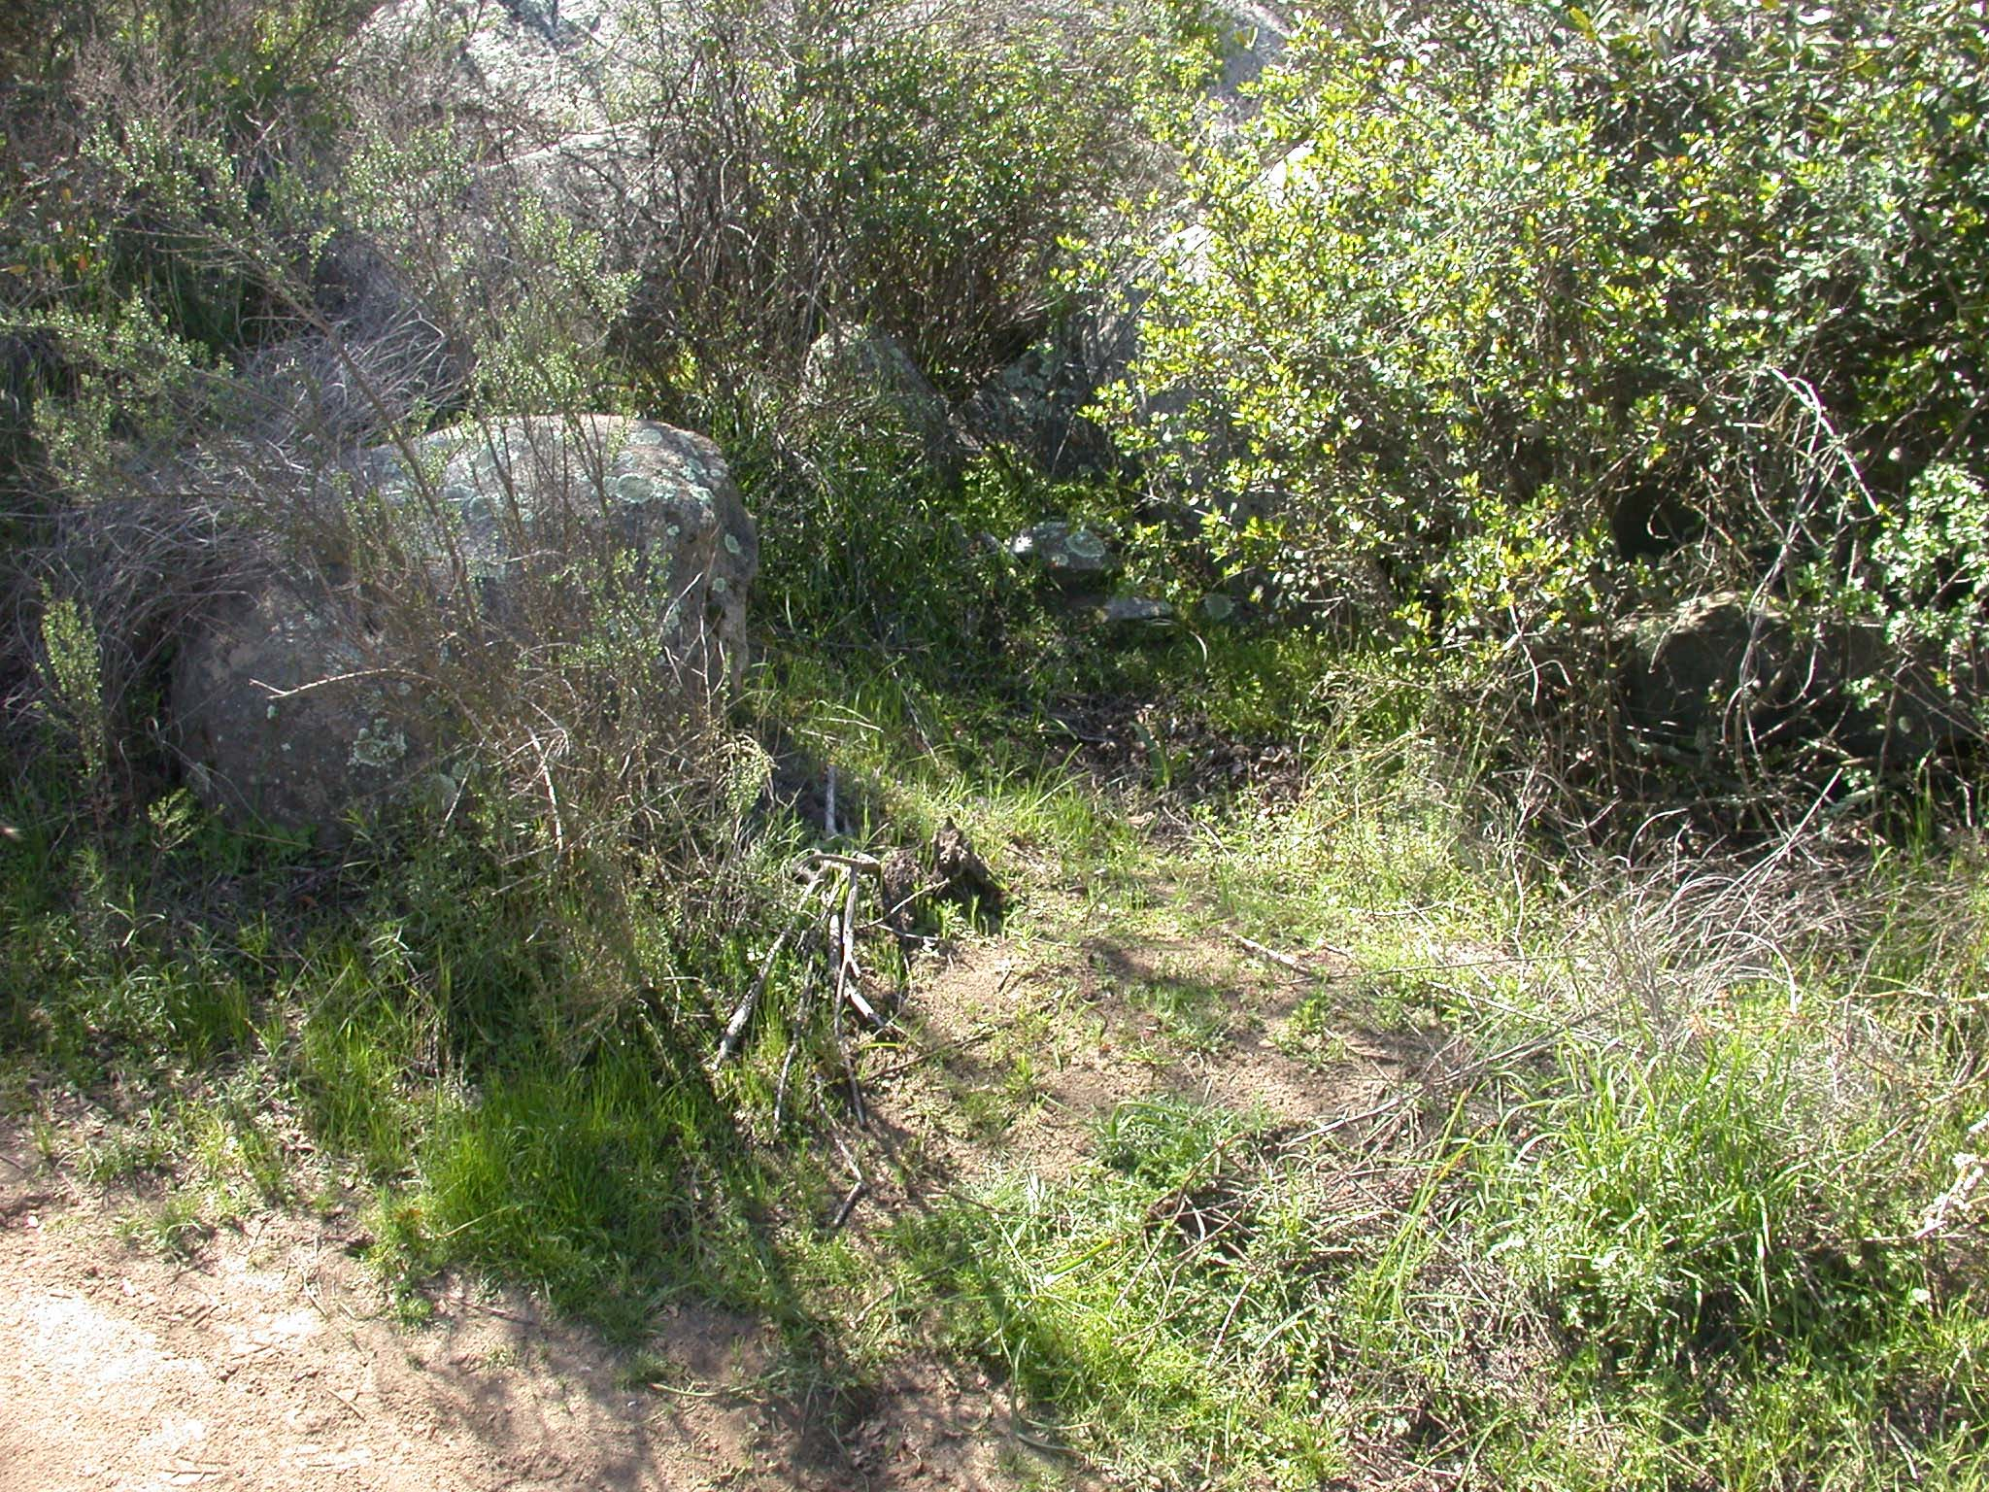
A
B
D
C

Figure 1. A Plants of Sphaerocarpos drewei; B Plants of Sphaerocarpos spec.; C, D Habitat pictures, arrows indicating location of collected plants

Conclusion This research on Sphaerocarpos is part of a postdoctoral research project and will contribute greatly towards the publication of a worldwide monograph on Sphaerocarpos. The DNA samples collected for phylogenetic work will also give a clearer picture of the relationships between the different species of Sphaerocarpos.

Acknowledgements I thank Jim Shevock, National Park Service Research Coordinator, Berkeley for much help in providing me with permits for the Californian State Parks and Carole Bell, Reserve Manager at Santa Rosa Plateau Ecological Reserve for issuing a collecting permit of liverworts in the Reserve. I am very grateful to Jim Clarke for much assistance in the field.

Appendix List of Sphaerocarpos specimens collected:

Sphaerocarpos drewei
California, San Diego County, San Diego, Old Otay Mesa Road, next to road, top of ravine, 32°33.8’N, 117°01.7’W, on ground, 17 iii 2008, D.B.Schill & J.Clarke 198B (E); Riverside County, Santa Rosa Plateau Ecological Reserve, Torino Trail, at edge of path, shaded by trees, 556m, 33°32’10.4’’N, 117°16’30.1’’W, on damp bare soil, 19 iii 2008, D.B.Schill & J.Clarke 221 (E)
Sphaerocarpos spec.
California, San Diego County, San Diego, end of Town Centre Drive, by artificial drainage channel, 92m, 32°53.13’N, 117°12.95’W, on ground in shrub, 17 iii 2008, D.B.Schill & J.Clarke 200 (E); Riverside County, Dripping Springs, Agua Tibia Wilderness, Dripping Springs Trail, next to trail, 494m, 33°27’25.4’’N, 116°58’16.2’’W, on ground, 18 iii 2008, D.B.Schill & J.Clarke 202 (E); Dripping Springs, Agua Tibia Wilderness, Dripping Springs Trail, 595m, 33°27’24.5’’N, 116°58’16.9’’W, on banks of footpath, 18 iii 2008, D.B.Schill & J.Clarke 203 (E); Dripping Springs, Agua Tibia Wilderness, Dripping Springs Trail, 513m, 33°27’23.8’’N, 116°58’17.0’’W, on banks at side of footpath, 18 iii 2008, D.B.Schill & J.Clarke 205 (E); Dripping Springs, Agua Tibia Wilderness, Dripping Springs Trail, next to trail, 406m, 33°27’22.7’’N, 116°58’18.4’’W, on bank, 18 iii 2008, D.B.Schill & J.Clarke 206 (E); Opposite Dugan Drive on Highway 79, on hillside with big boulders, next to scrub, ca. 511m, 33°26’54’’N, 116°58’34’’W, amongst grass on ground, 18 iii 2008, D.B.Schill & J.Clarke 207 (E); Opposite Dugan Drive on Highway 79, on hillside with big boulders, ca. 511m, 33°26’54’’N, 116°55’34’’W, amongst grass on ground of damp soily bank, 18 iii 2008, D.B.Schill & J.Clarke 208 (E); Santa Rosa Plateau Ecological Reserve, Tovashal Trail on west side of Clinton Keith Road from Visitor Centre, next to path, 552m, 33°32’35.3’’N, 117°16’18.8’’W, on shady soil close to scrub, 19 iii 2008, D.B.Schill & J.Clarke 210 (E); Santa Rosa Plateau Ecological Reserve, Tovashal Trail on west side of Clinton Keith Road from Visitor Centre, next to path, 548m, 33°32’35.6’’N, 117°16’20.2’’W, on soily bank close to scrub, 19 iii 2008, D.B.Schill & J.Clarke 212 (E); Santa Rosa Plateau Ecological Reserve, Tovashal Trail on west side of Clinton Keith Road from Visitor Centre, at edge of path, shaded by scrub and trees, 555m, 33°32’35.9’’N, 117°16’23.3’’W, on damp bare soil, 19 iii 2008, D.B.Schill & J.Clarke 213 (E); Santa Rosa Plateau Ecological Reserve, Tovashal Trail on west side of Clinton Keith Road from Visitor Centre, at edge of path, shaded by scrub and trees, 555m, 33°32’35.9’’N, 117°16’23.3’’W, on damp bare soil, 19 iii 2008, D.B.Schill & J.Clarke 214 (E); Santa Rosa Plateau Ecological Reserve, on Tovashal Trail on west side of Clinton Keith Road from Visitor Centre, at edge of path, shaded by trees, 552m, 33°32’24.6’’N, 117°16’42.4’’W, on damp soil, 19 iii 2008, D.B.Schill & J.Clarke 215 (E); Santa Rosa Plateau Ecological Reserve, beginning of Fenceline Trail, west of parking lots, at edge of path, shaded by rock, 566m, 33°31’38.2’’N, 117°17’03.8’’W, on damp soil, 19 iii 2008, D.B.Schill & J.Clarke 216 (E); Santa Rosa Plateau Ecological Reserve, Granite Loop Trail, at edge of path, shaded by trees, 527m, 33°32’39.7’’N, 117°16’06.8’’W, on damp bare soil, 19 iii 2008, D.B.Schill & J.Clarke 218 (E); Santa Rosa Plateau Ecological Reserve, Torino Trail, next to path, small open grassy area next to scrub, 543m, 33°32’25.2’’N, 117°16’19.5’’W, on grassy ground, 19 iii 2008, D.B.Schill & J.Clarke 222 (E); San Luis Obispo County, NE of Arroyo Grande, east end of Lopez Lake, on small rocky escarpment opposite Registration Station, next to footpath, ca. 153m, 35°11’23’’N, 120°27’28’’W, on slightly damp disturbed ground, 23 iii 2008, D.B.Schill & J.Clarke 223 (E); Montañas de Oro State Park, Reservoir Flats Trailhead out of campground, by trail, ca. 26m, 35°16’33.5’’N, 120°52’42.8’’W, on bare soil on vegetated bank, 23 iii 2008, D.B.Schill & J.Clarke 224 (E); Montañas de Oro State Park, Reservoir Flats Trailhead out of campground, at edge of path, ca. 26m, 35°16’33.5’’N, 120°52’42.8’’W, on bare ground, 23 iii 2008, D.B.Schill & J.Clarke 225 (E); Montañas de Oro State Park, Reservoir Flats Trailhead out of campground, at edge of path, 33m, 35°16’35.9’’N, 120°52’39.0’’W, on damp bare soil, 23 iii 2008, D.B.Schill & J.Clarke 227 (E); Montañas de Oro State Park, Reservoir Flats Trailhead out of campground, at edge of path, 33m, 35°16’35.8’’N, 120°52’38.5’’W, on moist bare soil, 23 iii 2008, D.B.Schill & J.Clarke 228 (E); Montañas de Oro State Park, near Los Osos, Quarry Trail, at edge of path, next to dense high scrub, 59m, 35°20’54.2’’N, 120°49’17.7’’W, on damp bare soil, 24 iii 2008, D.B.Schill & J.Clarke 229 (E); Montañas de Oro State Park, near Los Osos, Quarry Trail, at edge of path, next to dense high scrub, 60m, 35°20’54.1’’N, 120°49’16.4’’W, on damp bare soil, 24 iii 2008, D.B.Schill & J.Clarke 230 (E); Contra Costa County, Mount Diablo State Park, near Live Oak campground, flat verge of Forest Road (Fire Road 59-14), mixed oak and pine woodland, 462m, 37°51’02.1’’N, 121°56’19.1’’W, on damp bare soil, 27 iii 2008, D.B.Schill & J.Clarke 232 (E); Mount Diablo State Park, near Live Oak campground, along Forest Road (Fire Road 59-14), mixed oak and pine woodland, at small vertical road cut, 446m, 37°51’03.2’’N, 121°56’21.1’’W, on damp bare soil, 27 iii 2008, D.B.Schill & J.Clarke 233 (E); Alameda County, Brushy Peak Regional Preserve, NE of Livermore, Brushy Peak Trail, next to small bouldery knoll, at mouth of ground squirrel hole, N-facing, 307m, 37°45’31.6’’N, 121°42’15.7’’W, on damp soil, 27 iii 2008, D.B.Schill & J.Clarke 234 (E); Brushy Peak Regional Preserve, NE of Livermore, Brushy Peak Trail, next to trail, 257m, 37°45’29.5’’N, 121°42’27.2’’W, on grassy soil under shade of tree, 27 iii 2008, D.B.Schill & J.Clarke 235 (E).

