JAMES RENNIE BEQUEST

REPORT ON EXPEDITION/PROJECT/CONFERENCE

Expedition/Project/Conference Title: Orang-utan Conservation project

Travel Dates: 9th July – 21st September 2009

Location: Sepilok, Sabah, Malaysian Borneo

Group Members(s): Paula Radley

Aims: To better understand the issues surrounding the decline of wild orang-utan numbers and what could be done to improve conservation of these apes. Also to fulfil a life long aim to observe orang-utan behaviour first hand and learn more about orang-utans in general.

OUTCOME

During the summer 2009 I took part in a conservation project at in Sepilok, an Orang-utan Rehabilitation centre in East Sabah, Borneo. My duties there included everyday care of orang-utans aged from 1 to 6 years old. Day to day we fed, bathed and cleaned out the orang-utans, as well as taking them out to learn to climb, build nests & to take part in enrichment activities such as learning to fear snakes. In the wild, an orang-utan is cared for by its mother until the age of 6, as they cannot survive on their own much before this. As solitary animals, it is vital for them to be able to find food and build nests on their own before being released into the rainforest and these are the skills that they learn at Sepilok. As well as this, my placement included jungle trekking, where I learned more about the jungle and the ecology of the orang-utan’s habitat. I also looked after sun bears, an even more critically endangered bear only found in the wild in Borneo. Although only a small proportion of my time was spent with the bears – also rescued, I learnt a great deal about the trade in their bile (for traditional medicines) and pet industry; both of which has lead to the massive decline in numbers, making them critically endangered. I learnt a little of the Malay language and also became familiar with other native animals such as macaques and proboscis monkeys, scorpions, flying squirrels, vipers and of course leeches. During our days off I also climbed Mount Kinabalu, the highest mountain in South East Asia, and scuba dived at Sipadan Island, one of the top three spots in the world. This gave me an opportunity to learn more about the coral reefs and conservation issues associated with them such as dynamite fishing that is rife there.
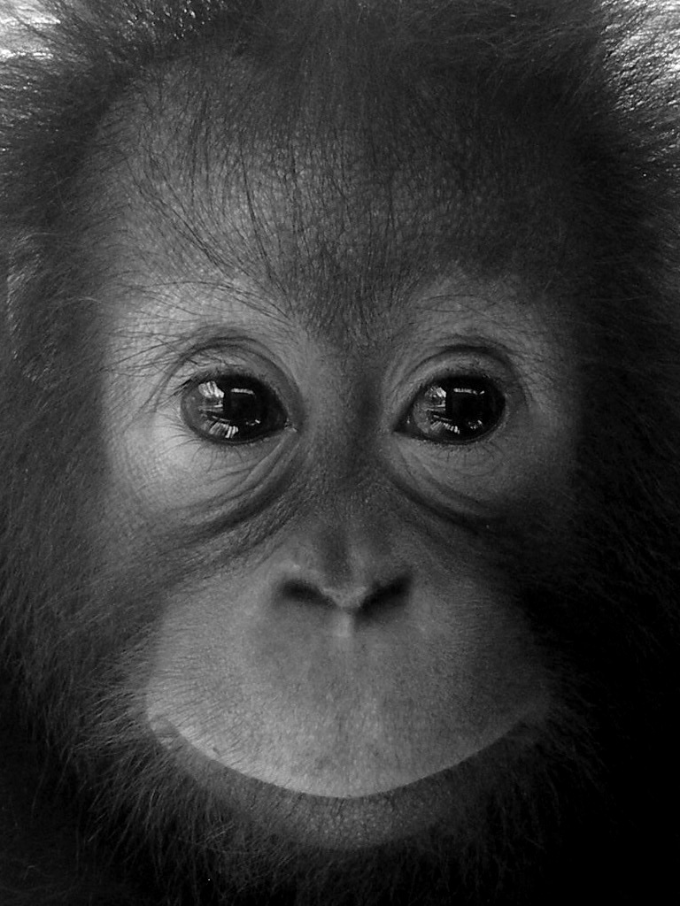
The Orang-utans at the centre are rescued orphans, either victims of the pet trade, deforestation or sometimes the disgusting reality that is the illegal human – orang-utan sex trade. As a result of these previous situations many of the orang-utans have behavioural problems, that either makes them aggressive, or more often too “humanized” which jeopardises their rehabilitation into the wild. However, on the whole the orang-utans I got to know were extremely gentle and intelligent, each with their own personalities and sense of humour. Their similarity to humans was uncanny, with so many behaviours exactly the same as a child’s behaviour. I got to know all the orang-utans I had contact with very well and was very familiar with which Orang-utan was shy, which liked what foods and the relationships they formed between themselves. Just like children, the orang-utans took likes and dislikes to certain people for no apparent reason – either gripping on to people they liked for more cuddles, or spitting at and tripping up those that they did not like. Some of the rangers were particularly hated by some orang-utans they had given injections to years before and despite no contact with them for years, these rehabilitated Orang-utans still bore a grudge against a particular person based on a previous bad experience.
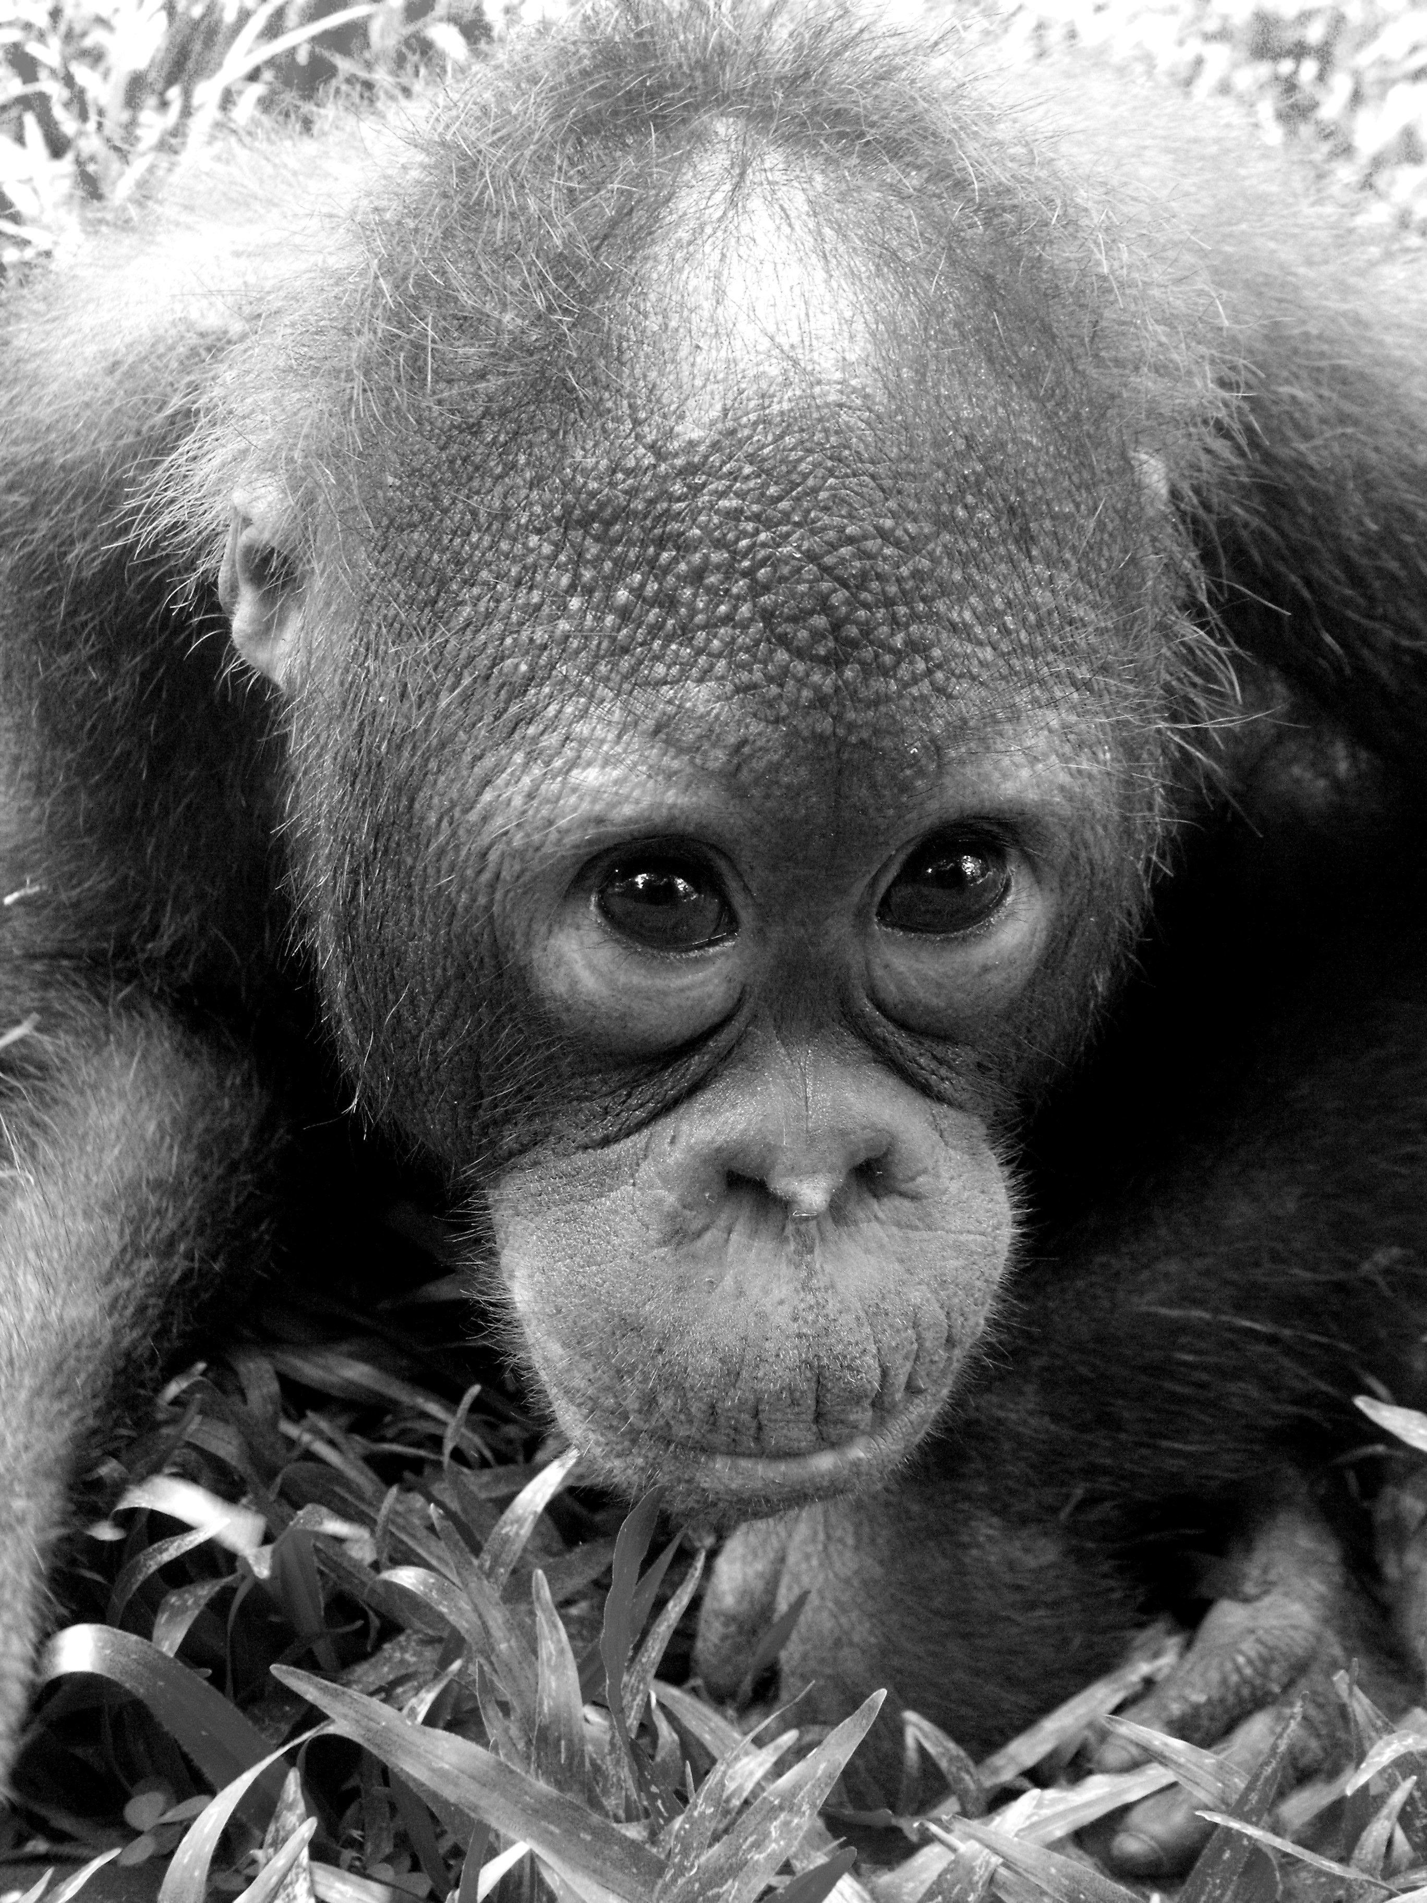
I was surprised to witness certain behaviours in the orang-utans that demonstrate their similarities to humans, such as depression, apparent anorexia, post natal depression and self harm. Other behavioural problems displayed by the orang-utans seemed to correlate with having recently had Malaria, a field that does not seem to be extensively researched. Although the incidence of Malaria coinciding with these behaviours may be a coincidence, this is a subject I plan to research further in the future.
Before my trip I was aware of the current issues surrounding the decline of wild populations of ora ng-utans, particularly the Palm Oil industry. I was interested to see the difficulties with rehabilitation, how the palm oil industry and the conservation of these apes was viewed by the local people, opposed to how the western media depicts these problems. I was also keen to find out more about the problems involved with rehabilitating these apes and what could be done to increase the numbers of these animals in the wild. What I found was that the majority of issues surrounding conservation are extremely political and the real issues cannot be outlined here as I have been told this would be detrimental to the volunteer programme and therefore the orang-utan’s welfare. From the alternative point of view I found that as a country, Sabah is proud of their palm oil industry, which provides the majority of jobs in the area and is a vital part of the local economy. Compared to many other countries with rainforest deforestation, Sabah has the largest protected jungle areas, with the smallest being the size of Singapore. This is a great deal more than Indonesia, which has already lost most of its rainforest, making orang-utan rehabilitation there an even greater issue. From my experiences I have formed the opinion that huge amounts of money and preventing deforestation is not sufficient to restore Orang-utan populations in the wild, as I believe the main issue threatening orang-utans is a lack of wildlife education of the local people. Many local people asked me why I did not look after orang-utans in the UK, completely unaware that these animals are not only rare, but very endangered. Unfortunately there remains what westerners would view as a barbaric and unethical attitude towards animals amongst a lot of people there, with television programmes such as “Man vs Beast,” where humans fight with animals, aired regularly on television channels. Most of the orang-utans were rescued from the pet trade, where a baby fetches the equivalent of one month’s wages. For every baby in the pet trade the mother has usually been murdered, as a baby Orang-utan constantly grips to their mother and this is the only way a poacher can get a baby. The pet trade exists there largely due to ignorance about these animals, which hopefully over time can be changed with more education. There are small schemes just beginning in Sabah to teach children about wildlife and not taking these animals as pets which will hopefully cause a decline in the pet trade there in future generations.
During my time there I and many volunteers on the project, often felt frustrated that changes and improvements took a long time to implement. However stepping back from the situation has made me realise how important centres like Sepilok are to the future of these apes and whatever criticisms can be made, the fact that the rehabilitation project even exists is an advance towards increasing the number of wild orang-utans. Hopefully with time the improvements that could be made to their conservation will go on to advance the effort that is already being made there. One of the most memorable days on the project was releasing some 6 year old orang-utans into the forest for the first time and getting to see the end result of 5 years of rehabilitation effort. I was extremely fortunate to have been able to be a part of their first release into the wild and am now more determined than ever to continue to help with their conservation.
I grew extremely attached to all the orang-utans and relished every day I got to spend in their company, the two months of which have been the best of my life. I consider myself very lucky to have had these unique opportunities & I would like to thank the patrons of the James Rennie Bequest for helping me fund this experience. I left Borneo with fond memories, a life time ambition fulfilled and an insight into a country and situation that I could never have fully understood from afar.

