REPORT ON EXPEDITION

Expedition/Project/ Conference Title: | Operation Wallacea - Honduras
Travel Dates: | 5th July – 3rd August 2011
Location: | Cusuco National Park and Cayo Menor, Honduras
Group member: | Heather Paterson
Aims: | To assist ongoing conservation and research, with a focus on Amphibians in the terrestrial sites
OUTCOME (not less than 300 words):-

Operation Wallacea – Honduras July 2011

Operation Wallacea is a series of biological and conservation management research programmes that operate in a variety of remote regions of the world; currently running in 11 separate countries. The expeditions that they run are designed to have wildlife conservation in mind and provide vital information on the best possible conservation practices that can be implemented. They are led by teams of University academics so completed surveys lead to a large number of publications in journals and even the discovery of new species. Since the first expedition in 1995, 30 vertebrate species new to science have been discovered.

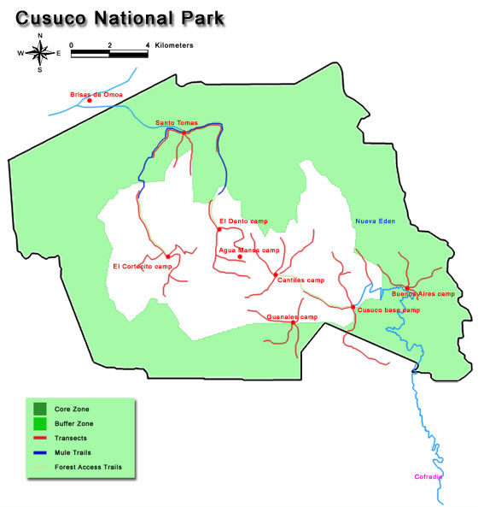
In July of this year I enrolled on a project with Operation Wallacea in Honduras. Honduras benefits from having a diverse landscape ranging from montane and cloud forests to isolated islands. I decided to undertake both a terrestrial and a marine project as I believed it would be beneficial to gain experience in the two different environments. For the first two weeks of my expedition I was based in the Cusuco National Park in the northwest of the country, completing terrestrial projects.

Terrestrial Projects 6th-20th July

I was very excited setting off for my first transatlantic flight and 10 and half hours after taking off from London I reached my destination, San Pedro Sula, Honduras! The next morning we were driven from our hotels in an old American yellow school bus as far as the road lasted. We were then transferred onto a series of pick-up trucks which drove us up the mountain track, past the village of Cofradia (one of the research posts outside the national park boundary) and eventually into Cusuco Base Camp on the east-side of the park. This is the main centre of research and the most permanent camp. We slept in tents on platforms and there were huts housing a lecture theatre and DNA lab. This was the very first year that the camp also had flushing toilets which the camp staff were very excited about!! The camp also had a mini-market run by local families where we could buy home-made crafts, fresh fruit, drinks and snacks.
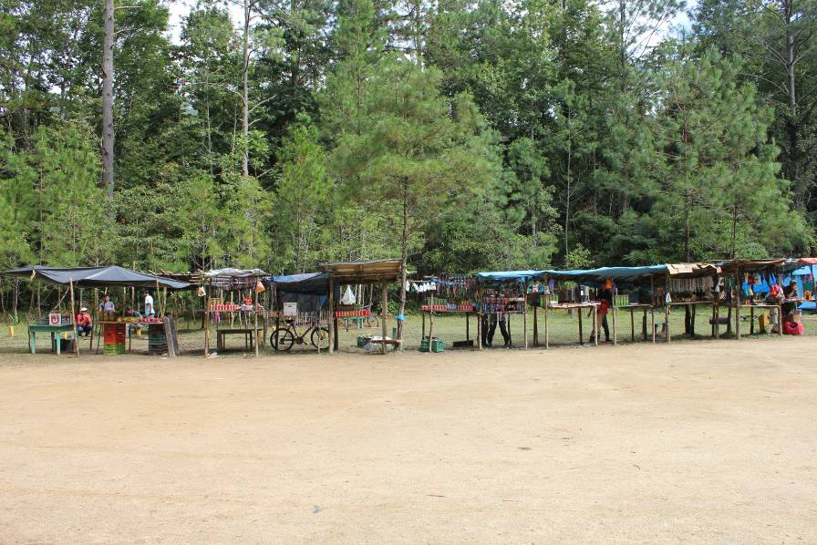
As we were quite a large group of University volunteers we were separated into two smaller groups for our jungle training exercise. My group would be heading out early the next morning for the practical side of training, essentially getting us used to walking and working in the climate of the cloud forests. We set off at 8.30am the next morning carrying all our
The market at Base Camp
essential equipment to make camp – hammocks, food, sleeping bags and cooking pot. We were forewarned that all paths in Honduran mountains are very steep, and it was definitely true! It was very hard work walking in the heat up to 2000m but we got to our satellite camps by 12.30 and started making camp. The local guides taught us how to light fires, but it still took us 4 hours to get our wood dry enough to burn!!

I had a lovely first sleep in a hammock, and then we were up early the next day for more jungle walking. We took a detour from our route to walk through a dwarf forest, which involved crawling through holes in large tree roots, but eventually gave us a great view across the mountains until the clouds rolled in! At our second camp we decided to be much more efficient and produced a wonderful fire.
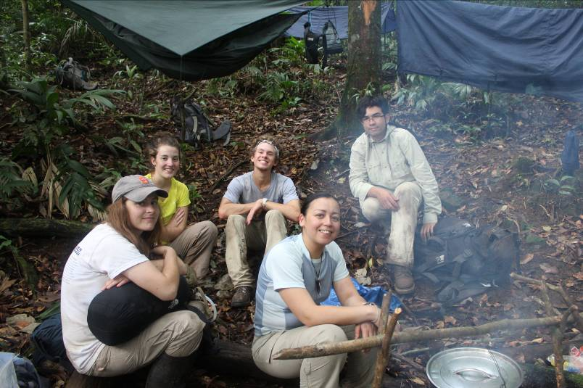
In the afternoon we learnt how to make emergency shelters out of palm leaves, and tried palm hearts as a source of food and water (they were actually really nice!). In the evening we all ate together round a large camp fire, then learnt how to make ‘boats’ out of leaves to cook eggs, cooked sweet dough on sticks and for a final treat marshmallows!!

The next day we walked back to Base Camp in time for breakfast, followed by a freezing cold shower! We then had lectures for the rest of the week on the biodiversity of the park and on the current research that Operation Wallacea is involved in. A lot of work is aims to protect the park from deforestation and get its status as a national park certified. In the evenings we participated in bat surveys, insect light trapping and played many games of cards. We also laid small mammal traps (with peanut butter, honey and oats) and went on early morning bird trapping walks using mist nets.
My group looking pleased with our second camp!

On the 12th July we were transferred down the mountain in pick-up trucks and then driven round the outside of the park to reach the west-side. We then had to walk back up into the mountains to reach the west-side base camp, Santa Tomas. Once we reached the camp (after a long and very hot walk) I got to take part in a canopy access course, climbing 40m up a tree into the canopy on ropes. It was an amazing experience being suspended so high watching birds flying around me, but once I reached the top a rainstorm started and I was soaked within seconds. I had to come down when the thunder and lightning started though!

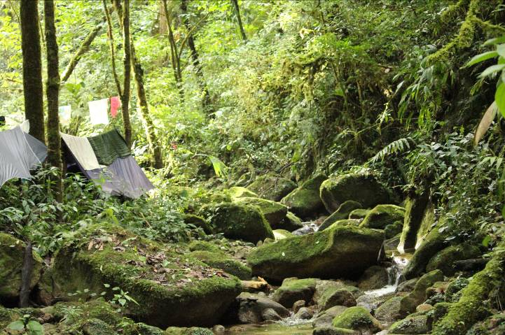
The next day we loaded our large bags onto mules and started a 6hour walk into the mountains to the satellite camp of El Cortecito that would be our home for the next week. It was a walk consisting of mostly steep uphill followed by a final very steep descent (that required rope hand-rails to stop us slipping!) into the camp. We arrived just in time for lunch, after which we were all very tired. We were allocated tents then given time to explore the river which separated the camp into two halves; one for all the tents and hammocks and the other for the kitchen, eating area and camp fire. We washed ourselves and our clothes in the river, using biodegradable products only, although unfortunately due to our high elevation storms rolled in every evening and after washing them our clothes never dried!!
The River running through camp Cortecito

During the days I accompanied the herpetologist on his trips along the steep transects that ran out of the camp searching for leaf litter frogs Craugastor rostralis. In order to do this we had to walk slowly along the transects lightly tapping the surface of the leaf litter and observe any frogs that happen to jump out because of the disturbance. The frogs were often very small and it took me a while to get any good at finding any! My proudest moment was finding a young frog that was smaller than the nail of my little finger; unfortunately he was considered too small to take data from. After catching the frogs we weighed and measured them. We also swabbed their skin for the fungus Batrachochytrium dendrobatidi which causes chytridiomycosis and took DNA samples via toe clips. It was very fun work although it often took a while for us to find any frogs. The transects were around 4km long and covering a whole one took us all day so we came back very tired.

In the evenings we were entertained by the camp managed Finn and his brother Niall as they played their Ukuleles and sang around the fire. We also took part in night time frog searches up the river that ran through camp, locating frogs by their calls as they sat on branched overhanging the water. One of my favourite activities was when we got to capture and swap tadpoles for the Chytrid fungus. Although it was easy catching the tadpoles in small pots, it was very hard trying to swab their mouths whilst wearing gloves to hold them. It took a lot of concentration!

While we were at camp Cortecito we also got to see a great number of other animals, particularly snakes such as the Green Racer, the Mexican Jumping Pit Viper and the Palm Viper. They were all incredibly pretty, as were most of the insects we got to see, although I avoided most of the spiders!!
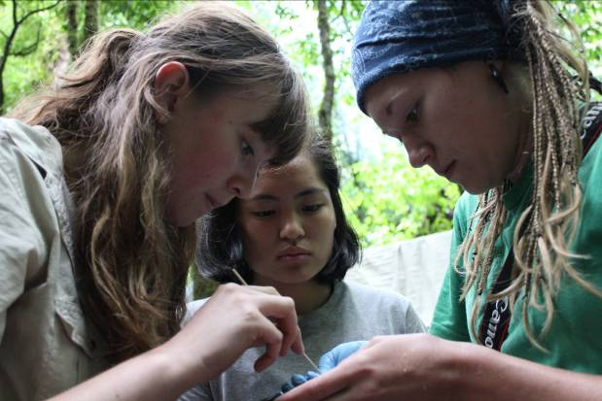
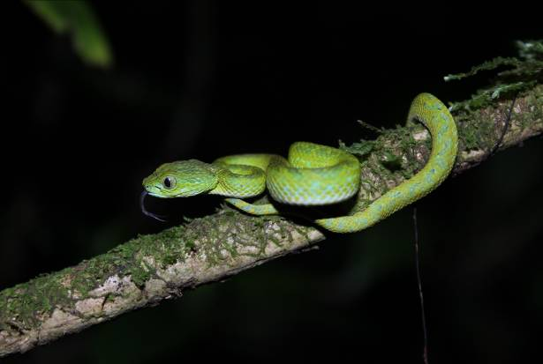
Concentrating on swabbing tadpoles and a young palm viper sticking his tongue out!

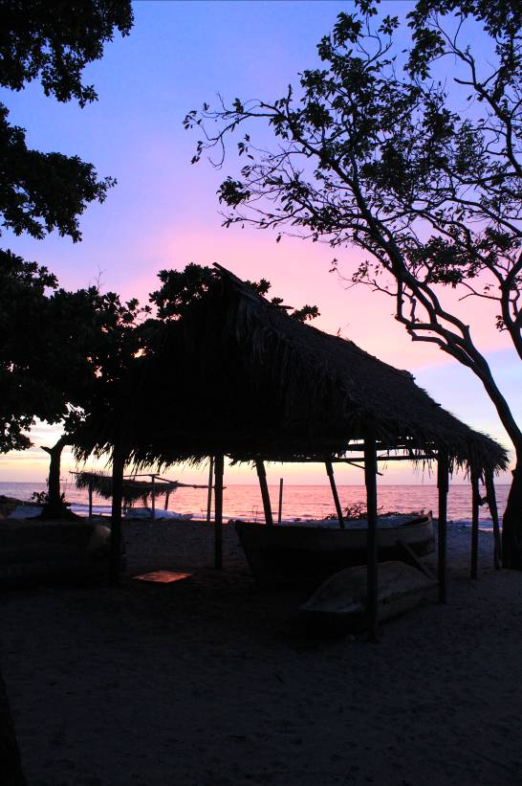
On the 19th of July we walked back out of the mountains to the West-side base camp which only took us 3hours, much easier going downhill all the way. After a short rest at camp we walked to a waterfall to cool off by jumping from the top into the water. The next day our bags were taken by mule out of the jungle and we followed them on foot until we reached a road. From there we were picked up by minibuses and after a very long journey reached the coastal village of Rio Esteban where we would stay for the night before transferring to the Cayos Cochinos islands the next day. We met our family, the father of which ran the local school, and then we were taken to the village hall for a delicious meal of curried chicken and rice with fresh peach juice. We were then treated to a demonstration of traditional drumming and dancing which resulted in everyone being dragged onto the dance floor by the women of the community for a group circle dance. It was very fun, but very hot! We went for a walk to cool off and got our first view of the Caribbean Sea, complete with sunset.

At 4.30am we were loaded onto small boats with all our bags and set off for the Bay islands, we managed to get ourselves on the fastest boat so we were the first to arrive, just in time for breakfast. We ate all our meals on the island in a wooden hut on the side of the hillside that overlooked the sea; the only downside being the number of steps we had to climb to get to it!

We got straight into our dive training that day with swim tests and treading water, none of us complained about getting to go in the water! We spent the first week doing our PADI training during the day, and spending the evenings learning about the research that the scientists on the island were undertaking. It was very interesting to learn about how research is aiming to preserve the coral reefs and species in the area from over-fishing from large companies, whilst allowing local fisherman to continue with their trade.

The species we saw on our dives were amazing, and so beautiful, I never wanted to leave the water! It was even better when in the second week we had lectures on all of the organisms we were observing so that we were able to identify them. I also completed my advanced diver certificate which allowed me to do deeper dives; we went down to observe the wreck of a small plane that had crashed around 20 years ago. It was very fun opening the doors to see the fish living inside!

On some evenings the herpetologists on the island often gave presentations of all the other animals living on the island and the research they were undertaking. They often collected examples of the species for us to observe and in some cases we even got to hold them. When we were occupied with this we lay on the dock at night watching the eagle rays and squid swimming underneath. It was a very beautiful area at all times of the day and night and I was very sad when the time came to leave. I made many friends from all over the world and gained a passion for field research, travelling and adventure.

I feel very privileged to have been able to participate in the conservation and research that Operation Wallacea undertakes each year. It was a wonderful opportunity and I am very grateful for the James Rennie Bequest contribution towards my experience.
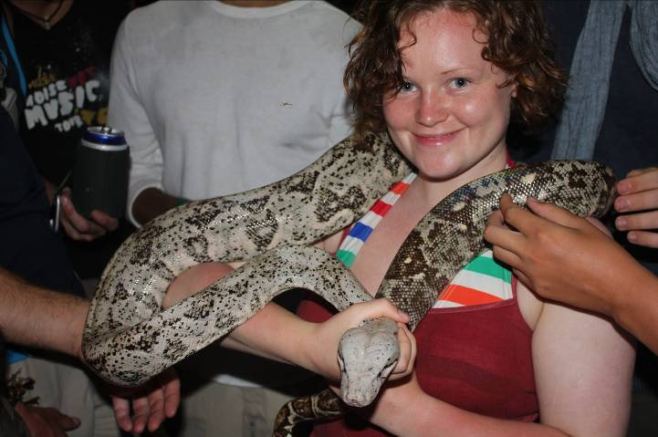
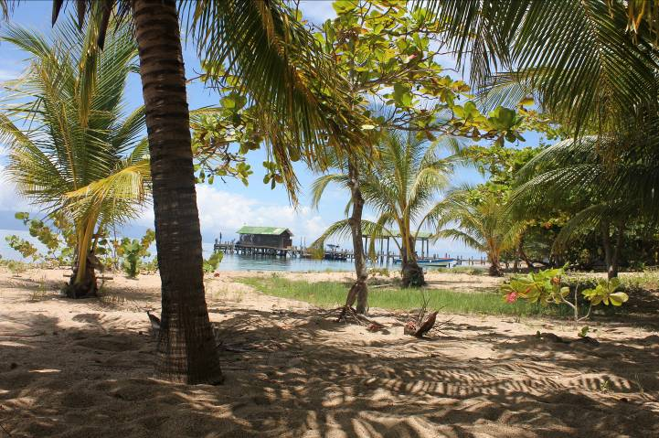
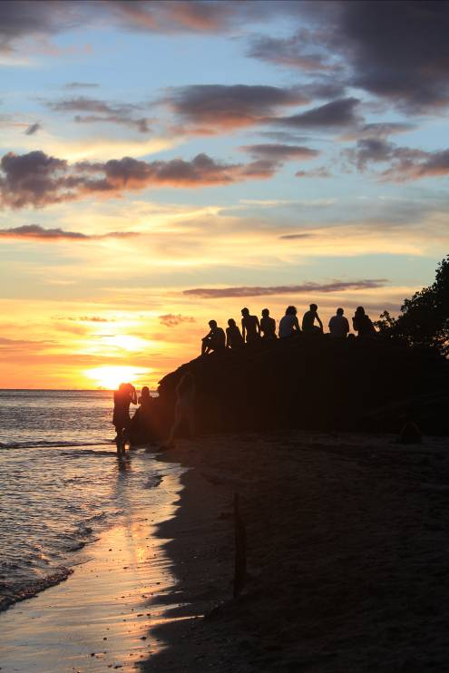
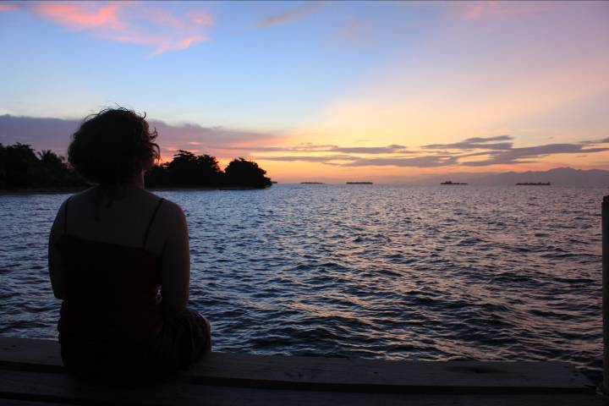
Me holding the largest snake the Herpetologists found on the island and a view of the main bay with the dock in the background

Sunset and Sunrise on Cayo Menor

