DAVIS EXPEDITION FUND

REPORT ON EXPEDITION / PROJECT

Expedition/Project Title: | Collection of scientific materials from the family Podocarpaceae in Bolivia
Travel Dates: | 15th of May – 12th of June
Location: | Department of La Paz and Cochabamba, Bolivia
Group Members: | Esther Nieto Blázquez
Aims: | Collect research materials of Podocarpaceae, in the form of herbarium specimens, silica-dried leaf samples (for DNA extraction and sequencing) and habitat data and digital images  Collate base-line data for IUCN conservation assessments to be published on-line and to form part of a dedicated paper on the conservation of Bolivian Podocarpaceae.

Outcome (not less than 300 words):-

DAVIS FUND EXPEDITION REPORT
Fieldwork in Bolivia (15th May-12th June)
Esther Nieto Blázquez

Collection of scientific materials from the family Podocarpaceae in Bolivia

OVERVIEW
The taxonomy, distribution and conservation of the Podocarpaceae species are relatively poorly understood compared with other conifer families; the largest genus in the family, Podocarpus, is particularly poorly known. The lack of knowledge is largely due to the paucity of key diagnostic morphological characters; herbarium material is mostly sterile and even this is often insufficiently representative of much of the variation within each taxon. Many of the species are poorly field-collected due to their habitats being inaccessible and in some cases access is restricted due to a lack of local security. Most of the poorly known species are from SE Asia and Tropical South America.
Tropical South America contains ca. 30 species belonging to the Podocarpaceae, many of which are relatively poorly understood taxonomically and as a result there has been difficulty in producing accurate IUCN conservation assessments. In order to improve this situation a series of field visits are being organized by the International Conifer Conservation Programme (ICCP) over a period of five years to visit key locations for the Podocarpaceae. Some South American countries, due to their lack of security, are difficult to conduct fieldwork in, however Bolivia is relatively safe. As a result of recent field work in Bolivia by RBG Edinburgh staff the Garden now has good contacts through the Nacional Herbarium of Bolivia in La Paz. Ten species (ca 30% of South American Podocarpaceae) of the family occur in Bolivia and these include: Podocarpus celatus, P. glomeratus, P. magnifolius, P. parlatorei, P. rusbyi, P. salicifolius, Prumnopitys exigua, P. harmsiana, Podocarpus ingensis and the newly discovered Retrophyllum rospigliosii.

AIMS OF THE FIELDWORK
- collect research materials of Podocarpaceae, in the form of herbarium specimens, silica-dried leaf samples (for DNA extraction and sequencing) and habitat data and digital images
- collate base-line data for IUCN conservation assessments to be published on-line and to form part of a dedicated paper on the conservation of Bolivian Podocarpaceae.

FIELDWORK AND OUTCOMES

The first three days were spent in the National Herbarium of Bolivia in La Paz where we discussed logistics for the fieldwork with our counterparts and reviewed the herbarium material. The fieldwork was centered in the Departments of La Paz and Santa Cruz. (See Figure 1 for localities where specimen where collected). Our first field work was close to Santa Cruz in the sector known as the “Siberia”, north of Comarapa. Here the road transected a small area of disturbed forest which contained Podocaprus glomeratus and Prumnopitys exigua. None of these conifer species were common in this classic Podocarpus location, for the latter species this represented its main centre of distribution. Efforts to find the more widespread species of Podocarpus rusbyi in locations closer to La Paz were unsuccessful.

A series of visits were made to the provinces of Nor Yungas and Los Andes north-west of La Paz, Department of La Paz, including the areas around the localities of Coroico, Huancané and Chulumani. The ridge vegetation in these areas mainly contained Podocarpus oleifolius which is the most widespread Podocarpus species in tropical South America. Mixed with some of these populations were P. ingensis which is a controversial species thought by European taxonomist to be conspecific with P. oleifolius. Extensive collections were made from these locations, sampling herbarium specimens from every tree that we could find in order that detailed herbarium observation can be made from a broad range of individuals in an attempt to resolve the taxonomy of these taxa.

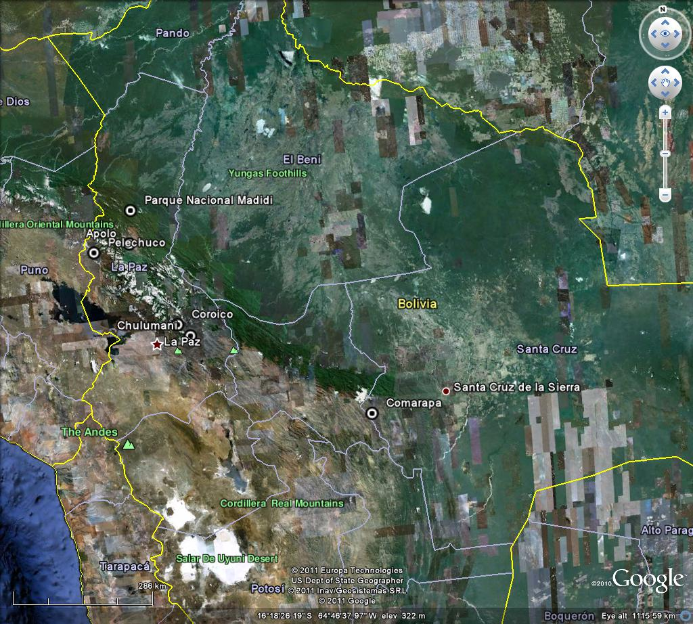

Figure 1. Collection sites shown as black and white dots

An important visit was made to the Madidi National Park along the river Tuichi and also to Pelechuco, in the province of Franz Tamayo. Here significant species were collected which included Retrophyllum rospiglosii. This recently discovered species for Bolivia was once very widespread in its main locations of Perú, Colombia and Venezuela. In its only location in Bolivia we only saw a few old-growth trees in an area that, although was in a protected area was nevertheless threatened by small-scale forest clearance for agriculture. The most important species seen in this remote area was the relevantly recently described Podocarpus ballivianensis. From the small number of individuals we saw, this is obviously a very distinctive species which has a very limited distribution.

In all 70 herbarium specimens were collected which included 8 members of the Podocarpaceae family. In addition to these collections, a small number of Begonia species were encountered and collected. Begonia is a major group of taxonomic research at RBG Edinburgh and these collections will prove valuable material for this research.

All herbarium specimens were collected in sets of four (some in sets of 5-8). Sets are to be desposited at RBG Edinburgh (E), Herbario Nacional de Bolivia (B), Nacional Forestal Martín Cárdenas (BOLV), in Cochabamba, Missouri Botanical Garden (MO). All herbarium specimens were accompanied by silica dried-gel samples.

The herbarium material collected will be a valuable resource for the monographic work of the genus Podocarpus which is currently being carried out by Dr. Robert Mill at RBGE and the silica dried gel samples will also help with this research.
A large amount of useful conservation data was gathered which is now allowing more accurate IUCN conservation assessments to be made. Much of the forest disturbance is attributable to local land use such as forest clearance for agriculture, much of which includes the cultivation of coca. As a result of the field work I have co-authored two assessments for Prumnopitys harmsiana and P. exigua which are now in the system for IUCN to publish on their website.

ACKNOWLEDGEMENTS
I would like to thank the staff of the National Herbarium of Bolivia (B), especially to Zen Zenteno for all his help organizing the logistic of the trip. Also thanks to Daniel Alanes and Pablo Solis for helping with the local contacts and their expertise on the family Podocarpaceae.
Many thanks to the Davis Fund Expedition for making this trip possible- this makes a great contribution to the research carried out at RBGE, for the monographic research of the Podocarpaceae family and IUCN assessments of the species of the family.

