JAMES RENNIE BEQUEST

REPORT ON EXPEDITION/PROJECT/CONFERENCE

Expedition/Project/Conference Title: GRC Plant Cell Walls

Travel Dates: 31 July – 13 August 2009

Location: Rhode Island, USA

Group Member(s): Kyle Mohler

Aims: Present a poster and attend the Gordon Research Conference on Plant Cell Walls

OUTCOME (not less than 300 words):-

My experience of the Gordon-Kenan Research Seminar, Plant Cell Walls and the Gordon Research Conference on Plant Cell Walls was nothing short of a success. Being my first conference two years into my PhD, I was greatly anticipating discussing my work with other experts in the field and hearing about others’ recent discoveries on the topic of plant cell walls. Everything including the conference organization, entertaining speakers, campus of Bryant University, and compelling personal conversations added value to my time spent in Smithfield, Rhode Island.
The first two days of the conference were specifically an opportunity for graduate students and postdoctoral researchers who study plant cell walls to interact, present their own ideas and provide input to others’ work. The seminar was opened by a professor introducing the topic’s past, present, and future. After this the students and postdocs took over. I was a given the opportunity to present my data at a poster session, in which many people showed interest in my work and findings. That evening and the next morning were spent hearing presentations from my peers, approaching and exploring the plant cell wall from all facets. A particular focus was applied its application in lingo-cellulosic bioethanol production. Since I have limited interaction with my peers in the field outside my lab, the evening social was a perfect time to become acquainted with them in a relaxed and fun environment.
The two day GKRS was followed by a much longer and more in depth conference, with about 160 of some of the world’s foremost researchers in plant cell walls in attendance. While not being an overly large conference, it was quite potent, and allowed me to meet many of the attendees. The format closely followed the previous two days. I presented my poster at two of the four poster sessions, but was discussing and answering questions much of the time allotted. I received renewed interest in my poster the second day after my PI, Professor Stephen Fry, gave a presentation which highlighted parts of my project. I was overjoyed to accept an award for an outstanding poster at the end of the conference! During socials and meals I took advantage of the opportunity to speak with older members of the community from both academia and industry. They were able to answer many questions I had relating to my future direction and career potential. I was even invited to travel to two other labs around the world to complete part of my PhD project. I hope that I will be able to secure another position after my PhD from people I met at this conference.
The time spent at the Plant Cell Walls Gordon Research Conference was invaluable to me and my project. I am deeply thankful to the James Rennie Bequest and other funds which made my attendance possible. The relationships formed and ideas exchanged will be cultivated for years to come.

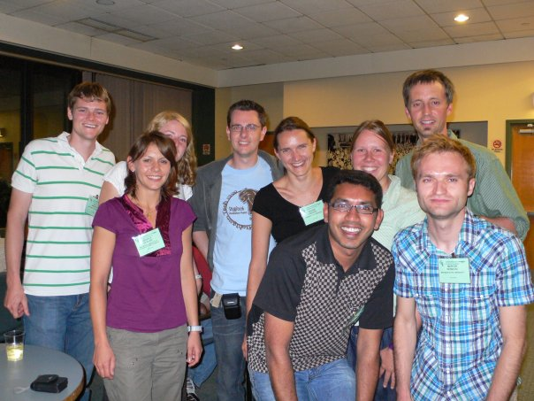

Many of my peers and I were very happy to have attended the conference.

