REPORT ON EXPEDITION/PROJECT/CONFERENCE

Expedition/Project/ Conference Title: | Forests and the Environment - An international conference to celebrate John Grace’s contribution to science
Travel Dates: | 7 April 2011 – 21 April 2011
Location: | Bologna, Italy
Group member(s): | Toshie Mizunuma
Aims: | To present a poster: ‘The use of digital cameras for remote assessments of forest phenology - A modern approach to an old problem’.
 | To meet researchers in the field of forest ecology through John Grace’s superb network
OUTCOME (not less than 300 words):-

John Grace, Professor of Environmental Biology at the School of GeoSciences in the University of Edinburgh formally retired in September, 2010. He is a former president of the British Ecological Society and a Fellow of the Royal Society of Edinburgh. His remarkable work is widely recognized. As a student in MSc and PhD, I have enjoyed opportunities to study under his tutelage. An international conference ‘Forests and the Environment’ was designed to mark his work and influence, and address some hot topics in forest ecology and biogeochemistry. Thanks to the James Rennie Bequest Fund, I was able to attend the unrepeatable conference held in Bologna, Italy in April 2011.
The conference consisted of four main themes; plant water transport under climatic stress, the terrestrial carbon cycle and interactions with the cycles of nitrogen and water, biogeographical limits and species distribution and tropical forests and the environment. The presentations were followed by discussions chaired by field experts, mainly colleagues of John Grace.. I study the seasonal change (phenology) of forests to gain a more comprehensive understanding of carbon sequestration in the forest ecosystem. The discussions between world-leading scientists were inspiring. I learned a lot from the sessions.

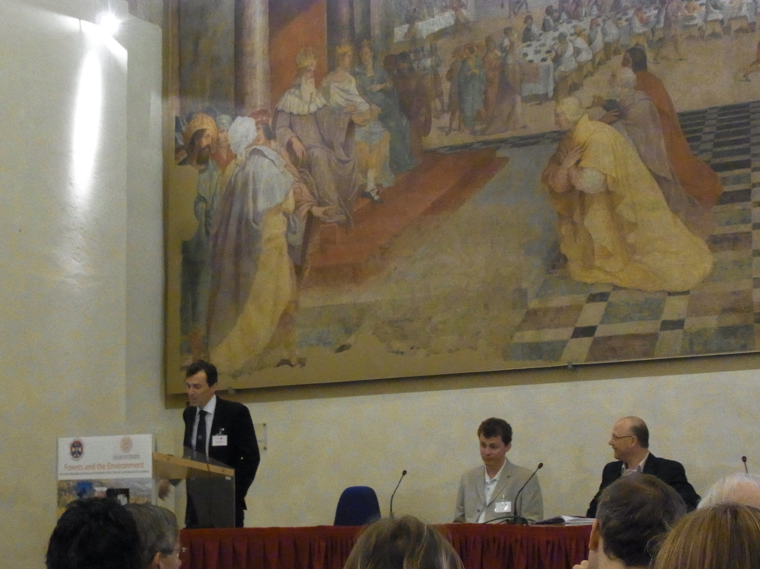 | 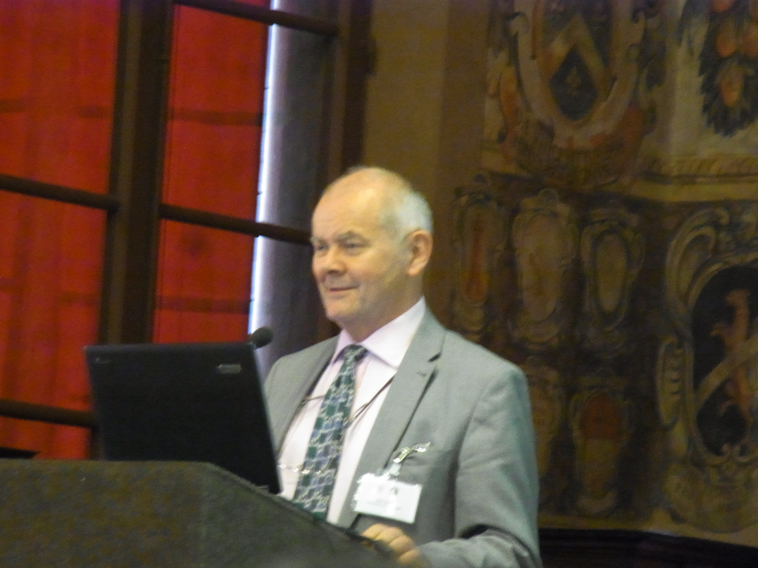
Fig. 1 Greeting of Organising Committee | Fig. 2 Professor John Grace at his talk

I presented a poster entitled ‘The use of digital cameras for remote assessments of forest phenology - A modern approach to an old problem’. I received valuable comments and scientific feedback on the innovative webcam techniques and on my methods and preliminary results. The feedback was very useful as I am in the process of writing a thesis chapter on this area of my research.
One month before the conference, my hometown in north-east Japan was suffered from an earth quake and tsunami. I led a fundraising activity in support of this catastrophe. The organiser kindly allowed me to promote the fundraising activity. Many participants expressed their sympathy by donating through the British Red Cross, helping to make the cranes (origami) and writing messages in a variety of languages. Their kind help was much appreciated.
I would like to end the report with my acknowledgments to the James Rennie Bequest Fund. The award allowed me to attend this unique, sociable and inspiring conference. The meeting was very beneficial for my study and the future career. I am deeply grateful for the generosity of the organisers of the James Rennie Bequest.

