JAMES RENNIE BEQUEST

REPORT ON EXPEDITION/PROJECT/CONFERENCE

Expedition/Project/Conference Title: Epidemics 2 – Second International Conference on Infectious Disease Dynamics

Travel Dates: 1st-5th December 2009

Location: Athens, Greece

Group Member(s): Kate Mitchell

Aims: 1) To present a poster entitled “Understanding the mechanisms underlying the slow development of protective immunity in human schistosomiasis”, which summarises some of the recent findings from my PhD.

2) To meet other researchers using mathematical models to understand infectious disease dynamics, learn from the approaches they are using and receive feedback on my own work.

OUTCOME:

Epidemics 2 - the second international conference on infectious disease dynamics - was held in Athens, Greece from the 2nd to the 4th of December 2009. This is the only international meeting dedicated to the multi-disciplinary field of infectious disease dynamics, and has a special emphasis upon the use of mathematical models to understand the dynamics of infectious disease, which is central to the work I am undertaking for my PhD.

As well as attracting mathematical modellers from across the world, the meeting was also attended by laboratory and field scientists, and representatives of government agencies involved in making public health policy decisions. The plenary talks covered a diverse range of subjects, and included Mark Feinberg describing very interesting immunological work investigating why natural reservoir hosts for HIV do not become ill, Peter Piot highlighting what mathematical models have and potentially could do for global health, and Andrew Read suggesting that we need to re-think how to design control strategies for malaria to avoid resistance developing to insecticides or drugs.

Because of the recent pandemic, influenza dominated the conference programme, with five sessions of oral presentations dedicated to influenza epidemiology, including several different but complementary analyses of the early transmission dynamics of the swine flu pandemic. Other sessions covered a wide range of pathogens in a variety of host populations (humans, plants, and both wild and domestic animals). There were several talks which demonstrated how modelling can give important insights into the best ways to control infectious diseases, including studies into drug treatment regimes for trachoma, vaccination for rotavirus, mosquito control for reducing malaria transmission, and strategies for preventing the chytrid fungus from wiping out amphibian populations. The session on networks was very interesting - it highlighted the importance of understanding contact networks for predicting the spread of a variety of different infections, and included descriptions of recent efforts to characterise real contact networks in schools and other populations.

I presented a poster on some of my recent PhD work, entitled “Understanding the mechanisms underlying the slow development of protective immunity in human schistosomiasis”. This described work I have done using deterministic mathematical models to test different hypotheses for delayed immune development in schistosomiasis, and identifying models which are able to reproduce characteristic patterns seen in field studies. A few days before the conference started, I was asked if I would also give an oral presentation of this work at the conference, to fill in for a late cancellation. I decided to take the opportunity to do so, and was asked to speak in a session on ‘within-host’ dynamics. I was asked some interesting questions after the talk about the practical implications of my work for schistosomiasis control, particularly for vaccination and treatment strategies. My poster also generated some useful discussion about the biological observations underlying my models. I was awarded a prize for my poster, which included an Amazon gift voucher which I spent on a textbook, ‘Modelling Infectious Diseases’ by Matt Keeling and Pejman Rohani, which I hope will help me with my future modelling work.

The conference provided me with a great opportunity to meet others working on mathematical modelling of infectious disease, including former tutors and colleagues from my MSc course in London, as well as the chance to make new contacts with people working in this field.

After the conference had finished, I had some time to spend sightseeing, taking in the Acropolis and other monuments in the city in balmy weather conditions, and enjoying authentic Greek cuisine. I am very grateful to the James Rennie Bequest for funding my travel to this fascinating and worthwhile conference.

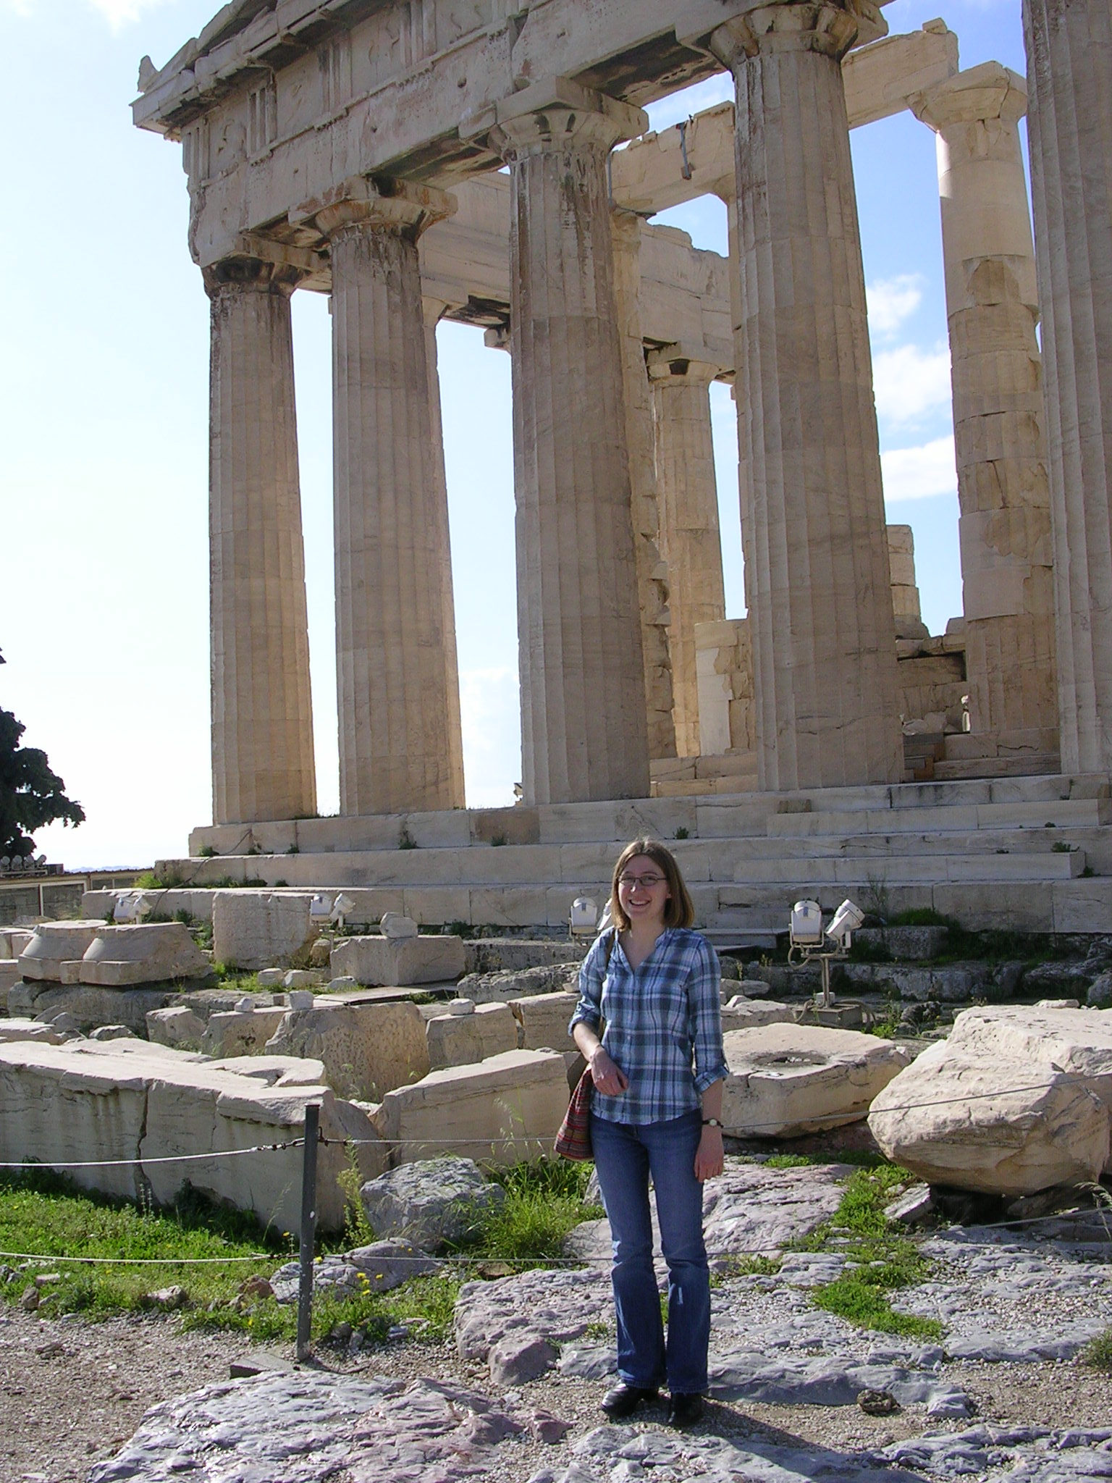

Seeing the sights in Athens

