DAVIS EXPEDITION FUND

REPORT ON EXPEDITION/PROJECT

Expedition/Project Title: Project Hiyare 2007

Travel Dates: 29/06/07-16/08/07

Location: Hiyare Reservoir, Galle, Sri Lanka

Group Members: Suraj Goonewardene, Rebecca McIntosh, Alexander Fullbrook and Jonathan Mutch

Aims: to study of the herpetofauna of a fragment of Lowland rain forest, Hiyare –Galle, Sri Lanka.

Project Hiyare 2007:
A study of the herpetofauna of a Lowland rain forest, Hiyare –Galle, Sri Lanka.

The Wet Zone of Sri Lanka together with the Western Ghats of India are considered to be one of the eight hottest global biodiversity ‘hotspots’ (Myers 2000); with estimates of 3.9 amphibian species of per 1,000km2 in Sri Lanka alone. This is the highest level of amphibian diversity per unit area of land in the world (Pethiyagoda & Manamendra-Arachchi 1998; Manamendra-Arachchi & Pethiyagoda 2005; Meegaskumbura & Manamendra-Arachchi 2005). Unfortunately, researches also suggest Sri Lanka’s amphibians are experienceing rapid population declines at an alarming rate, with more than half of worldwide extinctions being reported from the country (Stuart et al 2004). In In September 2004, the Global Amphibian Assessment announced that 19 out of 35 global instances of extinction had been reported from Sri Lanka (Stuart et al 2004). However, since this report two more species of extinct amphibians were reported, thus a total of 21 extinctions are presently known from Sri Lanka (Meegaskumbura et al 2007).

Much of the available research is based on large forested areas such as Sinharaja, Peak Wilderness, Horton Plains and Knuckles World Heritage Sites, which have considerable Government protection but very little research have been done on small isolated forest fragments such as Hiyare, that are most at risk from anthropogenic factors such as habitat loss which makes most species vulnerable to predators.

Hiyare forest consists of small wet zone forest fragment of lowland rainforest (Elevation Range: 98-152m), surrounding the present Hiyare Reservoir, which was built in 1911. This supplied fresh water to the residents of Galle town until 2002 and for a short period after the 2004 tsunami. The Hiyare forest is surrounded by villages and the location of the Hiyare Forest within the densely populated Galle district wet zone would suggest this forest fragment has much higher population pressure than the island as a whole. The population density of Sri Lanka-Western Ghats is the highest of the global biodiversity hotspot regions (Cincotta et al 2000).
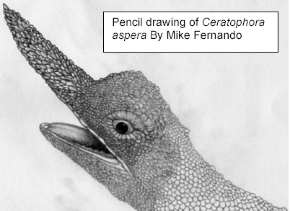
Prior to this study, no in-depth research on any taxonomic group had been carried out at Hiyare, widely used and accepted ecological research techniques were used to ascertain the herpetofaunal diversity of this ecosystem. These being quadrat sampling and line transect. In addition, many ecological observations were made on endangered and data poor species such as Nagao’s pugsnout frog (Ramanella nagaoi), Rough-nose Lizard (Ceratophora aspera), including audio recordings of calls, behaviour, microhabitat use and threats.

Some of the important findings of Project Hiyare 2007 include:

- Physical verification and documentation of 46 species of reptile inhabiting the fragment, of which 54% are endemic. See table below.
- Discovering two species of amphibians of the genus Philautus and a crotalid snake Hypnale species (Family Viperidae) that could not be identified using the available keys. These animals could be new to science (pers comm, M Bahir & A de Silva, 2007).
- The project has documented the natural history of endemic species such as Ramanella nagaoi and Ceratophora aspera. This information is useful for research workers and wildlife managers for future in situ breeding programs.
- According to available literature, it is the first time the calls of the amphibian species present in Hiyare have been recorded, except R. nagaoi. The recordings of the latter were different to those described in literature (Manamendra-Arachchi & Pethiyagoda 2001). It is hoped that this new information can be used to carry out Audio strip transects in the future by other research groups, to carry out diversity surveys in the region and monitor population densities of this extremely secretive frog.

Table 1 : Distribution of Taxonomic Groups observed, Number of Endemic Species, and Percentage Endemic of Taxonomic group within parenthesis .
It is also important to note that the diversity is much higher as quite a few common snakes observed by other researchers have not yet been recorded by our fieldwork, for example the Russel's Viper (Daboia russellii), Olive Keel-back Water Snake (Atretium schistosum), Common bronze back (Dendrelaphis tristis ), Trinket snake (Elaphe helena Helena), Wolf snake (Lycodon aulicus aulicus), Pipe snake (Cylindrophis maculata) and Green pit viper (Trimeresurus trigonocephalus).

Taxonomic Group | Species observed | Number of Endemic Species (% Endemic )
Bataguridae | 1 | 0(0%)
Trionychidae | 1 | 1(100%)
Agamidae | 6 | 4(67%)
Gekkonidae | 4 | 3(75%)
Scincidae | 4 | 3(75%)
Varanidae | 2 | 0(0%)
Boidae | 1 | 0(0%)
Colubridae | 7 | 3(43%)
Elapidae | 1 | 0(0%)
Typhlopidae | 1 | 0(0%)
Viperidae | 1 | 0(0%)
Total reptiles | 31 | 14(45%)
Bufonidae | 2 | 1(50%)
Microhylidae | 1 | 1(100%)
Ranidae | 3 | 0(0%)
Rhacophorinae | 8 | 8(100%)
Ichthyophidae | 1 | 1(100%)
Total amphibians | 15 | 11(73%)
Total | 46 | 25(54%)

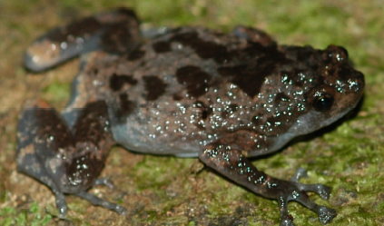
Above: Ramanella nagaoi by Suraj Goonewardene
Other significant contributions by the project
1. Training was given to local Conservation NGO’s such as Wildlife Conservation Society of Galle and Amphibian and Reptile Research Organization of Sri Lanka and a postgraduate student of the Rajarata University of Sri Lanka. in the latest herpetological techniques, using both basic and more complex tools such as GPS units, audio recording equipment, computer programmes. This has provided them with hands-on experience in herpetology, encouraging them to participate in the conservation of Sri Lanka’s reptiles and amphibians in the future.

2. The project has documented various anthropological activities, which are threatening the ecosystems and species of the area. To try to counteract this, the project has helped the NGO Wildlife Conservation Society of Galle, based at Hiyare, to continue with conservation education work amongst the residents of the area as well as school children across the Galle district. This has involved the provision of coloured pictorial stickers of various important herpetofauna living in the area. Providing pictures and information to create display boards in the conservation center at Hiyare and nearby Kanneliya Conservation forest (used by the Forest Department of Sri Lanka). It has also involved informing locals through demonstration, the non-venomous nature of most of the region’s herpetofauna. As residents generally regard all reptiles as venomous, many are needlessly killed. It is hoped that education will raise local residents’ awareness not only of the non-venomous nature but also of the global importance of the endemic and threatened species living alongside them. We also hope to print a poster entitled 'The Diversity of Galle’s Herpetofauna'.

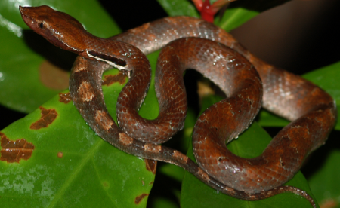
3. Photographs taken during the project have been selected by other research workers and media for use in many forthcoming publications. Hence increasing awareness amongst the public of the amphibian diversity of the country.
Left: Hypnale species by Suraj Goonewardene

The following institutions have providing funding for the expedition:

Barnson Bequest (University of Edinburgh- UoE), Davis Fund (UoE), James Rennie Bequest (UoE), Jeremy Willson charitable trust, Royal Geographical Society Expedition Research Grant, Royal Scottish Geographical Society Expedition Research Grant, Student Travel Fund (UoE), Weir Fund (UoE), William Dickson Travelling Fund (UoE).

Contact details for Team Leader: H.S.R.Goonewardene, 97, Battersea Park Road, London, SW9 4DU, E-mail: hsr.wild@gmail.com. 07983476545

NB The GIS component planned for documenting the distribution of target species could not be completed due issues with Esiri software supplied by University of Edinburgh.

References
- Cincotta, R.P., Wisnewski, J. & Engelman, R., 2000. Human populations in the biodiversity hotspots. Nature, 404: 990–992.
- Manamendra-Arachchi K & Pethiyagoda R, 2001. Ramanella nagaoi, a new tree-hole frog (Microhylidae) from southern Sri Lanka, J. South Asian Nat. Hist., ISSN 1022-0828. May, 2001. Vol, 5 No. 2, pp. 121-133.
- Manamendra-Arachchi, K. and Pethiyagoda, R. 2005. The Sri Lankan shrub-frogs of the genus Philautus Laurent, 1943 (Ranidae, Rhacophorinae), with description of 27 new species. Raffles Bulletin of Zoology Supplement. 12:163-303.
- Meegaskumbura, M. and Manamendra-Arachchi, K. 2005. Description of eight new species of shrub-frogs (Ranidae: Rhacophorinae: Philautus) from Sri Lanka. Raffles Bulletin of Zoology, Supplement. 12:305-338.
- Meegaskumbura, M., K.Manamendra-Arachchi, C. J. Schneider & R. Pethiyagoda. 2007. New species amongst Sri Lanka's extinct shrub frogs (Amphibia: Rhacophoridae: Philautus). Zootaxa 1397: 1-15.
- Myers, N., R. A. Mittermeier, C. G. Mittermeier, G. A. B. da Fonseca & J. Kent, 2000. Biodiversity hotspots for conservation priorities. Nature, 403: 853–858.
- Pethiyagoda, R. & K. Manamendra-Arachchi, 1998. Evaluating Sri Lanka’s amphibian diversity. Occasional Papers of the Wildlife Heritage Trust,2: 1–12.
- Stuart S. N, J. S. Chanson, N. A. Cox, B. E. Young, A. S. L. Rodrigues, D. L. Fishman & R. W. Waller, 2004. Status and trends of Amphibian declines and extinctions worldwide. Science, 306: 1783–1786.

