DAVIS EXPEDITION FUND

REPORT ON EXPEDITION/PROJECT

Expedition/Project Title: Project Mexico: The effect of management on populations of Strombus gigas in Quintana Roo, Mexico.

Travel Dates: June 30th to August 4th, 2009

Location: Chetumal, Quintana Roo, Mexico

Group Members: Adam Cross, Tony Marshall, Sophie Eastwood, Neil Clark, Sarah Hutcheon and Conor McCone

Aims: To study the effect of differing management policies on populations of Strombus gigas in different locations.
To assist in the compilation of a nematode inventory collected from Laguna de Términos.

OUTCOME (not less than 300 words):-

See attached report.

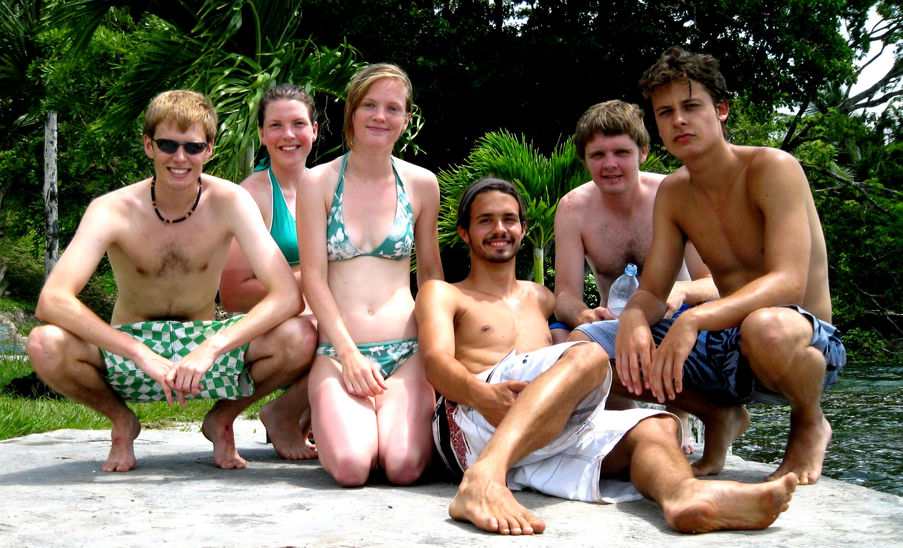
Marine Expedition to Mexico 2009

The effect of management on populations of Strombus gigas in Quintana Roo, Mexico.

In July this summer, six undergraduate ecology students from the University of Edinburgh completed a successful four week expedition to Chetumal in southern Mexico, in collaboration with the Mexican institution, El Colegio de la Frontera Sur (ECOSUR). The primary aim of this expedition was to study populations of conch (Strombus gigas) subject to differing management policies in two geographically separate locations: Banco Chinchorro and Punta Herrero (Fig. 1). An additional aim was to assist in the compilation of a nematode inventory. We were also fortuitously able to work, in addition to our own investigation, on parasites and elasmobranchs.

Species of conch such as S. gigas are an important resource within local fishing communities, since the conch forms a part of people’s diet, and more significantly because they provide a source of income. Increasing pressure from harvesting has highlighted the need to study populations of S. gigas for conservation and sustainability. The data we collected in conjunction with ECOSUR will be used to further improve management strategies to sustainably maintain and increase local populations of conch at both Banco Chinchorro and Punta Herrero.

With regards to our study on conch, the management at Banco Chinchorro for conch harvesting is restricted to a quota of 10 tonnes (held by one organisation approved by the government) between the months of December and February. The management at Punta Herrero for conch harvesting is that of an annual strict no take zone, as this area falls within the Sian Ka’an Biosphere Reserve.
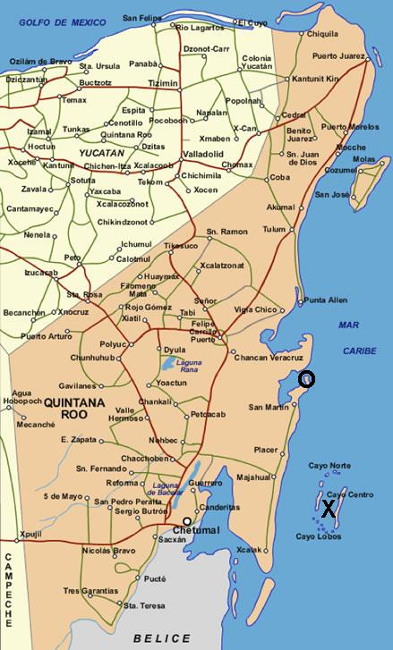
Figure 1. Map of the state Quintana Roo, Mexico with site locations marked by ‘X’ for Banco Chinchorro and ‘O’ for Punta Herrero.

Both sites are subject to the problem of illegal harvesting of conch. Talking to scientific officers, there were many reports of illegal fishing in Banco Chinchorro, whereas this did not seem to be such a significant issue at Punta Herrero.

Method

Conch collected and sampled at both locations was measured for siphonal length (SL) and lip width (LW). These morphological measurements were taken because age can be inferred based on these parameters (CFMC, 1999; Appeldoorn, 1988). For juvenile conch though SL is often used to predict age (Appeldoorn, 1990). Huitric (2005) studied juvenile conch and identified the SL size at which individuals reached maturity to be 210 mm on average. Problems with aging conch with SL is that it becomes an increasingly inaccurate measurement with older conch as the SL and age correlation decreases in significance, due to, for example, shell erosion. Appeldoorn (1988) thus suggests that the most accurate method for all conch is LW, whereby individuals reach maturity at approximately 5mm LW.

Results

 | Table 1. Descriptive statistics for siphonal length (SL) and lip width (LW) for Strombus gigas at the locations; Banco Chinchorro and Punta Herrero. SEM = Standard Error of the Mean.
 | Variable | N | Mean (mm) ± SEM | Minimum (mm) | Median (mm) | Maximum (mm)
 | B. Chinchorro SL | 569 | 169.77 ± 1.93 | 41.0 | 184.0 | 297.0
 | B. Chinchorro LW | 569 | 1.286 ± 0.173 | 0.5 | 0.5 | 42.0
 | P. Herrero SL | 442 | 176.96 ± 1.70 | 67.0 | 175.0 | 297.0
 | P. Herrero LW | 442 | 6.287 ± 0.457 | 0.1 | 2.3 | 141.0
From Table 1 it can be seen that the mean siphonal length (SL) and mean lip width (LW) are greater at Punta Herrero compared to Banco Chinchorro. The range of measurements for SL is greater at Banco Chinchorro than Punta Herrero, but both sites have the same maximum SL of 297 mm. The range of LW is greater at Punta Herrero compared to Banco Chinchorro, and has a greater maximum value difference of nearly 100 mm.

The results show that there was not a significant difference (P > 0.05) in SL between the sites of Banco Chinchorro and Punta Herrero (Mann-Whitney U-test: U = 286340.0, P = 0.7326). For LW, there was a highly significant difference (P < 0.001) between sites (Mann-Whitney U-test: U =192020.5, P = 0.0000).

From percentage calculations based upon the size at maturity for both LW and SL measurements within each site, there is an observed difference in results. LW measurements (when excluding LW <5 mm) indicate that 4% of the Banco Chinchorro population is adult, whilst at Punta Herrero 30% of the conch population is adult. Comparing age structure with SL (when excluding SL <210 mm), it can be seen that at Banco Chinchorro 15% are adult within the population, whilst at Punta Herrero 20% of the population is adult. Differences in calculated age structure of the population could be attributed to the weak correlation between SL and LW (Banco Chinchorro, Pearson’s correlation = 0.206; Punta Herrero, Pearson’s correlation = 0.393).

Discussion

Based upon the results, it can be inferred that conch populations contain a greater proportion of juveniles at Banco Chinchorro than at Punta Herrero. From statistical tests, the age structure (inferred from LW measurements) between the two populations is shown to be significantly different based on the conch population median LW value of the two sites (P < 0.001). The low adult population at Banco Chinchorro, if not natural, may be exacerbated by over-harvesting during the open season and perhaps illegally during the closed season. Whether these differences are due to the management at each site and not indicative of other variables, e.g. population fluctuations or environmental variation, is open to further discussion and study.

On the assumption that the statistical difference in LW between sites is representative of the current management, further studies should concentrate on temporal variability and estimate the long-term viability of populations with low numbers of adult individuals at Banco Chinchorro. Consideration in further management proposals should be provided to shortening the open season or reducing the quota allowed, without damaging the economy of local communities. Management and monitoring at Punta Herrero should remain constant, and policing of illegal harvesting, as at Banco Chinchorro, should be increased, dependent upon resources and cost.

An important point to note is that using LW and SL to estimate the age of conch within this study has been based upon data from other work, not specific to Mexico. Therefore, caution should be inferred when drawing conclusions about differences between and within the age structure of conch populations at Banco Chinchorro and Punta Herrero.

Additional Experience

Two weeks were spent working in the laboratory at ECOSUR-Chetumal, helping in the research being carried out on nematodes. We were involved in locating nematodes in sediment collected from Laguna de Terminos, using microscopes, and then putting them into formaldehyde for preservation. These nematodes will then be identified and classified by experts at ECOSUR. The purpose of this is to create an inventory of the nematode species present at Laguna de Terminos and several new species have already been recorded.

Also whilst at ECOSUR-Chetumal, we were given the opportunity by Dr. David Gonzalez Solis to spend time in his lab gaining experience assisting his work on parasitology. This involved dissecting fish and snakes, and using a microscope to find endo-parasites present within them. The parasites found may be new to science and endemic to the Chetumal area.

We were also introduced to Dr. Manuel Mendoza Carranza, a researcher at ECOSUR-Villahermosa, with whom we spent three days learning about his work and assisting him with data collection. Dr Mendoza Carranza specialises in aquatic ecology, and is currently involved in researching the biology of elasmobranchs, and the fishing industry’s impact upon their populations off the coast of Tabasco. On the first of the three days we received a tour of the labs at ECOSUR Villahermosa, and were given a presentation on the work of Dr Mendoza Carranza and his team. On day two we were taken to a large inter-tidal lagoon where we were shown and practiced the various ways in which fish samples can be collected. The third and final day was spent at San Pedro, a small fishing village in Tabasco, where we dissected and took measurements of all the shark species and stingrays being landed by the returning artisanal fishermen. This is part of Dr Mendoza Carranza’s ongoing work, and he will add the measurements we made to his data set.

Summary

Overall the aims of this expedition were successfully achieved. This achievement arose from the help and consideration that the members of ECOSUR gave us in fulfilling our goals. In general, we all developed an appreciation for different cultures and awareness of different scientific techniques that will be invaluable and applicable in many future scenarios

Acknowledgements

The group would like to thank the following people for their help and support in making this expedition possible.

A large thank you goes to Dr. Salvador Hernandez-Daumas and his family, for their endless help in organising this expedition. To all the staff of ECOSUR including: Dr. Alberto de Jesus-Navarrete, David Gonzalez Solis, Jose Juan Oliva, Adriana Valencia, Manuel Mendoza Carranza and to Aristeo Hernández for his patience.

To those that financially helped us with this expedition: The Davis Fund, James Rennie Bequest, Barnson Bequest, Student Travel Fund, British Association Travel Fund, Clingan’s Trust and friends and family.

References

Appeldoorn, R.S. (1988) Age determination, growth, mortality and age of first reproduction in adult Queen Conch, Strombus gigas L., off Puerto Rico. Fisheries Research. 6(4):363-378
Appeldoorn, R.S. (1990) Growth of Juvenile Queen Conch, Strombus gigas L., off La Parguera, Puerto Rico. The Journal of Shellfish Research. 9(1):59-62
Appeldoorn, R.S. (1993) Reproduction, spawning potential ratio and larval abundance of Queen Conch off La Parguera, Puerto Rico. To Caribbean Fishery Management Council. [Available at: http://www.aoml.noaa.gov/general/lib/CREWS/Cleo/PuertoRico/prpdfs/appledoorn-reproduction.pdf, accessed on: 25/02/09]
CFMC, Caribbean Fishery Management Council. (1999) Queen conch stock assessment and management workshop. Caribbean Fishery Management Council, Belize City, Belize. [Available at: http://www.caribbeanfmc.com/workshops/BelizeConchWGReportFinal.PDF, accessed on: 26/02/09]
Huitric, M. (2005) Lobster and Conch Fisheries of Belize: a History of Sequential Exploitation. Ecology and Society. 10(1):21-35

