JAMES RENNIE BEQUEST

REPORT ON EXPEDITION/PROJECT/CONFERENCE

Expedition/Project/Conference Title: Operation Wallacea - Indonesia 2007

Travel Dates: 23 June to 14 August

Location: LaBundoBundo (Buton) and Hoga (in the Tukangbesi Islands); both in the Wallacea province of Indonesia

Group Member(s): A large group of volunteers from various parts of the world, each applying independently

Aims: To build my zoological knowledge as a background to my degree; to gain experience in writing about and photographing such a diverse environment in preparation for a career as a nature journalist, and to promote conservation practices

OUTCOME (not less than 300 words):-

Please see the accompanying document “Falling fortunes of the South Pacific.”

Falling Fortunes of the South Pacific
- Reporting on a conservation expedition in Wallacea
By Zena Marks

Indonesia is publicised as a tremendously dangerous place; malaria, dengue fever, terrorism, poisonous snakes, even centipedes; public transport accidents; water-borne parasites; bird flu.

Although since age 11 I have dreamt of being intrepid in exotic places, pining to work as a nature journalist, fear set in the night before I flew. The media however, obviously blows things out of proportion – I’ll have to get used to that!

I hoped, on departing, to taste life from a different perspective – would I feel palpably isolated, or free, on a tiny island in the Pacific? In any case it would be a cultural leap from my home turf in the north of England.

But the lust for adventure persisted. On arriving in Jakarta, I could have been at any airport – air-conditioning and hotel-chain bed-linen meant I hardly noticed I’d landed. It was on the flight from Java to Sulawesi that I really felt my passions excited – while others slept I peered excitedly down on emerald atolls peeping up, just a few feet below the surface of the transparent azure sea. I pondered, with curiosity, the apparent fields of water at the edge of the land – what disaster had happened? But they were just paddy fields – heard of so frequently but completely alien n sight.

As expected, the journey to my first destination – a village in the jungle on the relatively large island of Buton, just off the Sulawesi mainland - was bumpy, delayed and tiring. One thing I was not prepared for was the pollution - on such a small island, which in my mind would be a ‘natural paradise.’ Awareness of spreading industrialisation dawned rapidly with each diesel-doused intake of breath due to the inefficient engine of our jeep. I realised I had been living with serious misconceptions about lifestyles in the wider world – surely it was England that had the industrial revolution?! Smog is so outdated…

Map of the Sulawesi region, highlighting the large island of Buton, courtesy of www.opwall.com

Living with locals was not the stick hut experience I had ignorantly imagined; residences were concrete dwellings – some with satellite dishes! After a week or two, we discovered (through visits by the social scientists to neighbouring villages) that ours, LaBundoBundo, was pretty much the envy of the entire island. Western customers of Operation Wallacea, and their local partner company Lawana Ecotone, evidently kept the villagers in fine fettle with Coca-cola habits and fair-trade rent payments.

Wisely, Operation Wallacea employed locals to help train the volunteers, thus building skills and economic capital in the community. Our guides took great pleasure in our distress throughout our first ‘initiation’ week: jungle-training. I have never been muddier. Global-warming has certainly altered the Sulawesi ‘dry season.’

As I have long dreamt, we strung our own hammocks and built shelters from bamboo – large canes, tied together with sinuous threads from spiky rattan stalks, covered with woven palm leaves. We boiled our water from muddy jungle pools over fires we had conjured with a machete and hard-won scraps of dry wood. We learnt principles to help us avoid eating toxic plants- furry stalks, or sap which made your skin itch, were a bad sign, as well as ones of which the sap coloured a knife black or purple. We learnt which jungle vines could provide us with desperately needed drinking water, and baked eggs over an open fire in folded palm leaves, or in the flames, clad in balls of mud.
Returning to the village was an ascension to heaven – dry clothes! No mud! A revelation.

There was a wealth of nature to enjoy and explore. I arranged to spend a week studying tarsiers, under the guidance of wildlife trust specialists from the UK, and three days each studying birds of paradise and the Buton macaque. I was also able to view the bird-rich canopy at dusk by rigging ropes and pulleys to hoist myself into the treetops.

Our bird walks taught us mist-netting techniques, and enabled me to recognise over 60 birds (by latin name) on the basis of either their call or plumage. Indonesia is the most diverse bird habitat in the world, and it is the indigenous birds which most clearly demonstrate the Wallace line divide in their minute variations. Notable, distinctive and common species included the purple-winged roller (Coracias temminckii), which makes a harsh repetitive sound, rather like a cheeseboard instrument, and the hair-crested drongo (Dicrurus hottentottus), which has a white iris and emits a harsh screech. My favourite, however, was the brown-throated sunbird (Anthreptes malacensis) for its beautiful plumage.
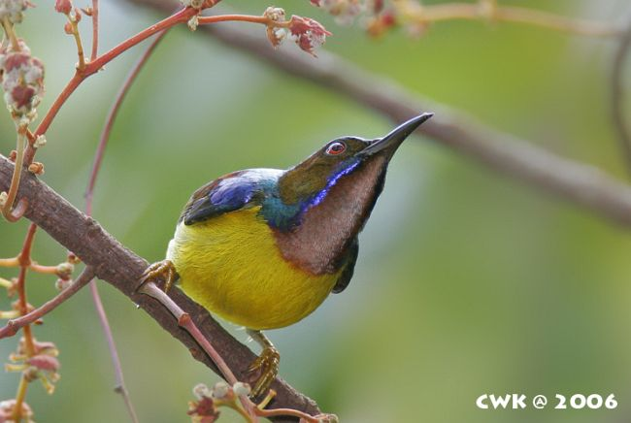

Image of the brown-throated sunbird, courtesy of www.orientalbirdimages.org

I followed the macaques with an Aberystwyth student who was writing her dissertation on their anger displays, and was lucky enough to spend most of my (minimum 8-hour) days within a metre or two of the (relatively habituated) Kakanawe troupe. Their gestures were more human-like than I had ever realised – one can accept anything one sees on a TV screen. These animals had obvious conscious awareness of our presence, communication methods and bonding rituals. I had never seen such intelligent animals before (other than other humans).

I was also struck by the simple appeal of their lifestyle; animals, I have long thought, have an extremely boring time. Cows, for example - chewing grass, mating every now and then, sleeping, chewing again… But these macaques’ lifestyles seemed rich enough to satisfy even a human’s ways of wasting time. Our research method involved regular behavioural scans and the range of activities undertaken was extraordinary – grooming, tickling, playing, running, leaping, feeding, stealing, teasing, mating, ritual mating with members of the same sex… I remember feeling distinctly envious of the sprightly juveniles running and bouncing on springy branches, realising that their days consisted of this and snacking on delicious fruits gathered from farmers’ fields. Many men would happily exchange their nine-to-fives for such a lounging lifestyle.

Luckily, I was working closely with a primate specialist, who was recording the macaques for university films; I also joined another filmmaker making a conservation series for Indonesian television, particularly focusing on local mangrove swamps. The mangroves, natural carbon sinks, have the amazing capacity to burn for long periods of time; below the surface fires could burn slowly for up to a year – emitting huge amounts of carbon dioxide into the atmosphere.

My final week in the jungle was distinctly hard work; the tarsier project was thorough and rigorous. It required hour-long dawn and dusk watches of suspected tarsier sleep sites, with the days spent on surveys of transect sections. Around 200 transect squares (10m x 10m) were under surveillance in my week, with around a random sample of 10 squares being surveyed per day. Every millimetre of ground cover – whether rock, wood, mud or vegetation - was recorded, as well as the circumference of every tree and liana in the square, the dampness of the area (indicated by tree fungus at certain heights), the terrain’s slope aspect, and so on. Tiring work – especially as tarsiers are rare and this particularly species had never even been filmed. However, odd glimpses of these tiny, strange creatures in the half-light were worth the wait. I like to think they inspired the ‘lovely monkey with lollipop paws’ line in Edward Lear’s ‘The Jumblies’ – perhaps his ideas were not so fantastical after all.

And so on to Hoga – a tiny island off the South-East tip of Sulawesi, in a chain known as the Tukangbesi Islands, and part of the Wakatobi National Park - so named due to the first letters of the major islands (Wanci, Kaledupa, Tomia and Binongko).
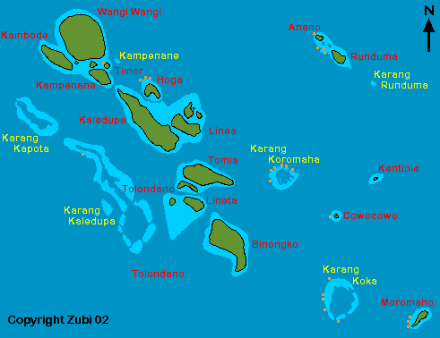

Map of the Tukangbesi island chain, courtesy of www.starfish.ch/dive/Sulawesisoutheast

There were creatures in the water here that could kill you in minutes, so consideration of, as well as for, the environment was essential. One quickly realised that it these organisms did not aim to attract attention to themselves, so a conservative, careful manner was all that was required to avoid a bite or sting.

I spent my first week on this tiny isolated shore learning to scuba dive – observing beautiful species of coral, algae and tropical fish throughout. There is a strange peace in breathing underwater – the apparatus forces slow, deep, almost yogic breathing, which is highly meditative. The colours of the tropical sea are calming; the dull swoosh of a huge expanse of water provides almost an ontogenal deja-vu, like the ticking clock placed in a young puppy’s basket which recreates the comforting sound of its mother’s heartbeat.

On qualifying, I was able to spend a week studying and learning the names and practices of the various species of wildlife surrounding me underwater – the porcupinefish (Diodontidae), for example, puffs itself up into a ball when agitated, and if pushed will fire its dart-like, tetrodotoxin-containing spines at perceived predators. This blocks action-potentials by blocking voltage-gated sodium channels, and results in death as the muscles of the diaphragm are paralysed ( - one to avoid then).

After passing tests which qualified me to identify the various ocean inhabitants, I boarded the Operation Wallacea live-aboard (the Bintang Sedang, or ‘Rising Star’) for my final week, to perform thrice-daily reef checks along the corals of the Wakatobi chain. Our data, which was numerical and consisted of population sizes of various indicative organisms along 100m line transects of reef, was to be entered into a worldwide database to indicate changes in reef quality in years since a previous reef check in the same area. This data would be correlated with data on C0₂ levels, pollution, changing climate and water temperature in the area to assess the impact, and significance, of global warming for oceanic life in the south Pacific.

Coral quality had obviously vastly diminished since the last thorough report in 2003, though underwater scenes were still beautiful. Operation Wallacea’s financial incentives for locals have been key in slowing this decline, providing monetary replacement to discourage harmful net and bomb-fishing - it now almost never occurs. However, changes in water temperature due to climate change could seal the fate of many species, despite these measures to counter other threats.

We sailed through the night, under a Pacific sky in which the constellations were the clearest I’ve ever seen, and in which (unlike in the Northern hemisphere) the Southern Cross was visible (I have since taken an extra-curricular astronomy course, expanding on the curiosity this awesome experience provoked). By day we weathered freak, out-of-season hordes of Portugese man-o’-war jellyfish to continue our dives, and swam with Spinner dolphins jumping alongside our boat, with squid, giant clams, Moorish idols and giant turtles.

The gracefulness of that underwater life has been much missed since I last carried my suddenly-heavy oxygen tank out of the surf, and boarded the returning boat for the first stage of my diesel-fuelled journey home (- I hope my ecological efforts did enough to offset that carbon footprint!)

My sincerest thanks to the James Rennie Bequest, which allowed me to undertake this expedition. My education and future career have been given a huge boost thanks to the bequest and I am deeply indebted to the trustees for their kindness and consideration.

Cocoa, oranges, plantains, bananas…whatever they could get
Tarsiers have a large suction pad at the tip of each of their long skinny digits; these enable incredible grip and even allow the tarsier (in artificial conditions of course) to scale walls of smooth glass.

