REPORT ON EXPEDITION/PROJECT/CONFERENCE

Expedition/Project/ Conference Title: | Operation Wallacea – Indonesia Expedition
Travel Dates: | 7th July – 18th August 2011
Location: | Lambusango Nature Reserve and Wakatobi National Park, Buton, Sulawesi
Group member(s): | Frances Manning
Aims: | Rainforest and Coral Reef Conservation
OUTCOME (not less than 300 words):-

I have always had a passion for the environment, turning my mother’s hair grey when I was eight by announcing that I was giving up meat to prevent animals from being killed, and always arguing with my flatmates about the recycling. So when an opportunity arose to get my hands dirty in the name of rainforest and coral reef conservation and research I had to get involved.
Operation Wallacea organises biological research and conservation in eleven different countries. European and North American academics organise research projects to aid and support local conservation efforts. Students are encouraged to participate in the conservation, providing essential funding to allow the projects to commence and continue. Members of local communities are employed by partnership NGOs, funded by Operation Wallacea, to act as guides and provide accommodation. Operation Wallacea ensures that Westerners do not encroach on local job opportunities by employing locals where possible and only hiring Western staff when essential, under voluntary conditions.
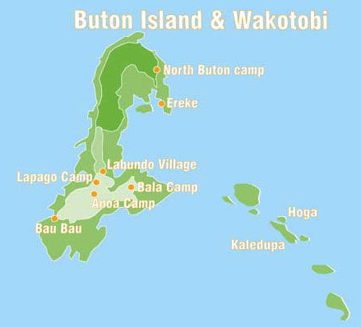
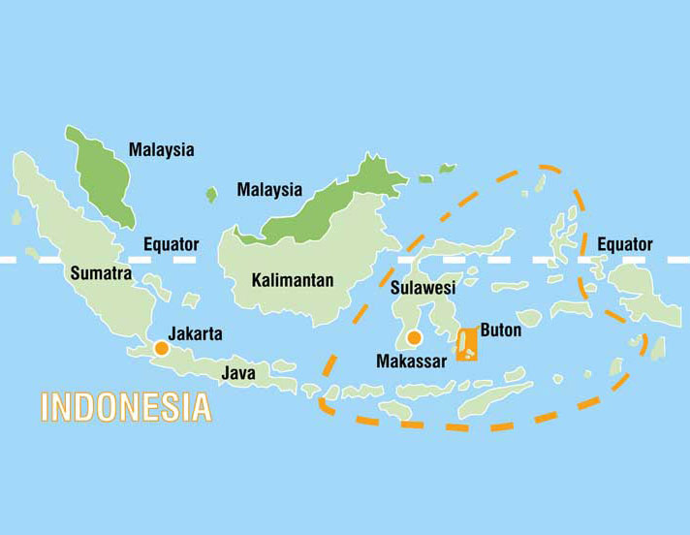
I chose to participate in the Indonesian research base. This is where Tim Coles founded Operation Wallacea eleven years ago and therefore both the marine and terrestrial sites have well established research programs.
The map of Indonesia (above) highlights the Wallacea region of Biodiversity. I was based on Buton Island (right) at Labundo village for two weeks, Bala camp for one week, Lapago camp for one week and Hoga Island for two weeks. (Pictures taken from Operation Wallacea website).

Travelling to Indonesia took me four days, one train, two international flights and two domestic flights. We were given one night in a luxurious hotel in Makassar to recover from our jet lag, and we finished our journey at a hotel in Bau Bau on Buton Island, Sulawesi.
On Thursday 7th July, after a breakfast of fried rice, we were met by a convoy of minibuses to take us on a three-hour drive to the research base in a village called Labundo in the rainforest. On arrival, we were taken to the village town hall, used by Operation Wallacea during the summer months as a dining hall and lecture theatre; we were then split into groups and distributed among the village families.
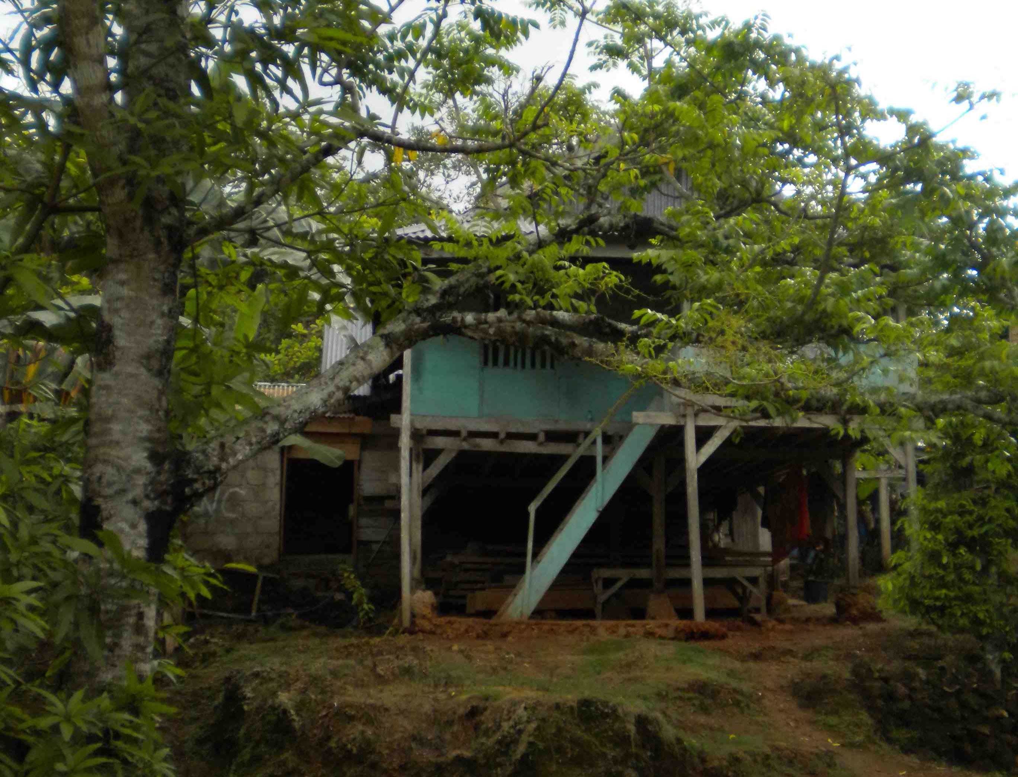
I was staying with a lady called Aga, her elderly father and three students from Bristol and Durham universities. We lived in a house on stilts, built this way to prevent snakes from accessing the living areas, and were each provided with a mattress on the floor and a mosquito net. We also shared the family mandi – a squat toilet with a plastic scoop and a basin of cold water for showering.
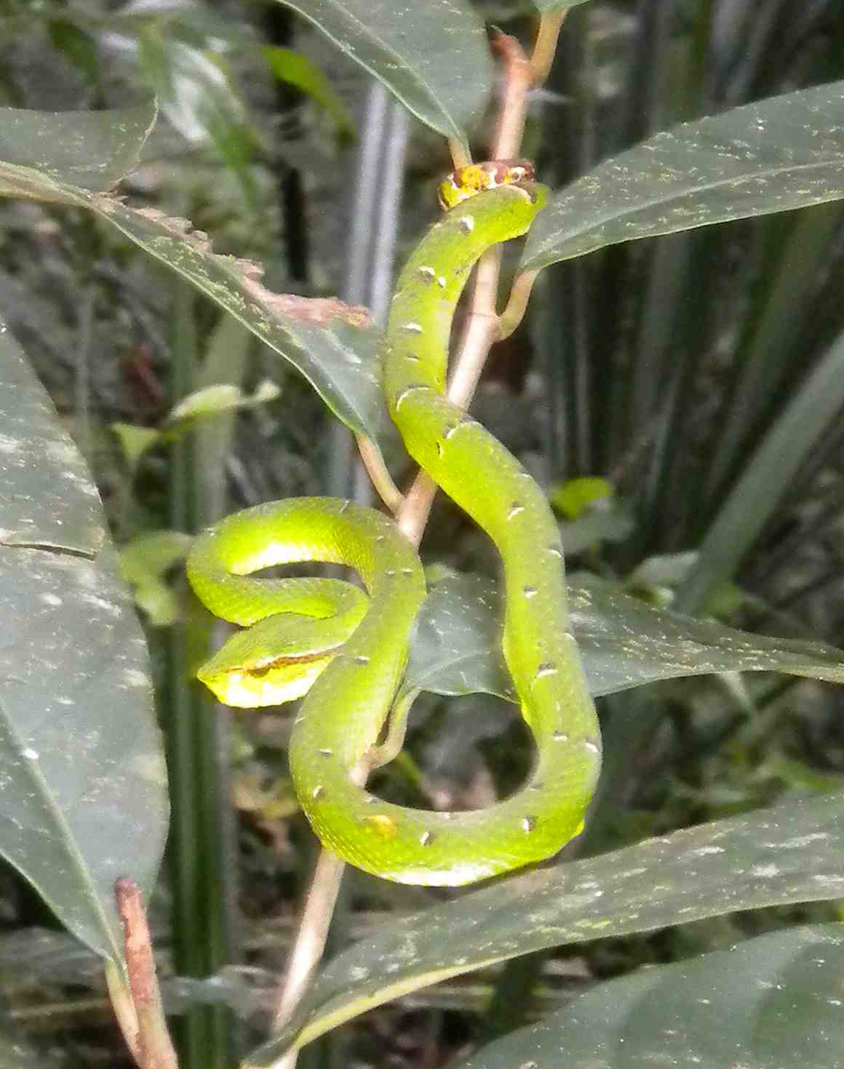
Village life did not take long to adjust to. At first the idea of waking up at six in the morning sounded like an ordeal, but we soon realised that there was not any breakfast rice left after seven, so it was worth the early alarm. We would not have been able to sleep in much longer anyway because of the noise of the chickens, who were woken up by the sunrise.
My house in Labundo. It was built on stilts to keep the snakes out.
My first week consisted of lectures about the ecology of the Wallacea region. The island archipelago is rich in endemism, resulting in high biodiversity. Being on the Australian side of the Wallace line, the fauna includes marsupials, such as tarsiers. We also participated in a comprehensive habitat survey, which will be compiled with 40 others to provide evidence for REDD funding for Lambusango National Park.
Following our ecological training, we were introduced to the terrain with a three-day trek. We were accompanied by guides but carried our own food and hammocks.
Green pit viper.
The first day involved crossing a river, walking through paddy fields and a flat two-hour walk into the rainforest. Despite the walking being easy, we were soaked in sweat by the time we reached the first camp. Here our guides helped us to put up our hammocks, mosquito nets and bashas. We were provided with lunch and drinking water, but from then on we were supposedly self-sufficient.
The afternoon involved a navigation exercise where we followed a guide for an hour, counting our paces and taking a compass bearing at every change in direction. We attempted to draw an accurate map of the route we had been taken on. Following this, we were taught how to make shelters from wood and a plant called rattan. We then lit campfires to cook rice. Immediately the group divided responsibility, with the girls in charge of the food and the boys the fire, based on the inability of the girls to keep the fire going. It was a wet evening so people went to their hammocks fairly early, in anticipation of the walk the next day.
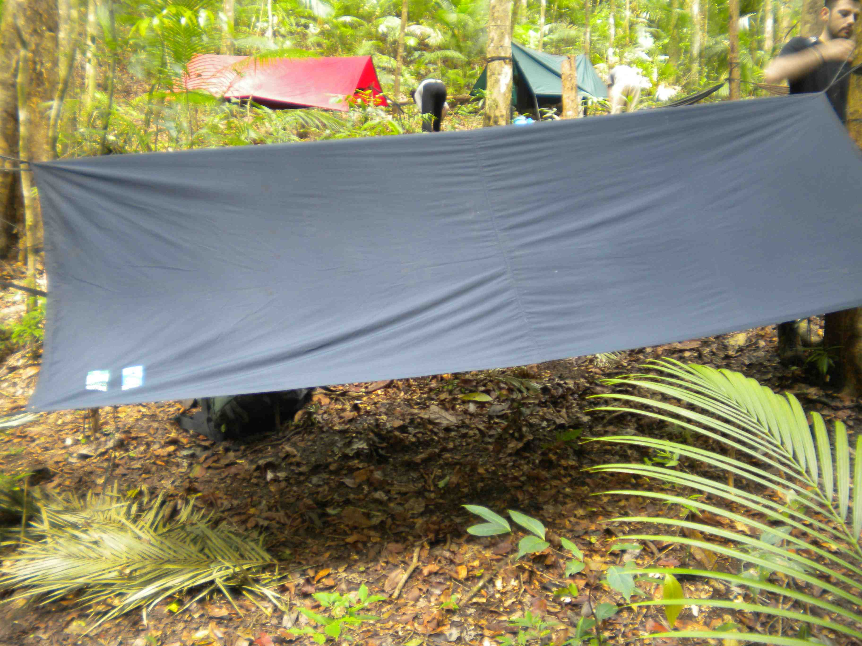
The second day’s walking was much harder than the first. The walk was steeper and the night’s rain meant that we spent more time on the forest floor than actually walking. The guides had fun laughing at us. We stopped halfway to practise more survival skills, such as frying eggs in leaves and drinking water from lianas.
We slept in hammocks at node camps. They had bashas to keep us dry, and mosquito nets.
After setting up camp on the second night we climbed to the top of the hill to watch the sunset. You could see over the forest canopy right to the sea. We spent the evening sat around a campfire playing Mafia.
This was the end of the jungle training. The following day involved trekking back to Labundo and a fully clothed swim in the river, respecting the local custom of modest dress. It was a Wednesday, which meant it was party night. In the evening, the staff set up a tarpaulin outside the office and played songs from students’ iPods. We were allowed to drink local beer and were given coconut rice for dinner.
Following the first week’s training I began assisting with research projects. In my second week, I helped survey birds at Bala camp, a three-hour trek away from Labundo. Bird surveys were taken as ten-minute point counts at 300m intervals at dawn and dusk. The birds were identified by their calls, while we estimated their distance from the point. This involved waking up at half past four in the morning, which was surprisingly refreshing. We saw many birds including knobbed hornbills.
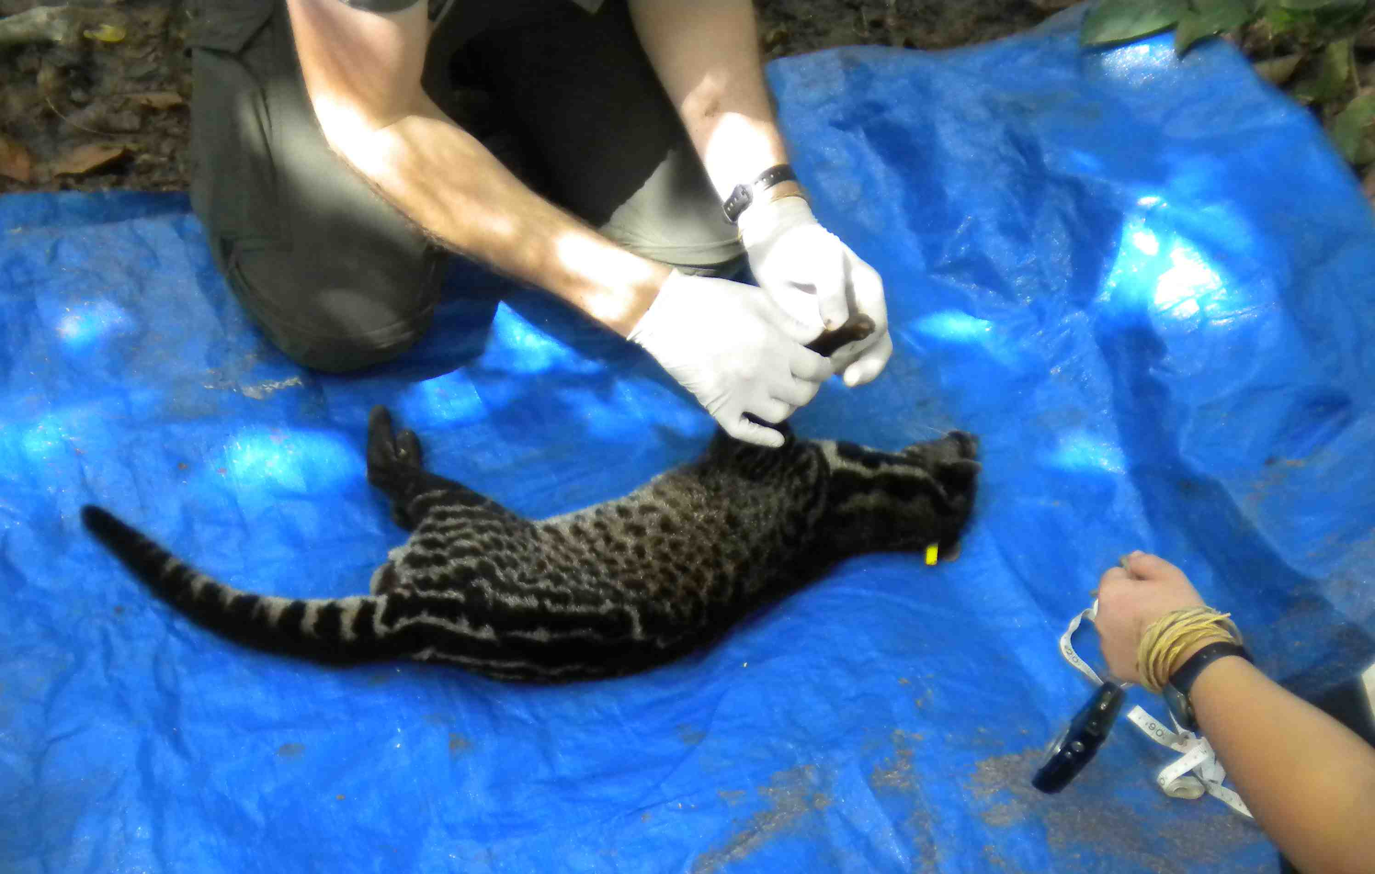
My third week was based in Labundo doing civet population estimates. We walked along two six-kilometre transects each day, baiting traps for civets. When a civet was caught we tranquilised it with ketamine, before measuring, weighing and tagging it. In the event of recapture, the tag allowed for easy identification.
My final week doing terrestrial research was at Lapago base camp, an hour’s walk from Labundo. The first half of this week involved following macaques to assess their behaviour. We would find a troop waking up at six in the morning in one of the five strangler fig trees in our plot. For the rest of the day we would record each individual macaque’s behaviour every twenty minutes. Conflict was noted whenever it occurred. The troops did not mind us following them, but were known to throw their faeces at humans. Macaques occasionally jumped onto branches that failed to support their weight. This resulted in an enormous fuss from the embarrassed monkey.
Taking anatomical measurements of a civet. Ketamine was used as a tranquilizer.
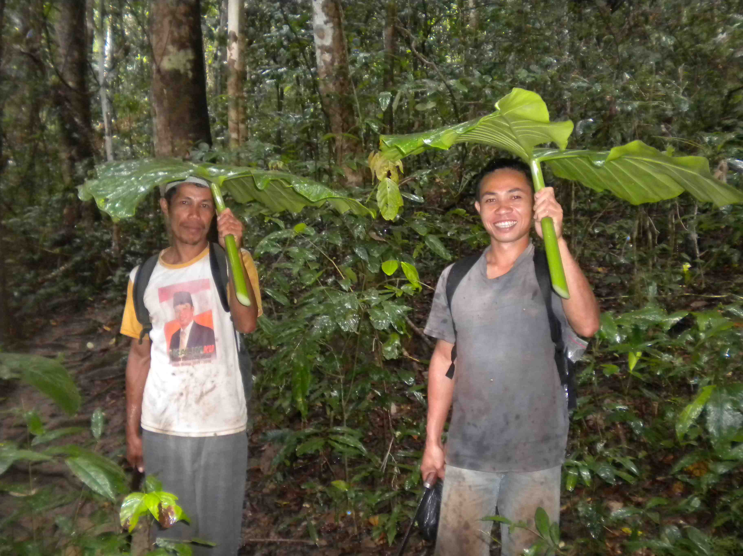
I spent the last few days in Lapago helping to survey butterflies to see whether their biodiversity and abundance was different than in Labundo based on reduced human disturbance. This involved ten-minute point counts in each corner of five plots.
As well as assisting on these four projects I visited a bat cave, saw a poisonous pit viper, looked for tarsiers in strangler fig trees and waded up rivers at dusk searching for frogs. We also learnt how to make bracelets out of rattan, learnt some vital Indonesian phrases (including ‘hati hati kamu mati’ – be careful or you will die) and swam in rivers. This month was absolutely fantastic.
Laduni and Sahudin staying dry during a quick ‘shower’.
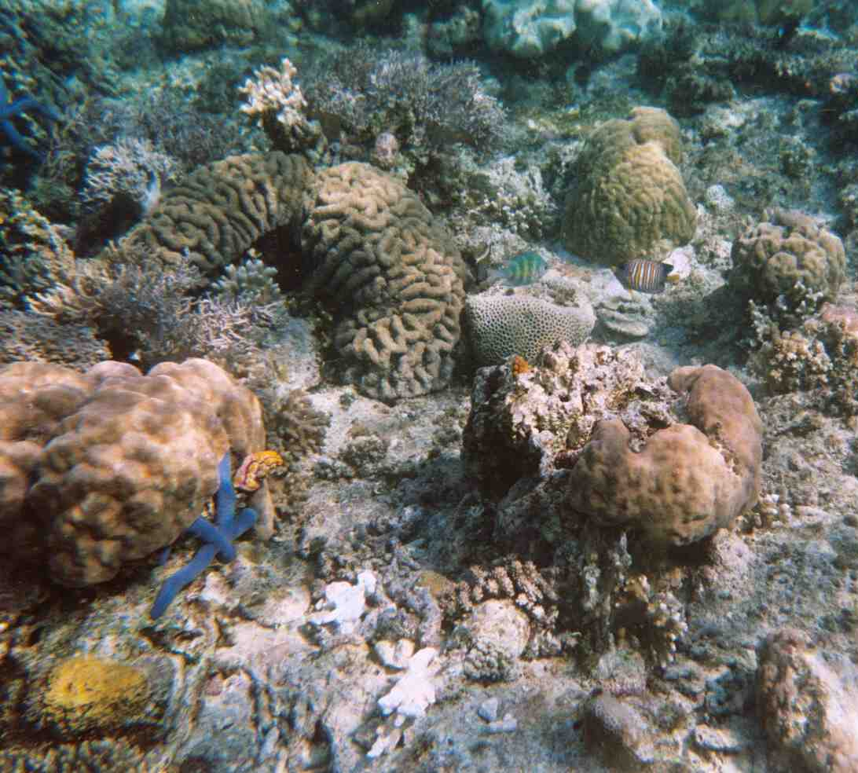
Leaving Labundo and travelling to the marine research base at Hoga Island took two ferries. I underwent a larger culture shock arriving at Hoga than when I reached London two weeks later – the Hoga base was much more luxurious than Labundo, with beds to sleep in, iced juice at lunch and a flushing toilet (as well as squat toilets).
My first week on Hoga consisted of learning how to scuba dive. I followed this up with my PADI advanced diving course in my second week, to improve my buoyancy, so that I could get closer to the reef without damaging it.
On completing our PADI open water courses we were allowed to participate in the coral ecology course. This taught us how to identify different corals, invertebrates, algae and fish. We visited pristine reefs as well as damaged reefs from local blast fishing and we went snorkelling amongst mangrove trees.
The regal angel fish (right hand side) was my favourite fish.
Unfortunately these essential courses took up all the time I had at Hoga, preventing me from assisting with the research projects. I would recommend that those considering doing Operation Wallacea learn to dive in the UK first.
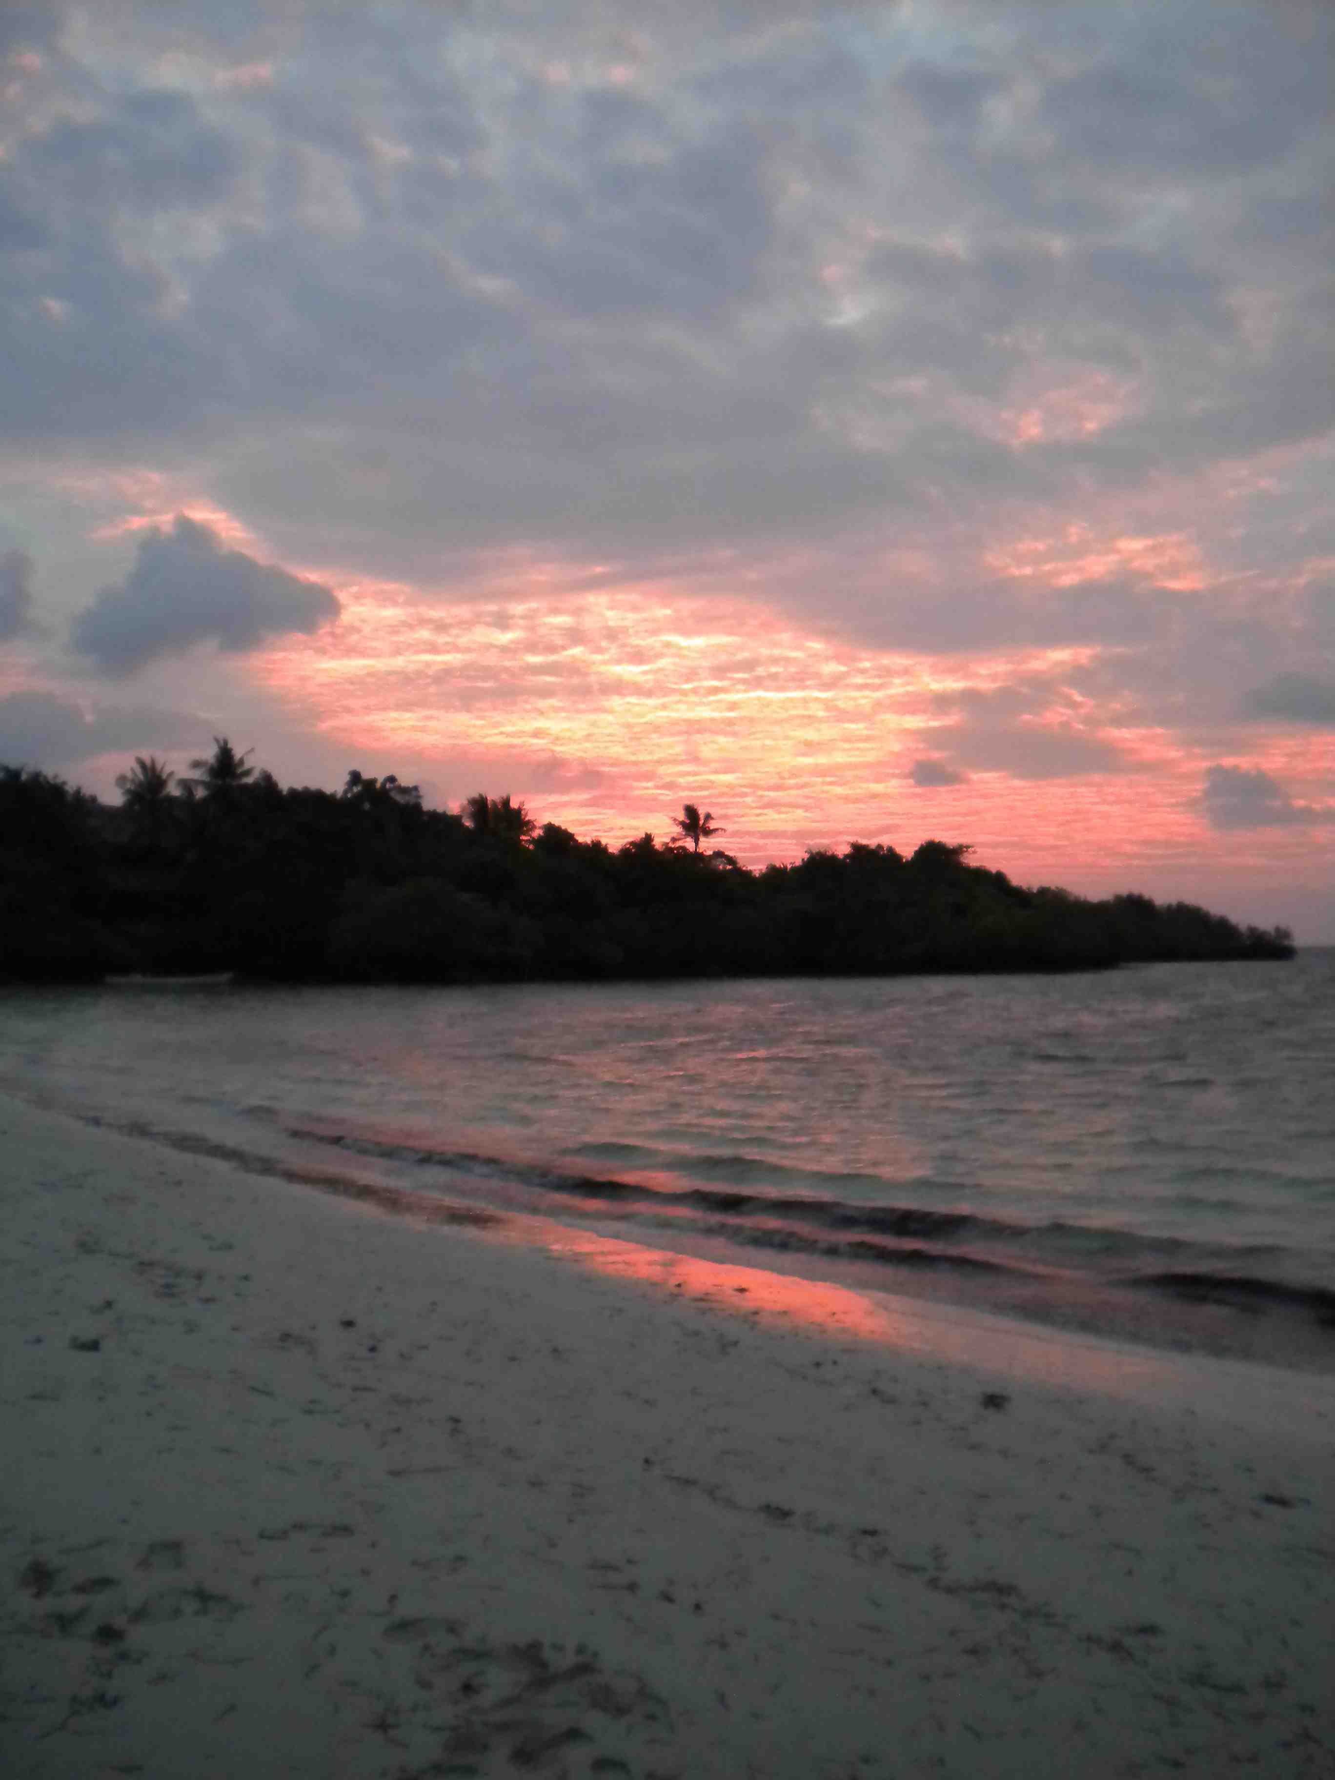
Overall the trip was absolutely amazing. The ecology was beautiful and the local people were so friendly. I thoroughly enjoyed myself and would definitely recommend the trip. The experience has given me an appetite for rainforest research, which I will consider pursuing after my undergraduate degree.
Thank you very much for the support.
Sunrise on Hoga Island.

