DAVIS EXPEDITION FUND

REPORT ON EXPEDITION/PROJECT

Expedition/Project Title: Palynological characterisation of Amazonian rainforest communities

Travel Dates: 01 July 2006 – 14 August 2006

Location: Noel Kempff Mercado National Park, Northeast Bolivia

Group Member: Michael Burn

Aims: To determine the characteristic pollen-rain signatures of three Amazonian rainforest communities (Terra firme liana forest, seasonally-inundated forest and riverine forest).

OUTCOME (not less than 300 words):- A full report is presented below.

Rationale
There is an urgent need to improve our interpretation of Amazonian fossil pollen records in order to better understand Amazonian palaeoecology and palaeoclimatology. The resolution of the long-standing debate on the extent of the Amazonian Rainforest during the Last Glacial Maximum (Haffer, 1969; Colinvaux, 1996; Pennington et al., 2000) is strongly dependent on sound understanding of fossil pollen records. Unfortunately, considerable uncertainty and speculation has arisen regarding the interpretation of these records, primarily because of the sparse distribution of fossil pollen sites (Mayle et al., 2004). Ecological inferences derived from fossil pollen assemblages are very simplistic and ignore the structural and floristic complexities of Amazonian forests and savannahs. Determining the characteristic pollen-rain signatures of different Amazonian plant communities is one way in which progress can be made in this field of enquiry. Interpretations of fossil records may then be made on the basis of phytosociological changes through time, rather than just on changes in the relative abundance of one or two taxa.

Project Aims
In order to improve the interpretation of Neotropical fossil pollen records within Noel Kempff Mercado National Park, Northeast Bolivia, Gosling, (2004) utilised a variety of statistical techniques to successfully characterise and differentiate terra firme evergreen forest, semi-deciduous dry forests and savannahs by modern pollen spectra obtained from a series of pollen traps situated within vegetation plots in the park. Our aim is to develop this work further and to attempt to distinguish between four rainforest communities (terra firme evergreen, evergreen liana, seasonally-inundated and riverine forests) using the pollen spectra produced by each. The data will then be compared with fossil pollen spectra obtained from core-top samples from Laguna Chaplin and Laguna Bella Vista (Figure 1) and from a suite of lakes surrounded by rainforest in the Beni Basin, Northern Bolivia, in order to test for similarity between pollen trap and lake surface samples.

Site Description
Noel Kempff Mercado National Park (NKMNP; Figure 1) is a 15,230 km² biological reserve in northeast Santa Cruz, Bolivia, which occupies part of the southwest margin of the Amazonian Biome. It is situated on an ecotone between moist evergreen forest and cerrado (savannah) ecosystems and provides a physical setting that supports considerable ecosystem diversity (Killeen et al., 2002). Detailed floral inventories were obtained from twenty-two plant communities within NKMNP between 1993 and 2000 by Killeen and Schulenberg (1998) and are readily available from the Salvias Project database (2006). Study sites were selected from within a range of representative forest communities identified by field expeditions, fly-bys and LandSat images (Killeen and Schulenberg, 1998). Two one-hectare quadrats (500m × 20m) were set-up for each of the studied communities and installed in visually homogeneous forest in order to minimize intra-plot heterogeneity. Between 1999 and 2001, pollen data were retrieved from a series of ten pollen traps within each plot in order to be compared with the surrounding vegetation. Pollen analysis on sediment cores obtained from two large lakes, Laguna Chaplin (14º28'S, 61º04'W) and Laguna Bella Vista (13º37'S, 61 º33'W) have revealed changes in vegetation and fire dynamics over the last 50,000 years (Burbridge et al., 2004; Mayle et al., 2000).

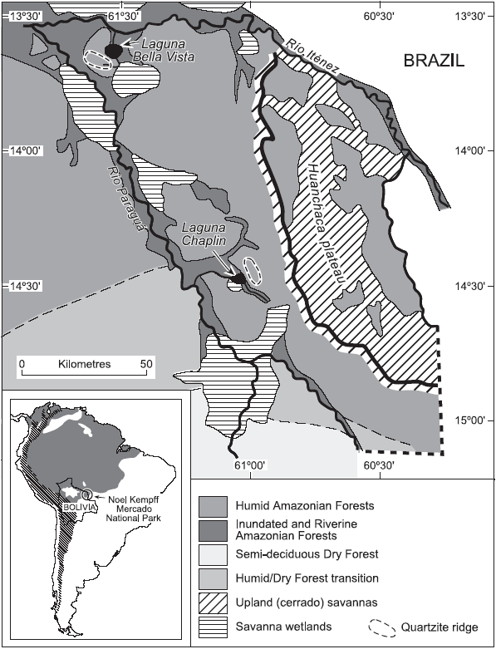

Figure 1: Location and vegetation map of Noel Kempff Mercado National Park situated on the SW margin of Amazonia. Source: (Burbridge et al., 2004)

Fieldwork Aims
Fieldwork was undertaken within the NKMNP and the Beni Basin in July and August 2006. The principal aims were:

- To collect surface sediment pollen samples from a suite of lowland Neotropical lakes within rainforest communities of the Beni Basin.
- To collect pollen from plant species not yet represented in the Neotropical reference collection held at the Institute of Geography, Edinburgh University.
- To gain experience in tropical plant identification and a better ecological understanding of Neotropical plant communities under the instruction of Botanists of the Natural History Museum of Santa Cruz in Bolivia.

Interim Results
Research on the surface samples obtained from five lakes surrounded by rainforest communities within the Beni Basin (14º59'; 65º40') is ongoing. The lakes cored were: Laguna Isirere, Oxbow 1 (no name), Laguna Huachi, Laguna Puente de Ibare, and Laguna Loma Suarez.

Preliminary results of pollen rain data obtained from rainforest communities within the NKMNP suggests that they can indeed be differentiated by their pollen spectra, which has implications for the interpretation of the “rainforest signal” lodged in many Amazonian fossil pollen records. These include key sites such as Laguna Chaplin and Bella Vista (Mayle et al., 2000), the Amazon Fan (Haberle and Maslin, 2000), and Lake Pata in central Amazonia (Colinvaux et al., 1996).

The analysis of modern reference pollen collected from the NKMNP in June 2006 indicates that we are able to distinguish key pollen types of the mulberry (Moraceae) and nettle (Urticaceae) families. Moraceae, one of the most abundant and ecologically important families growing in tropical rainforests of Central and Southern America, has hitherto only been identified to the family taxonomic level and grouped with Urticaceae in fossil pollen diagrams. Many of these pollen types are indicator species, such as Maquira coriacea, which is restricted to varzea (floodplain) forests throughout the Amazon Basin. Our ability to distinguish indicator taxa of the Moraceae family may help resolve much of the controversy surrounding the interpretation of key fossil pollen sites across the Amazon Basin (Colinvaux and De Oliveira, 2000; Pennington et al., 2000; Bush et al., 2004; Anhuf et al., 2006). Research is ongoing.

Acknowledgements
The author would like to thank the Davis Expedition Fund at Edinburgh University for generous financial assistance. Thanks are also extended to the Quaternary Research Association’s for their financial support and to my fieldwork colleagues Bronwen Whitney, Huw Jones and Francis Mayle whose invaluable hard work and determination are much appreciated.

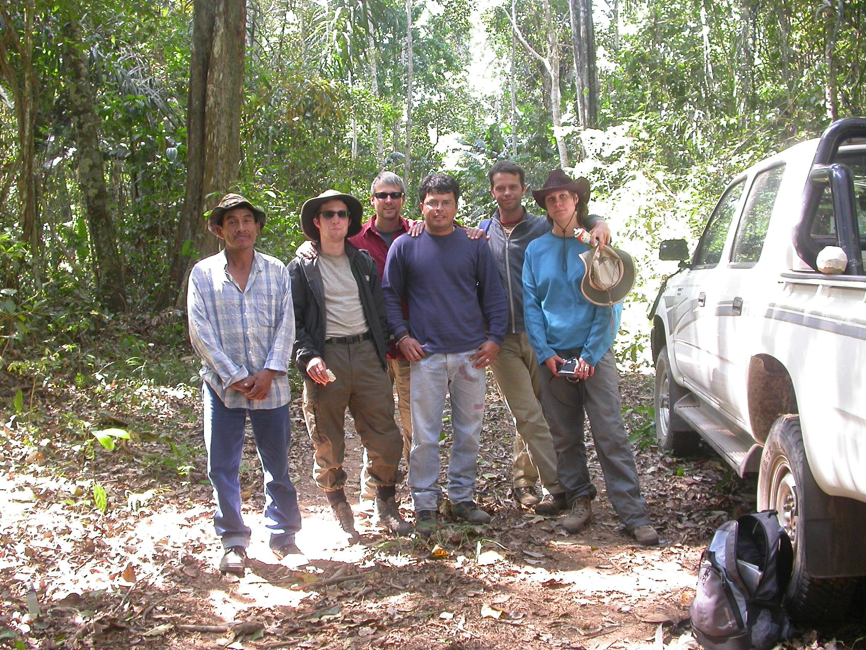
Working at Los Fierros, NKMNP, from left to right: Juan, Huw Jones, Francis Mayle, Ezequiel Chavez, Michael Burn and Bronwen Whitney.

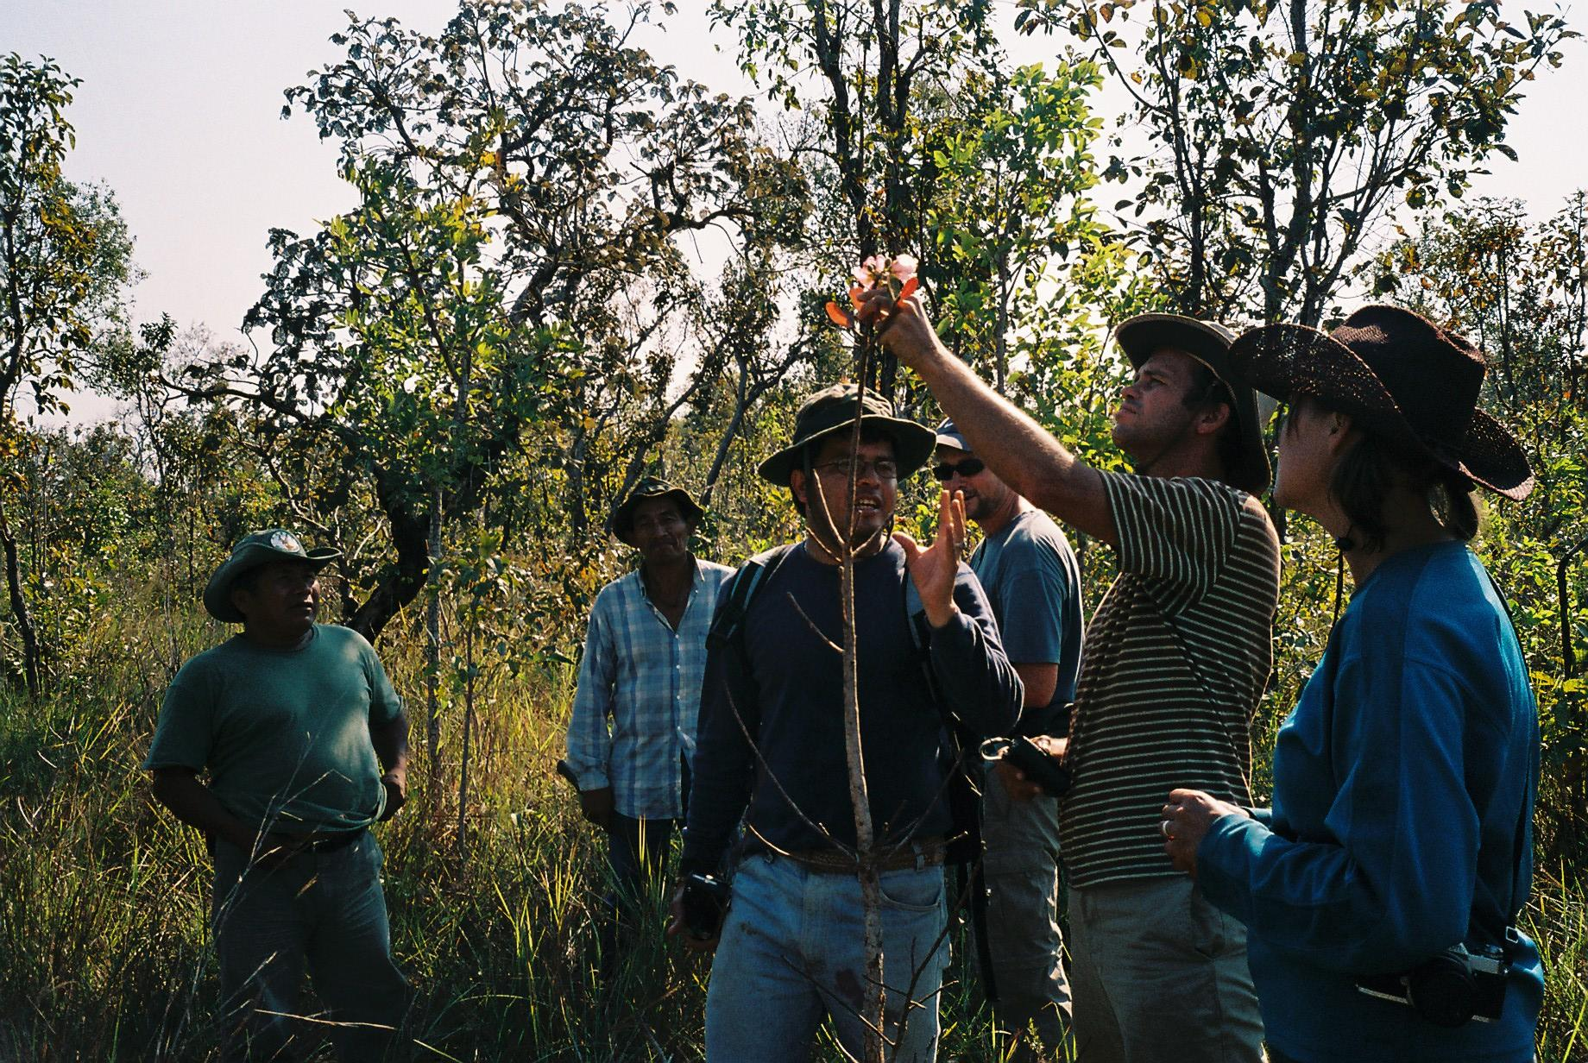

Getting to know the local flora under the instruction of Ezequiel Chavez, a botanist at the Natural History Museum of Santa Cruz in Bolivia.

References

Bush, M.B., de Oliveira, P.E., Colinvaux, P.A., Miller, M.C. and Moreno, J.E. 2004: Amazonian paleoecological histories: one hill, three watersheds. Palaeogeography, Palaeoclimatology, Palaeoecology, 214, 359-393.

Colinvaux, P.A., De Oliveira, P.E., Moreno, J.E., Miller, M.C. and Bush, M.B. 1996: A long pollen record from lowland Amazonia: forest and cooling in glacial times. Science, 274, 85-88.

Haffer, J., 1969: Speciation in Amazonian forest birds. Science, 165, 131-137.

Pennington, R.T., Prado, D.E. and Pendry, C.A. 2000: Neotropical seasonally dry forests and Quaternary vegetation changes. Journal of Biogeography, 27, 261-273.

Mayle, F.E., Beerling, D.J., Gosling, W.D. and Bush, M.B. 2004: Responses of Amazonian ecosystems to climatic and atmospheric carbon dioxide changes since the last glacial maximum. Philosophical Transactions of the Royal Society London B, 359, 499-514.

Killeen, T.J. and Schulenberg, T.S. 1998: A biological assessment of Parque Nacional Noel Kempff Mercado, Bolivia. RAP Working Papers 10, Conservation International, Washington D.C.

Killeen, T. J., Siles, T. M., Grimwood, T., Tieszen, L. L., Steininger, M. K., Tucker, C. J., and Panfil, S. 2002: Habitat heterogeneity on a forest-savanna ecotone in Noel Kempff Mercado National Park (Santa Cruz, Bolivia): Implications for the long-term conservation of biodiversity in a changing climate. Ecological Studies, 162, 285-312.

Mayle, F.E., Burbridge, R.E. and Killeen, T.J. 2000: Millennial-scale dynamics of southern Amazonian rain forests. Science, 290, 2291-2294.

Burbridge, R.A., Mayle, F.E. and Killeen, T.J. 2004: Fifty-thousand year vegetation and climate history of noel Kempff Mercado National Park, Bolivian Amazon. Quaternary Research, 61, 215-230.

Haberle, S.G. and Maslin, M.A. 1999: Late Quaternary vegetation and climate change in the Amazon basin based on a 50,000 year pollen record from the Amazon Fan, ODP site 932. Quaternary Research, 51, 27-38.

Colinvaux, P.A. and de Oliveira, P.E. 2000: Palaeoecology and climate of the Amazon basin during the last glacial cycle. Journal of Quaternary Science, 166, 51-63.

Anhuf, D., Ledru, M.P., Behling, H., Da Cruz Jr., F.W., Cordeiro, R.C., Van der Hammen, T., Karmann, I., Marengo, J.A., De Oliveira, P.E., Pessenda, L., Siffedine, A., Albuquerque, A.L. and Da Silva Dias, P.L. 2006: Paleo-environmental change in Amazonian and African rainforest during the LGM. Palaeogeography, Palaeoclimatology, Palaeoecology, 239, 510-527.

The SALVIAS Project (2006). Published on the Internet http://www.salvias.net [accessed 9 December 2006].

