JAMES RENNIE BEQUEST

REPORT ON EXPEDITION/PROJECT/CONFERENCE

Expedition/Project/Conference Title: 8th Botanical Microscopy Meeting of the Royal Microscopical Society

Travel Dates: 31st March to 5th April 2007

Location: University of Salzburg, Salzburg, Austria

Group Member(s): Kathryn Lord

Aims: Oral presentation

OUTCOME (not less than 300 words):-

I should like to take this opportunity to thank the James Rennie Bequest for providing my travel expenses to attend the 8th Botanical Microscopy Meeting of the RMS in Salzburg, Austria. This meeting occurs once every four years and our research group have aimed to maintain an active part in these meetings. I was able on this occasion to present my first international talk entitled 'Multicellular Development in Fungi'.

The meeting covered many aspects of botanical microscopy. There were presentations of the latest developments in imaging technologies to be used in plant and fungal cell biology. From elemental analysis with transmission electron microscopy through to confocal live-cell imaging using a multitude of fluorescent probes. The intricate structure of the cytoskeleton, the cell wall and the cell organelles were all scrutinised with a plethora of micrographs and movies. There was much discussion of ‘little spherical structures’ which confounded their observers, artefacts of preparation, chemical versus cryo preparation for microscopy and many more topics of interest.

The opening speaker was Anne-Mie Emons from the University of Wageningen, Netherlands. An inspiring speaker, she had returned to microscopy after raising her family, to become a dynamic group leader emphasizing to me especially that it is possible to be a scientist, post-children. Other invited speakers included Barbara Valent (Kansas State), Karl Oparka (Edinburgh), Mark Fricker (Oxford), David Logan (St. Andrews) and Sid Shaw (Indiana). Many of the studies presented were of model organisms such as Arabidopsis and Neurospora, supplemented by studies on less widely studied organisms such as Cucurbita pepo. A general message one received from the meeting was the need to quantify microscopy and many examples of how this could be achieved where presented. Also a need for mathematical modelling was stressed.

In my talk I presented a study of multicellular development in the filamentous fungi Sordaria macrospora and Neurospora crassa. I included a series of low-temperature scanning electron micrographs and light micrographs providing a baseline for the description of perithecial development. The perithecium is the multicellular sexual reproductive organ of Neurospora and Sordaria. With its many different cell types it provides an excellent model system for the study of multicellular development in filamentous fungi. A major focus of my research is the morphology and developmental origins of different perithecial cell types. For this purpose I am analyzing wild type and developmental mutants with a wide range of correlative microscopy techniques. My presentation was well received by the audience and a valuable discussion ensued over lunch.

There was a poster session, including posters presented by other members of our lab, which again stimulated much interest across many areas of botanical science. The scientific meeting was supplemented by a trade exhibition by leading microscope manufacturers and journal publishers.

View from the conference of the Hohensalzburg fortress

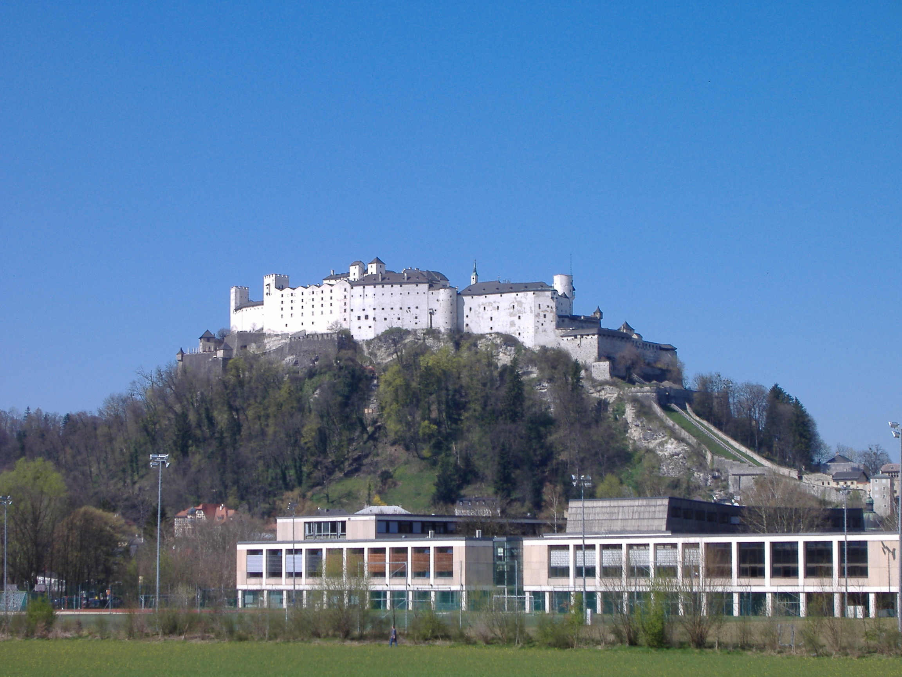

The meeting was held in the Faculty of Natural Sciences, University of Salzburg, situated within walking distance of the historic old town of Salzburg and in the shadow of the Hohensalzburg fortress. One afternoon there was time-out when an organised coach-trip of microscopists turned their eyes to the surrounding hills and lakes of the Austrian countryside. The vistas were spectacular and the cakes in the café in Bad Ischl were delicious. The conference dinner was held at the fortress and was preceded by a musical aperitif, including Schubert's Trout Quintet and two pieces by Salzburg's most famous son - Mozart.

Overall this was an invaluable experience for me, providing an excellent opportunity to discuss my work with experienced researchers and fellow PhD students alike. I should also like to thank my PhD supervisors Prof. Nick Read and Dr. Chris Jeffree for encouraging me to attend and present my work at this meeting.

Kathryn Lord

