REPORT ON EXPEDITION/PROJECT/CONFERENCE

Expedition/Project/ Conference Title: | 13th International Behavioural Ecology Congress (ISBE) 2010
Travel Dates: | 22 September 2010 to 22 October 2010
Location: | Perth, Western Australia
Group member(s): | Fiona Lethbridge
Aims: | 1) Present a talk on my PhD research entitled ‘Strategic ejaculation and its consequences in the beetle Callosobruchus maculatus’
 | 2) Attend conference talks and poster presentations
 | 3) Meet with Dr Joe Tomkins at the University of Western Australia and discuss research
OUTCOME (not less than 300 words):-

Having received a generous award from the James Rennie Bequest I was able to attend the 13th International Behavioural Ecology Congress, organised by the International Society for Behavioural Ecology (ISBE). The conference took place in Perth, Western Australia, between 26 September and 1 October 2010, and was attended by around 700 delegates from all over the world. ISBE holds international conferences biennially and I was fortunate that during the third year of my PhD the congress occurred in the beautiful surroundings of Perth; however it is only due to the generosity of the James Rennie Bequest that I was able to afford the significant travel costs involved in getting to Western Australia.

Covering the wide topic of behavioural ecology, the conference encouraged researchers involved in many aspects of biology to attend and present their work. This was an invaluable opportunity for me to see and hear about the wide range of research that goes on, and renewed my excitement and enthusiasm for science. Topics discussed during the five days of oral presentations included mating success in red deer, inbreeding in insects, alliances in dolphin populations, vocal mimicry in bowerbirds, and everything in between. Several parallel sessions ran each day, and although I focussed mainly on those talks specific to my area of interest (sperm competition and sexual selection), I enjoyed hearing about other aspects of behavioural ecology, which allowed me to take a step back from my research and see things from a different perspective.

I gave a talk entitled ‘Strategic ejaculation and its consequences in the beetle Callosobruchus maculatus’ on the penultimate day of the conference. Due to the presence of several eminent scientists in my field I found this a hugely valuable (and highly scary) experience, as I gained beneficial feedback and helpful comments from them. It is doubtful whether I would have ever had the chance to speak with these people had I not been able to attend this conference. Presenting a talk was also a great way to introduce myself and my interests to a wider audience, and numerous people approached me afterwards with research ideas.

One highlight of the conference was the selection of longer plenary talks, given by a number of notable scientists including Professors Nina Wedell, Jens Krause, Mariana Wolfner, Mats Olsson, Stuart West and Louise Barrett. These were interesting, entertaining and inspiring, and covered a wide range of research areas from social microbes to aggressive baboons. The Hamilton lecture by Nick Davies was also highly enjoyable.

There were three poster sessions during the conference week, which was a great opportunity to read and hear about research and findings in various areas of behavioural ecology. These were also great social occasions and a chance to meet with and chat to people in a less formal setting; I found this time particularly useful for introducing myself to others in my field and discussing research ideas with them.

Midweek there was a free afternoon, where I took the opportunity to travel north from Perth and visit the fantastic Pinnacles Desert; a strange red, dry landscape littered with naturally-formed limestone mounds. This was a great experience and unlike anything I had ever seen before.

After the conference I stayed in Perth for a while and took the opportunity to meet with Dr Joe Tomkins, a research fellow at the University of Western Australia who is a prominent scientist in my field of sexual selection. This was a great experience as Dr Tomkins showed me round the department and we discussed my research and its possible future direction.

Overall, my trip to Western Australia was excellent. The conference was both extremely valuable and enjoyable, and it was a unique opportunity for me to present my work and discuss my research with senior scientists in my field at a critical time in my PhD and as such I feel it has been vital in my career development. As my first trip to Australia I also found the experience great fun and full of exciting new sights and sounds. I am sincerely grateful to the James Rennie Bequest for their generous award, which allowed me to have such a worthwhile and beneficial experience.

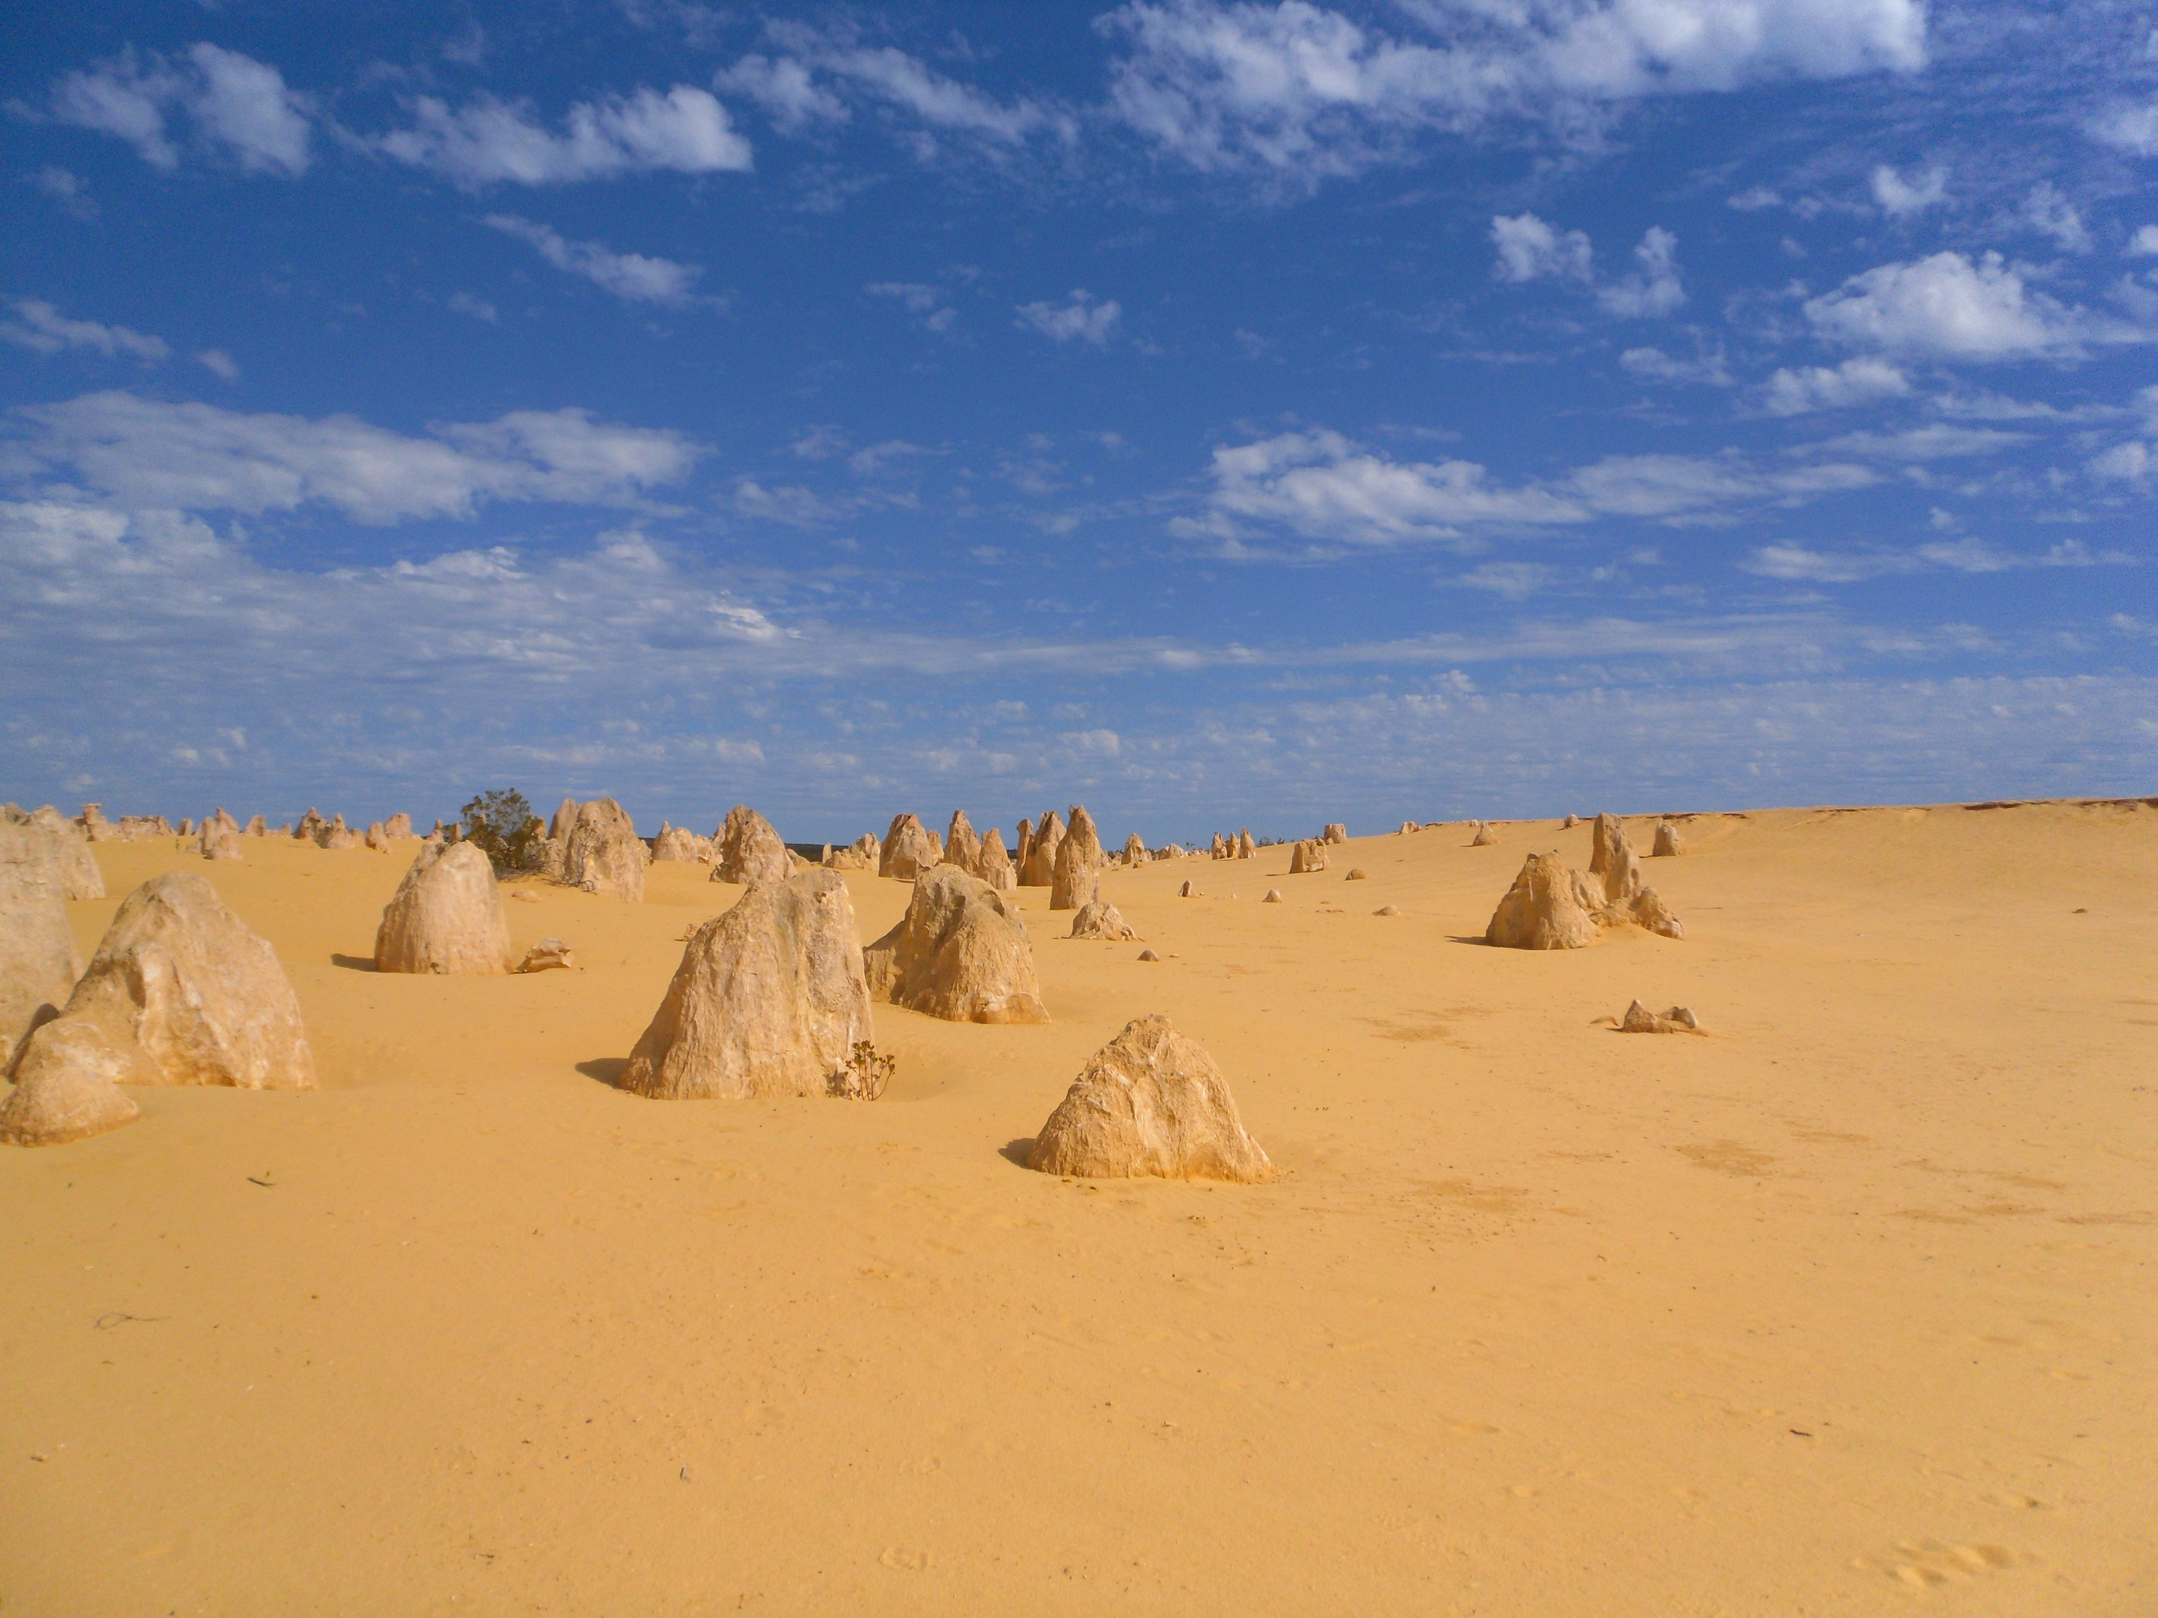
Pinnacles Desert, Western Australia.

