JAMES RENNIE BEQUEST

REPORT ON EXPEDITION/PROJECT/CONFERENCE

Expedition/Project/Conference Title: 41st Congress of the International Society for Applied Ethology (ISAE)

Travel Dates: 27/07/07 – 06/08/07

Location: Merida, Mexico

Group Member(s):

Aims: Presenting results of PhD studies, and networking with other Ethology researchers

OUTCOME (not less than 300 words):-

The International Society for Applied Ethology covers all applied aspects of ethology and other behavioural sciences, which are relevant to many human-animal interactions, such as farming, wildlife management, the keeping of companion and laboratory animals, and the control of pests.
The annual conferences are aimed at providing an international forum for scientists to communicate and discuss the results of their research. In 2007 the 41st conference was held in Merida, on the Yucatan peninsula of Mexico and it was title ‘Applying ethology to animal and ecosystem management’.

The conference was 5 days long and consisted of plenary papers, oral presentations, poster presentations and workshops. The keynote speakers included Professor Donald Broom who discussed ‘Cognitive ability and awareness in domestic animals and decisions about obligations to animals’, Professor Mike Mendl who discussed ‘Investigating the mental experiences of animals’, and Dr Jeff Rushen who discussed ‘Using knowledge of animal behaviour to improve animal health’.

I presented a poster entitled ‘Investigating the effect of feeding space on aggression and feeding behaviour of dairy cows’. The poster was designed from the first experiment I carried out as part of my PhD studies. The study investigated the effect of three different feeding space allowances on aggression and feeding behaviour in lactating dairy cows. Forty-five multiparous lactating Holstein Friesian cows were used in the study and cows were divided into 3 groups of 15 animals (balanced for stage of lactation and age). Each of the 3 groups experienced 3 different feeding space allowances, following a Latin square design. The space allowances were chosen to represent low (0.35m), standard (0.69m), and high (1.04m) allowances. Behaviours were continuously monitored using video cameras, specifically length of feed bouts, number of feed bouts and all aggressive interactions. Daily feed intake per group was also recorded. The number of displacements per cow was used to assess the competitive behaviour of cows at the feed face. It was found that there was a significant difference (p=0.016; F=60.42; d.f. =2) between feed intakes at the different space allowances, however, these differences did not confirm what was expected from the hypothesis. Feeding bouts were longer at the lowest feed-face space allowance (p=0.035) and the number of feeding bouts was significantly different between the lowest and highest space allowances (p<0.001). The number of aggressive interactions increased as the space allowance was reduced (p<0.001). Specifically, the number of displacements from the feed-face increased as the space allowance decreased (p=0.037). These results indicated that increased competition may adversely affect optimum feeding conditions. Subordinate animals may be more compromised than dominant animals at smaller space allowances.

During the conference several events were organised for conference delegates, including a welcome reception at Old University Building, Universidad Autonoma de Yucatan, excursions to several sites of interest in Yucatan, a Banquet, and a farewell party. During the excursions I visited Uxmal, a large pre-Columbian ruined Mayan city. I also had the chance to visit local cenotes. A cenote is a type of sinkhole containing groundwater, and are usually only found in the Yucatan Peninsula and some Caribbean islands.

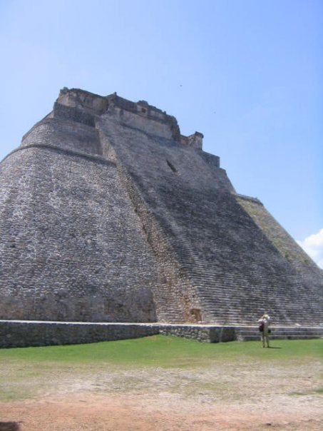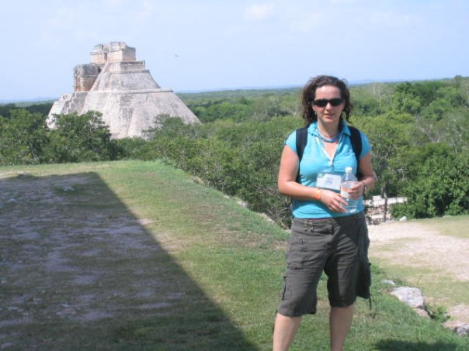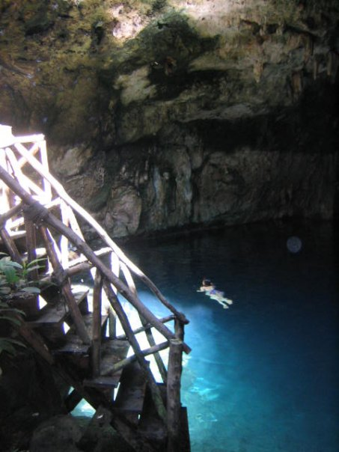

Above: pictures of Mayan pyramids at Uxmal, Yucatan, and a cenote (sinkhole).

I would like to take this opportunity to thank the James Rennie Bequest Fund for their generous contribution towards my attendance at the congress. It provided me with an excellent platform from which I could communicate my research to both students and academics. I enjoyed networking with animal behaviour researchers from all over the world and I hope to be able to attend ISAE conferences in future years.

