JAMES RENNIE BEQUEST

REPORT ON EXPEDITION/PROJECT/CONFERENCE

Expedition/Project/Conference Title: Operation Wallacea 2003

Travel Dates: 27th June – 27th July 2003

Location: Buton Island and Hoga Island, Sulawesi Region, Indonesia

Group Member(s): Emma Kennedy

Aims: To learn fieldwork skills; volunteer as a field assistant and work alongside university scientists to help achieve the conservation aims of Operation Wallacea; broaden knowledge and understanding of the flora and fauna of the rainforest and reef ecosystems of SE Sulawesi; and gain valuable work experience that will help with my career

OUTCOME (not less than 300 words):-


James Rennie Bequest

Report on Expedition

Operation Wallacea June - July 2003

Introduction
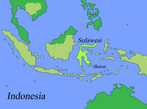
The coral reef biodiversity monitoring and bat diversity and distribution projects that I was working on this summer are both part of a much larger scientific programme, Operation Wallacea, that has been operating in the Sulawesi region (see Fig. 1) since 1995 and is currently the biggest scientific research project in Indonesia. The programme has been organized by a 60 strong team of university based academics, whose goal is to gather data which will help in the identification of priority areas for conservation and in their subsequent management.
Fig 1: Map showing Buton and Hoga island.

Buton Island Forest Research

The Lambusango and Kakenauwe reserves are the last remaining areas of undisturbed rainforest on Buton Island in Sulawesi, and one aim of Operation Wallacea was to raise the status of these reserves from Protected Area to National Park status in order to prevent local people from logging them. An application had to be submitted to the government detailing biological reasons and economic reasons supporting the case for the upgrade of the reserves status.
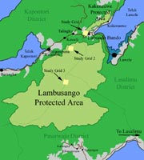
Operation Wallacea’s discovery of 21 new vertebrate species - including three bat species - within the reserves provided a biological argument, and the economic case came from the provision of alternative incomes to the villagers of Labundo Bundo, the village bordering the two reserves.

This summer, the objective of the program was to continue to work with the people of Labundo Bundo to lobby the government for enhanced status and to develop a detailed management plan for the Lambusango and Kakenauwe forests to ensure protection of the species found.

Figure 2: map showing the position of the grids on Buton Island

Three study plots have been established for the various forest projects (see fig. 2) each is 1km² and has trails cut across the plot every 100m to form a grid. Projects on small mammal populations, civet home ranges, birds, tarsiers, cuscus and anoa abundance, primate abundance and behaviour, impacts of ecotourism, forest management and sustainable usage and general biodiversity monitoring along with bat diversity and distribution are carried out within these grids and in Labundo Bundo, each project has its own aims but the findings from all the research is pooled to help achieve the aims of Operation Wallacea.

Bat Diversity and Distribution Project

This summer I spent a fortnight working with Dr. Tigga Kingston from the University of Boston on a bat project on Buton Island. The project, coordinated by Dr. Kingston and Dr. Stephen Rossiter of Queen Mary and Westfield College London is in its third year of monitoring on the Kakenauwe study plot, at the south-east tip of the reserve (fig 2).

Since the bat fauna of Sulawesi is poorly known - there have been no bat studies on Buton Island previous to this - the primary goal of Dr. Kingston and Dr. Rossiter’s research was to produce a preliminary description of the bat fauna of South-East Sulawesi. The projects main aim is the conservation of these bats, but since funds are limited, the immediate aims are to identify the most vulnerable of the forest species and so prioritize conservation efforts.

Figure 3.
Bat Conservation Justification
The overall aim of the project is bat conservation. There are three main reasons why the conservation of bats is important.

1. Taxonomic and ecological diversity. With 1111 known species, (209 from Indonesia) bats compromise a quarter of all mammal species, and this, coupled with the fact that they are an incredibly diverse group means they have a high existence value. Bats range in size from 1.5g to the 1.5 kg Pteropus vampyrus, the ‘flying fox’ with a 1.6m wingspan, they feed on a diversity of foods, from fruit to fish to insects to blood, and all have special adaptations to their diet, and this diversity is of great interest to scientists.

2. Utility. 186 paleotropical plant species rely on bat pollination or seed dispersal. One of these plants, the durian, is worth $120 million a year in South East Asia. Not only is there a strong economic case for bat conservation, but seed dispersal is important for forest regeneration, especially in Pacific islands, for example in the Krau wildlife reserve 14 species within a hectare plot are reliant on bat dispersal. As well as this, insectivorous bats eat up to 100% of their body weight each night, and are important in pest control, for example of cucumber beetles, june bugs and Jerusalem crickets in the United States.

3. Vulnerability. Low fecundity, prolonged maternal care and slow development are adaptations for life in stable, predictable habitats, so bats are vulnerable to habitat changes and act as important as indicators of forest disturbance. Recently many bats species have been experiencing range contractions and extinctions, the most significant causes of decline being habitat loss, commonly due to deforestation, cave disturbance (quarrying, mining, tourism, bird nest collection, guano mining and vandalism) and disturbance of old buildings (the UK is the only country that protects house dwelling species) where bats make their roost sites. Other factors causing their decline include the use of pesticides, especially organochlorines and endoectocides, which affect the insectivorous micro bats; persecution arising from mythology associating bats with the devil, Halloween and Dracula; and persecution triggered by health issues for example rabies, nipah virus (spread from bats to pigs to people) and histoplasmosis, a fungal infection of the lung caused by bat droppings in caves. In nearby Makassar we found bats hearts being sold as food. The vulnerability of bats means that today they are particularly at risk, and so their conservation is especially important.

Our project focussed on the small insectivorous bats that live within the forest since these are the species that are going to be most affected by changes in land-use. These bats are highly specialised with bodies designed for locating food in and manoeuvring through dense foliage. Living in an acoustically cluttered environment, they echolocate in a different way to bats found in open spaces or ‘edge’ bats, found in small clearings or on the forest edge, with short duration calls and very sophisticated adaptations such as flutter detection to distinguish between insects and vegetation, soft low intensity calls and the ability to sweep through a broad bandwidth of frequencies, to get accurate positioning. As the forest disappears or becomes more open due to selective logging, the specialised forest bats can not compete with the generalist bats found in edge or open areas – their small bodies get tired too fast, and so they are the projects priorities. In our particular study area, logging by local people in the south-west corner of the grid has caused changes to the forest as far as 500m in from the disturbance, mainly by drying out the forest, and decreasing biomass. These changes make the forest more accessible to generalist species. We set up harp traps (see fig. 4) in the study plot to find out more about them.

To identify the forest species most at risk, we were looking for patterns of species abundance and comparing this to differences in the forest to make extinction risk predictions. Patchily distributed clusters of bats are more at risk from extinction than bat species that have a more evenly spread distribution, since if the forest they are in becomes threatened the risk of extinction is higher.
This involved looking at where bats were caught, and using long term data to see whether bats from one summer were being recaptured in the same place in later years.

We also looked at longevity and populations, and tried to identify breeding seasons to help us predict how well certain species will be able to recover from large population losses, and thus identify the species most at risk. To do this we collected data on bats age, growth, sexual development and recapture rates.

Methods

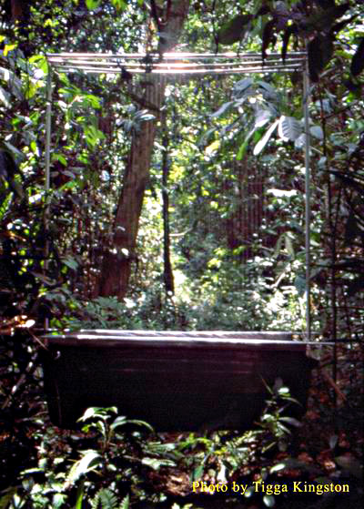
Based with a family in the village of Labundo Bundo, my job involved heading out the Kakenauwe Forest Reserve with another volunteer at 6am everyday (since dawn, and dusk, are the most active times for bats), and walking along the grid lines checking each trap for bats as we came across it. We’d collect the bats in soft bags, taking note of which trap they were taken from, and process them in the field, before releasing them where they were found.

Processing the bats involved identifying the species, (there were about 10 different species we commonly trapped) checking the sex, checking reproductive condition of females, measuring the forearm using calipers (this was the best indicator of size, since a bats weight varies considerably after feeding), and weight using a balance (the bat was in a sock), and estimating the age by shining a light through the wing: older bats had fused wing bones. Finally, before being released, a DNA sample would be taken from the wing membrane, and the bat would be marked with a lightweight metal wing band, with an identification number on it. All volunteers were taught to identify, handle and process the bats, and were monitored during processing.

Figure 4: Harp traps consist of thin vertical wires that can not be detected by bats, which ‘see’ horizontally. The bats fly into the wires and slip down into a large carpet bag, where they sit until collected. They are only suitable for trapping species with high frequency echolocation calls.

Next we dismantled the thirteen harp traps and moved them along to the next vertical grid line, setting them up along the path and surrounding them with natural vegetation to encourage the bats to fly through it rather than around the outside (see fig. 4). We’d spend the rest of the morning labeling up the paths and positions on the next grid line.

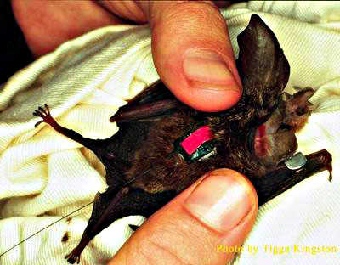
At 8pm we’d return to the reserve, and walk along the grid lines, again checking each trap for bats. Any Hipposiderus cervinus found in the trap we’d release (after checking sex, and for the presence of a ring tag) as these bats did not tend to do so well overnight in the lab, finding being taken back to the lab extremely stressful. Any other bat we put into a soft bag, labeled with exactly where it was captured, and took back to the lab for processing in the light. These bats were released in the morning.
We’d gently ping the harp strings of the trap before we left the reserve to remove any water which enables the bat to see the trap.
Figure 5: Kerivoula papillosa fitted with an 0.75g radio transmitter.

In addition to this, we helped Dr. Kingston with a radio tracking programme: we fitted one Rhinolophus philippinensis and two Kerivoula papillosa bats with radio transmitters and tracked them using a receiver attached to a three-element antenna in an attempt to locate their roosts as part of a more detailed long term study into roosting ecology. Roosts were identified by homing in on the highest amplitude signals.

Finally, we strung up mist nets in the village to look for bats found above the canopy or in more open areas like the village and crop plantations to the east of the reserve. The larger open space and edge bats tend to eat fruit or vertebrates and are less vulnerable to the land use changes in the reserve. Since these bats are bigger, fly higher and often hunt by sight rather than echolocation, harp traps can not be used to capture them. Unfortunately, the night we put up the mist nets the moon was full and there was enough light for the bats to see and avoid the nets.

Results
Since July 2000, when the bat project started, over 500 harp trap positions have been sampled and mapped, with 600 individual bats and 33 species being captured. We now know that the bat community at Kakenauwe is comprised of 29 species, 4 endemic to Sulawesi, 5 restricted range species and 2 new records for Sulawesi, with many of the species showing interesting divergence from current species descriptions that has to be looked in to. This summer work also began at the less disturbed site in central Lambusango Forest Reserve (see fig. 2).
Within the community three spatial distribution patterns have been identified. Bats like Rhinolophus trifoliatus show no spatial association, tending to roost under leaves when they are tired, while Hipposiderus cervinus show a spatially clumped distribution, being found in cave roosts or old trees. The third pattern was one of ‘variable hotspots’ found in a clumped distribution that changes from day to day. Broad habitat differences did not seem to effect distribution, indicating that it was more subtle factors like certain vegetation that influenced the patterns.
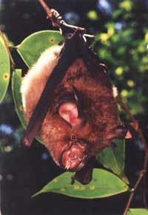
Dr. Kingston and Dr. Rossiter are also developing a library of calls for the insectivorous bats belonging to the open-space and edge communities since these can avoid mist nets but can not be captured in harp traps or caught on flick nets in bamboo poles. Calls are time expanded and recorded onto a cassette recorder before being analyzed by a program BATSOUND. Once established, the library will allow students to take acoustic transects.
The project is still young and there is still a lot of work to be done, but the progress has been impressive.
On a more personal level, I gained a lot of fieldwork experience, being taught how to recognize the three main families of bats, Rhinolophidae, Hipposiderae and Vespertilionidae, and how to handle and process the bats in the field. I learned a lot about the importance of bats, their biology and their ecology.

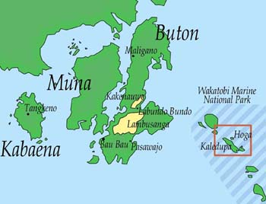
Hoga Island Coral Reef Research

In 1996 Operation Wallacea successfully lobbied for the ‘Wakatobi’ (Wangi wangi, Kaledupa, Tomea and Binongko – see Fig. 7) Islands of South East Sulawesi to be declared a Marine National Park. At 1.39 million hectares, Wakatobi is the second biggest protected area in Indonesia, and encompasses some of the most biologically diverse coral reefs in the world. A marine research centre was set up on the Island of Hoga (see fig. 6), from which scientists could examine the long-term trends in coral reef communities. An idea of coral reef dynamics over a number of years is essential if coral reef systems are to be managed sustainably, efficiently and appropriately in the mid- to long term.
Figure 6: Hoga Island and the Wakatobi Marine National Park in relation to Buton Island and Labundo Bundo.

Biodiversity Monitoring of Reefs

The aim of the project on Hoga is to balance the protection of the wildlife within the marine park area with the needs of the local 80,000 people who rely on the reefs and inter-tidal areas of the park for their livelihood. A stakeholder zone was established along the eastern coasts of one of the main Wakatobi islands, Kaledupa, and I was involved in helping monitor the changes resulting from this coastal zone management initiative.
Before I could do this, I spent a week at the research base of Hoga Island attending lectures by marine biologist Dr. Dave Smith from the University of Essex as part of an intensive coral reef course designed to prepare us with the background knowledge required to be able to be useful to the scientists as field assistants. Each set of lectures focused on species identification, field biology skills and survey techniques and was supported by a dive practical to consolidate lecture information and practice the skills needed by reef researchers. After a week I had to pass three tests to show that I was familiar enough with all the commonly occurring invertebrates, algae, hermatypic (reef-building) corals and major fish families to help with data collection for the coral reef monitoring programme, part of the long term survey to assess the changing health of the reef.
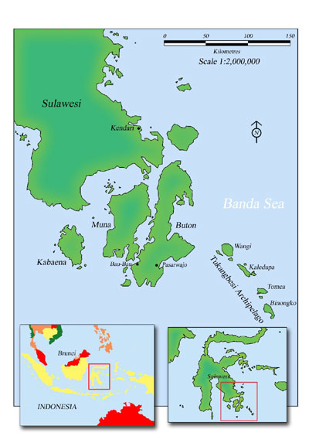
Figure 7: Indonesia is the worlds largest archipelago, and is the centre of the worlds coral reef diversity, with over ten times more species of coral than in the Caribbean, because the reefs are a lot older and lack of large scale disturbance events such as hurricanes and glaciation. In our lifetime, 90% of coral reefs will be lost.

The biodiversity monitoring programme was first established in 2002 during which time 108 permanent transects were laid at twelve stations around the Kaledupa Stakeholder Area. Nine sites were chosen within the area and three outside, at each site three permanent replicate transects were positioned on the reef flat, reef crest and upper reef slope.

The main aims of the programme were;
- To assess the diversity of the Kaledupa Stakeholder Area reef so it can be compared to other sites around the world.
- To provide data to support other studies in the area.
- To assess the change brought about by affording the reef Stakeholder protection, and to use this data as guidelines for protecting other reefs.
The project is coordinated by reef experts from the Indonesian Institute of Science who will examine the permanent transects repeatedly over the next five years. The monitoring programme provides the core data collection of the Coral Reef Dynamics research theme and underpins many of the other research programmes carried out by the Marine Team.

Methods and Results
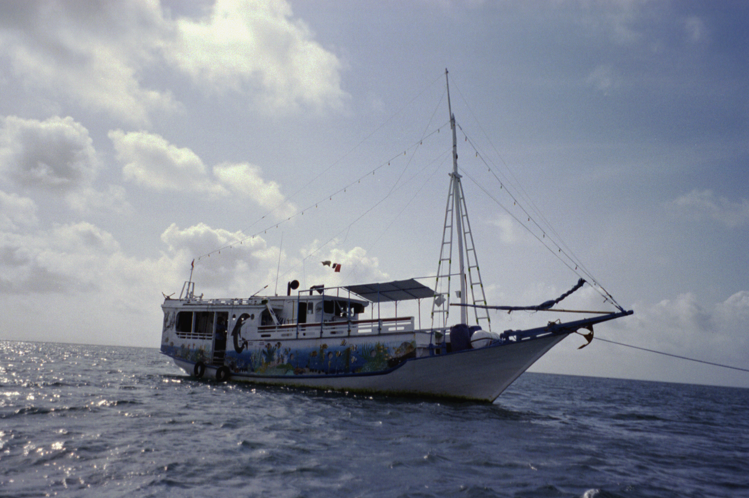
I lived aboard a boat, the Sama Bahari, with the monitoring team for a week and we did two dives each day, using the line-intercept technique for data collection. At each transect data was taken on the diversity and percentage of hard and soft corals, algae, dead coral and coral rubble, fish abundance and diversity, and abundance of ecologically and economically important invertebrate species. As a general volunteer I helped with the monitoring of ecologically and economically important invertebrate species. This involved swimming a 30m line transect and identifying the species and measuring the size of any giant clams, Acanthaster crown-of-thorns sea stars, sea urchins or holothurians (sea cucumbers) that I came across one meter to either side of the transect. Giant clams are a protected species but are still being caught in the Wakatobi national park. The giant triton Charonia tritonis is another protected species that is being exploited; it is a predator of the crown-of-thorns sea star, which predates on the reef. Cone shells and sea cucumbers are monitored since they are exploited commercially and have no legal protection.
Figure 8: the Sama Bahari, from which we surveyed the reef.
The data is collected in a form compatible with the monitoring programmes of five other sites around Indonesia, established by COREMAP and the Indonesian Institute of Sciences. Species diversity indices were later used to analyze the data collected.
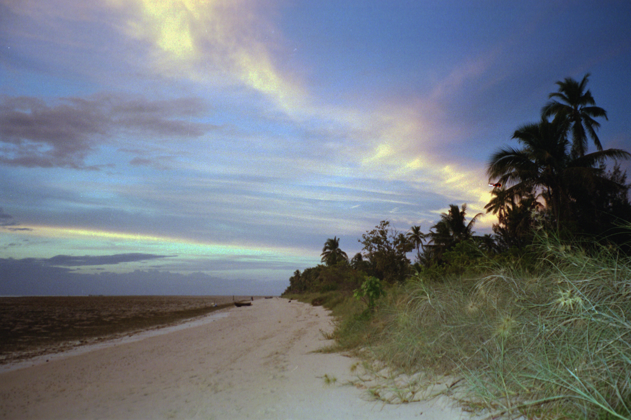
Figure 9: evening on Hoga Island, South East Sulawesi, July 2003

Acknowledgements
James Rennie Bequest for financial assistance with my airfare.
Operation Wallacea.
Dr. Richard Hayward of Edinburgh University for his references.
Dr Tigga Kingston of Boston University.
Dr. Dave Smith of University of Essex.

