JAMES RENNIE BEQUEST

REPORT ON CONFERENCE

Conference Title: 8th European Fungal Genetics Conference

Travel Dates: 8th of April – 11th of April 2006

Location: Vienna, Austria

Aims: Presenting my work

OUTCOME :

I attended the conference to give an oral presentation on my PhD subject; endocytosis in filamentous fungi, and it was very well received. There were several other presentations with a similar topic, and there were some useful discussions. An audience of approximately 100 people was present at my presentation and I did get some interesting questions. The regular presentation sessions were held in lecture theatres of the university of Vienna with capacity for approximately 200 people. It was by far the largest lecture theatre and audience I have presented to and was a very good experience for me. The plenary sessions were held in a large lecture theatre holding roughly 500 people. The first plenary session, given by Prof. Salomon Bartnicki-García, gave a very good overview of what has been done in the model organism Neurospora crassa to date. Prof. Louise Glass presented work on the Neurospora genome project, and an update on the progress of the Neurospora gene knockout project. Another interesting presentation was given by Prof. Kitamoto from Japan on the GFP tagging of a great number of different SNARE proteins and the endocytic uptake of a GFP labelled uracil permease in Aspergillus oryzae, the main microorganism of interest in Japan. Another member of the lab, Kirsten Altenbach, gave a talk on Fluorescence Resonance Energy Transfer imaging in the fungus Aspergillus niger, which was well received as well. During the meeting I met several people with an interest in my work and discussed the possibility of postdoc opportunities with two different groups. On the whole the feedback was quite positive and did get some good ideas for my future career. Vienna was a very lovely city and the conference program included a number of nice social occasions to see more of Vienna.

The first was the welcome reception in the Naturhistorisches Museum of Vienna, a picturesque old building. It included a night view of Vienna from its roof, which was an amazing sight.

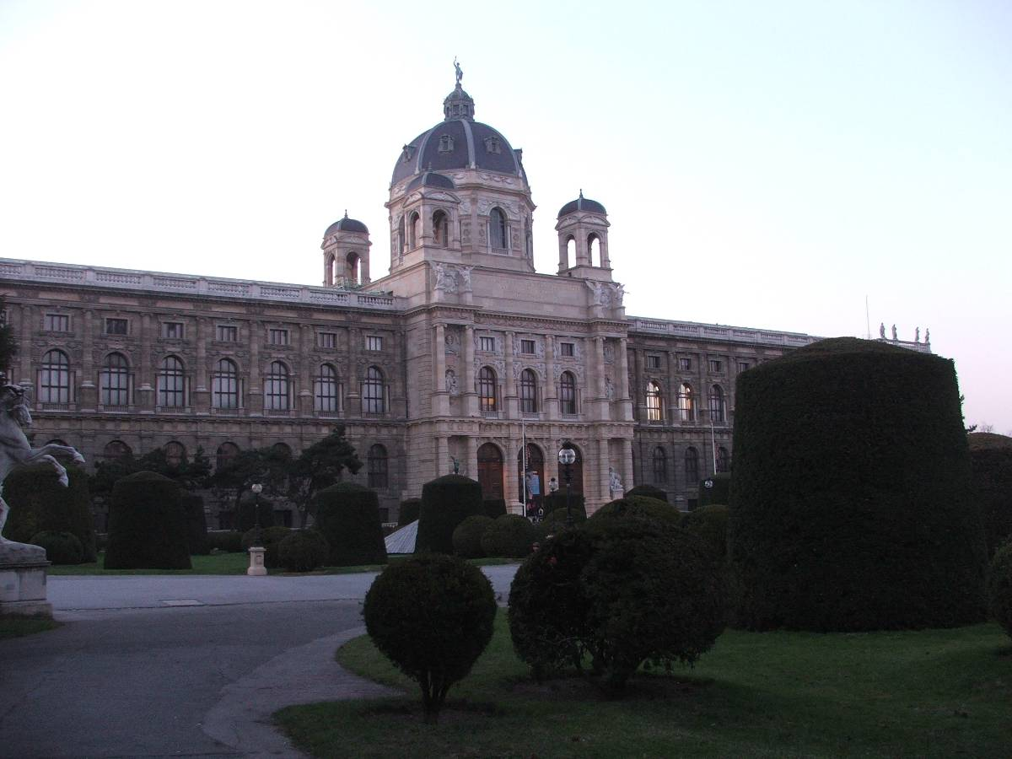
Naturhistorisches Museum of Vienna

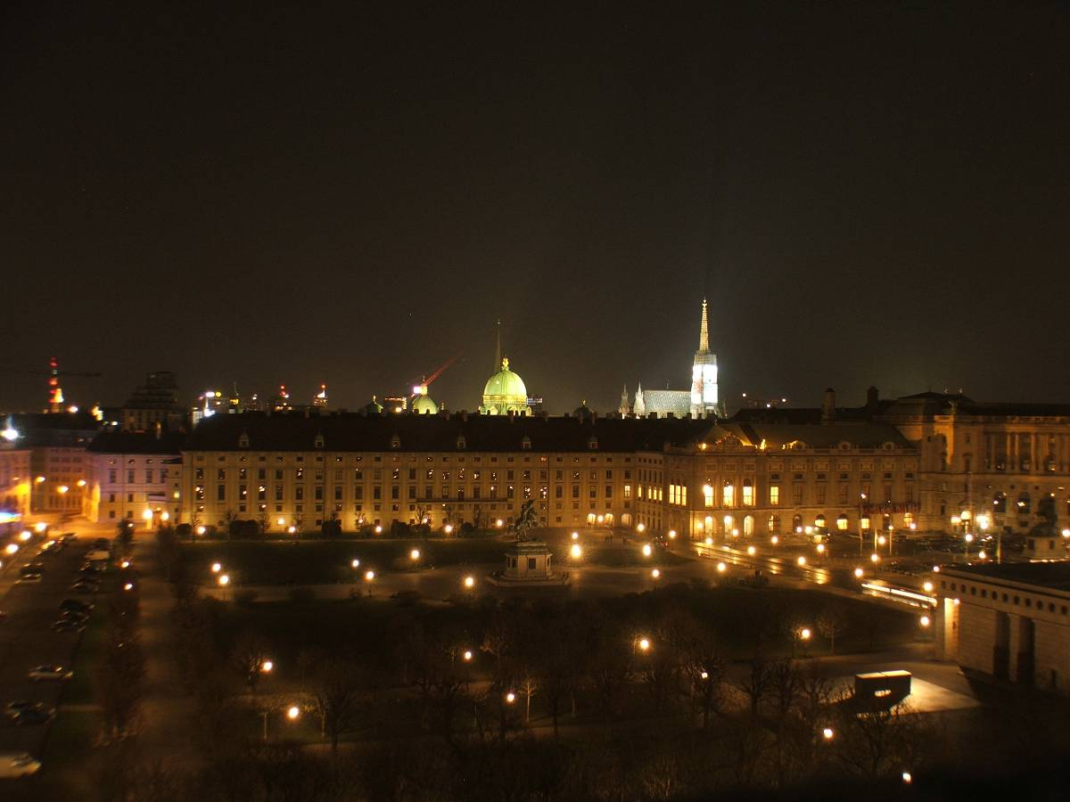
View from the roof of the Naturhistorisches Museum

Another social event was the reception at the Vienna City Hall, which gave a good opportunity for more informal discussions with other scientists.

The poster presentations were good for providing new ideas for my own research and an indication as to what research on filamentous fungi is going on all over the world. This was very useful for suggestions for postdoc positions.

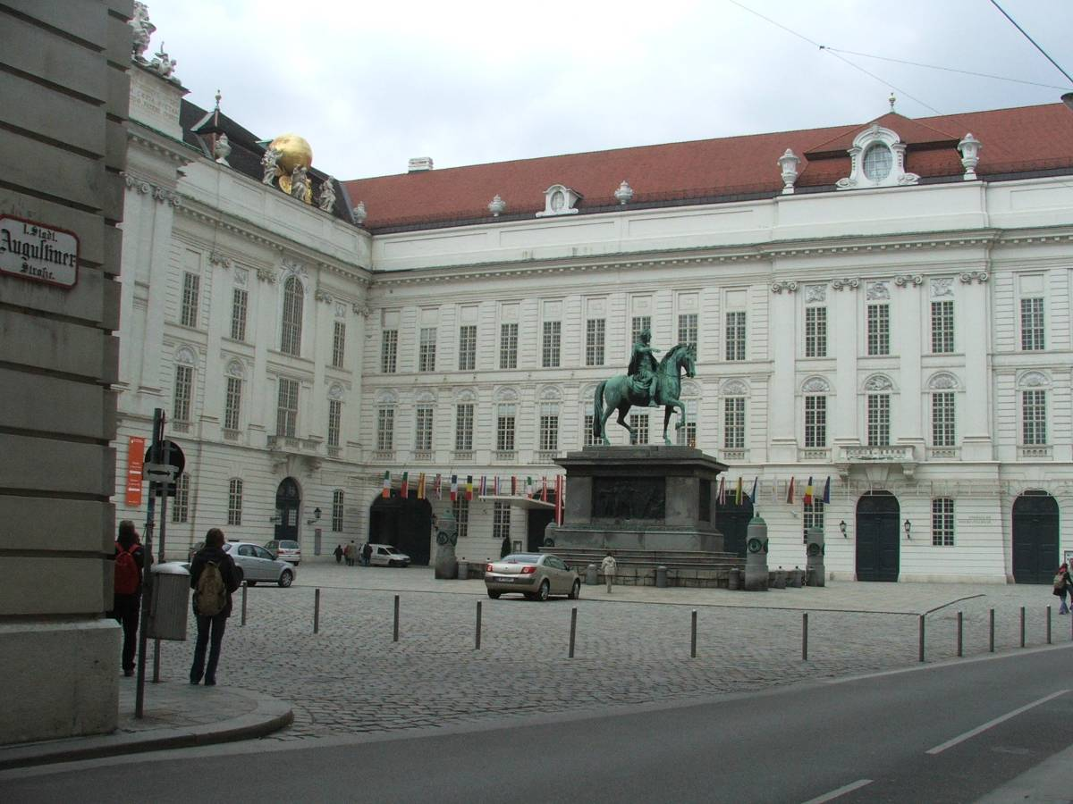
The Spanish Riding school of Vienna

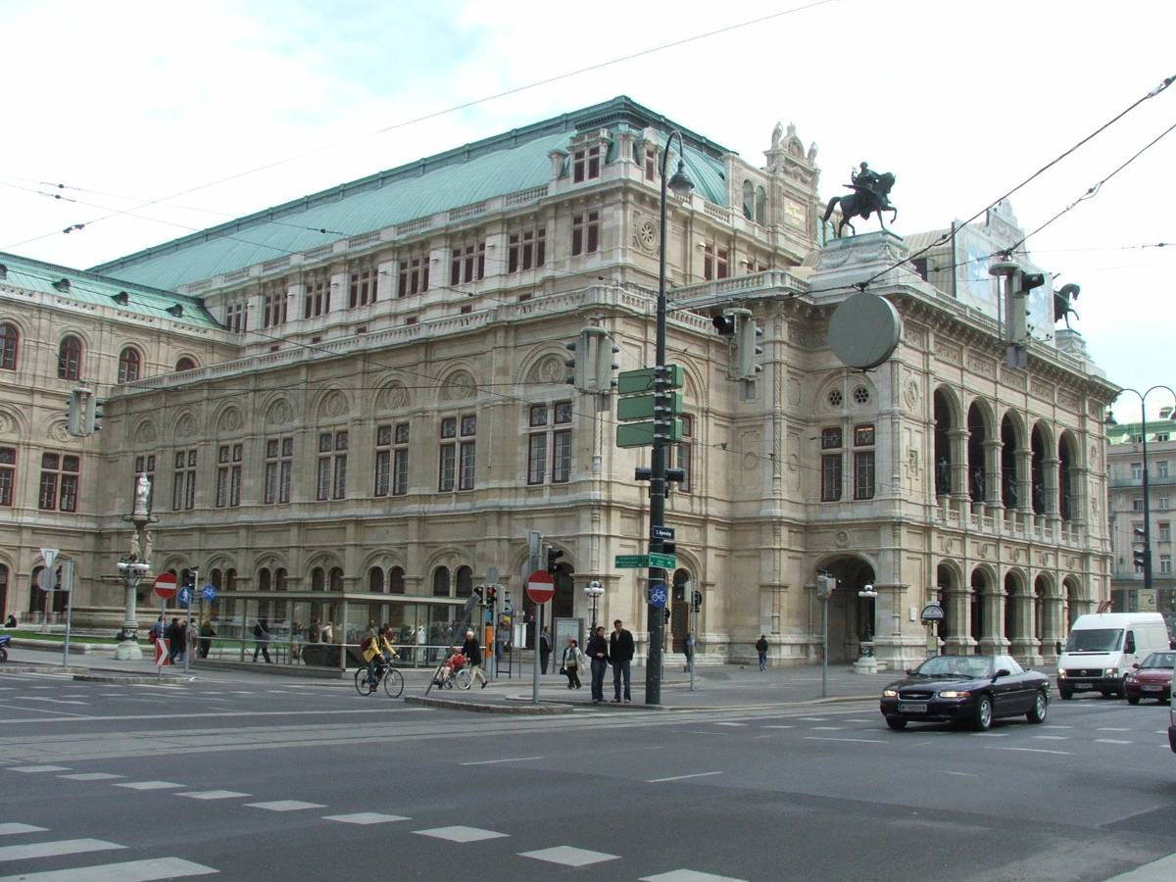
The Vienna Opera house

