JAMES RENNIE BEQUEST

REPORT ON EXPEDITION/PROJECT/CONFERENCE

Expedition/Project/Conference Title: 23rd Fungal Genetics Conference

Travel Dates: 15-20 March 2005

Location: Asilomar, California, USA

Group Member(s): Mari Valkonen, Kirsten Altenbach, Gabriela Roca, Pete Marris, Nick Read
Aims: To present a poster

OUTCOME:-

The trip was extremely useful and worthwhile as I received a lot of interest for my poster and had many interesting discussions about my data and other peoples’ results. I met a few other scientists working on endocytosis in filamentous fungi and several important scientists in the field of fungal biology.

The meeting left me with some good ideas and a wider view of the science performed on filamentous fungi, which will not only help my current PhD project, but will also be useful in my further career, whether a postdoc or a job in industry. The discussions helped in pointing out some of the gaps in my research and gave me some connections for collaborating on papers.

Since time allowed I did have a look around the Monterey aquarium which also proved a very worthwhile visit, as it has a magnificent collection of marine animals. We also made a very brief visit to a redwood forest during the drive from San Fransisco to Monterey.

The poster I was presenting was a combination of BLAST search analyses and live-cell imaging results using Confocal Laser Scanning Microscopy and endocytosis marker dyes. It gave an overview of what is currently the evidence for endocytosis occurring in filamentous fungi and gave preliminary data on an endocytic protein I have GFP-tagged in the filamentous fungus Neurospora crassa. There was a great deal of interest from many people, especially since it is still a controversial subject in the filamentous fungal world, so I had many interesting discussions about my data.

The scientific content of the meeting span from fundamental research and basic cell biology to industrial applications of filamentous fungi. It gave a good overview of the fungal science regarding genomics research as well as some excellent live-cell imaging of numerous different species of filamentous fungi.
Most notably of interest to me were sessions about the fungal cytoskeleton, as it is known to be closely connected to endocytosis and cellular morphogenesis and development, both sessions had presentations of great interest to me and gave me interesting ideas for further work.

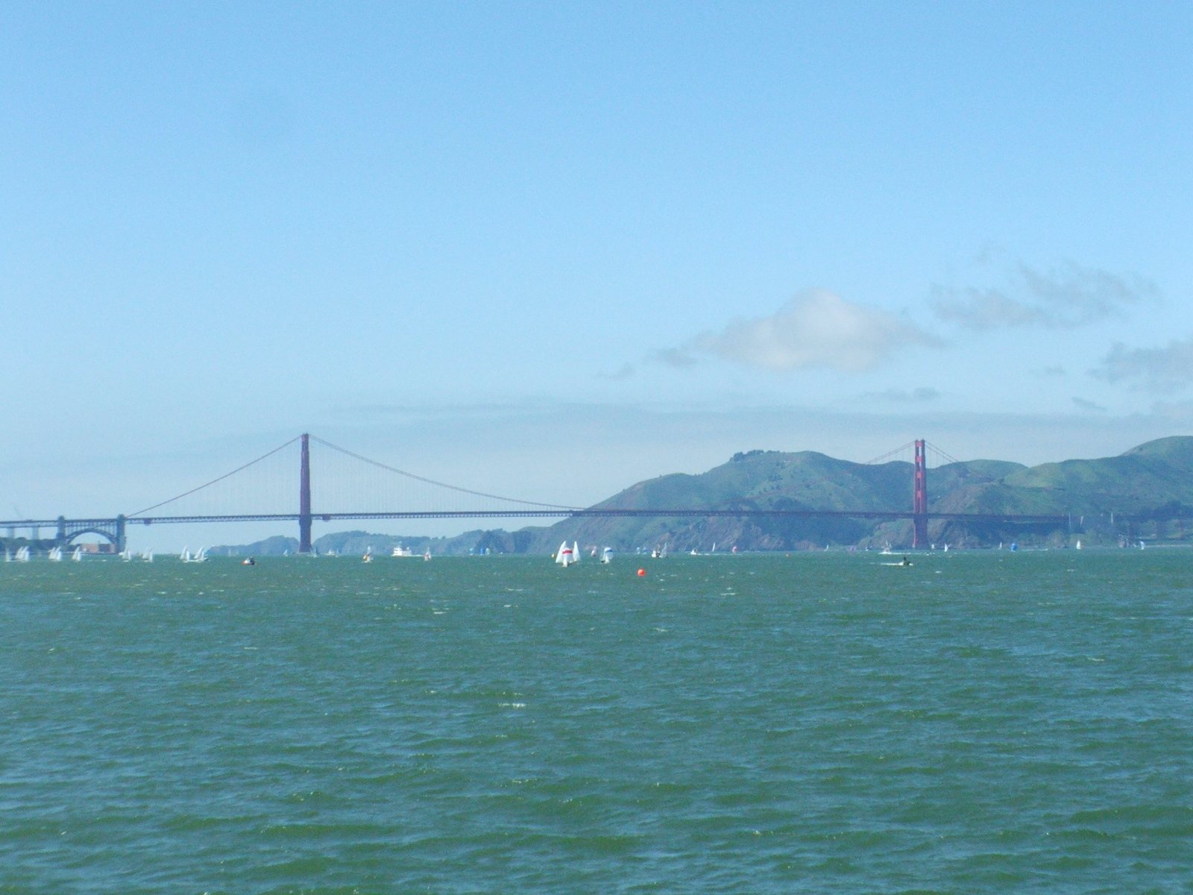
Since we flew into San Fransisco International Airport and had some time in advance of the meeting we saw at least a few of the sites in San Fransisco.

Golden Gate Bridge

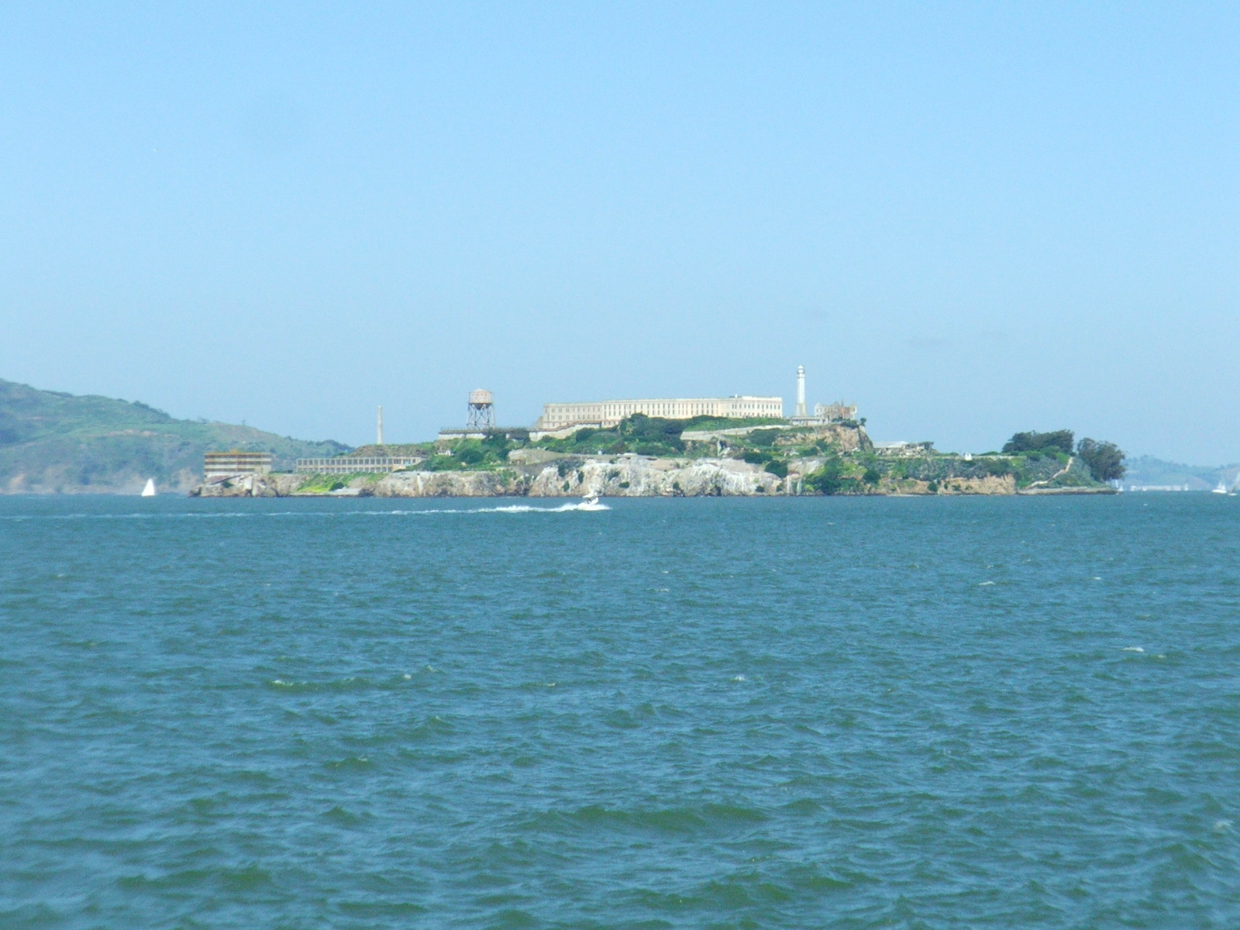

Alcatraz prison

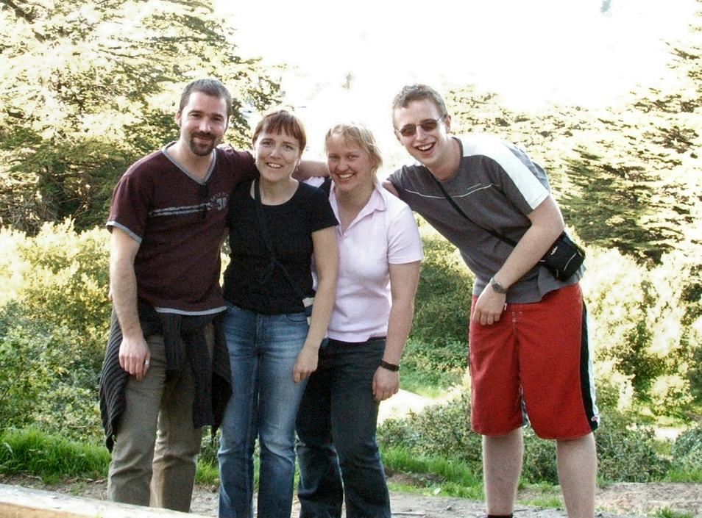
Part of the group attending the meeting (Me far left, members of the lab: Mari Valkonen, Kirsten Altenbach and Pete Marris)

