**DAVIS EXPEDITION FUND**

**REPORT ON EXPEDITION / PROJECT**

|  |  |
| --- | --- |
| **Expedition/Project Title:** | The seed dispersal mechanism of the African sausage tree (Kigelia africana) in the Chobe Enclave, Botswana. |
| **Travel Dates:** | 1st July – 29th July |
| **Location:** | Botswana |
| **Group Members:** | Sophie Jones (receiver of the fund), Aisling Kinsella­­,  Nelly Maiyo |
| **Aims:** | Participant on the Tropical Biology Association field course 2019 to Botswana. The first two weeks involved workshops and lectures on fieldwork skills and the local ecology. The last 2 weeks were conducting and independent project which I detail here. |
|  |  |
|  |  |

**Outcome (a minimum of 500 words):-**

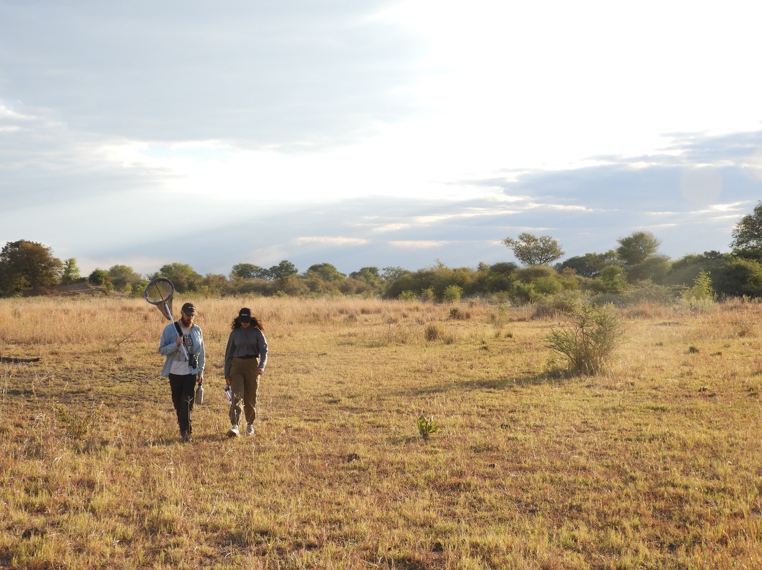

Personal Development

My experience attending the Tropical Biology Fieldwork course was hugely eye-opening. Not only did I enjoy the benefits of experiencing a new environment and culture, I was also able to gain a much better understanding of what I’d like to do within my career. I made great friends from a wonderful variety of countries, all sharing the same desire to work within conservation and ecology. I was able to envision new job prospects through learning about their careers. After studying at university, my scientific network consisted of mainly academic professors, who may have in the past done fieldwork, but since focussed on academia. Thus, being able to interact with people who had their main goal to conduct fieldwork was very useful. I learnt a variety of field skills and now feel much more confident and comfortable organising and running projects.

Scientific Report

**The seed dispersal mechanism of the African sausage tree (*Kigelia africana*) in the Chobe Enclave, Botswana*.***

**Aisling Kinsella­­, University College Cork, Ireland**

**Nelly Maiyo, Ol Pejeta Conservancy, Kenya**

**Sophie Jones, University of Edinburgh, Scotland**

**Abstract**

The seed dispersal method of *Kigelia africana* is widely unknown. While there is evidence of herbivory by a wide range of both small and large mammals, the mechanism of dispersal has not yet been documented. As the fruit is indehiscent, it seems more than likely that the seeds are dispersed by endozoochory. However, the mass and toughness of the fruit seems more suited for herbivory by megaherbivores as opposed to small herbivores. This study was conducted to test the hypothesis that large herbivores are more suited to *K. africana* seed dispersal than small herbivores, using the African elephant (*Loxodonta africana*) and the cape porcupine (*Hystrix africaeaustralis*) as the respective study species.

**1. INTRODUCTION**

**1.1 Seed dispersal**

Seed production is an important component of sexual reproduction in many plant and tree species. Producing seeds incurs advantages over asexual vegetative coppicing such as increased genetic variation and therefore species persistence (Stelli, 2011). Seed dispersal is a vital component in maintaining species diversity, particularly throughout the tropics (Nyiramana *et al,* 2011). Seed producers rely on biotic and abiotic methods of seed dispersal for propagation. Abiotic factors facilitating seed dispersal include waterbodies and wind while biotic factors include the diets and movements of animals. Seeds are a significant component of diets for a large range of both vertebrates and invertebrates. Seed eaters can be classified as either a disperser or a predator (Stelli, 2011). A seed predator destroys the seed, and therefore its ability to germinate, through either mechanical or chemical digestion (Miller, 1996). Seed dispersers on the other hand will release intact seeds through their dung. This is a mutualistic relationship – the seedeater benefits through nutrient provision and the tree benefits through endozoochory.

**1.2 *Kigelia africana***

*Kigelia africana,* more commonly known as the sausage tree due to its fruit’s likeness, is widespread throughout central Africa. It is a widely studied tree species for its chemical composition in both the traditional and alternative medicinal fields. There are numerous publications regarding its possible pharmaceutical and commercial applications (Bello *et al.,* 2016) such as treatment for malaria (Gessler *et al.* 1994; Ferluga *et al,* 2013), polycystic ovary syndrome (Oyelami *et al.,* 2012) and diarrhea (Otimenyen & Uzochukwu, 2012). However, there is a significant gap in knowledge regarding its seed dispersal mechanisms and the mutualistic relationships with its common herbivores.

*K. africana* is a semi-deciduous tree that can reach a height of 25m. Its fruit hangs down on cords growing up to 1.5m with a mass sometimes exceeding 12kg (Bello *et al.,* 2016). Once ripe, the fruit falls to the ground where it remains intact. This provides a large foraging ground for potential herbivores. This large, oddly shaped fruit is the most defining feature of the tree but also raises the most questions about its seed dispersal mechanisms. Its tough exterior and indehiscent nature create a barrier to wind and water dispersal, especially as the fruit is not buoyant. As such, it is extremely likely that it is dependent on the foraging and movement of its most common wild and domestic vertebrate herbivores such as elephants, baboons, squirrels, porcupines and cattle. However, as cattle are not native to the home range of *K. africana*, it is unlikely that they were involved in the evolution of the hard seed pods. This raises the question as to who the main wild seed disperser is and whether these indehiscent fruits are a result of co-evolution or more recent environmental pressures. Addressing the former, this study aims to investigate (i) who are the seed eaters (herbivores) of *K. africana* and (ii) who are the seed dispersers of *K. africana*?

**2. MATERIALS &METHODS**

**2.1 Study area**

The study took place in the Chobe Enclave surrounding the Vanthuyne- Ridge (VTR) Research Center, a semi-arid area in Parakarungu in the north of Botswana. It was conducted during a particularly dry season between the period 17 June – 29 June 2019 and as a result there were no trees sampled in riparian zones, a common habitat for this species. The sites mainly consisted of open woodland where *Acacia* and *Combretum spp.* were most abundant. Nineteen *K. africana* trees were sampled at different sites. The trees ranged in level of maturity and fruiting, but no trees were currently in flower. Figure 1 shows the distribution of *K. africana* and the location of the current study. GIS was used to map the different sites and their corresponding vegetation of the STs (n=19).

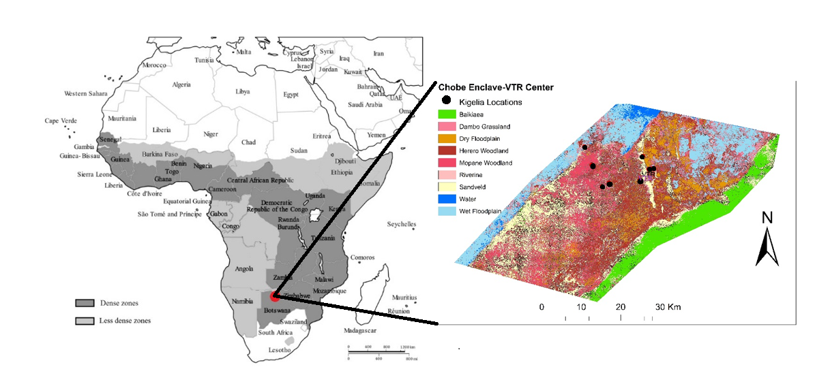Figure 1: The distribution of *K. africana* in its native range across central Africa and the location of the study shown in red [left (adapted from Bello *et al.,* 2016)]. The ST study sites and the dominant vegetation surrounding the VTR (right).

**2.2 Herbivory**

At each sausage tree (ST), the amount of both elephant and porcupine dung under the canopy was counted as an indicator for herbivore presence. The same was done at a control species for each ST within the same area but at least 20m apart. At each ST, the abundance of eaten and uneaten seed pods present on the ground were recorded. Bite and claw marks on the eaten seed pods were scored according to the potential seedeater responsible. As it is believed that elephants eat the full pod and given the high level of cattle activity in the area, the study focused on cattle and porcupine. Porcupine were chosen over other small herbivores as the locals, and the staff at VTR, believed them to be the main seed eater and disperser of *K. africana.* Cattle eaten pods were identified by large bites on the edge of the fruit while the rest of the fruit remained intact. Porcupine herbivory was identified from multiple small bites along the fruit often accompanied by long slashes across the fruit by claws. These identifications were verified by a local wildlife guide from the VTR Center. Figure 2 displays photographic evidence of each.

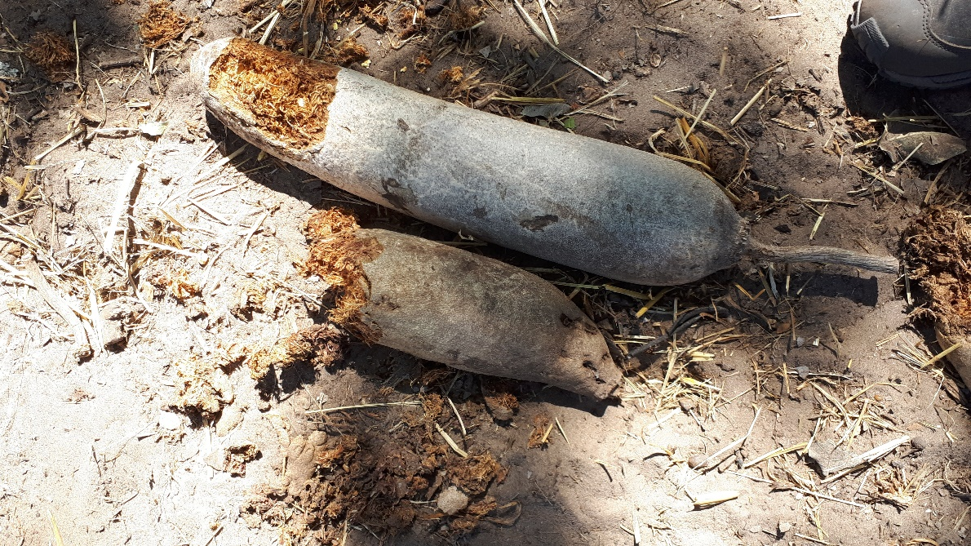

Figure 2: Herbivory on two seed pods. On the left is the markings of cattle, on the right are the markings of a porcupine.

**2.3 Seed Dispersal**

Porcupine and elephant dung were then collected from a selection of the ST sites (n=5). Fresh dung was dried in the sun before getting the dry weight with seeds still present. All dung was subsequently weighed before seed inspection. Dung was broken apart and sifted through and all seeds found were collected, identified and weighed.

**2.4 Camera trap**

In order to observe herbivores and their method of herbivory on *K. africana* seed pods, a camera trap was set up at ST2 (18º05”62.3’S, 24º32”45.4’E) mid-morning on the 20/06/19 until mid-afternoon on 22/06/19. ST2 was chosen due to the abundance of fresh, uneaten fruit covering the floor as well as evidence of fresh porcupine herbivory, approximately 8-10 hours old. The camera trap was secured to an adjacent tree and all the fresh, uneaten pods were collected and placed in view of the camera.

**2.5 Data analysis & software**

The data was analysed using RStudio version 1.1.463. The map of the ST sites was created using ArcMap version 10.2.1 in GIS.

**3. RESULTS**

**3.1 Herbivory**

A t-test was performed to investigate whether tree species (*K. africana* versus control species’) influenced seedeater presence. No difference was found for elephant dung between *K. africana* and the control species’ (t = -0.67901, df = 18, p = 0.2529) however the abundance of porcupine dung was significantly different [(t = -5.2222, df = 18, p = 2.877x10^5) Fig. 3a]. Additionally, it was found that under *K. africana* porcupine dung was more abundant than elephant dung [(t = 2.8726, df = 18, p = 0.005064) Fig. 3b].

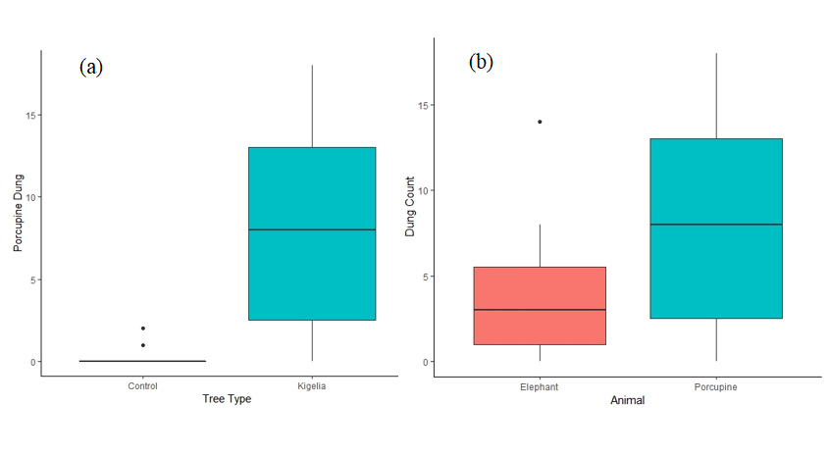Figure 3: The abundance of porcupine dung under *K. africana* and the control species’ (a). The abundance of both elephant and porcupine dung under *K. africana* (b).

The data also showed that evidence of herbivory by porcupines on eaten seed pods was more prevalent than that by cattle [(t = 2.9312, df = 18, p = 0.0045) Fig, 4].

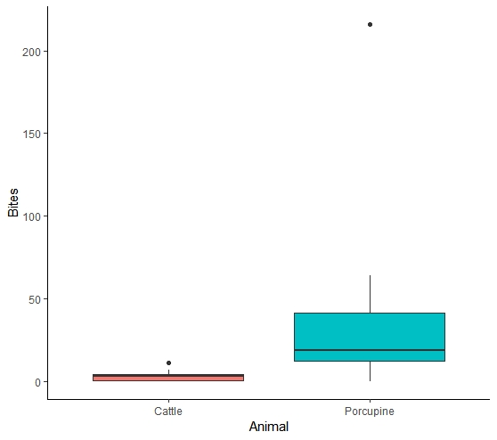

Figure 4: The proportion of cattle bites to porcupine bites on the eaten seed pods.

**3.2 Seed dispersal**

Using a binomial distribution, there was no significant difference found between the presence of *K. africana* seeds in the porcupine dung collected (n=21) and the elephant dung [n=18 (z 39,37 = 1.623, p = 0.1045)]. The weight of the dung did not influence the number of *K. africana* seeds found per pile (z 39,37 = 1.605, p = 0.1086). As multiple seeds belonging to species other than *K. africana* were found in the elephant dung (Table 1), a GLM was run to decipher whether the type of dung (elephant vs porcupine) influenced the proportion of *K. africana* seeds found. No significant effect was found (z15,14 = 1.866, p = 0.062).

Table 1: Seeds other than *K. africana* that were found in elephant dung collected (n=8).

|  |  |  |  |
| --- | --- | --- | --- |
| Elephant | *Dichrostachys cerea* | *Acacia hebeclada* | *Acacia erioloba* |
| 1 | 3 | 0 | 0 |
| 2 | 2 | 2 | 0 |
| 3 | 3 | 0 | 0 |
| 4 | 8 | 1 | 0 |
| 5 | 6 | 0 | 0 |
| 6 | 0 | 0 | 1 |
| 7 | 1 | 0 | 0 |
| 8 | 2 | 1 | 0 |

**3.3 Camera trap**

Due to a technical error, no images or footage were retrieved from the 20/06/19. Between 12.56pm on the 21/06/19 and 2.46pm on the 22/06/19,25.85 minutes of footage were recorded. The animal activity included domestic cattle, tree squirrel (*Paraxerus cepapi*), red-billed spurfowl (*Pternistis adspersus*) and *H. africaeaustralis.* No *L. africana* triggered the camera.

|  |  |  |
| --- | --- | --- |
| **Activity** | **Minutes** | **Percentage (%)** |
| Empty | 6.33 | 25.77% |
| Cattle | 14.1 | 55.41% |
| *P. cepapi* | 4.2 | 15.47% |
| *P. adspersus* | 1.03 | 2.50% |
| *H. africaeaustralis* | 0.19 | 0.85% |

Table 2: The total time and percentage of the camera trap footage activity.

Empty footage was most likely triggered by wind or an animal that was passing by too quickly to then be captured once the camera started recording (recording was set to 5 seconds after triggering). As expected, the cattle grazed on the fallen seed pods by picking them up by their edge and attempting to bite through their tough exterior which some succeeded in doing so. They frequently licked the pods before picking them up. One cow seemed to pick up, chew and ingest a full seed pod. The squirrels were either alone or in groups of two and could be seen gnawing on the fresh seed pods or eating seeds from the already open gaps in the eaten pods. The spurfowl were sometimes present with the squirrels and the rest of the time alone, again individually or in groups of two. They seemed to be foraging for seeds that had fallen on the ground as a result of mammalian herbivory. Unfortunately, the porcupine activity was caught from an angle from which the method of herbivory could not be confirmed.

**4. DISCUSSION**

Elephants are generalist frugivores (Hawthorne & Parren, 2000) and the only ones which can ingest whole seeds (Cochrane, 2003). This is evident from the prevalence of elephant dung under both *K. africana* and the control species’ which included other seed producers such as *Acacia erioloba*. However, while they might be browsing *K. africana* or foraging the fallen seed pods, there was no evidence to support that they had a higher proportion of *K. africana* seeds in their diet than porcupines. As porcupine dung was more restricted to the ground surrounding *K. africana*

In contrast, porcupine dung was restricted to the ground surrounding *K. africana* trees.

These results do not support the original hypothesis. According to this study, *L. africana* does not have a higher dispersal rate of *K. africana* seeds. This does, however, confirm the common belief that the cape porcupine is dispersing *K. africana* seeds. While sorting through the porcupine dung

**Acknowledgements**

We would like to extend our gratitude for the help and support of the staff and students of the Tropical Biology Association Botswana field course of 2019. To Dr. Craig Peter for his supervision. To Dr. Michelle Greve for her patience and guidance with our data analysis. To Anitah Faranjirina Rakotoharimalala from Madagascar, Stephen Ofori from Ghana and Samson Dognimon from Benin for their help with field work. To Picture and Ali Maina from the Vanthuyne Ridge Research Center for their field guide expertise and to all the other staff from the VTR for their hospitality. Finally, a massive thank you to Dr. Kevin Wallace for his dedication and hard work in insuring a safe, informative, challenging and wonderful Tropical Ecology and Conservation field course.

**References**

Bello, I., Shehu, M.W., Musa, M., Asmawi, M.Z. and Mahmud, R. (2016). *Kigelia africana* (Lam.) Benth. (Sausage tree): Phytochemistry and pharmacological review of a quintessential African traditional medicinal plant. *Journal of Ethnopharmacology*, **189**, 253-276.

Cochrane. E.P. (2003). The need to be eaten: *Balanites wilsoniana* with and without elephant seed-dispersal. *Journal of Tropical Ecology*, **19**, 579–589.

Ferluga, J., Nayak, A. and Kishore, U. (2013). Host-pathogen interaction in malaria and trypanosomiasis, In: Kishore, Uu., Nayak, A. (eds.). *Microbial Pathogenesis: Infection and Immunity*. Landes Bioscience and Springer, Science + Business Media.

Gessler, M., Msuya, D., Nkunya, M., Mwasumbi, L., Schar, A., Heinrich M. and Tanner M. (1994). Traditional healers in Tanzania: the treatment of malaria with plant remedies. *Journal of Ethnopharmacology*, **48,** 131-144.

Hawthorne, W.D. and Parren, M.P.E. (2000). How important are forest elephants to the survival of woody plant species in Upper Guinean forests? *Journal of Tropical Ecology*, **16**,133–150.

Miller, M.F. (1996). Dispersal of *Acacia* seeds by ungulates and ostriches in an African savanna. *Journal of Tropical Ecology,* **12**, 345-356.

Nyiramana, A., Mendoza, I., Kaplin, B.A. and Forget, P-M. (2011). Evidence for Seed Dispersal by Rodents in Tropical Montane Forest in Africa. *Biotropica*, **43** (6), 654-657.

Otimenyin, S.O and Uzochukwu, D.C. (2012). Spasmolytic and anti-diarrhea effects of the bark of *Erythrina senegalensis* and root *of Kigelia africana*. *Asian Journal of Pharmaceutical and Clinical Research*, **3** (4), 11-14.

Oyelami, O.A.,Yusuf, K.O. and Oyelami, A.O. (2012). The use of *Kigelia africana* in the management of polycystic ovary syndrome (PCOS). *Chinese Medicine*, **3**, 1-3.

Stelli, S.A. (2012). Seed fate and density of soil seed banks of four Acacia species in the Kruger National Park, South Africa (*Doctoral dissertation*).