JAMES RENNIE BEQUEST

REPORT ON EXPEDITION/PROJECT/CONFERENCE

Expedition/Project/Conference Title: 3RD INTERNATION SYMPOSIUM ON SPECIATION IN ANCIENT LAKES

Travel Dates: 2ND – 7TH SEPTEMBER

Location: IRKUTSK, RUSSIA

Group Member(s): FELICITY JONES

Aims: TO PARTICIPATE AND PRESENT A POSTER OF MY RESEARCH AT THE
ABOVE MENTIONED CONFERENCE.

OUTCOME : Please see next page.

THE 3RD INTERNATIONAL SYMPOSIUM ON

SPECIATION IN ANCIENT LAKES
Irkutsk, Russia, 2-7th September, 2002.

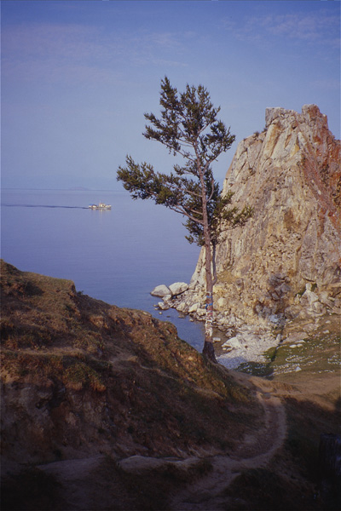
Siberia’s Lake Baikal is one of the world’s oldest and deepest lakes, and contains tremendous variety of endemic flora and fauna. The interesting evolutionary history of these endemic species made Baikal the perfect setting for the 3rd International Symposium on Speciation in Ancient Lakes (SIAL-3). Held in the Limnological Institute in the nearby town of Irkutsk this symposium had a friendly atmosphere. Delegates from all around the world presented research on a wide range of topics in both oral and poster form.
Research in fields such as geology, palaeoecology, molecular phylogenetics, and evolutionary ecology was presented under the unified topic of speciation in ancient lakes. Although Baikal dominated, several presentations were given on research in other ancient lakes including Malawi, Tanganyika, Biwa, Khubsugul, and Matano. Concern for the conservation of the endemic flora and fauna of the world’s ancient lakes was expressed several times during the symposium and is likely to be an even more prominent topic at SIAL-4 (2006) to be held in Berlin.
The highlight of the symposium was a two-day excursion on Lake Baikal with overnight stay in island town of Huzir. On board the Vereshchagin deep-water pelagic and benthics organisms were sampled. Of particular note was the remarkable diversity of endemic amphipods and the enormous Baikal sponge. A trip to the Museum of Baikal also enabled us to observe the amazing diversity of fishes some of which we were later given the opportunity to taste in traditional Russian dishes!
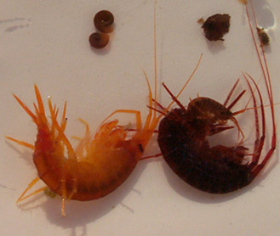
SIAL-3 gave me the opportunity to meet leading scientists in the field of fish speciation as well as the opportunity to present a poster of part of my own work on speciation in Scottish sticklebacks. This symposium has also triggered many on-going discussions on analytical techniques and potential collaborations that will be of great benefit towards my Ph.D. I would like to take this opportunity to thank the James Rennie Bequest for the financial assistance that enabled me to attend this conference. It was an invaluable experience!
Baikal Amphipods.

