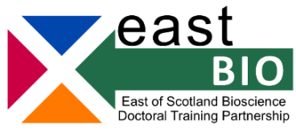

EASTBIO Thematic Programme 2022-2023
Integrated Understanding of Health Group

Session 4 - Science Communication & Impact
Edinburgh, 14 June 2023
Schedule
Student activity practicing pitching research projects at different levels and for different audiences – e.g. children, lay people, peers.
Talks
- Dee Davidson (Public Engagement Manager, Institute of Genetics and Cancer (formerly known as the MRC IGMM) at The University of Edinburgh )on her experience of public engagement.
- Elaine Emmerson (UKRI Innovation Fellow, The University of Edinburgh Academic Lead for Public Engagement) on how to negotiate difficult conversations in science.
- Elaine Emmerson on curating an online presence using LinkedIn, twitter, etc.
- Jennifer Lorigan (Information Officer - Gene and Cell Therapy for EuroGCT at the University of Edinburgh's Centre for Regenerative Medicine) on opportunities for PhD students to get involved in science communication outside of a purely academic context.
Session organisers: Eleanor Stamp, Josephine Stewart & Erin Watson

