JAMES RENNIE BEQUEST

REPORT ON EXPEDITION/PROJECT/CONFERENCE

Expedition/Project/Conference Title: Project Mexico: The effect of management on populations of Strombus gigas in Quintana Roo, Mexico

Travel Dates: June 30th to August 4th 2009

Location: Chetumal, Quintana Roo, Mexico

Group Member(s): Sarah Hutcheon, Sophie Eastwood, Adam Cross, Tony Marshall and Conor McCone

Aims: To study the effect of differing management policies on populations of Strombus gigas in different locations. To assist in the compilation of a nematode inventory collected from Laguna de Términos.

OUTCOME (not less than 300 words):-

In July 2009 I was part of an expedition group which travelled to Chetumal in southern Mexico. In collaboration with the Mexican institution, El Colegio de al Frontera Sur (ECOSUR), over the four week period we monitored conch (Strombus gigas) populations in different locations. The main aim was to study conch populations subject to differing management policies in two geographically separate locations; Banco Chinchorro and Punto Herrero (fig. 1). An additional aim was to assist in the compilation of a nematode inventory.
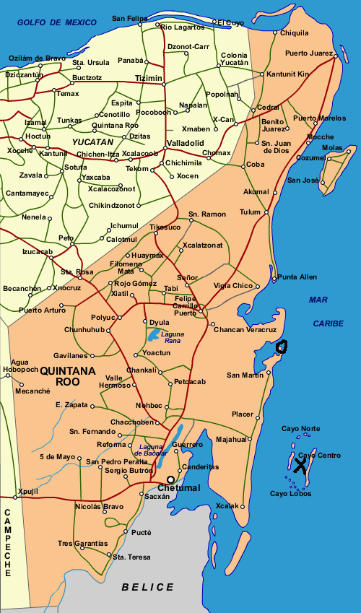
We were also fortuitously able to work, in addition to our own investigation, on parasites and elasmobranchs.

Conch species such as S.gigas are an important resource within local fishing communities; they provide both food and a source of income. Increasing harvesting pressure has created reason for studying conch populations for conservation and sustainability. The data which we collected will be used to further improve management strategies to sustainably maintain and increase local populations of conch at both Banco Chinchorro and Punto Herrero.

The two sites selected have different management strategies in place regarding conch. At Banco Chinchorro harvesting is restricted to a quota of 10 tonnes between the months of December and February. The management at Punto Herrero is that of a strictly no take zone, as this area falls within the Sian Ka’an Biosphere Reserve.

Method and Results

Conch collected at both sites were measured for siphonal length (SL) and lip width (LW). These parameters allowed age to be determined. Our results showed that the mean siphonal length and mean lip width were greater at Punto Herrero compared to
Figure 1. Map of Quintana Roo, Mexico with site
locations marked by 'X' for Banco Chinchorro
and 'O' for Punto Herrero
Banco Chinchorro. Using percentage calculations on LW measurements, the data indicated that only 4% of the Banco Chinchorro population were adults compared to 30% of the Punto Herrero population being adults. However, when doing the same calculations using SL measurements the data shows 15% of the Banco Chinchorro population being adults and 20% of the Punto Herrero population being adults. Differences in calculated age structure of the population could be due to the weak correlation between SL and LW (Banco Chinchorro, Pearson’s correlation = 0.206; Punto Herrero, Pearson’s correlation = 0.393).

Discussion

Based upon our results, it can be inferred that conch populations contain a greater proportion of adults at the Punto Herrero site. The age structure, based on statistical tests using mean LW measurements, between the two populations is significantly different for the two sites (P<0.001). The lower adult population at Banco Chinchorro may be due to over-harvesting during the open season and perhaps illegally during the closed season. Whether these differences are due to the management at each site and not indicative of other variables, e.g. population fluctuations or environmental variation is open for further discussion and study.

On the assumption that the statistical difference in LW between sites is representative of the current management, further studies should focus on temporal variability and estimate the long-term viability of populations with low numbers of adult individuals at Banco Chinchorro. Consideration in further management proposals should be provided in shortening the open season or reducing the quota allowed, without damaging the economy of local communities. Management and monitoring at Punto Herrero should remain constant and policing of illegal harvesting, as at Banco Chinchorro, should be increased dependent upon resources and cost.

Additional Experience

In addition to conch monitoring, the group spent two weeks working in the laboratory at ECOSUR helping in the research being carried out on nematodes. We were involved in locating nematodes in sediment collected from Laguna de Terminos, using microscopes and then putting them into formaldehyde for preservation. These nematodes will then be identified and classified by experts at ECOSUR. The purpose of this is to create an inventory of the nematode species present at Laguna de Terminos and several new species have already been recorded.

Also whilst at ECOSUR – Chetumal, we were given the opportunity by Dr. David Gonzalez Solis to spend time in his lab gaining experience assisting his work on parasitology. This involved dissecting fish and snakes, and using a microscope to find endo-parasites present within them. The parasites found may be new to science and endemic to the Chetumal area.

We were also introduced to Dr. Manuel Mendoza Carranza, a researcher at ECOSUR-Villahermosa, with whom we spent three days learning about his work and assisting him with data collection. Dr Mendoza Carranza specialises in aquatic ecology, and is currently involved in researching the biology of elasmobranchs, and the fishing industry’s impact upon their populations off the coast of Tabasco. On the first of the three days we received a tour of the labs at ECOSUR Villahermosa, and were given a presentation on the work of Dr Mendoza Carranza and his team. On day two we were taken to a large inter-tidal lagoon where we were shown and practiced the various ways in which fish samples can be collected. The third and final day was spent at San Pedro, a small fishing village in Tabasco, where we dissected and took measurements of all the shark species and stingrays being landed by the returning artisanal fishermen. This is part of Dr Mendoza Carranza’s ongoing work, and he will add the measurements we made to his data set.

Personal Experience

Overall the aims of the expedition were successfully achieved and this would not have been possible without the help and consideration from the staff at ECOSUR. The trip allowed me to experience many new things and develop an appreciation for different cultures. What really stood out was the general laid back attitude most of the people had; there was never any rush to get anything done, if something went wrong it didn’t matter it could be done again, everyone enjoyed their work and didn’t allow stress to get in the way.

In preparation for the trip I took beginner Spanish lessons and so whilst away I was able to further my learning of the language. The lessons proved particularly useful when staying at Punto Herrero where the people spoke very little English.

Working out on the boats we were able to use specialist scientific equipment for taking salinity measurements and water quality, back at the laboratory we were introduced to a different way of doing microscope work. This expedition has meant a great deal to me and in working with ECOSUR for four weeks I have created an awareness of different scientific techniques which will be invaluable and applicable in many future scenarios.

Acknowledgements

The group would like to thank the following people for their help and support in making this expedition possible.

A large thank you goes to Dr. Salvador Hernandez-Daumas and his family, for their endless help in organising this expedition. To all the staff of ECOSUR including: Dr. Alberto de Jesus-Navarrete, David Gonzalez Solis, Jose Juan Oliva, Adriana Valencia, Manuel Mendoza Carranza and to Aristeo Hernández for his patience.

To those that financially helped us with this expedition: The Davis Fund, James Rennie Bequest, Barnson Bequest, Student Travel Fund, British Association Travel Fund, Clingan’s Trust and friends and family.

