JAMES RENNIE BEQUEST

REPORT ON EXPEDITION/PROJECT/CONFERENCE

Expedition/Project/Conference Title: Project N.E.M.O

Travel Dates: December 2006 to January 2007

Location: Oman

Group Member(s): Aidan Hulbert

Aims: To collect DNA samples of the Omani clownfish, Amphiprion omanensis, for the examination of its population structure

OUTCOME (not less than 300 words):-

In recent years, many research groups have stressed the importance of conserving coral reefs as they are now becoming severely threatened with destruction and species loss. If we are to develop effective conservation strategies to preserve the diversity of coral reefs, we need to increase our knowledge with respect to population structure. Many reef fish spend their larval period out at sea coming back to the reef when they are juveniles. It is not understood how fish choose their habitat upon return to the reef. Do they return to their parents’ reef or go to a new reef?

The Omani clown fish Amphiprion omanensis is a perfect organism for studying population structure and the nature of a species as a whole. A. omanensis is endemic to the Omani coastline excluding the Persian Gulf. It is unique because unlike most coral reef fish, its entire global range can be studied. The isolated population of clown fish found in the southern coast of Oman provides the perfect opportunity to study the structure of marine populations on a large scale.

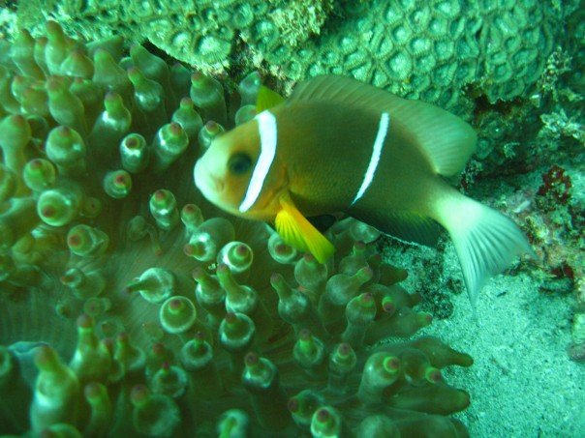
The Omani Clownfish Amphiprion omanensis

There are two separate regions where A. omanensis is found, and the aim of the project was to determine how much exchange of pelagic larvae between regions occurs and how many recruits return to their parents’ reef or other neighbouring reefs in their natal region. The method for achieving this was to collect DNA samples from individuals from different coral reefs along the coastline and to measure the diversity of individual geographical foci and their relatedness. Direct screenings of DNA sequences provide the means to estimate levels of genetic variation. The use of population genetics allows the investigation of how gene flow may occur between geographically isolated populations. Understanding this process is essential for designing management plans and marine reserves for conservation and fisheries and will provide a working model of the behavioural patterns of pelagic fish population.

DNA samples were taken from specimens collected from sites strategically located along the entire southern Oman coastline. This was an ambitious task and involved the collection of many samples. The only way such an experiment could be realised was through the hard work of a large team of 25 people. The team spent 4 weeks driving along the often-desolated coastline sampling different populations each day and camping on the beach at night.

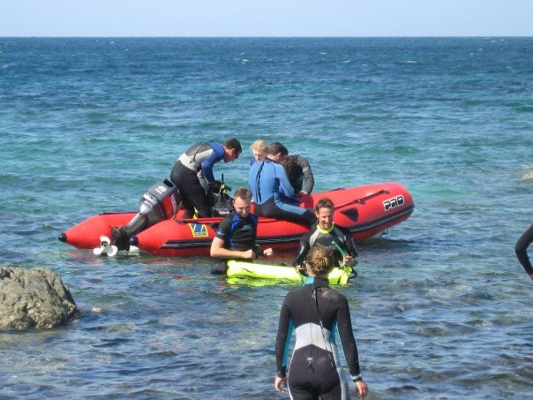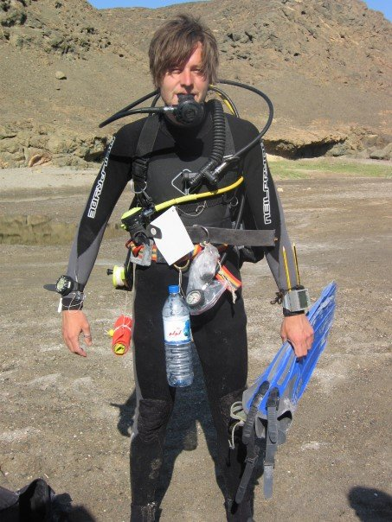
Left: Members of the expedition prepare to go out on a boat. Right: A team member with the kit necessary for sampling the fish prepares for a dive

The Omani clownfish lives in a close relationship with anemonies. This means it can easily be coaxed into SCUBA divers’ hand nets. DNA samples were collected from both mature adults and also juveniles. The target for each population was 30 (for statistical tests a sample size of 30 or above is advantageous). Sites were selected to include populations that are relatively near (e.g. neighbouring bays), as well as further apart (e.g. from different regions).

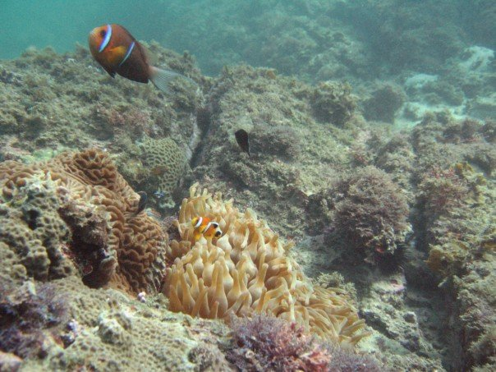
An adult and a juvenile in close proximity to their host anemone

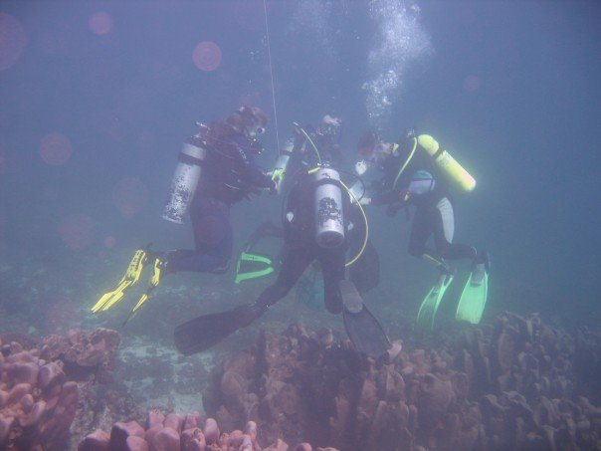
Divers learning how to catch clownfish in hand nets

DNA samples were obtained by taking a small clip of the pectoral fin of the fish. This method causes minimal stress to the fish which returns to the host anemone and behaves normally upon release. Fin clips were stored in separate vials and preserved in alcohol after the dive.

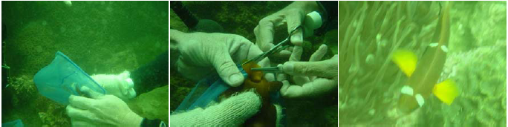
Left: a clownfish has been caught in a hand net and is being removed. Middle: one diver firmly holds the specimen as another carefully takes a fin clip. Right: A specimen with part of its fin removed.

DNA samples were successfully taken from many populations in the south and north extremes of the studied area. As expected, populations in the middle of these areas were sparse. Despite this some samples were successfully taken. This established knowledge of population hotspots for future studies.

The DNA samples are currently being stored at the University of Edinburgh awaiting genetic analysis. The results will provide us with crucial evidence on the behavior of coral reef fish populations and furthermore conservation models.

I would like to thank the James Rennie Bequest for the generous contribution towards travel to Oman that allowed me to take in this expedition. It was fantastic to have the opportunity to take part in a marine biology expedition. I look forward to developing a future career in this field as a result.

