JAMES RENNIE BEQUEST
REPORT ON EXPEDITION

Expedition Title: | Operation Wallacea, Honduras 2011
Travel Dates: | 7th June – 11th August
Location: | Cusuco National Park, Honduras
Group member(s): | Eleanor Hilton
Aims: | To gain knowledge and experience of scientific research in the field
 | and to assist in the long term biodiversity monitoring of key taxa.

I used the money I received from the Rennie Bequest Grant to travel to Honduras. It truly was the most amazing experience. I originally planned on spending six weeks with Operation Wallacea as a university volunteer. However they asked me to stay on as staff and I was delighted to extend my stay by three weeks. I loved every second of being out there and still didn’t feel ready to leave after nine weeks.
For the first six weeks my role on the project was a university research assistant. As a research assistant I assisted the different science teams with their data collection. There were many different teams of scientists studying the park and I was fortunate enough to be able to work with all of them. I assisted the ornithologists, herpetologist, entomologists, botanists, primatologists, bat team, small mammal team and the large mammal team. I enjoyed working with all the teams however found working with the botany team the most interesting and rewarding and actually spent two full weeks working solely with the botany team.
I feel like I gained a lot of scientific field skills and survival skills from the expedition. Scientific field skills that I learnt included bird mist netting, identifying birds by their calls, identifying insects to Order level, setting up and baiting pitfall traps, taking measurements and weights of various small animals, tracking, marking out large quadrants, taking botanical samples and pressing them in the field, taking GPS co-ordinates and creating activity budgets for behavioural studies. The survival skills I learnt were how to set up a hammock and basha, start a fire, use a machete to effectively chop fire wood, find or make safe drinking water and navigate my way out of the park if I got lost. I also learnt which animals and plants are poisonous and the basics of Spanish so that I could communicate with the guides.
After these six weeks I worked for Operation Wallacea as a school leader. My role as a schools leader was quite different. I was allocated a school group and had to travel around with them, leading them out to satellite camps, taking them to do habitat surveys, answering their general queries and liaising between the scientists on the project and the school groups. My main role was however to ensure that the school students were all happy and safe. I therefore had to entertain them in the evening and check they were all adequately prepared for hikes and activities. I really enjoyed this role as most of the students were very enthusiastic and interested in their surrounding and I was able to teach them the interesting things that I had learnt during my time as a research assistant. I also got to do jungle training with them and enjoyed the varying responses to basic questions such as “How long could you survive in the jungle without food?” one girl suggested 8 hours.
I have included some pictures of the activities mentioned above:

Sorting invertebrate bycatch from dung beetle pitfall traps.
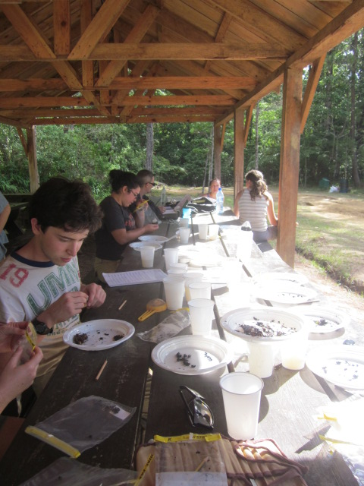
Trying to measure body length of a Mexican Jumping Viper (commonly known as Timbo).
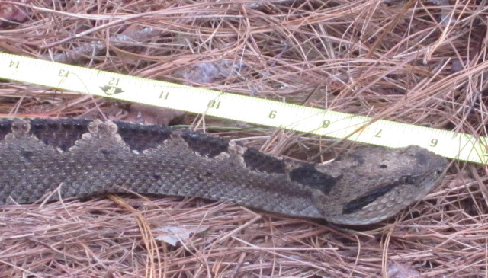
Feeding a bat sugar water after taking body measurements, weight and collecting ectoparasites.
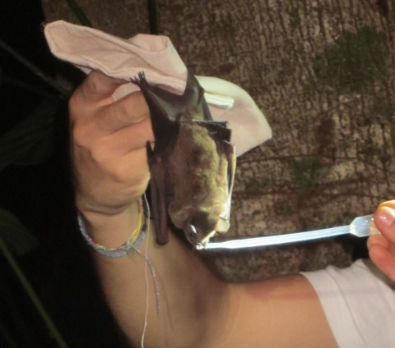
My hammock
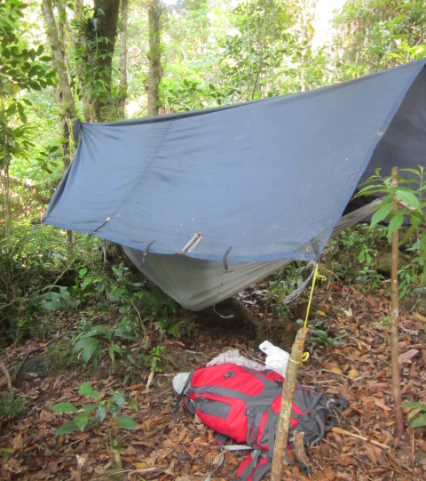

Working with the botany team collecting data on trees such as; diameter at breast height, bark and slash characteristics and collecting samples.
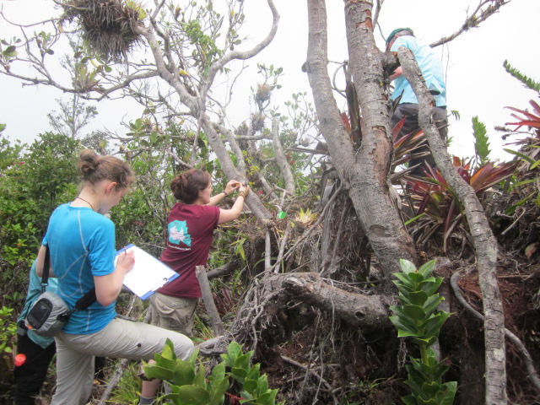
Bird mist netting with my school group, some of whom look rather tired (or bored).
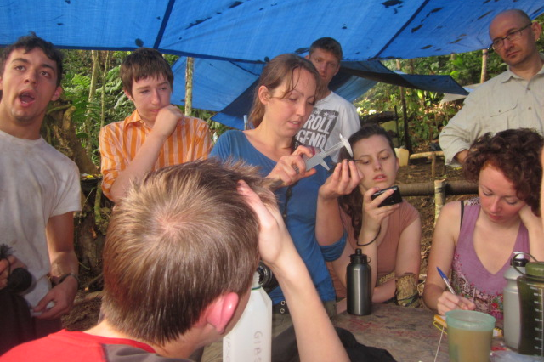

In conclusion I would like to thank the James Rennie Bequest for the money I received which really helped me in funding this expedition. It was an incredible experience and one which has helped me fully appreciate the work that goes in to conservation projects and scientific projects. Also on a personal level it has confirmed my passion for conservation and environmental education and has really inspired me to do more work like this in the future.

