
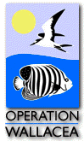
James Rennie Bequest
Report 2005

Louise Hickey

Operation Wallacea is a Scientific Conservation Expedition, which is designed to underpin the achievement of specific wildlife conservation aims. It has expeditions running in several different countries including Indonesia, Honduras and Egypt. It is dedicated to the conservation of rainforests and coral reefs, along with the preservation of cultural heritage.

Work done during such conservation projects is very important and has an extremely positive impact on the environment. Over 25 papers are published from each year’s research, with the data being used to achieve conservation objectives on the islands.

I decided to join the programme in the Cusaco National park Honduras last summer and for six weeks I had the opportunity to make a personal contribution to the conservation of the island Cayos Menor and the surrounding local communities.

The Cayos Cachinos Islands are a group of two small islands (Cayo Menor and Cayo Grande) and 13 small coral cays lying 19 miles north-east of La Ceiba on the northern Honduran coast. Since 1993 Operation Wallacea has held a long term agreement with the Honduran Coral Reef foundation, promoting high quality coral reef research.

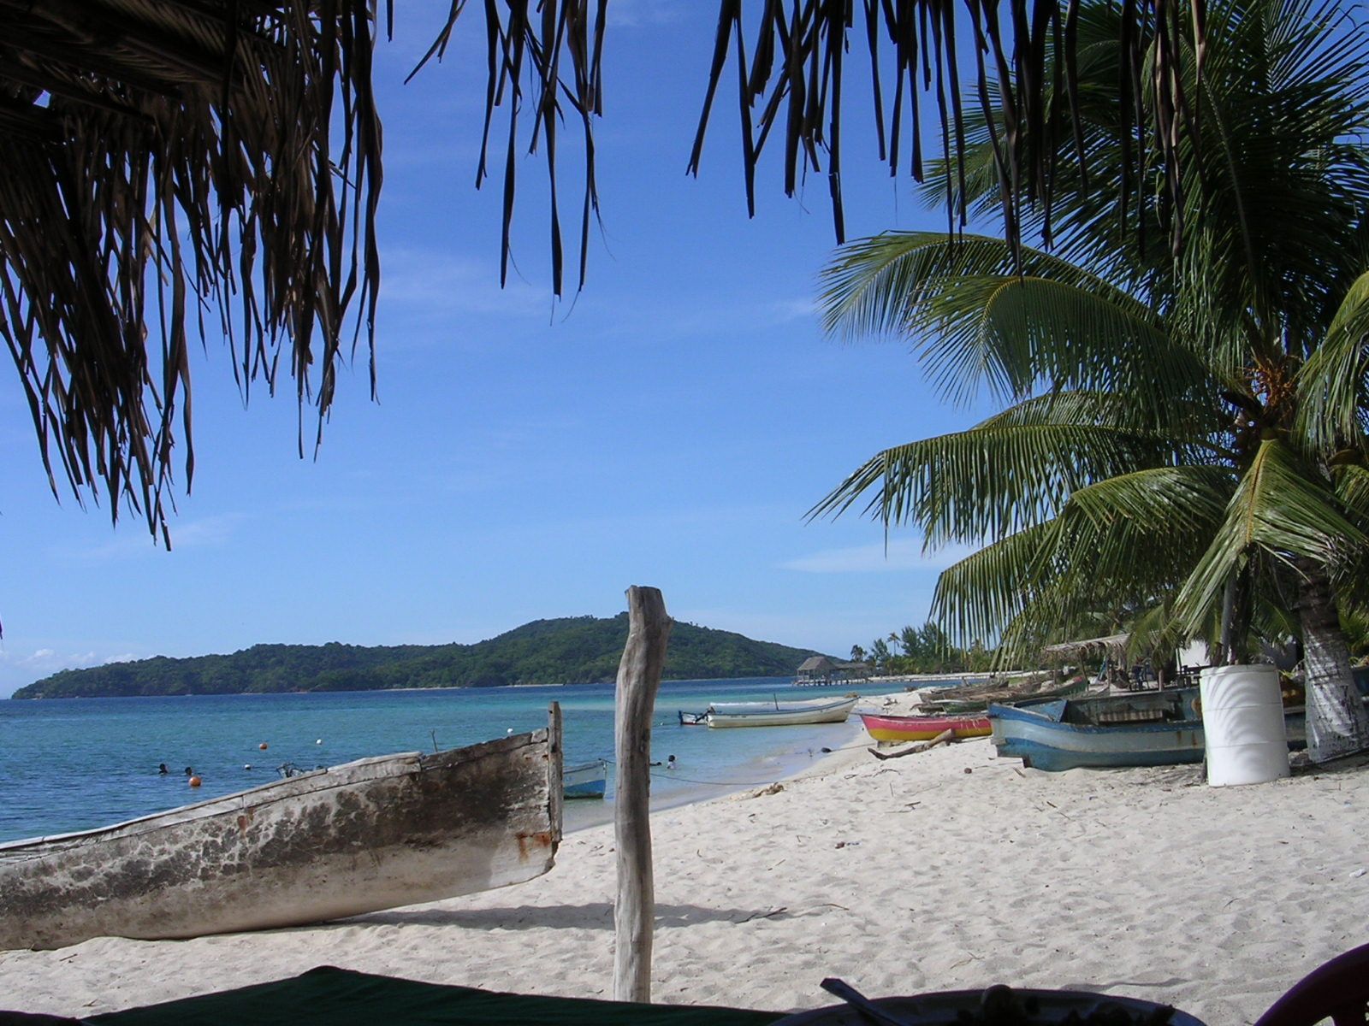
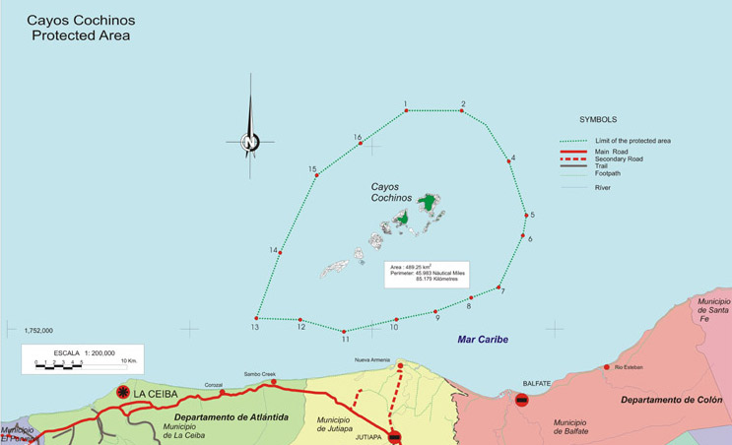

The Cayos Cochinos form part of the second largest barrier reef system in the World known as the Meso-American Barrier reef system and have been identified by the Smithsonian Institute, TNC, WWF, World Bank as one of the key sections of the Barrier Reef to preserve.

For the first week of my expedition I sat a coral reef ecology course, which gave me a good introduction to all the underwater life. In addition it gave me a fair understanding of the problems that the coral reef and its inhabitants were encountering, and demonstrated that the reef could potentially disappear if vital conservation work was not carried out.

In the following 3 weeks I participated in a project known as Reef Check. This is a scheme carried out on many reefs throughout the world, working to monitor the reef and point out any potential threats. Whilst carrying out this work on the Meso-American Barrier reef work we noticed that much of the reef was being plagued by a disease called black band disease. Such a disease has the potential to wipe out the whole of the reef and therefore it was important to monitor this problem carefully.

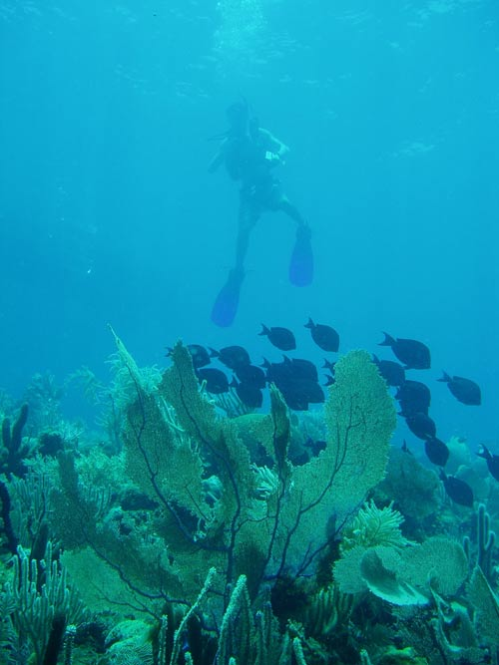
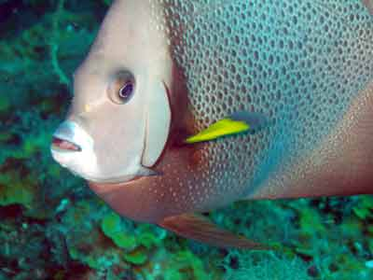

During these three weeks I also helped with several other aquatic projects including ‘the importance of sea grass beds as habitat for juvenile pelagic and reef fish species’, ‘factors affecting the population dynamics, distribution of marine hermit crabs around Cayo Menor’ and ‘estimating the value of the fisheries inside the Cayos Cochinos Marine Protected Area’.

For the last 2 weeks of my expedition I participated in a project, which aimed to protect the pink boa constrictors of Cayos Menor. This scheme was initially set up in 2004, in an attempt to protect the species from illegal exportation.
Sweep surveys across the island captured an average of 5 snakes a day and each of these were measured, sexed and a pit tag injected into them in order to assess population size, growth and mortality rates. Snakes that were tagged last year were re-captured this year, giving us additional habitat information and indicated growth rates of these tagged animals. This is a five year programme and I will hopefully go back to Honduras next summer in order to help further with this project.
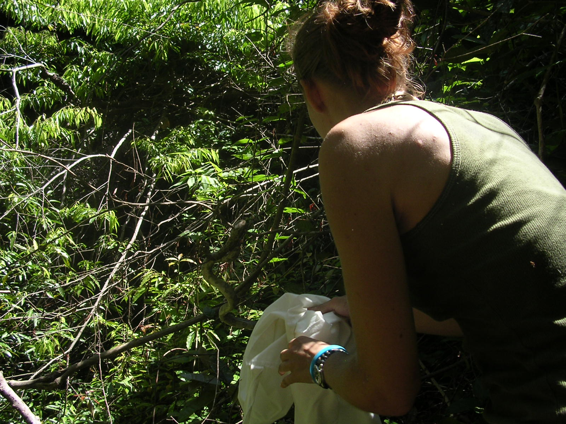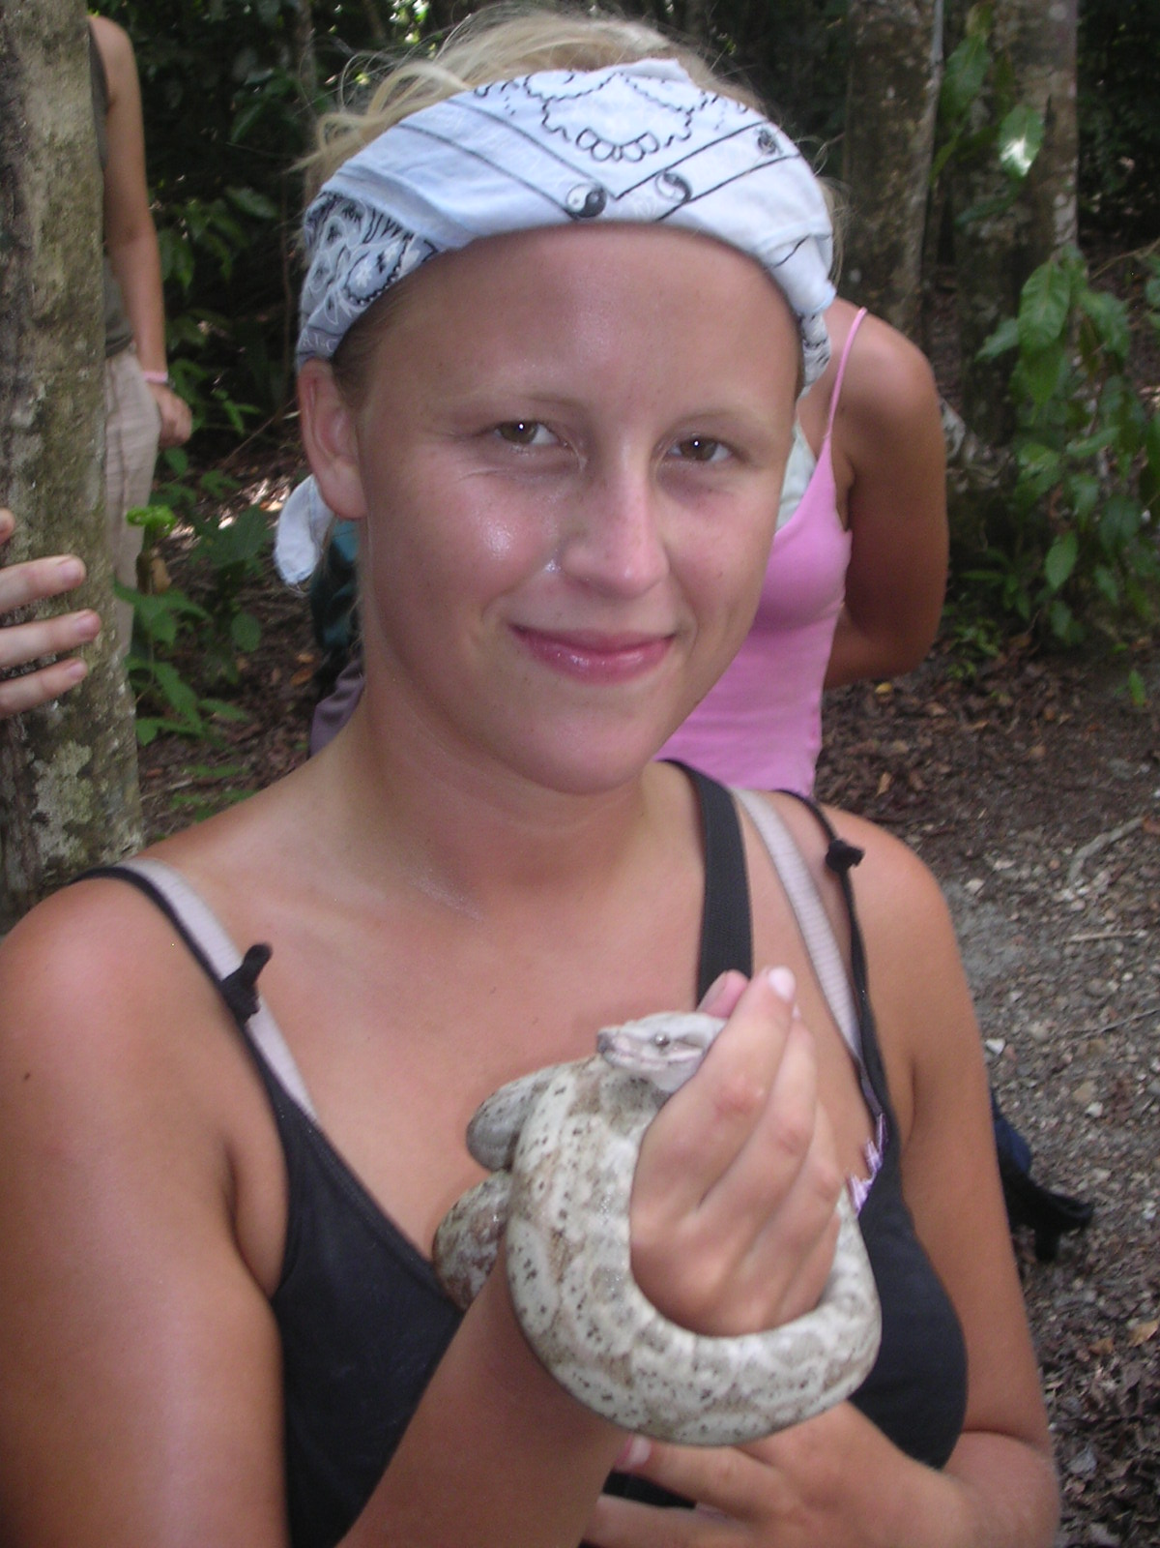

Having spent these six weeks in the Cusaco national park I have gained a great insight into the many problems associated with the Meso-American barrier reef. From this I have come to realise that if careful monitoring does not continue, we may well lose this reef altogether.

