
Project Las Piedras 2003

Preliminary report

Björn Schulte-Herbrüggen
Helfrid Rossiter
Hamish Mackintosh
Karen Mackellow

Edinburgh, 31st October 2003

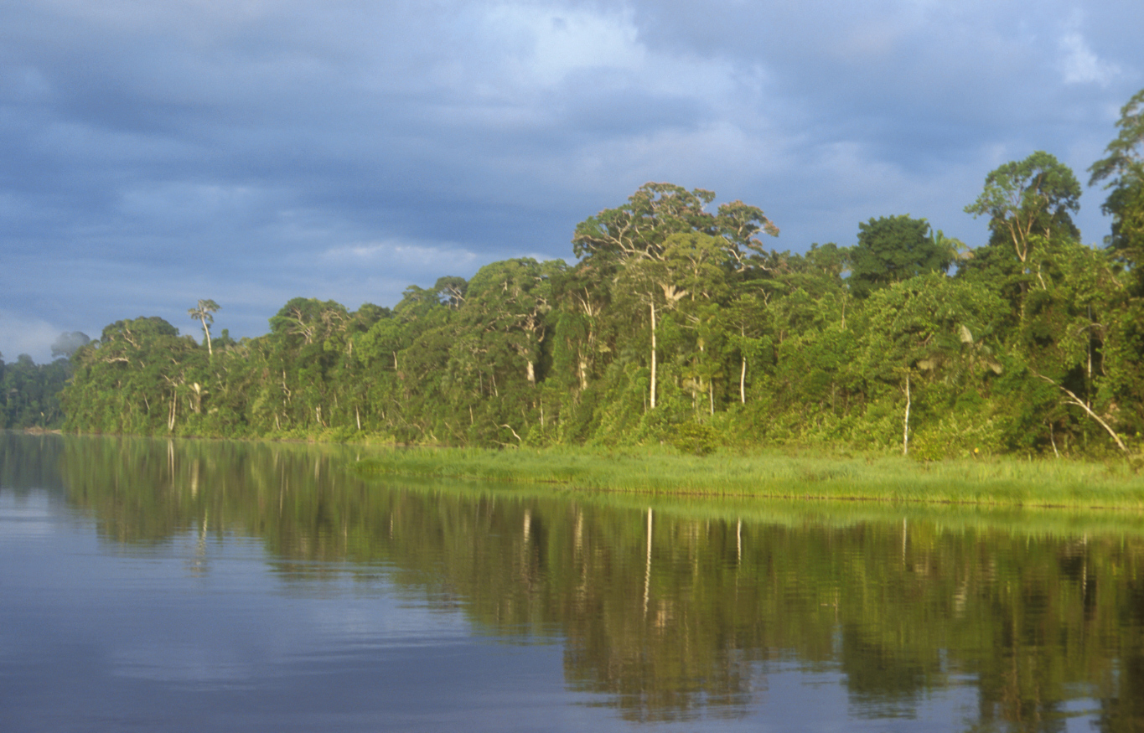

Contact  Helfrid Rossiter  102 Coniston Road 1f2  Edinburgh, EH10 5QJ  helfrid_rossiter@yahoo.co.uk | Project website  www.savemonkeys.org

Summary

Project Las Piedras has completed its second successful field period. This year’s team consisted of twelve people, the project coordinator, five students from the University of Edinburgh, two Peruvian students (one from Puerto Maldonado and one from Lima), three local guides and one cook. The field period lasted from the 1st of July until the 30th of August 2003.

After highlighting the devastating impact of mahogany extraction and associated hunting by illegal loggers in 2002 (find our report at www.savemonkeys.org/report) we realised that timber extraction has to be controlled and managed with the objective of sustainable land use. As this is a relatively new approach to the use of natural resources in Madre de Dios, scientific data that is crucial to its successful implementation is missing. We decided to co-operate with timber concessionaires who have an interest in sustainable management and provide them with required data. Several concessionaires showed interest and we were happy that within the time available we could work with two. In these concessions, we a) investigated the natural regeneration of plants on tractor roads, b) collected detailed information on working processes and time budgeting of timber extraction, c) set up an economic profile, to see whether they were actually gaining or still loosing money, d) assessed the hunting behaviour of loggers and finally e) conducted an extensive mammal census at several sites in Las Piedras, including the entrance of the “Reservado del estado para indigenas aislados”. A new species of primate, emperor tamarin (Sanguinus imperator), was encountered for the first time during mammal census in Las Piedras. In conjunction with the data collected in the previous year we were able to describe the range of the species in Las Piedras for the first time. Preliminary results indicated that the abundance of mammal at hunted sites in Las Piedras was at least twice as high as in the Bahuaja Sonene National Park, SW of Puerto Maldonado. This staggering result has been discussed with Chris Kirkby (TReeS) and Juan Loja (Conservation International-Perú) and led to the plan for a joined database with mammal census data for the whole of Madre de Dios. This new project is currently being set up in cooperation with Chris Kirkby and Juan Loja and will hopefully give insight into the natural factors that influence mammal populations. Besides the work in timber concessions we continued the monitoring of illegal mahogany extraction from the “Reservado del estado para indigenas aislados” and worked with the native community Montesalvado. We investigated the community’s impact of hunting on mammal populations and will for the first time provide detailed socio-economic information, including e.g. reasons for settling in the area, income from logging and hunting pattern.

Objectives

2.1 The impact of hunting activity associated with timber extraction and native Indians in Las Piedras
- Continue the census of mammal communities initiated in 2002.
- Investigate and compare the impact of subsistence hunting in timber concessions in Las Piedras and the native community Montesalvado.
- Compare the hunting behaviour of timber personnel and native people in Las Piedras.
- Investigate the influence of the spatial heterogeneity of food resources, i.e. fruiting trees, on mammal populations and its potential for ameliorating the impact of hunting.

2.2 Investigate natural regeneration of plants on tractor roads in logged forests in Las Piedras.
- Investigate the impact of soil compression on natural regeneration of plants.
- Estimate the biomass of vegetation destroyed when constructing a logging trail.

2.3 The social and economic environment of timber extraction in timber concessions in Las Piedras
- Continue the last year’s investigation into working processes in timber camps with a detailed data collection in active logging camps.
- Investigate illegal logging in protected areas in Las Piedras.

2.4 Logging and native people in Las Piedras
- Provide the first detailed information of the livelihood of the native people of Montesalvado.
- Investigate the dependency of the communities economy on timber extraction.

Methodology
Data collection was carried out from the 5th of June until the 30th of August 2003. The project consisted of four parts. Part I was an ecological investigation into the impact of hunting activity associated with timber extraction and a native Indian community on large diurnal mammals, consisting of mammal census at sites of different land use history. In addition, we collected detailed data on the abundance and diversity of fruiting trees in the censused sites. The second part focused on the impact of timber extraction on plants in tractor trails and the natural regeneration after cessation of logging activity. The social and economic environment of timber extraction in Las Piedras was investigated in part four, via detailed interviews with timber personnel and concessionaires, direct observations of timber extraction and monitoring of illegal timber traffic from protected areas in Las Piedras. Finally, we conducted a series of interviews in the native community Montesalvado concerning the history of settlement in the area, the Indians hunting behaviour and their economy.
Contacts with timber concessionaires were initiated during June 2002 with the help of project guides and local NGOs. After careful consideration of logistical constraints and the concessionaire’s interest in sustainable management, two concessionaires were selected. We had the full co-operation of the concession owner who saw the benefit of gaining useful time and economical data on the work carried out in his concession. Timber personnel was informed about the purpose of our study by the concessionaire ensuring their support during the course of the field period. Collaboration with the people of Montesalvado was initiated after a visit at the community, during which the possibility of cooperation was discussed and an agreement was made.

The impact of logging activity and associated hunting on large diurnal mammals

Site identification
Seven transect were censused, of which four were situated in the two timber concessions, one transect was positioned at a site that had been impacted by illegal loggers until 2001 and two transects close Montesalvado. Detailed information on hunting and logging history was obtained from the concessionaires and the president of Montesalvado.

Site classification
Because of the difficulty in assessing precise logging regimes and extraction rates, hunting history and rate of game recovery, and varying habitat productivity the sites were roughly classified into active and not active sites and the type of land use, i.e. timber extraction and native community. All sites were chosen in terra firme (non-inundated) forest in order to minimise the differences in soil and forest structure between sites, which can alter patterns of mammal assemblage. The transects did not cross different habitat types or run parallel to physical or biological boundaries (e.g. streams), to avoid skewed and unrepresentative data respectively.

Transect Preparation
Mammal census was conducted used existing trails that had been used for hunting. No hunting had occurred for at least three days before start of the census. Using existing trails was justified by results gained in by Project Las Piedras in 2002. We did not find a significant difference in the perpendicular distance of encountered mammals, such as A. belzebuth groups (Mann-Whitney test, n=151, z=-0.743, p= 0.458) between transects cut by the investigators in and transects that had been cut by timber personnel for logging and hunting purposes. None of the tested species showed a significant difference.

Census Technique
Transect censusing involved at two or three observers (one guide and one or two students), for safety reasons and also to ensure that all data during contact with desired species was collected efficiently. Data collection was carried out in both directions, i.e. on the outbound and inbound stretches. The outbound stretch was censused between 6:00 am and 11:30 am. On return the inbound stretch was censused between 1:00 pm and 4:00 pm. This approach was successfully applied in 2002 in avoiding times of decreased mammal activity and therefore encounter probability, as the statistical tests showed. No significant difference was found between data collected in the morning and the afternoon. Mann-Whitney test was performed on A. belzebuth (n=151, z=-0.930, p=0.352), C. apella (n=211, z=-1.264, p=0.206) and S. fuscicollis (n=118, z=-0.843, p=0.399). The two data sets could be merged.
Figure 3-1 schematic picture of the data collection. An observer is walking on a transect, encounters a group of animals and measures the perpendicular distance (PD) from the transect to the centre of the group, plus the group width and the distance on the transect.
Daily rotation of observer and sites minimised observer dependent bias. Observers walked slowly and quietly along the centreline of a transect at a rate of approximately 1-1.5 km/h. They stopped every 100 m for 10 sec to listen for animals and to ensure that they were aware of any animals before they themselves were noticed. During an encounter, up to 5 min, or until visual contact was lost, were spent recording the following data using a standardised recording sheet: species; number of individuals encountered; perpendicular distance (± 1 cm) to the first animal seen and the animals at the extremes of the group; number of juveniles; behaviour: e.g. eating, playing etc.; time of day; general visibility; principal detection method (visual, auditory or smell); signs of human activity: e.g. logging. Only accurate counts of animals were considered for analysis.

Fruiting trees: spatial variability of distribution and abundance
In order to investigate the influence of the spatial heterogeneity of food resources, on mammal populations and its potential for ameliorating the impact of hunting, the relative abundance of 40 species of fruiting trees and the density of the four most important fruiting trees for mammals during the dry season, shapaja (Sheelea sp.), uvo (Spondias sp.), pona (Iriartea sp.), shimbillo (Inga sp) were investigated with the help of local guides. The relative abundance of fruiting trees was investigated by recording the number of species and the number of trees per species visible in a 180⁰ half circle in the outbound direction of the transect. Recordings were taking every 100m on the transect. The sampling was conducted by each of the three guides on each transect in the timber concession but only by one guide on the transects in Montesalvado, due to time constraints. Sites censused in 2002 were revisited and fruiting tree data collected.

Working processes (Helfrid Rossiter)
During July and August 2003 a group of two students joined the loggers in their daily life in the logging camp for up to three days at a time and 14 days in total. Two types of logging camps were visited: one small illegal camp and one working camp in a concession. Two days were spent in the illegal camp. The loggers were on their way to Puerto Maldonado with wood that had already been cut, and ten days were spent with timber personnel working in a concession, before they also moved to a new place.

For the purpose of investigating the working process of timber extraction the loggers were assigned a number and a spot count was carried out every ten minutes where the activity of each logger at the particular time was noted down throughout the working period –usually from about 7 am until 4.30 pm. The overall time of certain activities, i.e. the cutting of a log into boards, was also noted down. The machinery and role of each worker was described, e.g. work leader. The area cleared for the felling of a tree was measured and documented as were the GPS positions of the felled trees. Other data of interest was also documented such as: the food that was consumed in the camp, animal species hunted, fuel used and any problems that the loggers came across.

The behaviour of mammals (Hamish Mackintosh)
During the length of our Investigation, any behavioural aspects of encountered mammals were noted. When a group was encountered, along with taking the mammal census data, the group was observed for up to a period of five minutes. It was first noted whether the individuals tried to escape, or if not whether they acted defensively, ignored us, or inquisitively.

Natural regeneration of plants in tractor tracks (Karen Mackellow)
In order to investigate the natural regeneration of plants on tractor tracks we placed squares of 1.0 x 0.5m on the centre line of the track every 100m. To investigate the impact of soil compression, the centre line, which had not been influenced by the tractor wheels, was compared with the wheel track, in which be placed 0.5 x 0.5m squares at the same intervals. Every plant inside the squares was classified into trees, shrubs, herbs, ferns, palms and grass. The height of trees was measured up to the beginning of the canopy and all other plant types were measured up to the end of the leaf highest at main stem. Identifying saplings to the species or family level proved difficult, even for the experienced project guides. We therefore recorded the number of different types, i.e. species, of each vegetation type for each plot
The original vegetation on the trail was assessed using 10 x 10m plots. Every 500m distance on the trail, we set up a 100m² plot, 40m inside the forest. We measured the diameter at breast height (dbh) of all trees and estimated the height of trees with a dbh greater than 10 cm. One 1 x 1m square was randomly placed within the 100m² plot and the vegetation assessed as described above for the tractor trail.
In total, we investigated two trails. One trail had been deserted approximately three years prior to the investigation and the second trail was used by loggers during the time of the investigation.

Montesalvado
Different team members and guides stayed in the native community Montesalvado for a total of 30 days. We conducted mammal census during the day and interviews in the evening. Structured and unstructured interviews were conducted with all male adult community members present at the time of the investigation. The different families hosted the researchers for lunch and dinner, during which informal conversations could be held and valuable information been collected. We were interested in investigating the number of people living in the community during the time of the investigation, the origin of the community members, the chronology of the arrivals of different families, the local economy, with special reference to timber extraction, as well as bushmeat preferences and estimates of monthly harvest.

Monitoring the boat and balsa traffic on the Las Piedras river
The extraction of S. macrophylla in Las Piedras was investigated during the course of the field period. The amount of wood transported with one balsa was estimated by counting the number of tramos (subunits of a balsa). One tramo was assumed to consist of 1.2m³ (500 board feet) of wood, as this approach proved to be successful in 2002. The market value of the recorded mahogany will be calculated. The price per Cubic Metre on the market on Puerto Maldonado equalled approximately US$ 847.6 and US$ 1150 on the US market. For one observation the following data was collected on a standardised data sheet: time, number of boats, number of balsas and the amount (board feet) of wood transported, direction of travel, number of men, women and children on the vehicle, number and type of motor on the vehicle, number of cylinders on the vehicle, and additional information like guns, bushmeat, food or tourists. Observations were aided by a binocular.

Site description
The study sites were situated along the Las Piedras river (13º08´S, 69º36´W) 50 to 100 km northwest of Puerto Maldonado in the department Madre de Dios. With 80.000 people living in the department and over half of the living in Puerto Maldonado the population density on a whole is about 1/sqkm and about 0,4/sqkm in rural areas. At approximately 200 m above ground level, lowland rainforest is the dominating vegetation type with variation due to different hydrological regimes found in the seasonally flooded alluvial flood plains along the river, and undulating terra firme hills, which characterise the adjacent higher landscape. Rapid changes in temperature are common during the dry season (April-October), with a minimum of 8 ºC a maximum of 34 ºC. The annual mean temperature is 24 ºC. Precipitation varies considerably from year to year (mean 2,400 mm).

With 18 different ethnic groups of Amazon Indians, Madre de Dios is one of the cultural capitals of the world. However, their numbers are strongly declining and today’s population of around 10,000 is only a fraction of their numbers at the beginning of the 20th Century; since the start of the rubber boom in the 1890s, their populations have been decimated by disease, slavery and murder.

The area lies in close proximity to protected areas, well known for their biological diversity, such as Manu National Park, Bahuaja Sonene National Park, and the Tambopata National Reserve. Due to the favourable ecological location within the transitional zone between humid tropical and subtropical rainforest, a great variety of different ecosystems can be found and contribute to an exceptional level of biodiversity. Biological inventories, undertaken since 1976, have revealed that the department is arguably one of the richest hotspots on the Planet. More than 1230 butterfly species, approximately 7% of the world's bird species (~600), and up to 4% of the world's mammal species (~160), including endemics and vertebrates that are considered highly endangered by IUCN, e.g. giant river otter (Pteronura brasiliensis), giant anteater (Myrmecophaga tridactyla) and yellow-spotted side-necked turtle (Podocnemis spp) have been recorded. Madre de Dios exceptional botanical diversity has long been recognised and led to its nomination as World Centre for Plant Diversity by the IUCN and WWF.

Economic development of the region has been slow. Since the early 20th century exploitation of natural resources, including rubber (Hevea brasiliensis), brazil-nut (Bertolletia excelsa), and hardwood (e.g. Meliacea), has been reported in Madre de Dios. Commercial exploitation of gold began 1940. Until the late 1980s governmental support for the conversion of forest into pasture for cattle, combined with the encroachment of human settlements around Puerto Maldonado, has been a major threat to the areas intact forest ecosystems and native Indian populations. The major industries of Madre de Dios at present include tropical timber (mainly S. macrophylla), alluvial gold mining, brazil-nut, tourism, and commerce.

Acknowledgements

The work reported here was supported by the British Ecological Society, Royal Geographical Society, The Davis Fund of the University of Edinburgh, The Weir Fund Rennie of the University of Edinburgh, The University of Edinburgh Travel Fund, The People’s Trust for Endangered Species, Anglo Peruvian Society, Tambopata Reserve Society, Otter Boxes and the British Knife Guild.
We are grateful to INRENA for their assistance in attaining the research permission.
We want to thank the following people for supporting us, without whom, this project could not have been carried out: Jessica Espinoza (INRENA), John Forrest (TReeS-UK & Anglo Peruvian Society), Alfredo Manuel Garcia Altamirano (TReeS-Peru), Prof. John Grace (University of Edinburgh), Emma Hume and Juan Julio Durand (Tambopata Expeditions), Chris Kirkby (TReeS), Colin Legg (University of Edinburgh), Helen Newing (University of Kent & TReeS), Ernesto Raez-Luna, Juan Loja and Cesar Ascorra (Conservation International Peru), Favio Rios (ProNaturaleza), Graham Russel (University of Edinburgh), Holger Thiel (webmaster), Dr Wolfgang Weber (University Hospital Bielefeld), and last but definitely not least our friends and families for encouragement and patience.

List of references

Castillo, B. H. (2002) Los pueblos indigenas en aislamiento - su lucha por la sobrevivencia y la libertad. Grupo Internacional De Trabajo Sobre Asuntos Indigenas, Denmark
Emmons, L. H. (1984) Geographic-variation in densities and diversities of non-flying mammals in Amazonia. Biotropica 16, pp. 210-222
Groom, M. J. (1999) Tourism as a sustainable use of wildlife. Neotropical wildlife use and conservation (eds Robinson, J. G. & Redford, K. H.), The University of Chicago Press, Chicago
International Tropical Timber Organization. Tropical Timber Market Report: 16 - 30th September 2002. 2002. Yokohama, International Tropical Timber Organization.
Ref Type: Report
Peres, C. A. (1999) General guidance for standardizing line transect surveys of tropical rainforest primates. Neotropical Primates 7, pp. 11-16
Schulte-Herbrüggen, B. and Rossiter, H. Project Las Piedras 2002: socio-ecological investigation into the impact of illegal logging in Las Piedras, Madre de Dios, Peru. 2002. University of Edinburgh.
Ref Type: Report

Peres 1999
Emmons 1984
Schulte-Herbrüggen et al. 2002
1 board foot is a unit of measurement represented by a board of 1 foot long, 1 foot wide and 1 inch thick, and equalled 0.00236m³. We used 423.8 as the conversion factor; hence 423.8 board feet = 1 m³.
July 2002, personal observation
Tropical Timber Market Report: 1-15th September 2002, ITTO
Castillo 2002
The World Conservation Union (www.iucn.org)
The World Wildlife Fund (www.panda.org)
Groom 1991

