JAMES RENNIE BEQUEST

REPORT ON EXPEDITION/PROJECT/CONFERENCE

Expedition/Project/Conference Title: The 10th Congress of the European Society for

Evolutionary Biology

Travel Dates: 15th-20th August 2005

Location: Krakow, Poland

Group Member(s): Alex Hayward

Aims: to present a poster on PhD research and review what’s currently going on in evolutionary biology in Europe

OUTCOME (not less than 300 words):

My grant enabled me to attend the tenth congress of the European Society of Evolutionary Biology, held at Jagiellonian University’s conference centre in Krakow, Poland. Symposia covered a wide variety of evolutionary themes including genome evolution, the use of Bayesian methods, major evolutionary transitions, human evolution, aging, and invasive species to name a few. This resulted in a varied line up of talks on subjects ranging from the biogeography of woolly mammoths to non-coding DNA in Drosophila. The diversity of talks on offer was one of the main attractions of the congress for me, since it provided a good opportunity to get an overview of what’s currently going on in evolutionary biology and where - perfect when you are in the final stages of a PhD and trying to decide what to do next! Personal highlights included ‘New biotechnologies for biodiversity and phylogeography’ by Professor Steven Carr, and ‘The tempo and mode of molecular evolution’ by Dr Lindell Bromham. Part of my thesis focussed on an investigation into the use of molecular methods to develop a high-throughput approach to the generation of ecological data from oak gall wasp communities. Having produced a set of DNA barcodes for species within
these communities, it was useful to catch Steve’s talk and hear about the development of DNA microchips that utilise such tools for high speed automated data collection. Lindell’s talk was of interest since it discussed the factors affecting the application of a molecular clock to DNA data. This topic is of key importance for dating the arrival of different components of oak gall wasp communities within Europe, one of the questions currently being addressed by the oak gall wasp research group at Edinburgh.  I presented a poster at the congress entitled ‘Oak gall wasps: evolution and ecology’ in the ‘Range changes and the nature of species limits’ symposium. Multiple sessions had been organised for poster viewing, and they proved highly popular, with ample time to discuss work with other delegates. | 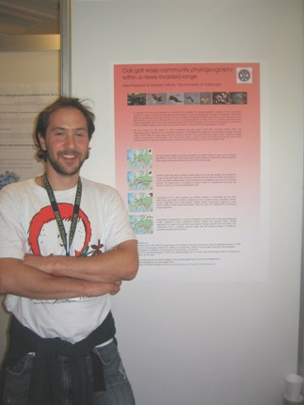  The author with his poster at one of the poster sessions

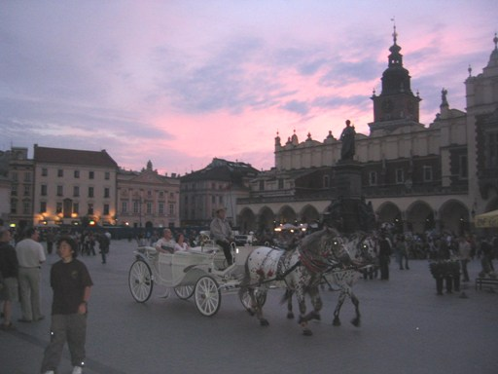  The Rynek Glowny or grand square of Krakow | The location was another positive feature of the congress. Krakow is often quoted as Poland's cultural capital and it proved to be a great place to explore during spare moments. The heart of the city contains the old town, and consists of cobbled streets lined with buildings of a diverse range of architectural styles. In the centre lies the Rynek Glowny (Grand Square), which is the largest square in Europe (200 square meters) and was laid out in 1257 after the Mongol hordes had swept through Poland. The large open square is lined with cafes and restaurants and contains the Cloth Hall (Sukiennice) in its centre. The rynek is almost constantly bustling with activity, ranging from tourists riding in horse-drawn carriages to local youths trying their hand at break dancing.

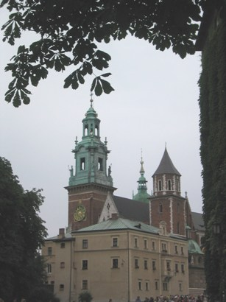  Wawel castle | Krakow was a former capital of Poland and possesses a royal castle known as Wawel, which served as the royal seat for 500 years during the Middle Ages. Wawel is perched on top of a 50m rock at the edge of the old town, within the western slope of which lies a 200 foot long cavern called the Smocza Jama or ‘Dragon’s Cave’. Legend has it that the cave was once home to a monstrous dragon that terrorised local residents. The dragon was apparently slain by Krak, the founder of the city (or by one of his sons depending on the version of the legend). Not content with the usual tools of the trade (swords, lances, etc) or perhaps preferring to keep his distance, Krak dispatched the dragon by tricking it into eating sheep that had been stuffed with tar and sulphur, causing it to explode!  Lying to the south of the old town is the former Jewish quarter of Kazimierz, which has a distinctly different style to the rest of the city. Kazimierz is home to Oskar Schindler's factory, the story of which was immortalized in the Spielberg film ‘Schindler’s list’. These days the district is a fashionable night spot and is home to a number of stylish bars and cafes, in which many delegates ended up during their evenings off!

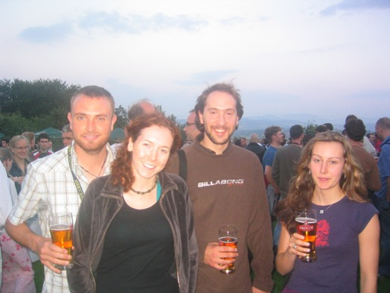  Enjoying a drink at the Flowark Zalesie | 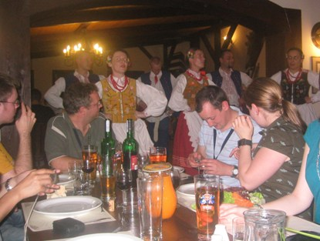  Traditional Polish song and dance at the conference dinner
The conference ended with a dinner held at the 'Folwark Zalesie', a countryside retreat outside Krakow, and featured horse drawn carts, a bonfire, and traditional polish food, song and dance.

Overall my visit was a very beneficial experience both academically and culturally, and I have since been in correspondence with several of the contacts I met at the congress. I would like to say a big thank you to everybody at the Rennie Bequest for making my attendance possible.

