JAMES RENNIE BEQUEST

REPORT ON EXPEDITION/PROJECT/CONFERENCE

Expedition/Project/Conference Title: Investigation into mimicry quality and repertoire size in the spotted bowerbird

Travel Dates: In the field from 17th July 2003 to 30th september 2003

Location: Taunton National Park, Dingo, Central Queensland, Australia

Group Member(s): Neil Hart

Aims: To investigate the link between mimicry quality and repertoire size in this species

OUTCOME (not less than 300 words):-
Due to unfavourable weather conditions in the field I was unable to carry out my intended project title. However, I was able to study the behaviour of several birds at the bower in this unusual year.

Bower location and behaviour of the spotted bowerbird (Chlamydera maculata), and the effect of climate on activity at the bower.

The study was carried out on Taunton National Park in Central Queensland, Australia. Due to inactivity of the bowerbirds in the initial period of the study and lower than expected levels of mimicry at this stage of the breeding season, I was unable to carry out the planned study, but was still able to gain some insight into the behaviour of the spotted bowerbird (Chlamydera maculata).

Taunton National Park was established to conserve the bridled nailtail wallaby (Onchyogalea lunata), a species believed to be extinct before a population was found living in the area. The park contains large amounts of brigalow regrowth, a habitat that also favours the spotted bowerbird. Taunton National Park, therefore, provides an ideal location to study this species. This habitat formerly covered large areas of Central Queensland and New South Wales, but large scale clearing for agriculture has reduced brigalow to small isolated patches. Several native species associated with brigalow are now extinct or endangered.
Spotted bowerbirds are distributed throughout Central eastern Australia. Males construct a bower out of dry sticks or grass, consisting of an avenue and two walls. The bower is then decorated with mainly green objects, usually fruits. All the bowers on the park also have a pile of white shells at least at one end of the avenue (see figure 1).

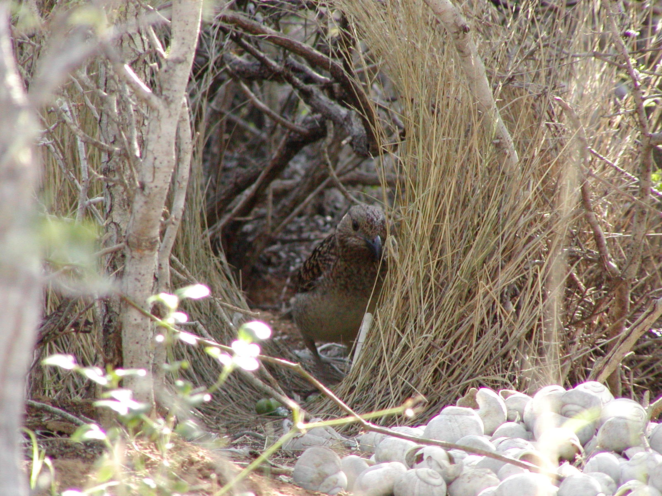
Figure 1. Spotted bowerbird at bower. The avenue and walls constructed from grass can be seen, as can a pile of white shells and a green decoration within the bower.

The bower is used to attract females for mating, and for male-male competition, with males displaying at the bower. Prior to and during the mating season, males spend large periods of time at the bower, maintaining the bower and practicing displaying. Spotted bowerbirds also mimic other birds, although the reasons for mimicry and the situations in which they mimic are uncertain, a subject currently being studied by Edinburgh University PhD student Becky Coe. The breeding season runs from about August to December. After mating, the male has no more to do with the female, and the avenue is abandoned at the end of the breeding season.
Over successive seasons, the same bower sites are often retained, and if a bower moves it appears to be within 100m of the previous bower site. Active bower sites are rarely less than 1km apart.

I have been able to collect data on bower movements and locations, as well as data on bowerbird activity at the bower in the early part of the breeding season.

METHODS

Bower sites are known through studies in previous years. Many of the birds in the park have also been ringed with colour rings allowing for individual recognition. By the time I arrived in the field, bowers that appeared to be active this season had been located. My study included 15 bowers in the park, and one on a property bordering the park. Observations were carried out at a bower for periods of 1.5 hours. Observations were carried out in the mornings and afternoons, avoiding midday, when the birds are relatively inactive. Throughout, the observation, the birds present at the bower and their activities were recorded. Birds were recorded as present if they were seen or heard within 20m of the bower, and where possible, an identification was recorded. Notes were also made on the decorations present at the bower, and the general condition of the bower. A bower was considered to be active if it contained decorations, particularly fresh fruits, and the walls of the avenue were in good condition. Green glass chips were then provided at a distance of 2m from the bower, and movement of these chips to the bower confirmed the bower to be active. Weather conditions were also recorded for each observation, with an estimate of cloud cover, and presence or absence of wind recorded. Rainfall was also recorded in the park area throughout the study.
Each bower on the park was observed at least three times throughout the study.

RESULTS

Situation of bowers:

Bowers are situated under a small number of plant species. The 15 bowers that were studied were all found under four species of plant; Carissa ovata, Wilga (Geijera parviflora), Heterondendrum diversifolium and brigalow (Acacia harpophylla). All old bower sites found were also under one of these four species.

Activity of bowers in relation to climatic conditions:

This aspect of the study provided the most striking results. The early part of the season was unseasonably dry, and although there was evidence that the bowers had become active, very little activity was recorded in this period. There was a heavy rainfall over two days in mid august, with 60mm rain falling between the 15th-16th August. Prior to this date, 30 observations were carried out, with birds seen at bowers on only 6 observations. Of these, two were at the one bower outside the park at which observations were carried out. Bowerbirds were recorded at 11 out of 17 observations after this date.
No bowerbirds were seen on overcast days.

Movement of bowers:

Two bower sites appeared to be active early in the season, but after the rain had moved. One bower moved back to the site or its previous years bower, and another moved to a completely different site. Both of these were within 50m of the site that had been recorded as the original bower.

Activity of birds at bowers:

Birds at bowers were seen to be maintaining bowers and practice displaying. More than one bird was seen at the bower on 5 observations out of the 17 observations where birds were seen. It is not possible to tell whether these individuals were helping the bower owner, or were being displayed to. The birds were recorded as maintaining bowers on 15 of the observations and displaying on 10.

DISCUSSION

Site of bowers:

The four plants under which bowers were located all had low canopies that provided cover of the bower, and also had sufficient space underneath to provide a light, open area for bower construction. Carissa ovata and Heterondendrum diversifolium have very similar growth forms, both being low thick shrubs with tough, spiny foliage. Brigalow and wilga grow taller and have more open canopies, although bowers appear to be sited under those plants with lower canopies - bowers under wilga appear to be under plants with a low growing canopy that conceals the bower, and those under brigalow are under dense stands of young brigalow. Thus bowers appear to be under canopies that afford some degree of protection, particularly from above, and to some extent from ground level. Most endemic predators of bowerbirds are raptors, so it may be advantageous to build bowers under the protection of a canopy. All bowers were also in an open space under the canopy. Light may be necessary for displaying, as colour seems to be important in the display, with green objects used as bower decorations and the pink crest erected during displays.
It is unclear whether these species are the only ones that have a suitable growth structure for bower building on the park, or whether they are preferentially chosen over other suitable species for some other reason.

Activity in relation to climatic conditions:

There appears to be an association with activity at bowers and rain. There is a clear increase in activity after the rainfall in August. Fieldwork last year in late July and August found much more activity than was recorded this year at the same time. This could be due to a period of rain between June 3rd – 7th. It seems possible that rain could be an important trigger for mating behaviour. Fruits play an important part in the display, acting as decorations. Previous work has shown that Solanum berries act as an indicator of mating success (Madden 2001). It is likely that such berries will increase in number after rain. It is also possible that females will wait until after rain to look for a mate, as rain will result in increased food available for young.
The one bower that appeared to have a high level of activity before the rain was that on the property neighbouring the park. This property had no shortage of available water, and the garden was kept well watered. It is an interesting possibility that the watering of the area near this bower had a similar effect as rain, and stimulated bowerbird activity when the birds on the park were inactive.

Movement of bowers:

Bowers have been previously noted to move between seasons. The initial activity in early July led to the establishment of bowers, followed by a period of inactivity. After the rain, two of the active bowers had moved, abandoning the previous site. The reason for this is not clear, however, in both cases it seems to be associated with the period of inactivity. The movement of bowers is an interesting phenomenon that requires further study to determine the cause.

Activity of birds at bowers:

The small number of observations with more than one bird present indicates that the mating season may not yet have started. In the observations where more than one bird was seen, it appears to have been the bower owner and an auxiliary male, rather than a male and a female. Both birds were often displaying or maintaining the bower, activities carried out by male birds.
The one situation where a possible true display was observed was at the bower on the property that appeared to be active earlier than those on the park.

Although unable to carry out my intended study, I have still been able to collect some data that may be useful to others studying this species. Although most results are anecdotal due to the low level of activity of the birds, and insufficient time to collect enough data for rigorous statistical analysis, several interesting results have been suggested. Further, longer-term work into these areas will produce interesting results.

ACKNOWLEDGEMENTS

I am indebted to the Weir Fund for Field Studies and the James Rennie Bequest, for providing financial support to enable me to carry out this project.
I would also like to thank Becky Coe for her help with field work and for support and assistance in the field.

REFERENCES
Madden J 2001. PhD report on the mating success of bowerbirds, for the University of Cambridge.

Appendix

Itinerary:
12th July 2003
Departed Edinburgh, Arrived in Sydney, Australia 13th July

18th July
Began fieldwork on Taunton National Park, Central Queensland, Australia.

31st August
Final day of fieldwork (a week less than intended, due to the park being closed for the first week of September.

Financial Support:
The money I received from the Weir Fund and James Rennie bequest were sufficient to cover my costs of flights to Australia, and transport within Australia, my travel insurance, and a contribution toward my accommodation costs. I was able to pay for food and the remainder of my accommodation with a personal contribution as stated in my proposal.

