JAMES RENNIE BEQUEST

REPORT ON EXPEDITION/PROJECT/CONFERENCE

Expedition/Project/Conference Title: World Association for the Advancement of Veterinary Parasitology

Travel Dates: 9th August -13th August 2009

Location: Calgary, Canada

Group Member(s): Sarah Hall

Aims: 1) To give a poster presentation entitled “Investigating gut microbiota as a target for control of sheep scab mites, Psoroptes ovis” which covers research results that I have achieved so far in my PhD.

2) To make contact with mite and ectoparasite disease experts to share and discuss my current research findings.

OUTCOME (not less than 300 words):-

From Buffaloes to Bagpipes: meeting the World’s Parasitologists.

The 22nd World Association for the Advancement of Veterinary Parasitology conference was held in Calgary, Canada from 9th-13th August. The title for this year’s conference was “One world, one health –Parasites in a changing landscape”

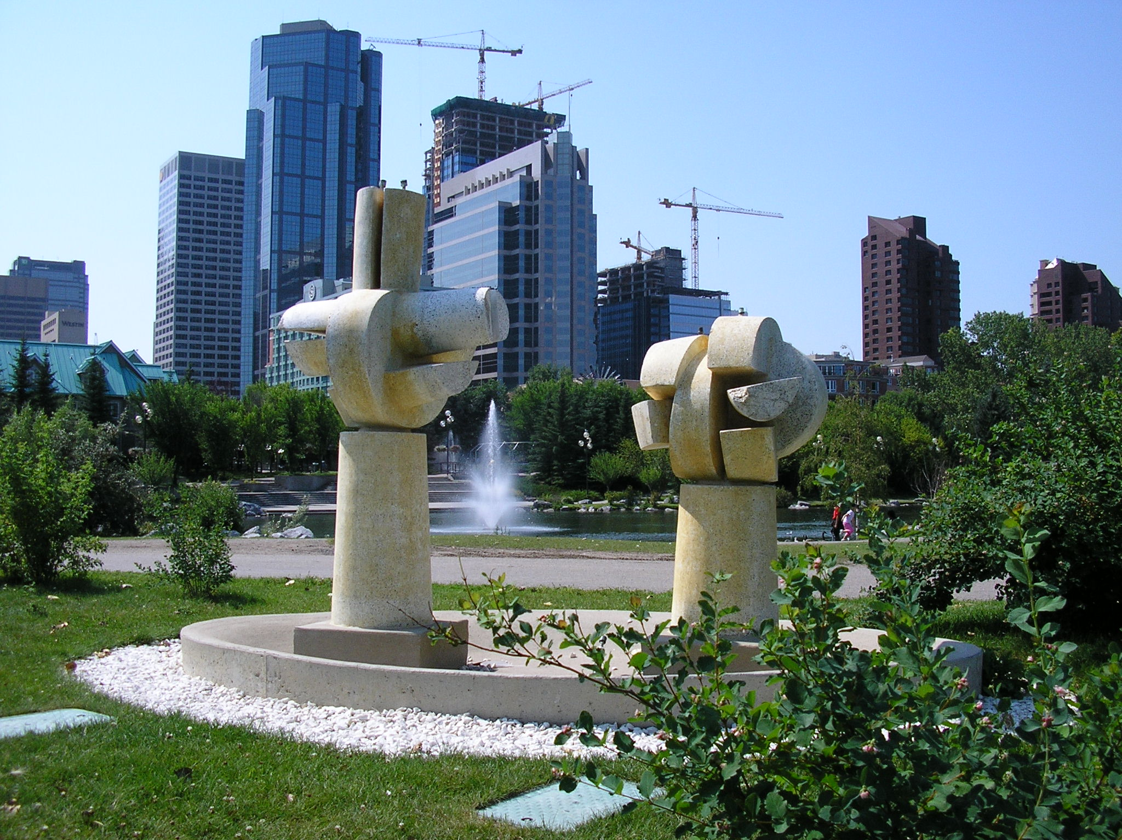
View of Calgary from Princes Island Park

This was the first international conference I have attended and it certainly did not disappoint.

The opening ceremony to welcome the delegates included the appearance of a 3 month old buffalo, which was the size of a small car and Canadian bagpipers playing ‘Flower of Scotland’. After this it was straight into the science, with the opening plenary session “Parasite control in the age of drug resistance and changing agricultural practices”. This was especially relevant to me as my project is concerned with novel, environmentally-friendly methods of treating parasite disease.

Each day after the morning plenary sessions there were a series of concurrent sessions that covered a number of different areas including epidemiology & control, drug resistance and diagnosis. I found the ectoparasite, vector and diagnosis sessions extremely thought provoking, interesting and informative. The setup of the sessions was fairly informal, encouraging questions and discussions. As this was a large conference, the concurrent sessions allowed for more specialised discussions with smaller groups of people.

On the Wednesday morning I presented my poster entitled “Investigating gut microbiota as a target for control of sheep scab mites, Psoroptes ovis”.
This poster presented the bacteria I have identified through molecular techniques and results of survival experiments that are associated with the mite, P. ovis and that I hope will be potential targets for disease control. I was thrilled to be visited by delegates I had met and talked with during the conference up to this point, but also others who I had not yet had the opportunity to meet –there were after all over 600 attendees! Interest in my project ranged from detailed molecular technique questions to larger scale objectives of my research interests.

Although I attended the conference by myself I managed to summon up the courage to talk to other delegates. I met Dr Karen Snowden who is an executive member of the American Association for Veterinary Parasitology. She kindly introduced me to a number of very interesting researchers, from all round the world, and invited me to the student’s forum lunch for the AAVP. I was very lucky to attend this lunch as it introduced me to large number of other graduate students attending the conference and it was especially interesting to learn about their projects, how they were going, and how graduate school was differed between America and Scotland.

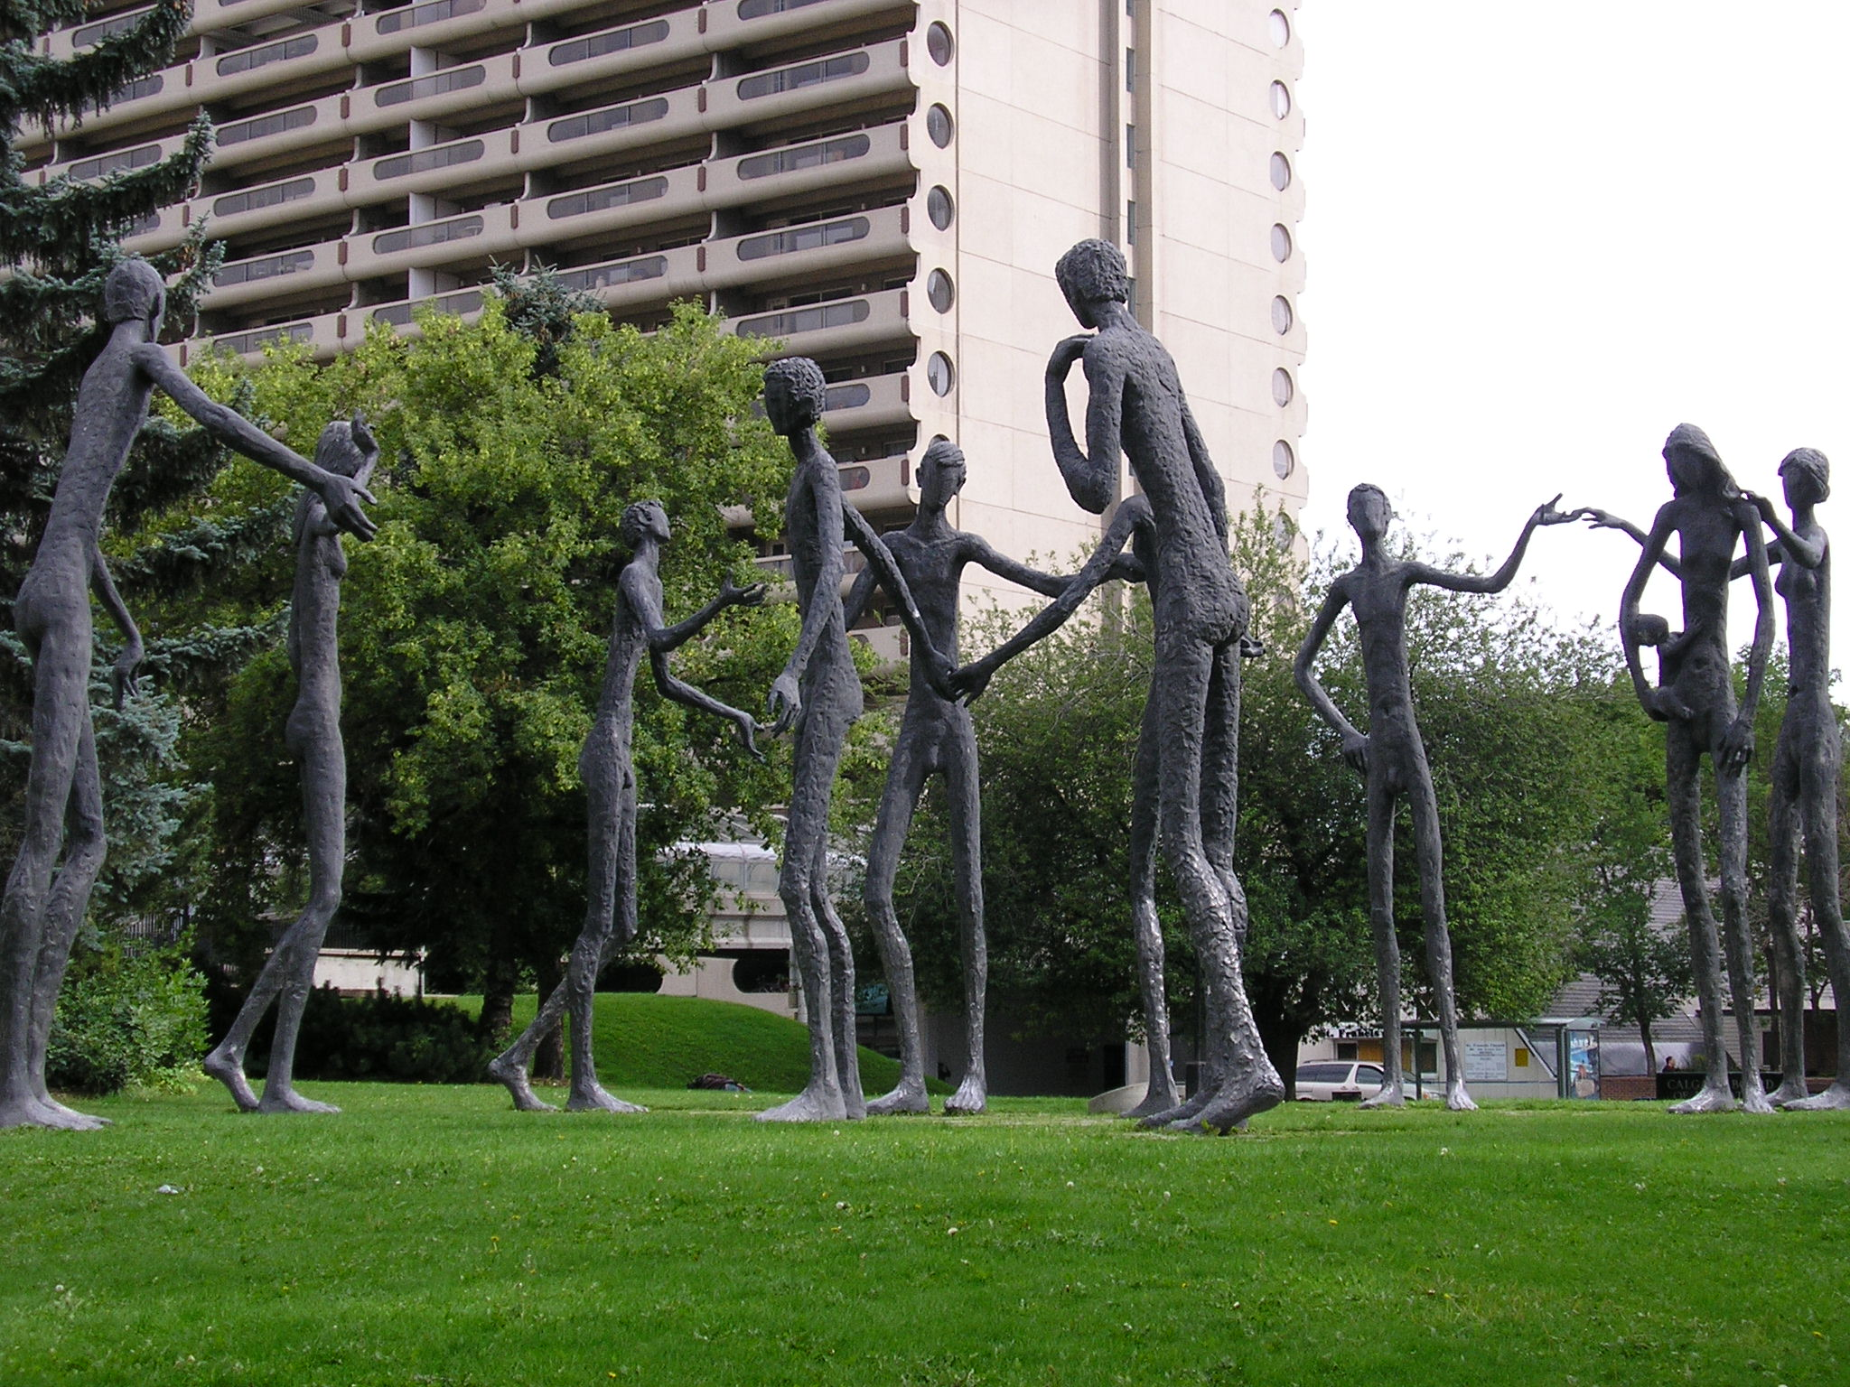
A sculpture near the conference centre

I was lucky that there was a whole morning session with talks concerning Sheep Scab disease, and from this I was able to meet a whole wealth of people who either work, or have worked on this parasite. They were all very interested and encouraging about my particular project.

There were a number of events also organised out with the conference programme including a visit to ‘Heritage Park’ and a 5km fun run –both of which I attended.
Heritage park was ‘How the West was Once" in the form of a living history museum. It was a fantastic event as it allowed us to learn more about Canada during the early 1930’s with real houses and delicious period food and also gave the delegates a chance to talk in more relaxed surroundings.

I learnt a huge amount during this conference, and have many references that I would like to investigate further. I also hope that I will see the delegates again, whether that be at another conference or to collaborate on a project once my PhD is finished.

I greatly appreciate the financial support from the James Rennie Trust without which I would not have been able to attend this wonderful opportunity.

