Project Mbegu expedition report

Conserving Plant Biodiversity
in the Coastal Forests of Eastern Africa
- Integrating ex situ and in situ Conservation in the
Shimba Hills, Kwale District, Kenya.

A University of Edinburgh Expedition conducted in collaboration with National Museums of Kenya
2006

For information contact: Sally Hinds s.e.hinds@gmail.com, Hannes Dempewolf hdempewolf@gmx.de
Index
Summary 3
The Coastal Forest hotspot 3
The Shimba Hills 3
Conservation 3
Aims and Objectives 3
Specific aims: 3
Team members 3
Collaboration 3
Seeds for Life 3
Professional collaboration 3
Logistics 3
Resources and Equipment 3
Accommodation 3
Transport 3
Itinerary 3
Site 3
Methodology 3
Plant collection 3
Taxa 3
Identification 3
Ex situ conservation: Seed Collection 3
Taxa 3
Collection 3
Processing 3
In situ conservation: Conservation Assessments 3
Taxa 3
Data collection 3
Data Analysis 3
Outcomes 3
Collections 3
Plant Collections 3
Database 3
Germplasm Collections 3
Conservation Assessment Conclusions 3
Technology Transfer 3
Geographic Information Systems (GIS) 3
Dissemination 3
Presentations 3
Publications 3
Traditional Plant Knowledge 3
Acknowledgements 3

Summary
The aim of Project Mbegu was to complement current plant conservation efforts in the Shimba Hills, Kwale district, Kenya; one of the last remaining fragments of the coastal forest of East Africa, and a world biodiversity hotspot. In situ conservation measures were supported by providing updated information on the conservation status of several rare and endemic plants and collecting specimens of under collected and potentially new plant species, as well as species new to the local and national checklist. The seeds of previously unbanked native plant species were collected and transferred to the National Genebank of Kenya for ex situ conservation. Where sufficient seed was collected, germplasm was also made available through the Seeds for Life Programme, for safeguarding outside the country of origin in the Millennium Seed Bank Kew, UK. The uniqueness of the area’s plant biodiversity and the consequent importance of its conservation were promoted through a series of presentations and the publication of a free public brochure which was published in Nairobi by Project Mbegu and distributed throughout Kenya by the Kenya Wildlife Service. Field work was conducted in the Shimba Hills National Reserve by a team from the University of Edinburgh and the National Museums Kenya in collaboration with the Seeds for Life Partnership, and with the cooperation of Kenya Wildlife Service. The expedition was supported by the University of Edinburgh and the Royal Geographical Society.

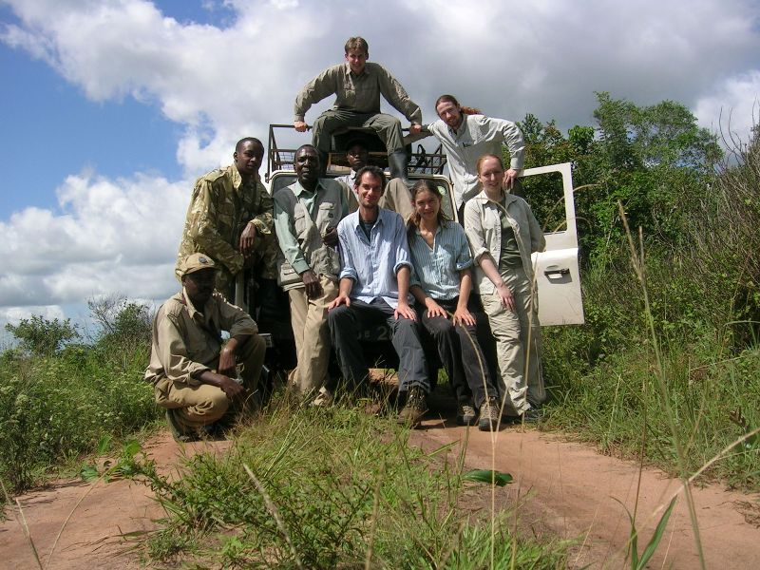

The Project Mbegu team with KWS ranger. From left to right: (front) Robert Kurui, Wilson (KWS), Joshua Muasya, Thomas Waibel, Sally Hinds, Lucy Inns, (back) Mathias Muindi, Hannes Dempewolf, Damian Bienkowski, Chan Moses (not shown).

The Coastal Forest hotspot

The now infamous biodiversity hotspots concept paper by Myers et al. (2000), devised a strategy for the identification of priority areas for conservation based on levels of plant endemism and threats. The Eastern Arc Mountains and Coastal Forests of Eastern Africa Hotspot is one of the 25 global hotspots identified in this and subsequent papers (Myers et al. 2000, 2003). It represents an area with one of the greatest densities of endemic plants and vertebrate species in the world and due to a high degree of forest fragmentation and the level of threats posed to its survival, it is considered to be one of the areas most likely to witness the extinction of species in the near future.
The Coastal Forests of Eastern Africa Hotspot stretches along the eastern edge of Africa, from Southern Somalia through Kenya and Tanzania and most of the coast of Mozambique. On the mainland it ends at the Limpopo River and the hotspot also encompasses several offshore islands. The hotspot's vegetation is a mixture of moist and dry forests, with coastal thicket, fire- climax savannah woodlands, seasonal and permanent swamps, and littoral habitats that include mangrove vegetation along some parts of the coast. Trees dominate the coastal flora, but lianas, shrubs, herbs, grasses, sedges, ferns, and epiphytes are also common. Despite the reduced and fragmented nature of the forest remnants, the coastal forests of Eastern Africa contain remarkable levels of biodiversity, especially plants. Approximately 17% (50,889 km²) of the Coastal Forests of Eastern Africa hotspot’s land area is now under some form of protection (CEPF 2003). However the management effectiveness of the protected areas varies widely and only 4% (11,343 km²) of the land area is conserved in areas with a higher level of protection (IUCN categories I to IV).
Figure 1 (from www.cepf.net).
The Coastal Forests of Eastern Africa Hotspot

The Shimba Hills
In Kenya, the Coastal Forest ecosystem is mainly confined to a relatively narrow strip only 40 km wide. The Shimba Hills located 33 km south west of Mombassa in the South East of Kenya contains one of the largest remaining forest fragments. The Shimba Hills were gazetted as National Forest in 1903, and the Shimba Hills National Reserve was created in 1968. The reserve falls under the jurisdiction of the Kenyan Wildlife Service (KWS) and the Forestry Department. Two Forest Reserves (Mkongani North and West) which adjoin the National Reserve are administered jointly by the KWS and the Forestry Department (FD) and are managed for a variety of forest products. Another forest reserve - Mwaluganje is connected to the Shimba Hills National Reserve by a fenced elephant corridor and is an extension to the Elephant Reserve.
Figure 2 (from Luke, 2005). The Shimba Hills National Reserve and surrounding area
The area also includes many Kayas – ancient and sacred sites of the Mijikenda people of the coast. Kayas within the Shimba Hills National Reserve are no longer in use as sacred sites, however several active sites remain in the area including Kaya Mtae within the Mwalunganje Reserve, and these have been gazetted as national monuments. Unfortunately the level of protection gained from this status is below that of the forest reserves (WWF-EARPO 2002) and while in the nineties they were known to comprise approximately 220ha of closed forest, their current status is uncertain. It is certain however that Kaya Miyani, previously situated near Kwale is now gone.
A recent checklist (Luke, 2005) has provided essential data on the plant species occurring within the Shimba Hills. A total of 1396 species representing 143 families and 686 genera, have been recorded as being indigenous or naturalised in the area. Sixty four of these species are endemic to the Kenyan coast and four are thought to be restricted exclusively to the Shimba Hills (Luke 2005). This level of biodiversity is exceptional for an area of this size and altitudinal range and the plant species which occur here represent 40% of the coastal flora and 21% of the Kenyan flora. 42 of these species are IUCN red listed (as critically endangered, endangered or vulnerable), yet over 440 have been noted by WWF ’s Coast Forest Survey as having some degree of rarity and 276 were listed as potentially threatened in a “List of Potentially Threatened Plants” of the hotspot (Gereau & Luke, 2003). The disparity between these figures has been noted and the urgent need to reassess the conservation status of the areas plants is recognised as high priority for work in the area (CEPF, 2003). This work is in fact ongoing and so far some 400 species have been assessed (Quentin Luke pers.com.)

Conservation
Specific threats to the biodiversity of the Shimba Hills area include the exploitation of mineral resources, namely titanium, by international enterprises, expanding subsistence agriculture and most significantly the areas expanding elephant population. Throughout the 70s and 80s hunting to supply the demands of the ivory trade reduced Kenya’s elephant population from 167,000 to about 16,000. Since then a worldwide moratorium on the ivory trade has allowed the population to recover and it is now growing so fast that in the Shimba Hills their high density has become a problem. As the population has increased the elephants have come out of the reserve and into conflict with the local human population, raiding or destroying the crops on which they subsist. In search of a solution for the local people and the growing elephant population, in 2000 more than 200 local farmers gave up their fields to create the community-run Mwaluganje Elephant Sanctuary from which they receive an annual dividend from tourism receipts. The reserve is connected by a corridor to the Shimba Hills National Reserve. While fencing off the reserve has reduced the elephant problem externally, the internal pressure on the forests has increased. Some forest areas have been severely damaged and chronic elephant damage, causing substantial changes in forest structure, may be responsible for the apparent loss of previously relatively abundant species. This situation led to the decision in 2004 to translocate 400 of the areas estimated 700 elephants.
Despite such significant and immediate threats, many of the area’s species remain unclassified because too little is known about them. Basic research is needed in order to establish the frequency, distribution and ecological requirements of these species and to assess the specific threats to their survival. Conservation status may then be assigned, guidelines for conservation action plans may be provided, and in this way in situ protection may be achieved. IUCN rules allow the assessment of conservation status of undescribed taxa, so long as species delimitation is clear. however although many new taxa have been collected and are in the process of being described, there may well be more which are still unknown. These must first be discovered and collected before any assessment of their conservation status can be made.
While in situ conservation of this area is a priority, and part of the Shimba Hills is already included within a protected area, many of its species are still under threat from a variety of sources, including the increasing elephant population and human utilisation of resources. It is therefore increasingly urgent to develop complementary conservation initiatives to safeguard this biodiversity ex situ. Seed banks offer one way of conserving a large part of this genetic diversity (Linington & Pritchard 2001) and provide an accessible genetic resource which increases research possibilities for the conserved genetic material as well as reducing collection pressure on wild populations.

Aims and Objectives
The aim of Project Mbegu was to complement current conservation efforts in the Shimba Hills particularly for endemic plant species, using both ex situ and in situ conservation measures. Through close collaboration with the 'Seeds for Life' project, we aimed to secure the ex situ conservation of previously unbanked native plant species as germplasm in seed banks in the country of origin. We also aimed to support in situ conservation measures by collecting specimens of under collected and potentially new plant species and by making conservation assessments of target rare and endemic plant species using qualitative and quantitative approaches to gather biological, ecological and socioeconomic data, and disseminating this information to the appropriate institutions in order to allow the assignment or updating of the IUCN conservation status for these species.

Specific aims:

- To improve herbarium records of under-collected and potentially new plant species through targeted specimen collection

- To increase the number of native species stored as germplasm in ex situ conservation in the country of origin.

- To assess the conservation status of selected threatened endemics within the reserve via survey of distribution, population size and potential threats.

- To develop the skills, knowledge and cultural awareness of participants through knowledge exchange and technology transfer

- To disseminate findings and promote awareness of the importance of the conservation of the flora of the Shimba Hills

Team members
The expedition team consisted of five U.K. based members, all Plant Science graduates from the University of Edinburgh (U of E), and four Kenyan members- three staff members of the National Museums Kenya (NMK) and one from the University of British Columbia (UBC). All members participated in field work activities as well as fulfilling their following specific roles
Sally Hinds (U of E) Co-leader
Hannes Dempewolf (U of E) Co-leader
Damian Bienkowski (U of E) Medical Officer
Lucy Inns (U of E) Coordination of Taxonomic studies
Robert Kurui (NMK) Driver
Chan Abraham Moses (UBC) Logistics, Translation
Joshua Muasya (NMK) Taxonomy
Mathias Muindi (NMK) Coordination of Seed collection
Thomas Waibel (U of E) Finance

Collaboration

Seeds for Life
The project was conducted in collaboration with Seeds For Life- a collaboration between the Millennium Seed Bank Project, Kew and several Kenyan institutions: National Museums of Kenya, The National Genebank of Kenya at the Kenya Agricultural Research Institute (KARI), The Kenya Forestry Seed Centre at the Kenya Forestry Research Institute (KEFRI), The Forestry Department (FD), and The Kenya Wildlife Service (KWS). The aim of the Seeds for Life project is to enhance ex situ conservation and sustainable utilisation of plant genetic resources indigenous to Kenya. In particular the University of Edinburgh expedition worked in close collaboration with Seeds for Life team members from NMK coordinated by Mr. Patrick Muthoka- Head of Plant Conservation and Technical Manager for the Seeds for Life project.

Professional collaboration
The Kenyan Botanist, Quentin Luke is a freelance taxonomist associated with the East African Herbarium and the Critical Ecosystem Partnership Fund and an expert in the flora of the Shimba Hills. He helped in the definition of the project goals, introduced us to the research site and taxa of interest, orientated us in our consultations of the collections at the East African Herbarium prior to field work and supported us during the identification process.

Logistics

Resources and Equipment
Prior to departure, access to plant specimens at the Royal Botanic Garden Edinburgh was permitted and both the herbarium and living collections were visited for the purpose of familiarisation with the taxa of interest. Whilst in Nairobi, office space was provided at the headquarters of the National Museums Kenya (NMK) and access to herbarium specimens, plant distribution data and an extensive library collection was provided by the East African Herbarium which maintains the largest botanical collection in tropical Africa, with over 700,000 plant specimens. Field guides and floras and some collection equipment were provided by NMK and a Land Rover was rented by arrangement with the Museum. Additional field equipment was provided by team members and the remainder was purchased locally. The KWS in Kwale provided a room for the processing of seed collections, drying of plant specimens and storage of equipment and specimens.

Accommodation
In Nairobi accommodation was in a self catering apartment provided by the Hill Crest Hotel, situated in the Westlands area, in close proximity to the National Museums of Kenya and other amenities. In the field, accommodation was at the Golden Guest House in Kwale, situated less than 1km from the KWS headquarters and 3km from the Shimba Hills National Reserve main gate. Food supplies were purchased in the nearby town of Ukunda and prepared by arrangement with staff at the Golden Guest House.

Transport
Travel within Kenya was via Land Rover hired by arrangement from the National Museums Kenya. A professional driver was also contracted from the Museums permanent staff for the duration of the field period.

Itinerary
The expedition team was in Kenya between 16th June and 6th August, with a field period of 30 days between 27th June and 27th July which coincided with the end of the delayed long rains. Time was spent prior to commencing field work and once field work was completed at the East African Herbarium at the National Museums of Kenya.

Site
The Shimba Hills National Reserve is located 33km south-west of Mombasa in the district of Kwale, Coast Province, Kenya (39º 25' East 4º 15' South) and has an area of 321 km². The area is a dissected plateau surrounded by escarpment and rises steeply from the coastal plains to an elevation between 120m and 300m, reaching as high as 450m in some places. Temperatures vary little throughout the year, ranging between 20 and 30°C. The area’s average annual precipitation is 1200mm which falls mainly during two wet seasons known as the long (April to June) and short rains (November to December). Rivers flowing from the Shimba Hills supply fresh water to Mombasa, and the Diani area which lies immediately to the east.
The reserve supports a heterogeneous mosaic of vegetation, with forested scarp slopes and undulating grasslands interspersed with woodland clumps and ribbons of riverine forest in the steep valleys as well as areas of scrub and exotic plantations. A rough vegetation map of the reserve produced by Kenya Indigenous Forests conservation programme (KIFCON) in the early 1990’s (Blackett, 1994) is based on six main vegetation classifications, which suggest that 44% (9,500 ha) of the total area was forested, a further 37% (8,000 ha) was forest/scrub, Grassland or grassland/scrub covered 15% (3,400 ha), and the remainder (4%) was plantation or other cover (800 ha). More specific species associations have been described extensively (Schmidt 1991).
Several Kayas are situated within the study area. According to local beliefs people of non Mijikenda origin must not enter without permission and a series of behavioural rules and customs should be respected upon entry. In respect of these beliefs, the Kayas were not included in our survey.

Methodology

Plant collection

Taxa
All under-collected taxa for which good fruiting or flowering specimens were available were collected. The recent checklist of the Shimba Hills (Luke 2005) together with additional information provided by its author, Quentin Luke regarding status of specimens were used to prioritise potentially threatened, rare and endemic species, and in particular potential new species and subspecies (as yet undescribed), for which flowering or fruiting material was required.

Identification
Taxonomic guidance and the known localities of taxa of interest were provided by the Kenyan Botanist Quentin Luke. Joshua Muasya from National Museums of Kenya was the expedition’s principal taxonomist. In the field standard references for the area such as (Beentje, 1994; FTEA, 1952) were also be referred to.
A photographic database of herbarium specimens created by Project Mbegu using specimens from the East African Herbarium upon arrival in Nairobi, prior to the commencement of the field period was available for reference during the field period. A herbarium of local flora at the Coastal Forests Conservation Unit in Ukunda was also referred to. Post field work, specimens were identified by reference to collections at the East African herbarium. Each expedition member took responsibility for the identification of particular families.

Ex situ conservation: Seed Collection

Taxa
In order to meet the aims of Project Mbegu and the Seeds for Life project to increase the number of native accessions in the Kenyan gene bank, we targeted previously uncollected species with preference for threatened rare and endemic species. Only species with orthodox seeds (which maintain viability when dried) were potentially collectable. Furthermore collectable species were restricted to those for which there were sufficient individuals with seeds at a suitable stage for collection. Due to the lateness of the rains this year, flowering and fruiting were delayed and the availability of seeds ready for collection was therefore limited. For this reason all taxa which met the requirements of being native, previously uncollected and having sufficient, orthodox seeds at a suitable degree of development were collected.

Collection
Protocols as laid out in the Millennium Seed Bank Project seed collecting manual (Gold et al. 2004) were followed. Because seed availability was restricted, quantities did not always reach an ideal minimum of 20,000 seeds per species, however, good numbers were collected. Seeds were collected so as to capture maximum genetic diversity and in accordance with the Convention on Biological Diversity. The collection of seeds from natural habitats for ex situ conservation purposes was regulated so as not to threaten in situ populations. In accordance with the protocol voucher specimens of the plants were collected in order to verify identification and collected plants were GPS referenced. Towards the end of project we were joined by tree climbers from the MSBP (Figure 3i), and KEFRI who assisted us in the collection of seeds from tall forest trees such as Xylopia sp. (Fig. 3) and Bombax sp.
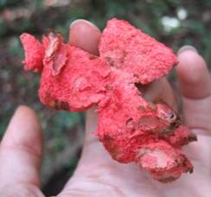
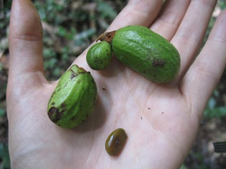
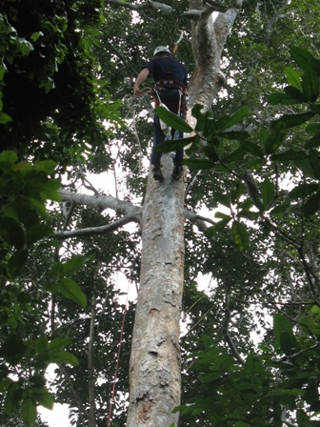
Figure 3. From left to right: i) David Waldon of RBG Kew climbing Xylopia sp.?nov, ii) X. sp? nov. unripe fruits and seed, iii) interior of a ripened and dehisced X.sp? nov. fruit

Processing
Collected seeds were processed and deposited in the National Gene Bank of Kenya in Nairobi. For those accessions for which sufficient seed was collected, seeds were also sent via the Seeds for Life Programme to the Millennium Seed Bank Project in Wakehurst Place, U.K. Voucher specimens for the seed accessions were identified and stored at the East African Herbarium.

In situ conservation: Conservation Assessments

Taxa
The recent checklist of the Shimba Hills (Luke 2005) together with additional information provided by its author, Quentin Luke regarding status of specimens were used to prioritise potentially threatened, rare and endemic species, and in particular, potential new species and subspecies (as yet undescribed), for which more information is required about their conservation status. An initial period of reconnaissance and familiarisation within the reserve allowed us to select 11 taxa for more detailed study.
These were:
Dichrostachys cinerea ssp. keniensis
Vangueriopsis sp.nov.
Pavetta tarennoides
Uvariodendron schmidtii sp. nov. ined.
Oxyanthus pyriformis ssp longitubus
Cola porphyrantha
Abrus sp A of FTEA
Ancistrocladus robertsoniorum
Bauhinia mombassae
Erythrococca pentagyna
Dalbergia gloveri sp. nov. ined.

Data collection
For each of the eleven species selected, populations were located by directed stratified sampling within the reserve. For this we first identified different habitat types and then searched specifically for populations of the target species. For each population observed, the following information was recorded: location, GPS locality and elevation, habitat type, number of individuals, height of tallest individual, diameter at breast height of tallest individual (if applicable), the presence or absence of flowers, presence or absence of fruits, presence of vegetative regeneration, associated species, and all observable threats as well as further qualitative observations were recorded.

Data Analysis
The collected data was used to summarise for each species the habitat type(s) in which they were found, and general characteristics of the populations including the minimum, maximum and mean number of individuals observed per population, and the percentage of populations in which flowering, fruiting and/or vegetative regeneration were observed. Observable threats were recorded and qualitatively described and on the basis of these observations a threat category from 0 to 10 was assigned.

Outcomes

Collections

Plant Collections
376 plant specimens with field notes were collected and recorded in BRAHMS database, a botanical database system created by Oxford University, widely used by botanical gardens around the world. Once identified, the samples were mounted with field notes, and added to the collections at the East African Herbarium. Of particular interest was a fruiting specimen collection number Mbegu 353, which matches Luke 2723 Xylopia sp? nov. No flowering specimens were found, however the fruiting specimens collected provided further evidence which supports this as a new species. Flowering material will now be targeted in order to describe the new species.

Database
A database of collected plants including field notes and observations on distribution, habitat, conservation status etc with colour photographs was compiled and made available to the KWS.

Germplasm Collections
31 new accessions were added to the collection at the National Gene Bank of Kenya. For each accession sufficient seed was available to provide duplicates for storage in MSBP.

Conservation Assessments
The observations and threat categories assigned to the eleven species studied during the conservation assessments are summarised in table I.

Table I. Values and qualitative observations for each of the 11 species assessed. Threat categories on a scale of 1 to 10, where 1= No Threat 10= Extremely Threatened.

Name | No. of obs | Mean No. individs. per site | Max. No. individs. per site | Min. No. individs. per site | % sites in which flowering observed | % sites in which fruits observed | % sites in which veg. regen. was observed | observable threats | Qualitative description/ grounds for threat category | Threat Category
Abrus sp A of FTEA | 4 | 12 | 30 | 1 | 50 | 50 | 75 | human impacts | few observations, but good regeneration and successful repro. | 5
Ancistrocladus robertsoniorum | 1 | 5 | - | - | 0 | 0 | 100 | none | one observation, signs of regeneration and no threats observed | 7
Bauhinia mombassae | 2 | 14 | 25 | 4 | 50 | 50 | 100 | none | few observations, but good regeneration, successful reproduction and no observed threats. | 5
Cola porphyrantha | 1 | 2 | - | - | 0 | 0 | 0 | elephant damage | only one observation, no regeneration signs, extreme threat | 10
Dalbergia gloveri sp. nov. ined. | 3 | 1 | 1 | 1 | 33 | 0 | 33 | elephant damage | few observations, all associated with observable threats, some signs of reproduction and regeneration | 10
Dichrostachys cinerea ssp keniensis | 9 | 4 | 10 | 1 | 11 | 22 | 44 | elephant browsing | high no. of observations., relatively high regeneration and signs of successful reproduction, almost always under observable threat | 5
Erythrococca pentagyna | 1 | 1 | - | - | 0 | 100 | 0 | none | one observation, signs of reproduction and no observable threats | 6
Oxyanthus pyriformis ssp longitubus | 1 | Many | - | - | 100 | 0 | 100 | none | one observation, but many individuals. Signs of reproduction and regeneration and no observable threat | 4
Pavetta tarennoides | 1 | Many | - | - | 100 | 0 | 100 | none | one observation site, covering a large area and comprising many individuals. Signs of reproduction and regeneration and no observable threats | 4
Uvariodendron schmidtii sp. nov. ined. | 1 | Many | - | - | 0 | 0 | 100 | elephant damage | one observation site, representing a localised stand comprising many individuals. Signs of natural regeneration. However the site is under elephant threat | 7
Vangueriopsis sp.nov. | 2 | 1 | 1 | 1 | 0 | 0 | 0 | human impacts | few observations, no signs of reproduction or regeneration, one site under observable threat | 10

Conservation Assessment Conclusions
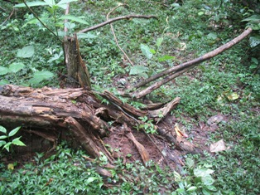
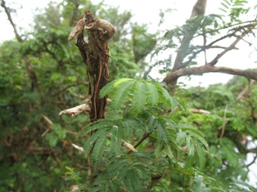
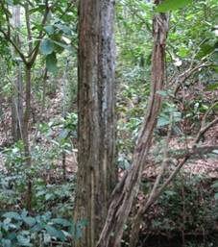
Due to the restricted nature of most of the species studied, any elephant damage or activities which affect them or their habitat directly such as widening of paths within the reserve may affect the species conservation status. Furthermore several species were observed to be specifically targeted by elephants, such as Dichrostachys cinerea ssp. keniensis, which although was found to be relatively abundant within reserve, was mainly present as vegetative regeneration from root stock and the only adult individuals observed were found to show signs of severe elephant browsing (Figure 4 i). Likewise only one mature adult of Dalbergia gloveri sp. nov. ined. was found and this was dead, evidently due to elephant damage (Figure 4 ii). Only two individuals of Cola porphyrantha were found, both dead, one had been uprooted, another snapped at the base (Figure 4 iii). A few fruits were found on the tree, so regeneration may be possible, however not a single individual is currently known within the reserve and thus the survival of this species within the reserve is of extreme concern.
Figure 4. From left to right: i) One of the few adult individuals of Dichrostachys cinerea ssp. keniensis observed showing clear evidence of elephant browsing, ii) The only adult individual of the liana Dalbergia gloveri observed, again showing clear signs of elephant damage and in fact appearing to be dead, iii) A Cola porphyrantha adult individual snapped at its base.

In general elephants were observed to cause a great deal of damage; adult trees are uprooted (Fig. 5i), chewed (Fig. 5ii) and ring-barked (Fig 5iii). It has also been reported that seedlings are eaten, thus preventing regeneration. Rather than increasing plant diversity, as has previously been claimed, elephant browsing appears to alter the process of succession, promoting nearly mono-dominant stands of non-forest, elephant-friendly species. For this reason, even those species not directly targeted by elephants are also under threat. Neither Vangueriopsis sp.nov. Erythrococca pentagyna, nor Oxyanthus pyriformis ssp longitubus were observed as being directly targeted by elephants, however due to their rarity within the reserve they are extremely vulnerable and chance elephant damage to these species is of greater concern than in those species with larger populations.
Uvariodendron schmidtii sp. nov. ined. although represented by more individuals, was found only in localised stands and although there was no evidence of specific threats, due to the localised nature of these individuals previous comments about susceptibility to habitat degradation are particularly relevant. Pavetta tarennoides was seen to be more abundant than the Uvariodendron and therefore was assessed to be less vulnerable. Ancistrocladus robertsoniorum was observed to be relatively rare. No sexual reproduction was observed, and population counts were impeded by strong vegetative regeneration, however it was decided that this species should be placed in a relatively high threat category. Bauhinia mombassae was observed as being restricted to riverside areas, but was seen in good sized populations which seemed to be reproducing sexually as both flowers and fruits were observed and so was of less concern. Abrus sp A of FTEA was found to inhabit disturbed areas or areas of open grassland, so elephant presence and human disturbance by the creation of paths, or burning of grassland for the management of sable antelope populations might be perceived as positive for this species. However due to its highly restricted nature, any strong disturbance in the areas it inhabits may be damaging to the future of this species in the reserve.
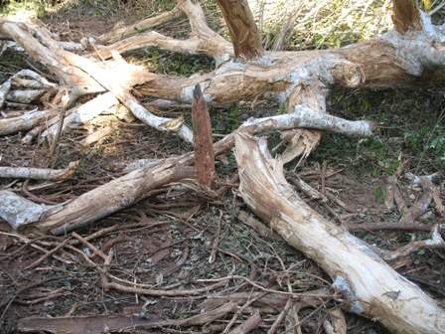
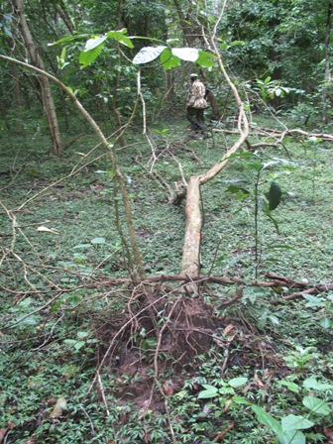
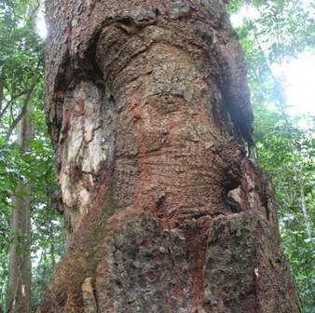
Figure 5. From left to right. i) Forest tree uprooted by elephants, ii) A recently trampled and bark stripped tree, iii) A tree recovering from previous ring barking by elephants.

The impact of the increasing elephant population is evident in the reduction of the forested area within the Mwaluganje Forest Reserve. Although no current vegetation classification figures are available, its area has been visibly greatly reduced since the early nineties when the most recent vegetation survey was conducted. As elephant populations continue to rise, the KWS has been forced to take action to alleviate the situation. The options currently perceived as viable are cull or translocation. The decision was made to relocate a herd of 400 elephants from Shimba to Tsavo and although this work began in 2004, bad droughts forced its suspension. The translocation was due to be resumed immediately after our field period, towards the end of August 2006, however, yet again, it had to be suspended due to adverse weather conditions, this time due to excess rains from that time until the present. It is hoped that it will be possible to resume the translocation soon and that such action will help to reduce pressure on the reserves plant diversity.

Technology Transfer

Geographic Information Systems (GIS)
Spatial data was acquired for every specimen that was collected as well as for every site that was examined for the conservation assessment. The data was made available to the National Museums Kenya in order to be incorporated into their spatial dataset for the region. The integration of our data with the already existing GIS framework for the area at the NMK will give future researchers and plant collectors of the area access to an updated geographical reference system and hence allow for more accurate spatial analysis of collection data. The exact geographic reference for each sample recorded on its herbarium label and stored with the specimen in the collections of the East African Herbarium will enable future students of the Flora of the Shimba Hills to accurately deduce information about the locality in which the collection was made.
Furthermore capacity building of local staff at the Shimba Hills KWS station was carried out. In particular the KWS Shimba Hills scientific officer was trained in the use of basic GIS software tools as well as GPS units. The GIS data that has been collected throughout the course of the project was assembled together with the specimen data and will be made available to the scientific officer at KWS in the form of a database. This database will be maintained in the future by the KWS scientific officer. With this newly acquired knowledge he will now be able to guide researchers to sites of taxonomic interest within the reserve. He will also be able to readily add future accessions to the database, thereby increasing the utility of this growing data resource for future researchers in the Shimba Hills from diverse disciplines, including ecologists, zoologists, taxonomists, natural resource managers and conservationists amongst others. In addition practical, intellectual and cultural exchanges between expedition members from Kenya and the U.K. were of great benefit to all involved and fundamental to the aims of the project.

Dissemination

Presentations
Presentations regarding the importance of plant conservation, with specific reference to the flora of the Shimba Hills and using the expedition Project Mbegu as an example of conservation work in action were given to students between 14 and 18 at several schools in Kenya including students from Ngonzini Primary School (Fig 6. i, ii) in Mwaluganje for whom the conservation of the Shimba Hills was most relevant. Presentations were also given to Ngomo Boys’ Secondary School from Laikipia (Fig 6. iii) and Sasiyo Girls’ Secondary School from Tanui, Eldoret at the National Museums of Kenya in Nairobi. Further presentations are planned for expedition sponsors and the University of Edinburgh Expeditions Society.

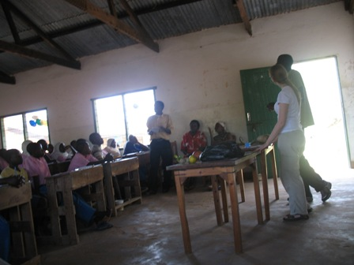
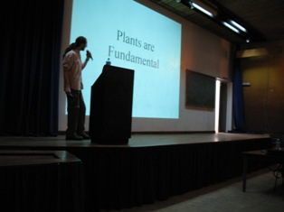
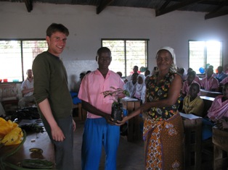

Figure 6. From left to right: i) Project Mbegu’s presentation to Ngonzini Primary school, ii) Hannes Dempewolf co-leader of Project Mbegu presenting an endemic sapling to Ngonzini primary school, received by the head boy and deputy head- Mrs Elizabeth Said, iii) Project Mbegu’s presentation to Sasiyo Girls School at the National Museums Kenya.

Publications
A colour leaflet entitled ‘Plants of the Shimba Hills’ was produced in English, with information regarding the importance of the conservation of the areas plant life. The brochure included colour photos and information about some of the areas native and endemic plants and interesting facts about endemics, as well as the reserves useful and more unusual plants. The intention of the brochure was to stimulate interest and awareness of the reserve as a centre of botanical interest and as an important conservation area as well as to promote the reserve and attract both national and international tourists, in order to generate more income for the reserve and the local stakeholders in the Mwaluganje Elephant sanctuary. An initial 1000 samples were produced in agreement with the NMK and KWS and will be distributed throughout Kenya. An article about the work done during the project is also in production for the magazine SWARA. A full expedition report will be made available to other interested parties through archives at the RGS as well as through the collections of the University of Edinburgh Expedition Society housed in the Darwin Library at Kings Buildings.
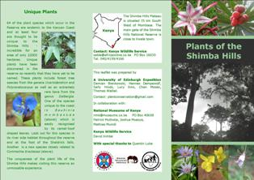
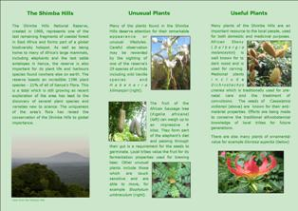

Fig 7. The colour triptych brochure produced by Project Mbegu in Nairobi. i) front and ii) back

Traditional Plant Knowledge

In addition to the dissemination of our research findings and observations we include here our observations on a particular issue which we became aware of during our stay in the Shimba Hills and whose dissemination we believe to be of great importance. During our field work period we met with a Giriama herbalist, resident of the Mwaluganje area, who was happy to share with us his knowledge of the medicinal uses of local plants. He gained most of his knowledge from his father and, despite having a desire to pass on his knowledge he expressed regret that none of his children were interested in becoming his apprentice. He remarked that this is an increasing problem and when questioned blamed their lack of interest on the successful development of the Kenyan education system. His reasoning for this was that because children who pursue higher education are unable to stay in their rural homes, they are less familiar with their local biodiversity, and furthermore they have less contact with their elders and their traditional knowledge. Additionally he said that the new education system emphasised the importance and prestige of subjects such as science and business and young people did not therefore appreciate the value of their traditional knowledge systems, preferring to pursue modern career prospects in urban centres- especially Nairobi.

We spoke to teachers of the local primary school who proved to agree with his conclusions. We were particularly concerned by these observations and as part of our presentations to local schools we emphasised the importance of traditional plant knowledge and encouraged children to take an interest in the traditional plant knowledge of their elders. Furthermore we consider that it is of importance that space is provided within the new curriculum to emphasise the importance of this knowledge and that new initiatives are created to rescue this knowledge before it is lost.

Acknowledgements

Project Mbegu would like to acknowledge Patrick Muthoka of National Museums Kenya for his coordination, assistance and advice throughout the project and Quentin Luke, whose time was kindly made available by the Critically Endangered Partnership Fund and without whom this work would not have been possible. We would like to give our very special thanks to Dr. Richard Milne of University of Edinburgh for his support and encouragement throughout the entire process of this project.
We would also like to thank and acknowledge the financial support of the following organisations:

The Gumby Corporation
The Royal Geographical Society
Davis Expedition Fund
Weir Fund for Field Studies
Barnson Bequest
James Rennie Bequest
The British Association
Edinburgh University Travel Fund

Many thanks to the following people and organisations who assisted us during the course of the project:

National Museums of Kenya
Paul Kirika
Dr. Siru Masinde
Dr. Helida Oyieke
William Wambugu
Halima Saado
Jonathan

KWS
Mr. John Kirui
Mr. David Kimtai
Mr. Moses Litoroh

National Gene bank (KARI)

RBG Kew

Henk Beentje

Millennium Seed Bank Project, Kew
Mr. Tim Pearce

RBG Kew Arboriculture & Conservation team at Wakehurst Place.

Mr. David Waldon

Mr. James Pumfrey

University of Edinburgh
Dr. Richard Milne
Robert Lawrie
Michelle Bain
The Expedition Committee

Royal Botanic Garden Edinburgh
Euridice Honorio
Dr. David Harris
Dr. Tony Miller
Dr. James Richardson
Fiona Inches

RGS
Greg Dow
Shane Winser

For more information about this project please contact
Sally Hinds (s.e.hinds@gmail.com) and/or Hannes Dempewolf (hdempewolf@gmx.de)

References
Blackett, H.L. (1994). Shimba Hills, Mkongani North & Mkongani West—Forest Inventory Report No 4. Kenya Indigenous Forest Conservation Programme (KIFCON), Nairobi.Unpublished Report.
Beentje, H.J. (1994). Kenya Trees, Shrubs and Lianas. National Museums of Kenya, Nairobi.
Critical Ecosystems Partnership Fund (2003) Ecosystem profile. Eastern Arc Mountains & Coastal Forests of Tanzania & Kenya BiodiversityHotspot. Unpublished Report, available from http://www.cepf.net/.
Flora of Tropical East Africa (FTEA). (1952–). Authors Various. Crown Agents for Overseas Governments and Administration, London; Balkema, Rotterdam & Royal Botanic Gardens, Kew.
Gereau, R.E. & W.R.Q. Luke (2003) List of Potentially Threatened Plants of the Eastern Arc Mountains and Coastal Forests of Tanzania and Kenya BiodiversityHotspot. Unpublished report. Critical Ecosystems Partnership Fund.
Gold K., León-Lobos P., Way M. 2004. Manual de recoleccion de semillas de plantas silvestres para conservacion a largo plazo y restauracion ecologica. Insituto de Investigaciones Agropecuarias, Centro Regional de Investigacion Intihuasi, La Serena, Chile. Boletin INIA No. 110, 62 pp
Linington, S.H. and Pritchard, H.W. 2001. Gene banks, pp. 165–181. In: S.A. Levin (editor-in-chief). Encyclopedia of biodiversity, Volume 3. Academic Press, San Diego, USA.
Luke, W.R.Q. 2005. Annotated Checklist of the plants of the Shimba Hills, Kwale district, Kenya, Journal of East African Natural History 94 (1): 5-120
Myers, N., R.A. Mittermeier, C.G. Mittermeier, G.A.B.da Fonseca & J. Kent (2000). Biodiversity hotspots for conservation priorities. Nature 403: 853-858
Myers, N. 2003, Hotspots revisited, BioScience 53 (10): 916-917
Schmidt, R. 1991. Ecology of a Tropical Lowland Rain Forest.Plant Communities, Soil Characteristics and Nutrient Relations of theForests in the Shimba Hills National Reserve, Kenya, PhD thesis, unpublished.

