JAMES RENNIE BEQUEST

REPORT ON EXPEDITION/PROJECT/CONFERENCE

Expedition/Project/Conference Title: Bird survey in Kuzikus, Wildlife Reserve in Namibia

Travel Dates: 28th June 2010 – 25th July 2010.

Location: Kuzikus, Wildlife Reserve in the Kalahari Desert, Namibia.

Group Member(s): Gonner Catherine

Aims: study the abundance and diversity of birds present in the reserve, become familiar with current survey methods and the visual identification of birds.

OUTCOME (not less than 300 words):-

This summer, I was in Namibia participating in a research project that aimed to describe abundance and distribution of birds in a small Wildlife Reserve. The research team was composed of five volunteers and one project leader. Given the very small size of our group, each participant had the opportunity to further his skills by helping to design the study and analyzing the results. Our results have important consequences for the management of the Reserve and the conservation of biodiversity.
Line transects and distance sampling were used to record bird species. A laser range finder and a compass helped to accurately find the bird’s distance and angle from the observer. Thus, the exact distance from the bird to our transect line was calculated (x=r sinθ). Additional information about bird sex, behaviour and identifying features was also noted to avoid recounting and to provide extra help for identifying the birds.
Distance and various detection function models were then used to assess density of birds. The 3 most common birds in the Reserve were the Ant eating chat, marico flycatcher and white browed sparrow-weaver. The latter was by far the most abundant (with an estimated 53.3 birds per km²) as it is a very sociable bird and usually occurs in a flock of up to 20 birds. Another very abundant bird was the sociable weaver. Sociable weavers have the amazing capacity of building huge nests in Acacia trees. Each bird pair then lives in a little chamber, which is connected to other chambers (Picture 1-2)

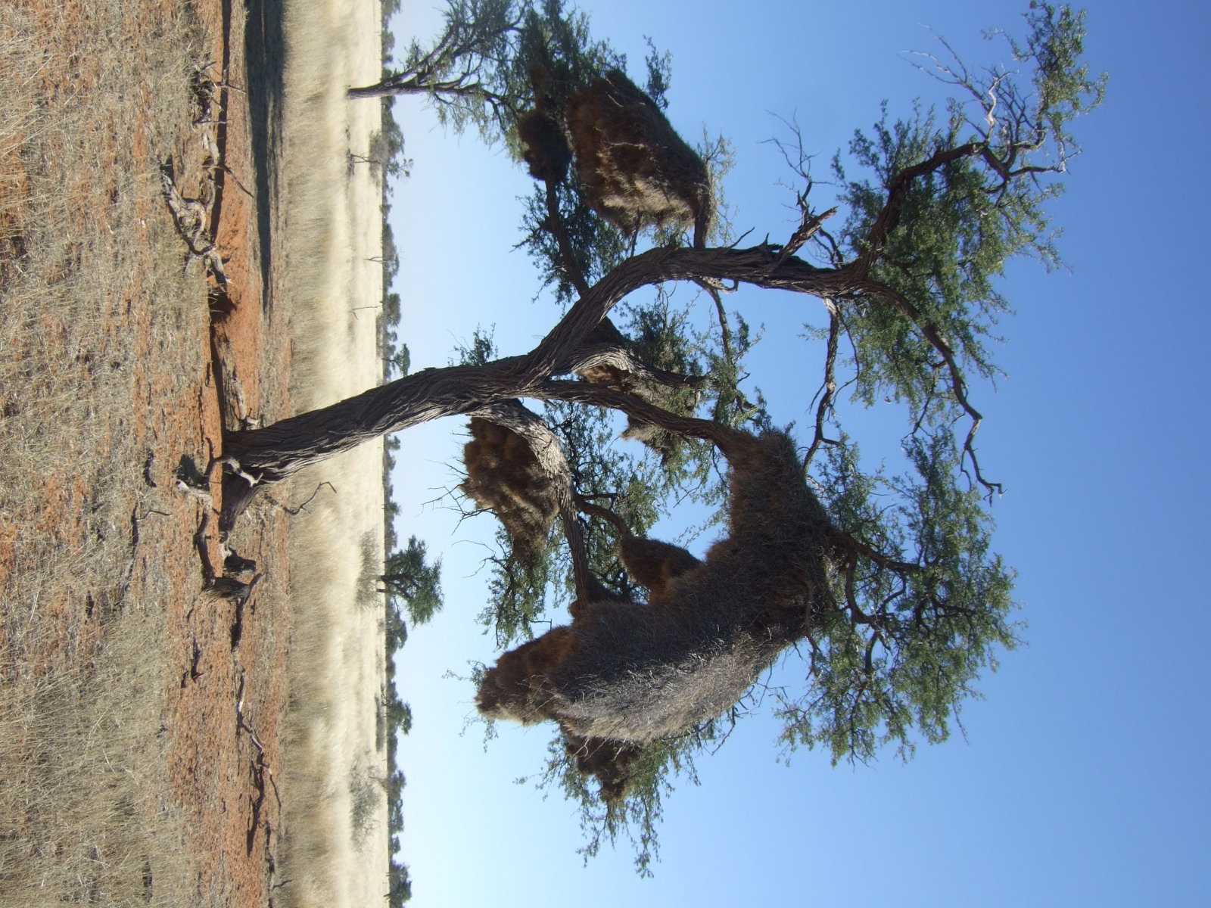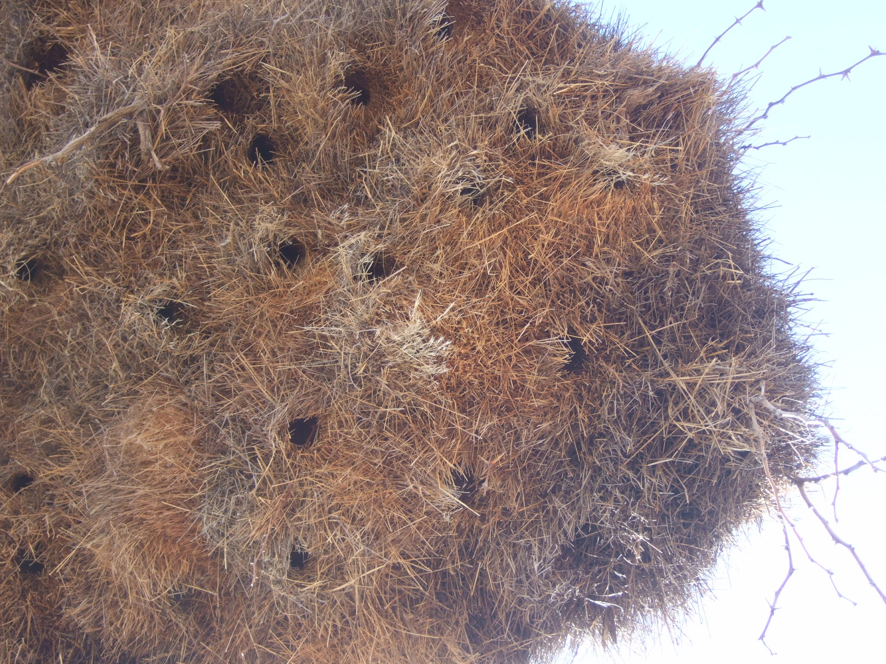
Picture 1&2: The complex structure of the weaver nest.

Vegetation surveys were done in order to detect correlations between birds and their habitat. We found that bird diversity is higher with a certain combination of shrub and grass species. However, bird diversity was not seen to correlate with a single vegetation species, which emphasizes the fact that mixed vegetation is important for bird thriving. Figure 1 shows an example of how bird diversity varies in habitats containing Acacia melifera and either Aristida or Stipagrostis grass.

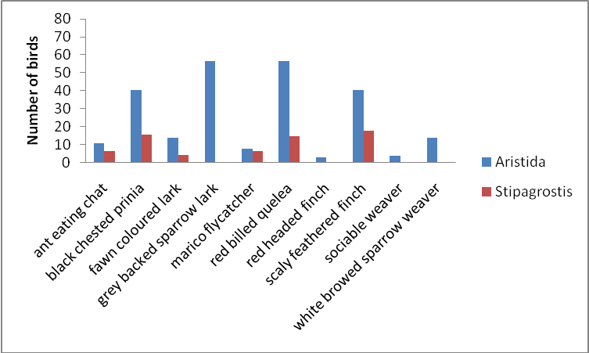
Figure 1: Mean bird number (of all transects) recorded in Acacia melifera dominated area with either Aristida or Stipagrostis grass.

This shows that areas with A.mleifera and Arisitda grass show a much higher bird diversity than the A.melifera with Stipagrostis grass. Similar correlations were found for other habitats containing different vegetation types. This has important management consequences: It is vital to keep mixed vegetation in the Reserve in order to maintain biodiversity. Also, a rich habitat allows thriving of invertebrates (In fact, a high bird diversity indicates the presence of a large variety of invertebrates to prey on.)

It was also possible to detect habitat preferences of some birds: The Marico flycatcher was recorded quite frequently on A.melifera, a dense shrub that is host to lots of small insects, a food source for this bird.
All in all, a total of 76 bird species were recorded during the 4 weeks, some of which are IUCN-red listed (Picture 3)

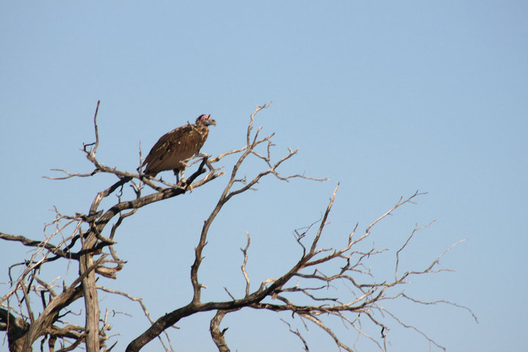

Figure 3: The Lappet-faced Vulture (Torgos tracheliotos) is listed as threatened on the IUCN red list.

Apart from learning a lot about designing scientific studies, recognizing birds and African wildlife, I also lived some very memorable experiences: While camping in the middle of the Reserve, we had a very unique relationship to nature: Being so close to wildlife, we could often hear and see from our tents the many game animals also present in the reserve: giraffes, springboks, gnus, kudus, zebras…! Thus, we also learnt a lot about the identification of large mammals, their behaviour and their track identification. Also, the desert, a biome, which I have never visited before is host to many well-adapted animals and plants about which I enjoyed learning more.
The camp facilities were basic: we cooked on fire, used solar showers… Thus, resting a while from the hustle and bustle of European city life, we could totally enjoy the calm of the desert. There was a tiny village a few kilometres away. From time to time we met the local kids who were very interested in getting to know us, picking up some English phrases and teaching us their native language. Before leaving for Africa, I thought about what I could bring as a little gift to people that I would meet along my journey. I finally came up with the idea of bringing balloons, something they might never have come across before. When they received the balloons, the kids were smiling from ear to ear and were laughing whole-heartedly at this little piece of plastic you could blow up to the size of a head! One kid hid the balloon under his t-shirt and ran away giggling. What might seem to you as a somewhat insignificant story, was much more to me: It made me realize how little those kids needed to be happy and how valuable it is to create, by such a small gesture, a large smile on their faces. It was fascinating to see how people there looked happy with so few belongings. So, there are certainly things we can / should learn from African culture: not to take small things for granted and to learn how to be happy on a daily basis without clinging too much to our material possessions…

I would like to thank the patrons of the James Rennie Bequest for helping me to fund this project. I certainly left Namibia with valuable and unforgettable memories.

