JAMES RENNIE BEQUEST

REPORT ON EXPEDITION/PROJECT/CONFERENCE

Expedition Title: Project Hiyare 2007, formally Project Knuckles

Travel Dates: 29/06/2007-16/08/2007

Location: Hiyare Reservoir, Galle Conservation Society field station, Sri Lanka

Group Member(s): Suraj Goonewardene, Rebecca McIntosh, Alexander Fullbrook and Jonathan Mutch

Aims: A study of the herpetofauna of a Lowland rain forest, Hiyare –Galle, Sri Lanka.

OUTCOME (not less than 300 words):-

James Rennie Bequest Report

Project Hiyare- Description and investigation of the advertisement calls of Sri Lankan lowland forest anurans

As part of Project Hiyare 2007, my focus was to record and describe the advertisement calls of frogs of the lowland rainforest of Sri Lanka.

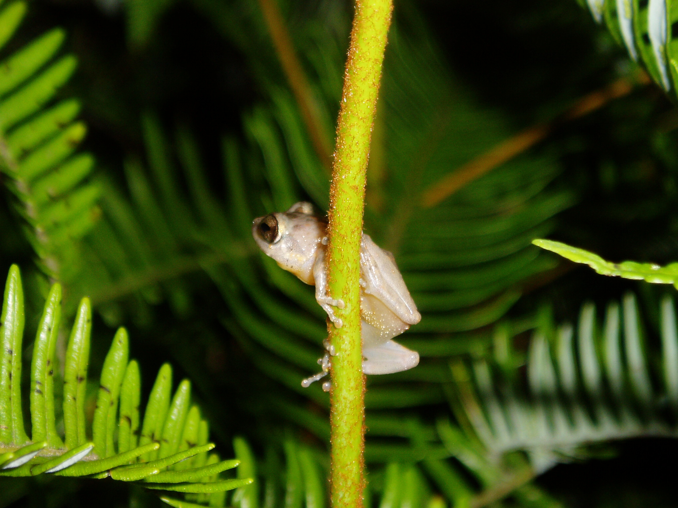
Most anuran communication is used to achieve mating (Wilczynski and Chu; 2001), whether this is directly advertising a male’s presence, species and reproductive fitness, or indirectly by establishing territories between males (Grosjean and Dubois; 2001). Advertisement calls can be used as an independent verification of divergence when describing potential new species (Vasudevan K et al; 2007). Knowledge of the calls of different species may also be used as the basis for carrying out audio strip transects. This method relies on ones ability to distinguish species by their calls, and can allow (with proper recognition of assumptions) an estimation of species populations and densities.

The calls of the majority of Sri Lankan frogs, especially of the genus Philautus have yet to be acoustically described. Philautus are restricted, for the most part, to the ‘wet zone’ rain forests of southwest Sri Lanka were annual precipitation typically exceeds 2000mm (Meegaskumbura et al. 2007). A total of 61 Philautus species from Sri Lanka have been described morphologically (including 17 extinct species) (Kotagama et al; 1981, Manamendra-Arachchi and Pethiyagoda; 2005, Meegaskumbura and Manamendra-Arachchi; 2005), of which only 4 have any bioacoustics data published (Meegaskumbura and Manamendra-Arachchi; 2005).
Male Philautus popularis calling from a perch, photo by Alexander Fullbrook

This project has recorded another 3 Philautus species (P. popularis (n=3), P. folicola and P. silvaticus (n=3)). Another recording was made of a Philautus sp. calling from just beyond our reach but identified as P. hoipolloi after perch site and call identification by specialists in the field. Clearly this needs further verification, but the description of the call is now described in the full project report, so that independent verification can occur. We also made recordings of Rana aurantiaca (unusually of both males (n=4) and females (n=4)), Lankanectes corrugatus (n=3) and Ramonella nagaoi (n=2). In this project we discovered a diverse approach to projecting the advertisement calls, for example Ramonella nagaoi uses partially water filled tree cavities presumably to enhance the call using resonance. This approach may also be used by Philautus folicola which was often found calling from dried, curled up leaves that form a horn-like structure. The sound recordings that we made will shortly be publicly available at the British Library.

P. silvaticus, P. popularis and P. folicola were observed giving visual signals. These consisted of arm waving, and hind foot lifting. To our knowledge this has not been recorded in these species. The visual signals all occurred at night, while calling from prominent perches away from any streams. Hôdl and Amèzquita (2001) note that of 56 anuran species that are known to signal visually, only 11 are nocturnal and a majority tend to inhabit fast-flowing streams, where acoustic communication is less effective. This makes the apparent visual signaling observed unusual.

Sound recordings was only part of the project as a whole, and other important findings include:

- Physical verification and documentation of 46 species of reptile inhabiting the fragment, of which 54% are endemic.
- Discovering two species of amphibians of the genus Philautus and a crotalid snake Hypnale species (Family Viperidae) that could not be identified using the available keys. These animals could be new to science (pers comm, M Bahir & A de Silva, 2007).
- The project has documented the natural history of endemic species such as Ramanella nagaoi and Ceratophora aspera. This information is useful for research workers and wildlife managers for future in situ breeding programs.

During my six weeks in Sri Lanka I had the chance to meet many interesting creatures and people. The work of the Galle conservation society must be praised for their commitment to restoring and maintaining small forest fragments. Without their support and hospitality within Sri Lanka this project could not have occurred. I must thank the James Rennie Bequest for supporting the extensive travel that I undertook on this expedition including flights, overland jeeps and buses etc. Without this help I could not have got to know and experience the rich diversity of Sri Lankas wild life and culture.

