JAMES RENNIE BEQUEST

REPORT ON EXPEDITION/PROJECT/CONFERENCE

Expedition/Project/Conference Title: Parasites of Oryx gazella gazella in the Klein Karoo

Travel Dates: 4th July – 25th July 2004

Location: Sanbona Wildlife Reserve (S33º 43’ E20º 36’), Western Cape, R.S.A

Group Member(s): Matthew B. Ellis

Aims: To document, and quantify where possible, the parasites of Oryx gazella gazella in the Klein Karoo within the Western Cape of the Republic of South Africa

Introduction
This research was carried out at the Sanbona Wildlife Reserve, in the Western Cape of the Republic of South Africa approximately 200km east of Cape Town. The reserve is composed of Montagu Shale rhenosterveld, transitional area North Langeberg sandstone fynbos and western little (klein) karoo.

The Warmwaterberg mountain range runs roughly east-west (Figure 1) through the middle of the reserve effectively cutting it in two. This leads to a variation in climate and vegetation in the north and south.
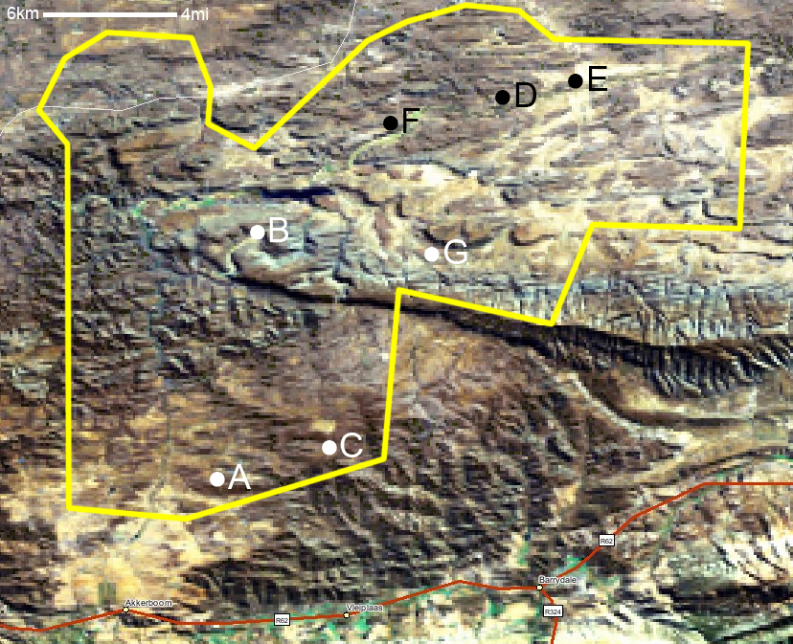
Figure 1: Satellite view of Sanbona reserve (marked in yellow) showing the Warmwaterberg division and the locations of the culls. Gemsbok marked in white, duiker in black
Gemsbok are a large antelope of the Hippotragini tribe, along with the seven surviving species in genera Oryx, Addax and Hippotragus. Members of this tribe are typically large, stocky animals with large, ridged horns, and within the Oryx genus these horns are straight. Members of the Oryx genus live throughout Africa in semi-desert and desert areas (Figure 2), but the gemsbok is found mainly in the south in areas with rainfall between 200-600mm annual rainfall (Ellis M, 2004)

Aims
There are few data regarding recorded parasitic species and distribution for this particular species (Table 1) and the primary aim of this expedition was to provide fresh data on parasitic species and typical burdens. This would include tick and other ectoparasite collection, helminth adults and faecal egg counts and pasture contamination levels.
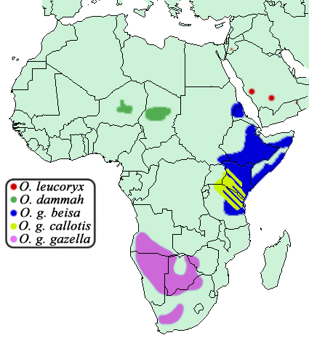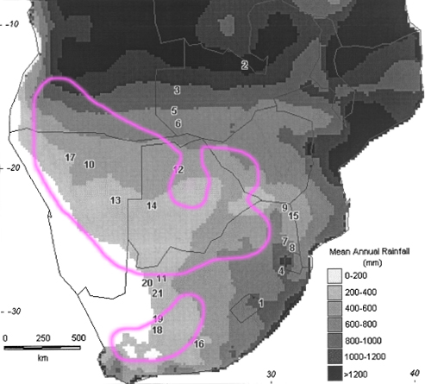
Figure 2: Distribution of Oryx spp. in Africa (left), and distribution of Oryx gazella gazella in southern Africa in relation to annual precipitation. Rainfall data from Swap R. J. et al (2003)

Table 1: Recorded parasites of Oryx spp. from around the world
Parasite Species | Host Species | Location | Reference
Eimeria oryxae | O. dammah | Saudi Arabia | Alyousif M. S., et al. (2002)
Mycobacterium tuberculosis | O. g. beisa | Jackson (MS. N.Am) | Lomme J. R., et al. (1976)
Agriostomum equidentatum | O. g. gazella | Kalahari-Gemsbok NP | Boomker J., et al.(1986)
Coernus cyst | O. g. gazella | Windhoek | Bohrmann R. (1990)
Haemonchus contortus | O. g. gazella | Kalahari-Gemsbok NP | Boomker J., et al.(1986)
Nematodirus spathiger | O. g. gazella | West Coast NP | Boomker J., et al.(2000)
Nematodirus spp | O. g. gazella | New Mexico | Bender L. C., et al. (2003)
Teladorsagia hamata | O. g. gazella | W. S.Af. | Boomker J., et al. (2003)
Trichostrongylus Looss | O. g. gazella | Kalahari-Gemsbok NP | Boomker J., et al.(1986)
Camelostrongylus spp | O. leucoryx | Antwerp | Goossens E. [17.02.2004]
Haemonchus spp | O. leucoryx  O. g. callotis | --- | FDA (1990)
Sarcoptes scabiei | O. leucoryx | Israel | Yeruham I, et al. (1996)
Toxoplasma gondii | O. leucoryx | Saudi Arabia | Mohammed O.B., et al. (1994)
Trichostrongylus spp | O. leucoryx | Antwerp | Goossens E. [17.02.2004], FDA (1990)
Trichuris spp | O. leucoryx | Antwerp | Goossens E. [17.02.2004], FDA (1990)

Methodology
As Moredun Research Institute standard operating procedures.

Results
Overall a lot of data was collected, and some of this is still being analysed. However the bulk has been collated and is shown and discussed below.
Table 2: Summary of culled individuals
Animal | Species | Sex | Age (yrs) | Weight (kg) | Cull Date | Location
A | O. g. gazella | f | 6 | 170 | 09.07.04 | S33 51.190 E20 33.069
B | O. g. gazella | f | 6 | 140 | 12.07.04 | S33 44.406 E20 34.160
C | O. g. gazella | f | 4 | 120 | 16.07.04 | S33 50.073 E20 36.519
D | S. grimmia | m | 1 | 17 | 20.07.04 | S33 40.422 E20 41.868
E | S. grimmia | m | 1 | 20 | 20.07.04 | S33 39.896 E20 44.334
F | S. grimmia | f | 3 | 30 | 20.07.04 | S33 41.308 E20 38.449
G | O. g. gazella | m | 8 | 180 | 21.07.04 | S33 44.965 E20 39.791
Helminths
Table 3: Helminth species found in the abomasum, shown as total worms per animal
Animal | H. contortus | O. ostertagi | T. rugatus
A | 10 | - | 70
B | - | - | 30
C | 20 | 50 | -

Table 4: Helminth species found in the ileum, shown as total worms per animal
Animal | Agriostomum | Cooperia sp. | H. contortus | N. spathiger | O. ostertagi | T. rugatus
A | 50 | - | - | 30 | - | 20
B | - | - | - | - | - | -
C | - | 50 | 50 | 120 | 40 | 80

Table 5: Helminth species found in the duodenum, shown as total worms per animal
Animal | Agriostomum
A | -
B | -
C | >1000

Unfortunately I was unable to recover any male Cooperia sp. and so it was not possible to identify to species level. It was possible to collect cysticercae from the mesenteries of animals C (gemsbok) and F (duiker), at time of publication these are still under analysis.

Ticks
Due to time constraints I was only able to obtain qualitative data (Table 7). However Rh. gertrudae was by far the most commonly encountered and widely distributed of the species found.
Table 6: Tick species and location recovered from animal s.
Species | Location
Ixodes rubicundus | Anus, Back, Belly, Feet, Flank, Legs
Rh. (Boophilus) decoloratus | Back, Belly, Ear Feet, Legs
Rhipicephalus gertrudae | Anus, Belly, Ear, Flanks, Feet, Legs, Neck, Tail
Rhipicephalus glabroscutatum | Feet

It should also be noted that although there is no quantitative data to support it, it was noted that animals with heavy parasite loads were usually infested with concurrently high tick and helminth burdens.

Pasture Samples
Table 7: Data from site of each animal cull. Animals D-F were collected at night and so pasture sampling was not possible. Units per Kg herbage.
Site | A | B | C | G
Eggs | 292.9 | 226.2 | 1507.9 | 1159.5
These data show a clear divide between the north and south of the reserve, with the north having pasture contamination more than five times higher than the south. This is unexpected as the population is higher in the south due to greater access to water and herbage. However until recently the reserve was subdivided into many farms with the north being predominantly pasture and the south being set aside for orchards, and so it is possible that the extra egg contamination may be due to previous livestock contamination.

Duiker haematoprotozoa
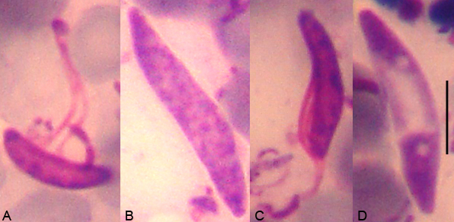
Figure 3: Haematoprotozoa recovered from duiker (Sylvicapra grimmia) blood films in Sanbona Wildlife reserve. Measure bar = 5μm
It has not been possible to identify these as all samples are fixed smears (Figure 3) and DNA extraction is no longer an option. However it was possible to measure a subset with similar morphology to specimen C (Table 9).

Table 8: Measurements (in µm) of various parameters (Penzhorn 1996) of the haematoprotozoa of type C found in the blood smear of three duiker (Sylvicapra grimmia) from Sanbona Wildlife reserve (n=25)
 | mean | max | min | variance | SD
Body length | 8.41 | 10.00 | 6.00 | 2.14 | 1.46
Body breadth | 2.73 | 4.00 | 1.50 | 0.47 | 0.68
Flagellum length | 9.76 | 13.00 | 6.00 | 6.57 | 2.56
Kinetoplast length | 0.90 | 2.00 | 0.50 | 0.24 | 0.49
Distance from anterior end of body to kinetoplast | 0.16 | 0.75 | 0.00 | 0.06 | 0.25
As these smears were taken at night and promptly after death I do not believe these are from infected arthropods feeding on the carcass, rather these are in fact a duiker parasite. It is worth noting that none of the culled duiker had any attached ectoparasitic arthropods.

Discussion
There is still a lot of data left to analyse from this expedition, including identifying the cysticercae with the help of Dr M. Blaxter and Dr T. Littlewood, identifying the Cooperia and unknown duiker helminth species and identifying the haematoprotozoa. Agriostomum equidentatum has previously been recorded in gemsbok and kudu (Tragelaphus strepsiceros) in the Kruger National Park (Boomker et al. 1986, 1989), as well as springbok (Antidorcas marsupialis) in the Western Cape (Horak 1982), so this confirms predictions that it should be present in gemsbok in this area. I can confirm the presence of H. contortus (Boomker 1986), N. spathiger (Boomker 2000) in gemsbok and add the klein karoo to their distribution. However O. ostertagi and T. rugatus appear to be a new parasite relationship.

Unlike previous studies (Horak 1998), I found that R. glabroscutatum was quite rare, but in accordance with MacIvor (1985) was very selective about feeding sites, being found only between the hooves, and in relatively small numbers. Data from the other tick species also confirms all previous reports and shows presence of the species within the klein karoo.

Acknowledgements
I would like to thank the staff of Sanbona wildlife reserve, especially Mr A. Schofield, Mr. R. Erasmus, Mr P. Vorster, Miss K. Heunis and Miss M. Groenewald for their patience and continued support with this project, Mrs M Cameron, Dr B. Matthews Dr M. Blaxter and Dr P. Preston of Edinburgh university for their help and support, Prof. B Penzhorn and Prof. J. Boomker of the University of Pretoria for their help in analysis and finally Mr J. Kitson for his help in collating the data. Many thanks to the James Rennie Bequest and the Weir Fund for their financial assistance.

References
Alyousif M. S., Al-Shawa Y. R. (2002) A new coccidian parasite (Apicomplexa: Eimeriidae) from the scimitar-horned oryx, Oryx dammah. Journal for the Egyptian Society of Parasitology. 32(1);241-6
Bender L. C., Li H., Thompson B. C., Morrow P. C., Valdez R. (2003) Infectious disease survey of gemsbok in New Mexico. Journal of Wildlife Diseases. 39(4):772-8.
Bohrmann R. (1990) Coenurus in the muscles of a gemsbok (Oryx gazella). Veterinary Parasitology. 36(3-4):353-6
Boomker J, Horak IG, De Vos V (1986) The helminth parasites of various artiodactylids from some South African nature reserves. Onderstepoort Journal of Veterinary Research. 53(2):93-102.
Boomker J, Horak IG, de Vos V. (1989) Parasites of South African wildlife. IV. Helminths of kudu, Tragelaphus strepsiceros, in the Kruger National Park. Onderstepoort Journal of Veterinary Research. 56(2):111-21
Boomker J, Horak IG, Watermeyer R, Booyse DG. (2000) Parasites of South African wildlife. XVI. Helminths of some antelope species from the Eastern and Western Cape Provinces. Onderstepoort Journal of Veterinary Research. 67(1):31-41
Boomker J. (1986) Trichostrongylus auriculatus n. sp. (Nematoda: Trichostrongylidae) from the steenbok, Raphicerus campest is (Thunberg, 1811). Onderstepoort Journal of Veterinary Research. 53(4):213-5
Boomker J., Durette-Desset M. C. (2003) Parasites of South African wildlife. XVII. Ostertagia triquetra n. sp. (Nematoda: Trichostrongylina) from the grey rhebuck, Pelea capreolus (Forster, 1790). Onderstepoort Journal of Veterinary Research. 70(1):37-41
Boomker J., Horak I. G., Watermeyer R., Booyse D. G. (2000) Parasites of South African wildlife. XVI. Helminths of some antelope species from the Eastern and Western Cape Provinces. Onderstepoort Journal of Veterinary Research. 67(1):31-41
Ellis M. (2004) Gemsbok (Oryx gazella gazella) in Southern Africa. Unpublished
Feldman-Muhsam B. (1960) The South African ticks Rhipicephalus capensis Koch and R. gertrudae n. sp. Journal of Parasitology. 46:101-8
Food and Drug Administration. (1990) Freedom of Information Summary: NADA 131-675. Freedom of Information Staff (HFI-35) (http://www.fda.gov/cvm/efoi/section1/131675s112090.html)
Goossens E. [17.02.2004] Zoo animals and parasites. (http://www.uia.ac.be/crc/zoo_animals_and_parasites.html)
Horak I. G., Potgieter F .T., Walker J. B., De Vos V., Boomker J. (1983) The ixodid tick burdens of various large ruminant species in South African nature reserves. Onderstepoort Journal of Veterinary Research. 50(3):221-8
Horak IG, Boomker J. (1998) Parasites of domestic and wild animals in South Africa. XXXV. Ixodid ticks and bot fly larvae in the Bontebok National Park. Onderstepoort Journal of Veterinary Research. 65(3):205-11
Horak IG, Meltzer DG, De Vos V. (1982) Helminth and arthropod parasites of springbok, Antidorcas marsupialis, in the Transvaal and Western Cape Province. Onderstepoort Journal of Veterinary Research. 49(1):7-10
Lomme J. R., Thoen C. O., Himes E. M., Vinson J. W., King R. E. (1976) Mycobacterium tuberculosis infection in two East African oryxes. Journal of the American Veterinary Medical Association. 169(9):912-4.
MacIvor KM. (1985) The distribution and hosts of Rhipicephalus glabroscutatum. Onderstepoort Journal of Veterinary Research. 52(1):43-6
Mohammed O.B., Hussein H. S. (1994) Antibody prevalence of toxoplasmosis in Arabian gazelles and oryx in Saudi Arabia. Journal of Wildlife Diseases. 30(4):560-2
Penzhorn B. L., Keet D. F., Bengis R. G. (1996) A trypanosomatid organism on blood smears made from a waterbok (Kobus ellipsiprymnus) carcass in the Kruger National Park. Journal of the South African Veterinary Association. 67(1):4-5
Yeruham I, Rosen S, Hadani A, Nyska A. (1996) Sarcoptic mange in wild ruminants in zoological gardens in Israel. Journal of Wildlife Diseases. 32(1):57-61

