JAMES RENNIE BEQUEST

REPORT ON EXPEDITION/PROJECT/CONFERENCE

Expedition/Project/Conference Title: Marine Expedition to Mexico 2009

Travel Dates: June 30th – July 24th 2009

Location: ECOSUR, Chetumal, Mexico

Group Member(s): Adam Cross, Tony Marshall, Sophie Eastwood, Sarah Hutcheon, Conor McCone and Neil Clark

Aims: 1) To assist in the recording of populations of Strombus gigas at Banco Chinchorro.
2) To assist in the compilation of a nematode inventory collected from Laguna de Términos.

OUTCOME (not less than 300 words):-

I was the Science Officer on the Marine Expedition to Mexico 2009, please see the report attached for further details on the expedition.

Personal Contributions and Achievements:

When we began organising the expedition we each had a couple of potential contacts in Mexico. One of my contacts, Dr. Alberto de Jesús-Navarrete, became the successful lead which we pursued. I maintained contact with Dr. Alberto de Jesús-Navarrete and thus significantly helped to organise the expedition, with the help of the group leaders. As a result of this communication I decided to do a piece of coursework on the Queen conch around Mexico. This required a detailed 10 page report on the species and its current management; which is why I was delegated Science Officer.
Also, while we were in Mexico I had a significant input to the Queen conch data recording and handling; and I found some of my previous knowledge on the Queen conch was applicable to the report writing. Out with my academic merits, I was one of the group members who had previously gone travelling which I think positively contributed to the group dynamics. I also shared photos which I took during the expedition on my SLR camera with the other group members.

Even though I was a qualified scuba diver before the expedition I was actually quite a nervous snorkeler. I have a mild fear of open water and I found this expedition greatly helped me to get over this fear. In addition I noticed a definite improvement in my snorkelling ability towards the end of the trip.
Before the expedition we all took basic Spanish lessons. Although I felt these lessons did not equip us well, in Mexico I learnt that confidence rather than knowledge is more important in speaking another language. Although my communication skills did improve (not necessarily speaking) I do think next time I will be more confident.
It was an amazing experience getting the chance to see everything I’d been reading about whilst completing my Queen conch report, for example the sea grass beds were not how I imagined them. As well, during my report, I found it very easy to criticise the fishermen for over-fishing. However, after spending time in Banco Chinchorro, where we helped fishermen with their English lessons and played football in the evenings it completely changed my perspective. This kept changing, and during our trip to Punta Herrero the generosity and simple but admirable lifestyles of these fishermen made me realise that these men were, perhaps, not the ones to blame and that small-scale fisheries are important for the community.
Our time with Dr. Manuel Mendoza Carranza was also enlightening. In his work he really emphasises involving the community in his research and helping locals such as the fishermen; and his relationship with the fishermen was impressive.

The Mexico Expedition exceeded my expectations. For me, the most worthwhile experience was taking the case study of the Queen conch and comparing what I had learnt through literature to what I learnt in practice. I think experiences such as these allow you to be more open-minded and empathetic.

Acknowledgements

I would like to thank Salvador Hernandez-Daumas for helping organise this trip and for his families’ endless generosity, Dr. Alberto de Jesús-Navarrete for allowing us to help with his research, and all the staff at ECOSUR. And of course, the James Rennie Bequest for making this expedition possible.

Marine Expedition to Mexico 2009

The effect of management on populations of Strombus gigas in Quintana Roo, Mexico.

In July this summer, six undergraduate ecology students from the University of Edinburgh completed a successful four week expedition to Chetumal in southern Mexico, in collaboration with the Mexican institution, El Colegio de la Frontera Sur (ECOSUR). The primary aim of this expedition was to study populations of conch (Strombus gigas) subject to differing management policies in two geographically separate locations: Banco Chinchorro and Punta Herrero (Fig. 1). Firstly, we spent a week at Banco Chinchorro to study and measure conch individuals whilst snorkelling with ECOSUR staff. An additional trip was carried out in week four to measure conch individuals over four days at Punta Herrero (an area 5 hrs north of Chetumal). This allowed us to make a comparison of conch populations. We were also fortuitously able to work, in addition to our own investigation, on nematodes, parasites and elasmobranchs.

The data we collected in conjunction with ECOSUR will be used to further improve management strategies to maintain and increase local populations of conch at both Banco Chinchorro and Punta Herrero.
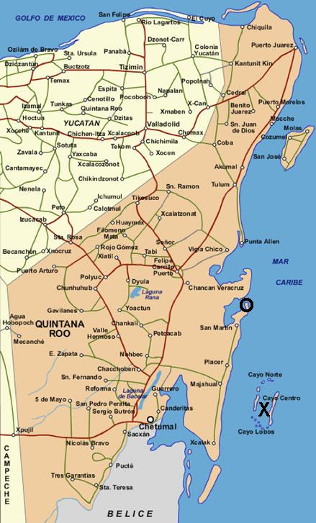
Figure 1. Map of the state Quintana Roo, Mexico with site locations marked by ‘X’ for Banco Chinchorro and ‘O’ for Punta Herrero.

The management at Banco Chinchorro for conch harvesting is restricted to a quota of 10 tonnes (held by one organisation approved by the government) between the months of December and February. The management at Punta Herrero for conch harvesting is that of an annual strict no take zone, as this area falls within the Sian Ka’an Biosphere Reserve.

Method

Conch collected and sampled at both locations was measured for siphonal length (SL) and lip width (LW). These morphological measurements were taken because age can be inferred based on these parameters (CFMC, 1999; Appeldoorn, 1988). For juvenile conch though SL is often used to predict age (Appeldoorn, 1990). Huitric (2005) studied juvenile conch and identified the SL size at which individuals reached maturity to be 210 mm on average. Problems with aging conch with SL is that it becomes an increasingly inaccurate measurement with older conch as the SL and age correlation decreases in significance, due to, for example, shell erosion. Appeldoorn (1988) thus suggests that the most accurate method for all conch is LW, whereby individuals reach maturity at approximately 5mm LW.

Results

Our results showed that the mean siphonal length (SL) and mean lip width (LW) were greater at Punta Herrero (N=442) compared to Banco Chinchorro (N= 569). The results show that there was not a significant difference (P > 0.05) in SL between the sites of Banco Chinchorro and Punta Herrero (Mann-Whitney U-test: U = 286340.0, P = 0.7326). For LW, there was a highly significant difference (P < 0.001) between sites (Mann-Whitney U-test: U =192020.5, P = 0.0000). From descriptive statistics and the Mann-Whitney U-test, it can be concluded that there are no significant differences in SL between sites but at Punta Herrero the median LW was highly significantly greater than at Banco Chinchorro.

Discussion

From the results collected it can be inferred that the conch populations are more greatly comprised of juveniles at Banco Chinchorro than at Punta Herrero. From statistical tests, the age structure (inferred from LW measurements) between the two populations is shown to be significantly different based on the two site’s conch population median LW (P < 0.001). The low adult population at Banco Chinchorro, if not natural, may be exacerbated by over-harvesting during the open season and perhaps illegally during the closed season. Whether these differences are due to the management at each site and not indicative of other variables, e.g. population fluctuations or environmental variation is open to further discussion and study.

Additional Experience

Two weeks in between the trips to Banco Chinchorro and Punta Herrero were spent working in the laboratory at ECOSUR-Chetumal, helping in the research being carried out on nematodes. We were involved in finding nematodes in sediment collected from Laguna de Terminos and using microscopes then putting them into formaldehyde for preservation. These nematodes will then be identified and classified by experts at ECOSUR. The purpose of this is to create an inventory of the nematode species present at Laguna de Terminos and several new species have already been recorded.

Also whilst at ECOSUR-Chetumal we were given the opportunity by Dr. David Gonzalez Solis to spend time in his lab gaining experience in his work on parasitology. This involved dissecting fish and snake samples and using a microscope to find endo-parasites present within them. The parasites found may be new to science and endemic to the Chetumal area.

Working with Dr. Manuel Mendoza Carranza, a researcher at ECOSUR-Villahermosa, we learnt over three days various ways in which fish samples can be collected and within the small fishing village of San Pedro we dissected and took measurements of all the shark species and stingrays being landed by the returning artisanal fishermen. This is part of Dr Mendoza Carranza’s regular work and he will add the measurements we made to his data set.

Summary

Overall the aims of this expedition were successfully achieved. This achievement arose from the help and consideration that the members of ECOSUR gave us in fulfilling our goals. In general, we all developed an appreciation for different cultures and awareness of different scientific techniques that will be invaluable and applicable in many future scenarios.

A large thank you goes to James Rennie Bequest for the support given to this expedition.

References

Appeldoorn, R.S. (1988) Age determination, growth, mortality and age of first reproduction in adult Queen Conch, Strombus gigas L., off Puerto Rico. Fisheries Research. 6(4):363-378
Appeldoorn, R.S. (1990) Growth of Juvenile Queen Conch, Strombus gigas L., off La Parguera, Puerto Rico. The Journal of Shellfish Research. 9(1):59-62
Appeldoorn, R.S. (1993) Reproduction, spawning potential ratio and larval abundance of Queen Conch off La Parguera, Puerto Rico. To Caribbean Fishery Management Council. [Available at: http://www.aoml.noaa.gov/general/lib/CREWS/Cleo/PuertoRico/prpdfs/appledoorn-reproduction.pdf, accessed on: 25/02/09]
CFMC, Caribbean Fishery Management Council. (1999) Queen conch stock assessment and management workshop. Caribbean Fishery Management Council, Belize City, Belize. [Available at: http://www.caribbeanfmc.com/workshops/BelizeConchWGReportFinal.PDF, accessed on: 26/02/09]
Huitric, M. (2005) Lobster and Conch Fisheries of Belize: a History of Sequential Exploitation. Ecology and Society. 10(1):21-35

